Insight Assessment Platform
Online Transition and Development Statement (TLDS)

Authorised and published by the Victorian Curriculum and Assessment Authority
Level 7, 2 Lonsdale Street
Melbourne VIC 3000
ISBN: 978-1-925676-91-4
© Victorian Curriculum and Assessment Authority 2018

No part of this publication may be reproduced except as specified under the Copyright Act 1968 or by permission from the VCAA. Excepting third-party elements, schools may use this resource in accordance with the VCAA educational allowance. For more information go to: www.vcaa.vic.edu.au/Pages/aboutus/policies/policy-copyright.aspx.
The VCAA provides the only official, up-to-date versions of VCAA publications. Details of updates can be found on the VCAA website: www.vcaa.vic.edu.au.
This publication may contain copyright material belonging to a third party. Every effort has been made to contact all copyright owners. If you believe that material in this publication is an infringement of your copyright, please email the Copyright Officer: vcaa.copyright@edumail.vic.gov.au
Copyright in materials appearing at any sites linked to this document rests with the copyright owner/s of those materials, subject to the Copyright Act. The VCAA recommends you refer to copyright statements at linked sites before using such materials.
The VCAA logo is a registered trademark of the Victorian Curriculum and Assessment Authority.
Contents
Introduction 1
Insight Assessment Platform user guides 1
About the Insight Assessment Platform 1
About this user guide 1
About TLDS 1
About the Online TLDS 1
Section 1 – Logging into Insight 2
Section 2 – TLDS for Insight School Administrators 2
Notifications 2
Accessing TLDS 3
Manually uploading a TLDS 4
Linking a TLDS 5
Returning a TLDS 7
Recalled TLDS 8
Downloading a TLDS 9
Creating Summary Reports 10
Section 3 – TLDS for Teachers 11
Accessing TLDS 11
Manually uploading a TLDS 13
Support 13

Introduction

Insight Assessment Platform user guides
The following user guides are available for non-government schools to learn more about using the Insight Assessment Platform:
- Technical Support Staff User Guide
- School Assessment Administrator User Guide
- Assessment delivery guide.

About the Insight Assessment Platform
The Insight Assessment Platform (Insight) is aimed at helping teachers assess the progress of all learners and to support more targeted teaching practices.
Insight has been run by the VCAA since August 2017. It provides a collection of quality online assessment instruments. It supports high-quality assessment practices and provides teachers with specific information to target the learning needs of students through its powerful data analytics and reporting capabilities. Students’ assessment data can be reviewed by teachers for diagnostic, formative and summative purposes.

About this user guide
This document provides non-government School Administrators and Teachers with information and support to enable the use of the online Transition Learning and Development Statement (TLDS) functionality within the Insight Assessment Platform.

About TLDS
A child’s TLDS is completed by their early childhood centre, with contributions from the child and their parents/guardians. A TLDS summarises a child’s abilities as they start school and identifies their individual approaches to learning. Section 1.2 of the TLDS provides additional information about children with an identified disability or developmental delay.
The information in the TLDS aims to assist Prep teachers in understanding the needs of the children entering their class, and plan appropriate learning and teaching programs.

About the Online TLDS
The Online TLDS is a tool for writing and sharing TLDSs. This tool is available for use via Insight.
The Online TLDS has been designed for early childhood services to complete students’ TLDS and share them with schools nominated by parents/guardians via Insight.
Sharing a TLDS via Insight will give schools the ability to link a student’s TLDS to their individual student record, along with other student assessment data that is held on Insight.
Once a TLDS is linked to a student's individual student record it can follow the student between schools within the same sector.

Section 1 – Logging into Insight
For information about logging on to Insight or registering your school for first time use of Insight, please see the Assessment Delivery User Guide.
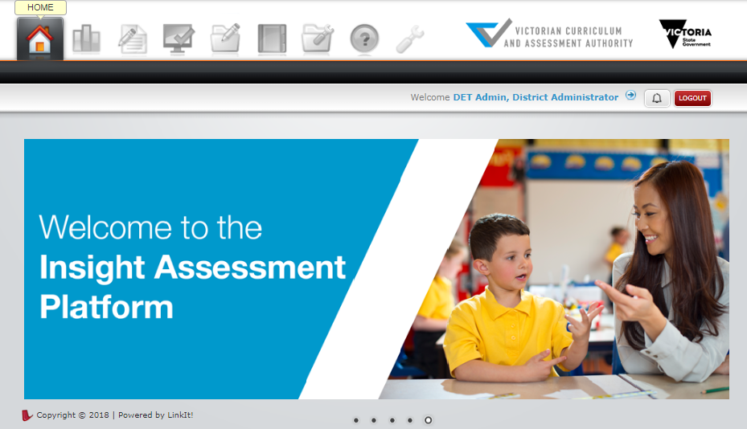
Figure 1.0

Section 2 – TLDS for Insight School Administrators

Notifications
When an early childhood service completes a TLDS on Insight, they are able to submit it via Insight to a school nominated by the student’s parents/guardians. When an early childhood service submits a statement to your school, all Insight School Administrators at the school will receive an email notification to the effect of:
A Transition Learning & Development Statement (TLDS) for [student’s name] has been submitted through the Insight Platform to [school name].
Note: Please ensure the School Administrators registered at your school on the Insight Assessment Platform are up to date to prevent incorrect members of staff receiving these notifications.

Accessing TLDS
The TLDS system is located on the TLDS Manager page of Insight. Accessing this page will allow you to see all TLDSs that have been sent to your school.
To access the TLDS Manager:
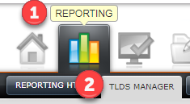
Figure 2.0
- Select Reporting, as shown in Figure 2.0.
- Select TLDS Manager, as shown in Figure 2.0.
TLDSs will be shown in your school’s TLDS Manager when:
- TLDSs are submitted to your school from an early childhood centre
- An Insight School Administrator uploads a TLDS that is received via email or in hard copy from the early childhood service or from the student’s family.

Manually uploading a TLDS
TLDSs that are submitted to your school via Insight will be shown in your TLDS Manager. If your school receives a TLDS from a student’s early childhood centre or parents/guardians via email or as a hard copy, it can be manually uploaded to the TLDS Manager as a PDF.
To manually upload a TLDS:
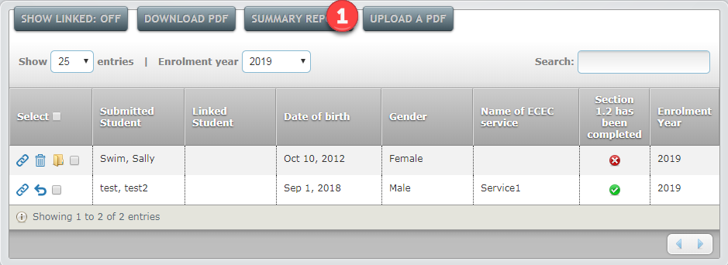
Figure 2.1
- Select upload a PDF, as shown in Figure 2.1.
- The Upload a PDF pop-up box will appear. Input the known details of the student on this screen.
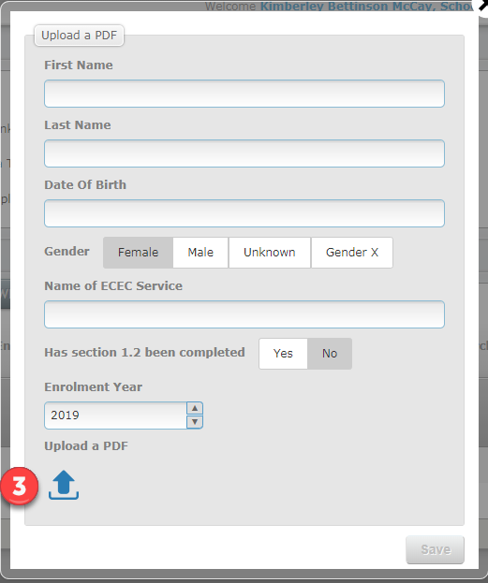
Figure 2.2
- Select Upload a PDF button to upload the students PDF, as shown in Figure 2.2. A window will open to select the file from your computer. Once you have found the correct file, select Open.
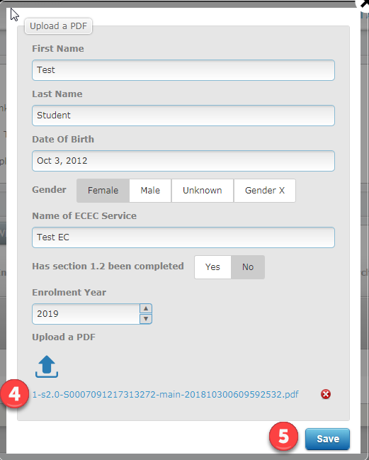
Figure 2.3
- The selected file name should now be visible in the Upload a PDF pop-up box, as shown in Figure 2.3.
- Select Save. The student’s details will now be visible in the TLDS Manager, as shown in Figure 2.3.

Linking a TLDS
TLDSs that are sent to your school via Insight, or manually uploaded to Insight, are required to be linked to a student’s Insight profile to enable the student’s classroom teacher to access the statement via Insight. All unlinked statements are only visible to Insight School Administrators.
To link a TLDS to a student’s Insight profile:
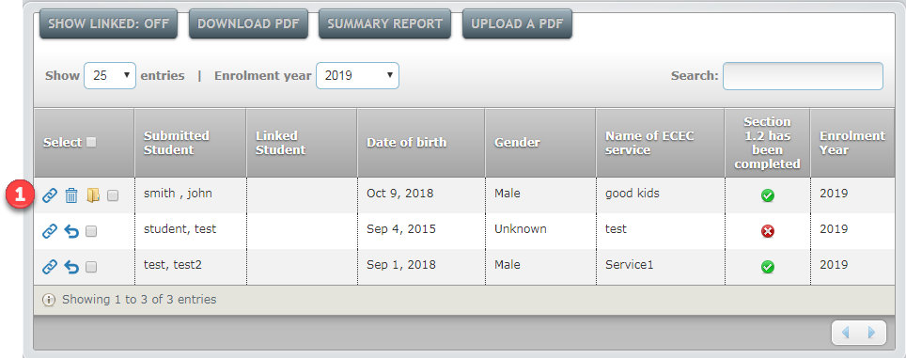
Figure 2.4
- In the TLDS Manager, select the link button as shown in Figure 2.4.
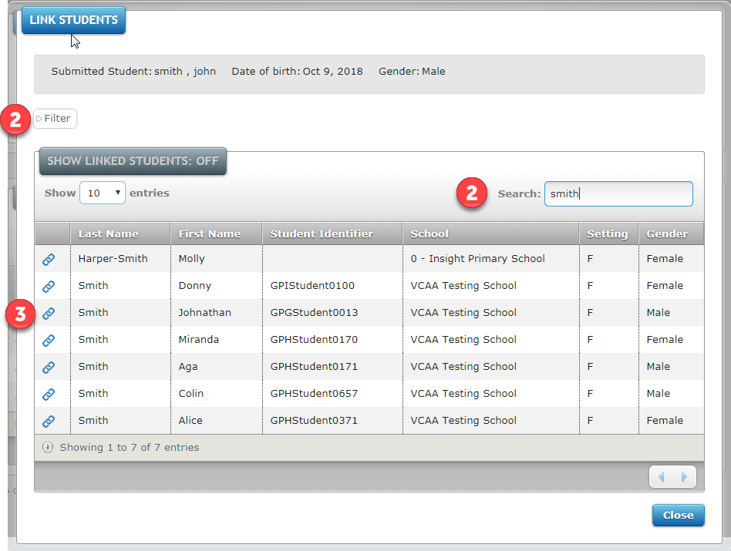
Figure 2.5
- A Link Students pop-up box will appear. If required, the Filter or Search functions can be used to find the student (see Figure 2.5).
- Select the Link button, as shown in Figure 2.5. The selected student has now been linked to the TLDS and the pop-up box can be closed.
Tip: Student names do not need to match to successfully link a statement to allow for variances, for example John and Johnathan.
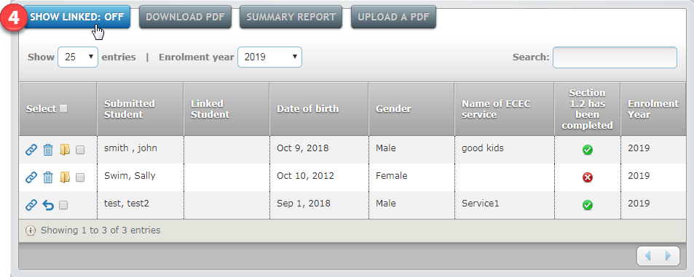
Figure 2.6
- The default view of the TLDS Manager shows only all unlinked statements. To see all linked and unlinked statements, select Show Linked: Off (see Figure 2.6).

Returning a TLDS
If a TLDS has been submitted to your school in error, or if it has been confirmed that the student will not be attending your school, the TLDS can be returned to the early childhood centre via Insight. This can only occur if the TLDS has not been linked to a student record.
To return a TLDS:
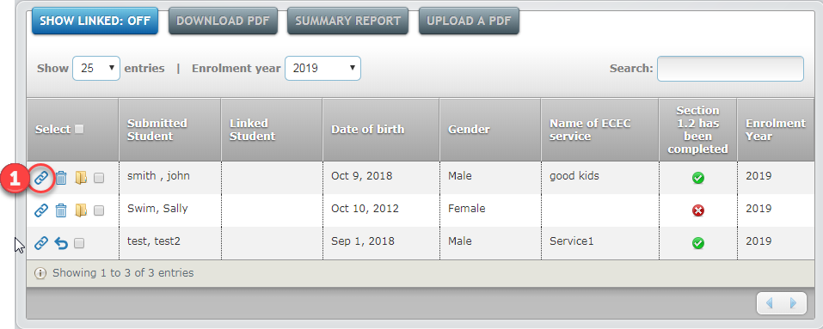
Figure 2.7
- In the TLDS Manager, ensure the TLDS is not linked to a student. An unlinked TLDS is by the icon in Figure 2.7.
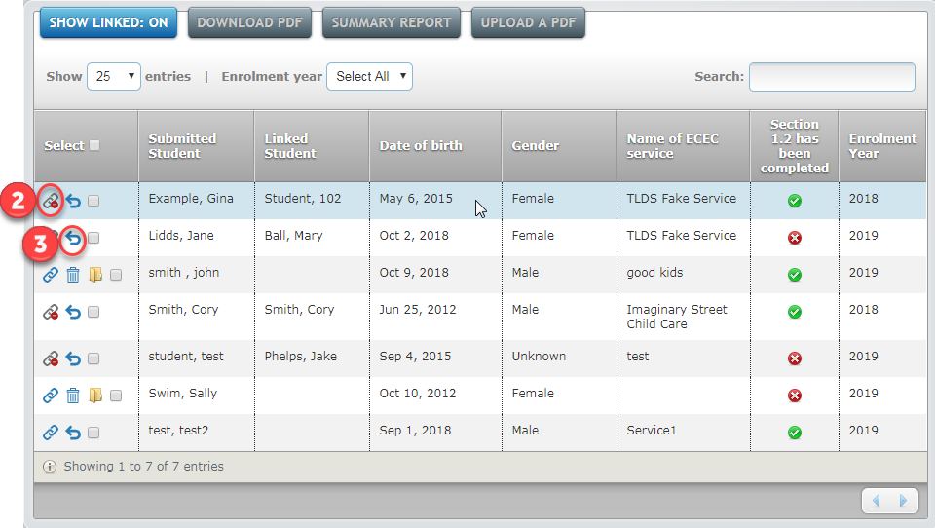
Figure 2.8
- If the TLDS has been linked to a student, select the Unlink button, as shown in Figure 2.8.
- Select the Return button, as shown in Figure 2.8.
- A Return Statement pop up-box will appear. Enter a reason for returning the statement to the early childhood centre. The reason will be shown to the early childhood centre.
- Select the Return button.
Once the TLDS has been returned to the early childhood centre, the centre will receive an email notification and the TLDS will no longer appear in your school’s TLDS Manager.

Recalled TLDS
As an Insight School Administrator, you will receive an email notification if an early childhood centre recalls a TLDS they have submitted to your school. An early childhood service may recall a TLDS if they have submitted it to the wrong school or they wish to add further details to the TLDS.
A TLDS that has been linked to an Insight student profile is unable to be recalled by the early childhood service.

Downloading a TLDS
Completed TLDSs are able to be downloaded from the TLDS Manager page as a PDF. This will allow you view the TLDS details and, if required, print the TLDS.
To download a TLDS:
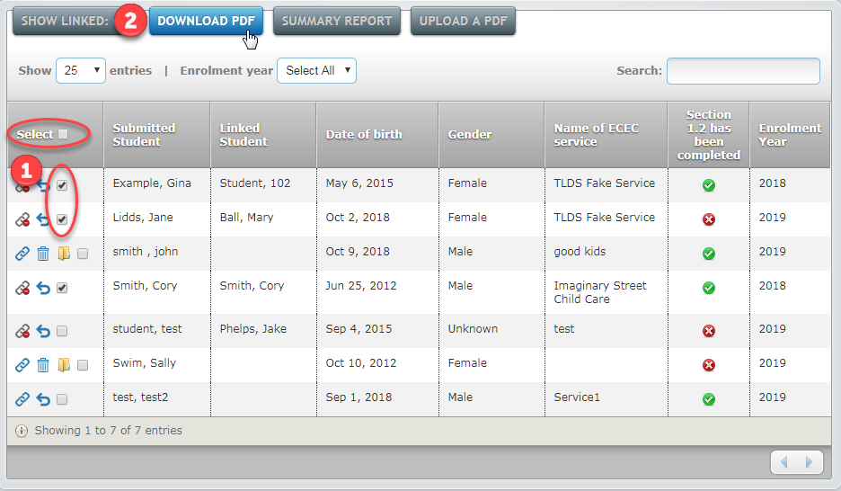
Figure 2.9
- In the TLDS Manager, select the tick box next to one or multiple student names as required, as shown in Figure 2.9. To download all TLDSs, select the tick box in the header.
- Select Download PDF.
- A Download PDF pop-up box will appear.
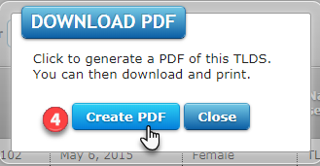
Figure 2.10
- Select, Create PDF as shown in Figure 2.10.
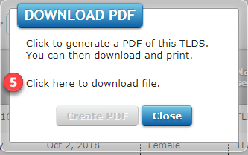
Figure 2.11
- Once the files have been generated, select Click here to download file as shown in Figure 2.11.
- A zip folder will then be downloaded. The TLDS(s) will be located in the zip folder as individual PDF files.

Creating Summary Reports
Summary Reports can be generated for TLDSs that are either linked or unlinked to an Insight student profile.
These reports contain the following details:
- Student name on TLDS
- Linked student name (if applicable)
- Date of birth
- Gender
- Name of early childhood service
- If Section 1.2 has been completed
- Enrolment year.
To generate summary reports:
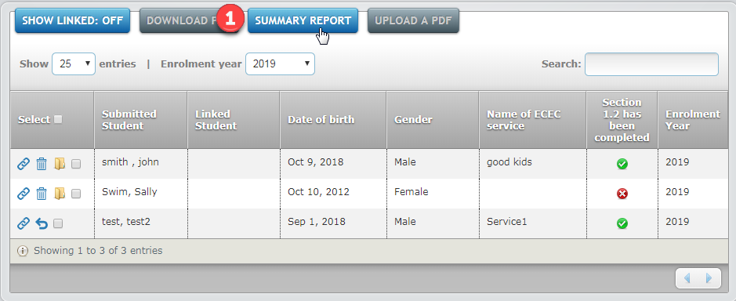
Figure 2.12
- In the TLDS Manager, select Summary Report as shown in Figure 2.12.
- A Summary Report Print pop-up box will appear.
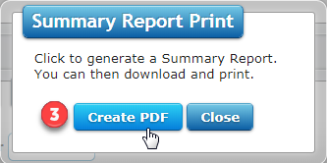
Figure 2.13
- Select Create PDF, as shown in Figure 2.13.
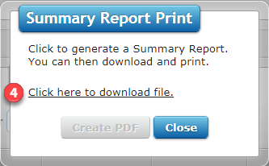
Figure 2.14
- Once the files have been generated, select Click here to download file as shown in Figure 2.14.
- A zip folder will then be downloaded. Two PDF documents are located in the zip folder: a summary report for linked TLDS and a summary report for unlinked TLDS.

Section 3 – TLDS for Teachers

Accessing TLDS
Teachers are able to view any linked TLDS for students in their class via Insight. A TLDS will not be able to be accessed if it has not been linked to a student’s Insight profile by your Insight School Administrator.
To download and view a student’s TLDS:
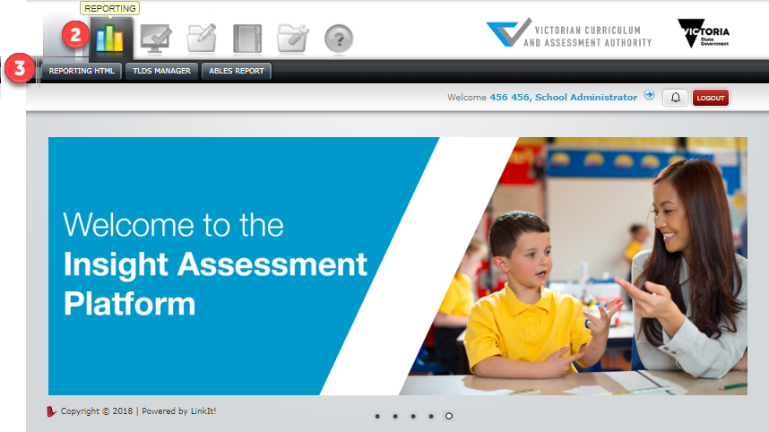
Figure 3.0
- Once you have logged in to Insight, you will see the home page as shown in Figure 3.0.
- Select Reporting, as shown in Figure 3.0.
- Select Reporting HTML, as shown in Figure 3.0. The reporting dashboard will open.

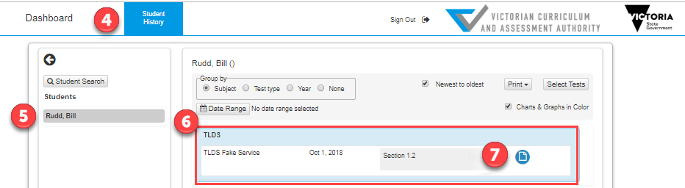
Figure 3.1
- Select Student History from the top menu, as shown in Figure 3.1.
- Select a student name from the list on the left-hand side.
- If the student has a linked TLDS, it will appear under TLDS, as shown in Figure 3.1.
- Select the blue document Open Report icon, as shown in Figure 3.1.
- A new window will open to display the PDF version of the statement, which you can print or save as required.

Manually uploading a TLDS
As a teacher, you may receive a TLDS via email or as a hard copy from a student’s parents/guardians or an early childhood centre. These TLDSs can be manually uploaded to Insight by your school’s Insight School Administrator (see page 4). Once an Insight School Administrator has linked the TLDS to a student’s Insight profile, it will be visible in reporting if you are the student’s classroom teacher.

Support
To find out more about TLDS, see: http://www.education.vic.gov.au/childhood/professionals/learning/Pages/transitionstat.aspx.
For further information about Insight, including platform user guides, see: https://www.vcaa.vic.edu.au/Pages/insightplatform/index.aspx.
If you have an issue you cannot resolve, contact your school’s Insight School Administrator in the first instance.
If the Insight School Administrator cannot resolve the issue, email: insight@education.vic.gov.au.

