VCE Vocational Major

VCE VM Unit 4: Flourishing communities
Numeracy curriculum support material

Acknowledgement
The Victorian Curriculum and Assessment Authority proudly acknowledges and pays respect to Victoria’s Aboriginal and Torres Strait Islander communities and their rich and enduring cultures.
We acknowledge Aboriginal and Torres Strait Islander people as Australia’s first peoples and as the Traditional Owners and custodians of the lands and waters on which we rely. We pay respect to Elders past and present of the lands where we conduct our work and recognise their ongoing contributions as the first educators on the land now known as Victoria.
Authorised and published by the Victorian Curriculum and Assessment Authority
Level 7, 200 Victoria Parade
East Melbourne VIC 3002
ISBN: 978-1-923204-83-6
© Victorian Curriculum and Assessment Authority 2025
No part of this publication may be reproduced except as specified under the Copyright Act 1968 or by permission from the VCAA. Excepting third-party elements, schools may use this resource in accordance with the VCAA educational allowance. For more information go to https://www.vcaa.vic.edu.au/Footer/Pages/Copyright.aspx.
The VCAA provides the only official, up-to-date versions of VCAA publications. Details of updates can be found on the VCAA website at www.vcaa.vic.edu.au.
This publication may contain copyright material belonging to a third party. Every effort has been made to contact all copyright owners. If you believe that material in this publication is an infringement of your copyright, please email the Copyright Officer vcaa.copyright@edumail.vic.gov.au
Copyright in materials appearing at any sites linked to this document rests with the copyright owner/s of those materials, subject to the Copyright Act. The VCAA recommends you refer to copyright statements at linked sites before using such materials.
The VCAA logo is a registered trademark of the Victorian Curriculum and Assessment Authority.

Contact us if you need this information in an accessible format, for example, large print or audio.
Telephone (03) 9032 1635 or email vcaa.publications@education.vic.gov.au

Contents
Using this resource 1
Student and teacher actions 2
Numeracy activities 3
Task 1: Orienteering 3
Numeracy context: Personal 3
Area of Study (AoS) 5: Dimensions and direction 3
Activity 1.1 Identify the mathematics 3
Activity 1.2 Act on the mathematics – Compass 4
Activity 1.3 School orienteering course 7
Activity 1.4 Evaluate, reflect and report 8
Task 1: Feedback and assessment 9
Numeracy task 2: Torquay tourist visit 11
Numeracy context: Personal 11
Area of Study (AoS) 5: Dimension and direction 11
Activity 2.1 Identify the mathematics 11
Activity 2.2 Act on the mathematics 12
Activity 2.3 Evaluate and reflect 14
Activity 2.4 Communicate and report 15
Task 2: Feedback and assessment 16
Numeracy task 3: Youth Census 17
Numeracy context: Civics 17
Area of Study (AoS) 6: Data 17
Activity 3.1 Identify the mathematics 18
Activity 3.2 Act on the mathematics 19
Activity 3.3 Evaluate and reflect 24
Activity 3.4 Communicate and report 25
Task 3: Feedback and assessment 25
Numeracy task 4: Likelihood and chance 28
Numeracy context: Personal 28
Area of Study (AoS) 7: Uncertainty 28
Activity 4.1 Identify the mathematics 29
Activity 4.2 Act on the mathematics 30
Activity 4.3 Evaluate and reflect 35
Activity 4.4 Communicate and report 36
Task 4: Feedback and assessment 36
Numeracy task 5: Festival planning weather 38
Numeracy context: Personal 38
Area of Study (AoS) 7: Uncertainty 38
Activity 5.1 Identify the mathematics 38
Activity 5.2 Act on the mathematics 41
Activity 5.3 Evaluate and reflect 41
Activity 5.4 Communicate and report 42
Numeracy task 6: Festival planning attendance 44
Numeracy context: Personal 44
Area of Study (AoS) 7: Uncertainty 44
Activity 6.1 Identify the mathematics 44
Activity 6.2 Act on the mathematics 45
Activity 6.3 Evaluate and reflect 46
Activity 6.4 Communicate and report 47
Numeracy task 7: Festival planning risk assessment 49
Numeracy context: Personal 49
Area of Study (AoS) 7: Uncertainty 49
Activity 7.1 Identify the mathematics 49
Activity 7.2 Act on the mathematics 50
Activity 7.3 Evaluate and reflect 52
Activity 7.4 Communicate and report 52
Numeracy task 8: Festival planning final report 55
Numeracy context: Personal 55
Area of Study (AoS) 7: Uncertainty 55
Task 8 Festival planning final report 55
Numeracy task 9: Budgeting and logistics for a trip 58
Numeracy context: Financial 58
Area of Study (AoS) 8: Systematics 58
Activity 9.1 Identify the mathematics 58
Activity 9.2 Act on the mathematics 60
Activity 9.3 Evaluate and reflect 64
Activity 9.4 Communicate and report 66
Task 9: Feedback and assessment 67

Using this resource
- This curriculum resource is an example and shows one way a school could deliver the Victorian Pathways Certificate (VPC) and VCE Vocational Major (VCE VM) through an integrated approach to teaching and learning.
- You will need to make changes to the curriculum resource to best suit your cohort’s needs and abilities by adding or removing scaffolds, and to tailor resources to your school's context. When modifying this curriculum resource, please review the relevant VCAA VCE VM curriculum design and check that the relevant area of study, key skills and key knowledge, and overall learning outcome statement are still being addressed.
- This document is a companion to the suite of curriculum support materials for VCE VM Unit 4: Flourishing Communities. Read over the ‘Advice for teacher delivery and assessment summary’ in detail before delivery. Applied learning requires proactive planning and preparation prior to delivery. The curriculum resource does not function like a traditional text or workbook. Pre-work and modifications are required to use this curriculum resource effectively.
- Unit preparation checklists in the ‘Advice for teacher delivery and assessment summary’ highlight key actions to be completed by the teacher prior to the overall unit delivery. It is essential for teachers to review and use the unit checklists prior to implementing or using this curriculum resource.
- This curriculum resource is designed to support your teaching and does not replace you as the teacher. How you deliver the resource and run applied learning activities to support your program is a teacher and school-based decision. Explicit instruction, teacher support and monitoring of student progress is still required.
- In accordance with the Pillars of Applied Learning (POAL) all assessment tasks are flexible and open to negotiation. To support individual students to successfully achieve learning outcomes, modification in collaboration is encouraged.
- This curriculum resource includes links to third party materials as examples for teacher reference only. It is not mandatory to use any of these materials or third party services. Inclusion of links to these materials does not constitute VCAA endorsement of the views or content contained in or linked from these sites. Teachers are advised to use their own judgement in determining what is appropriate for their students and school community. Teachers should ensure that any information or activity complies with their school or organisation’s policies.

Student and teacher actions
Within the student task activities, the following icons indicate these actions:
 | For teacher awareness, advice and information. Should be deleted before providing to students.
 | To be adapted or changed to the relevant educational context.
 | The teacher needs to hyperlink or add in their own documents or links to resources for their students to access the correct information from their own school-based documents.
 | Indicates ‘how to’ IT, document support or general guidance for students. Teachers can decide to leave this in or remove it.
 | Indicates to students which activities can be completed and submitted for assessment as a group.
 | Indicates to students which activities need to be completed and submitted for assessment individually.
 | Indicates to students which activities will be completed with a peer.

Numeracy activities

Task 1: Orienteering

Numeracy context: Personal

Area of Study (AoS) 5: Dimensions and direction
Key knowledge and key skills
AoS 5 KS 2 Understand and use compass directions and use appropriate language such as NE, SSW, N15°W.
AoS 5 KS 3 Demonstrate an understanding of angles using degrees.
AoS 5 KS 4 Understand where an object is in space using one-, two- and three- dimensions and using the appropriate language to describe an object’s position and movement in space.

Task checklist
Students will complete the following for Numeracy Context: Personal.
☐ Activity 1.1 Identify the mathematics
☐ Activity 1.2 Act on the mathematics – Compass
☐ Activity 1.3 School orienteering course
☐ Activity 1.4 Evaluate, reflect and report
In this task, you will show that you can identify a range of angles using degrees. You will demonstrate that you can use a compass and that you understand compass directions by combining knowledge of degrees and coordinates. You will show that you can use appropriate language to describe an object's position and movement in space.
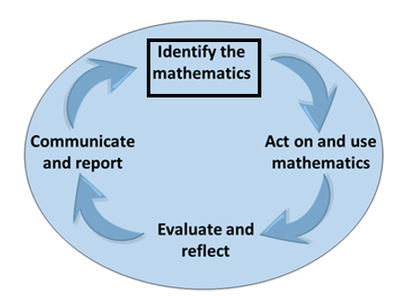
Identify the mathematics: Recognise, select and interpret the mathematical information embedded in a real-world context and decide what mathematics to use.

Activity 1.1 Identify the mathematics
Part 1: In a group, brainstorm a solution to the following conundrum. You can use the questions below the scenario to help you consider ideas and options.
You have organised a 5-day camping trip with your group of friends, the free camp spot is only accessible by 4WD, you don’t own a 4WD so you carpool with a friend who does. Your group arrives at the campsite before the other group, and after a few hours you start to get concerned – there is no phone service, however, there is a town 20km Northeast of your location with a phone tower. You arrived from the South and have never visited this town.
- How will you direct yourself to the town?
- How do you understand and use compass directions?
- When would you need this?
- What would you do if you were lost without service?
Add your brainstorm in the space below.
Part 2: Research the meaning of the following directional language words.
Key words | Meaning | Example
Coordinates
Angles
Body relative directions
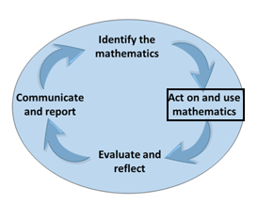
Act on and use mathematics: Perform mathematical actions and processes to complete a task – this includes the use and application of a range of technologies.

Activity 1.2 Act on the mathematics – Compass
Part 1: Compass – Show your understanding of angles and coordinates below.
Hint: If you are unsure of the angles and coordinates of a compass, access the videos linked here.
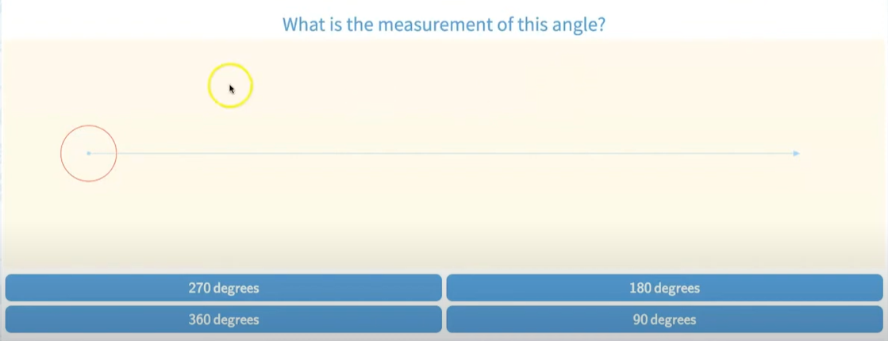
Video source: TeachMe, 4.21 Angles of 90, 180, 270 and 360 Degrees (youtube.com)
Diagram | Degrees
 | Example: 360 degrees
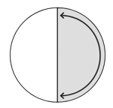
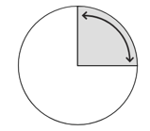
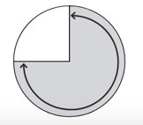
Part 2: Identifying coordinates – Complete the following diagram:
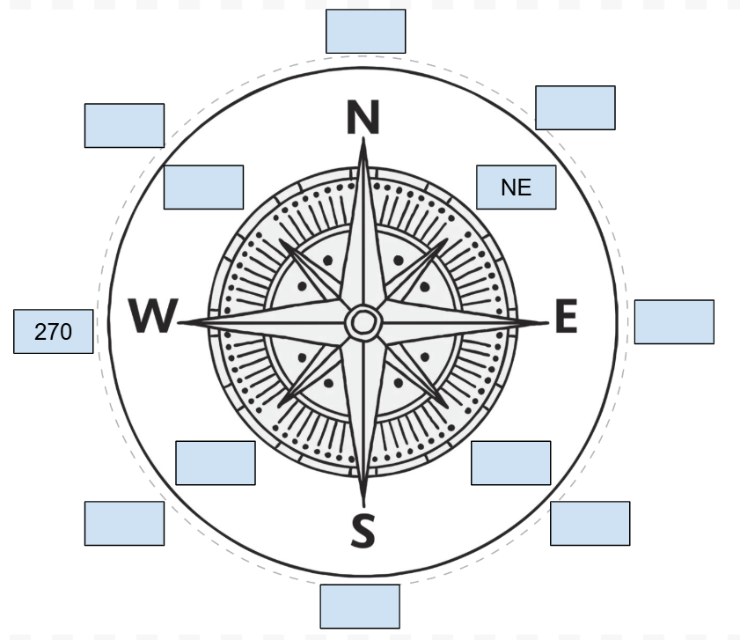
For assistance you can watch the following video.
REI, How to use a compass (youtube.com)

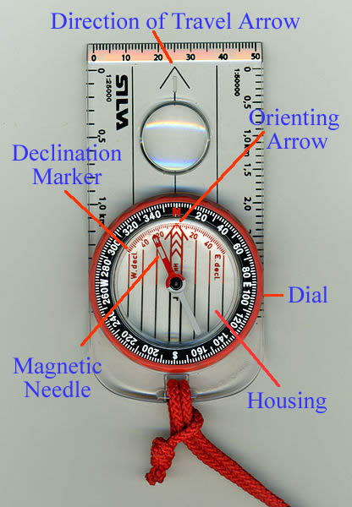
Part 3: Practise using a compass – Practise reading a compass by answering the following questions:
- Start facing north. How many degrees will you turn to face south?
- Start facing south. How many degrees will you turn to face west?
- Start facing east. How many degrees will you turn to face west?
- Start facing west. How many degrees will you turn to face south?
- Start facing north. Turn clockwise 90°. Which direction are you facing?
- Start facing south. Turn clockwise 180°. Which direction are you facing?
- Start facing west. Turn clockwise 270°. Which direction are you facing?
- Start facing east. Turn clockwise 360°. Which direction are you facing?

Activity 1.3 School orienteering course
Teacher advice: This is an example only. Change the following task and example to suit your context and students.
Part 1: In your group, complete the following school orienteering course.
Use the following map, clues and instructions to find the answer.
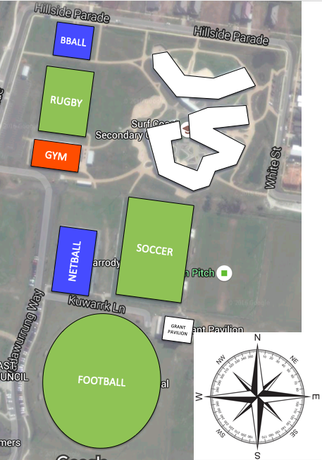
Map background © Google maps
Start at the basketball court next to the Veggie Garden.
- From the basketball court walk West to the large white shiny building.
- Walk North to the shelter across the grass.
- Walk East and stop at the path junction in front of the red box.
- Walk South along the concrete path until the T intersection.
- Walk East along the path to the green box.
- Follow a bearing of 142 degrees until you reach the soccer goal.
- Follow 117 degrees to the far right.
- How many solar panels are on the house that is located at 120 degrees?
- Set your compass to 35 degrees and walk 100 steps. What do you see at 180 degrees?
- Set your compass back to the classroom, what is the bearing, and how many metres/ steps?
Part 2: Insert a photo of your group completing the school orienteering course.

Activity 1.4 Evaluate, reflect and report
Part 1: Group reflection – Complete the following reflection table with your group.
What went well: | Even better if:
Part 2: Communicate and report – Discuss with another group and write down their reflections and share yours.
Peer group names:
What went well: | Even better if:

Task 1: Feedback and assessment
Peer feedback
Activity 1.1 | Identify the mathematics | Choose an item.
Activity 1.2 | Act on the mathematics – Compass | Choose an item.
Activity 1.3 | School orienteering course | Choose an item.
Activity 1.4 | Evaluate, reflect and report | Choose an item.
Peer comment:
Name of peer:

AoS 5 KS 2 Understand and use compass directions and use appropriate language such as NE, SSW, N15°W.
Student reflection: How well did you go with this step? (Please tick the box below)
☐Not Submitted | ☐Beginning | ☐Consolidating | ☐Achieving | ☐Excelling
Student comment (optional):
Teacher feedback
☐Not Submitted | ☐Beginning | ☐Consolidating | ☐Achieving | ☐Excelling
Not Submitted: No work has been submitted or attempted for this activity. | Beginning: You have attempted to show a basic ability to understand and use compass directions and use appropriate language such as NE, SSW, N15°W. To bump it up, you need to complete all parts of the activity and show that you can understand and use compass directions. | Consolidating: You have shown a basic ability to understand and use compass directions and use appropriate language such as NE, SSW, N15°W. To bump it up, you need to complete all parts of the activity. | Achieving: You have shown you can confidently use compass directions and use appropriate language such as NE, N15E etc. To bump it up, you need to show your workings out. | Excelling: You have shown a high ability to confidently use compass directions and always use appropriate language such as NE, N15E etc. You have shown all your workings out and all your answers are correct. Great work!
Teacher comment:

AoS 5 KS 3 Demonstrate an understanding of angles using degrees.
Student reflection: How well did you go with this step? (Please tick the box below)
☐Not Submitted | ☐Beginning | ☐Consolidating | ☐Achieving | ☐Excelling
Student comment (optional):
Teacher feedback
☐Not Submitted | ☐Beginning | ☐Consolidating | ☐Achieving | ☐Excelling
Not Submitted: No work has been submitted or attempted for this activity. | Beginning: You have attempted to answer some of the questions. To bump it up, you need to complete all parts of the activity and show that you can solve problems involving angles using degrees. | Consolidating: You have shown a basic understanding of solving problems involving angles using degrees. You have shown some working out. To bump it up, check over your answers to see if they are correct and include more details of your working out. | Achieving: You have shown an understanding of solving problems involving angles using degrees. You have shown your workings. To bump it up, recheck your answers to make sure your answers are all correct. | Excelling: You have shown a high level of understanding of solving problems involving angles using degrees. You have shown all your workings out and all your answers are correct. Great work!
Teacher comment:

AoS 5 KS 4 Understand where an object is in space using one-, two- and three-dimensions and using the appropriate language to describe an object’s position and movement in space.
Student reflection: How well did you go with this step? (Please tick the box below)
☐Not Submitted | ☐Beginning | ☐Consolidating | ☐Achieving | ☐Excelling
Student comment (optional):
Teacher feedback
☐Not Submitted | ☐Beginning | ☐Consolidating | ☐Achieving | ☐Excelling
Not Submitted: No work has been submitted or attempted for this activity. | Beginning: You have attempted to answer some of the questions. To bump it up, you need to complete all parts of the activity and show that you can solve problems involving angles using degrees. | Consolidating: You have demonstrated a basic understanding of where an object is in space using one-, two- and three-dimensions and sometimes use the appropriate language to describe an object’s position and movement in space. To bump it up, you need to consistently use the appropriate language to describe an objects position and movement in space. | Achieving: You have demonstrated an understanding of where an object is in space using one-, two- and three-dimensions and use the appropriate language most of the time to describe an object’s position and movement in space. To bump it up, you need to consistently use the appropriate language to describe an objects position and movement in space. | Excelling: You have demonstrated a detailed understanding of where an object is in space using one-, two- and three dimensions and consistently use the appropriate language to describe an object’s position and movement in space.
Teacher comment:

Numeracy task 2: Torquay tourist visit

Numeracy context: Personal

Area of Study (AoS) 5: Dimension and direction
Key knowledge and key skills
AoS 5 KS 1 Give direction and location instructions between multiple destinations, including unfamiliar locations using appropriate maps or technology.

Task checklist
Students will complete the following for Numeracy context: Personal.
☐ Activity 2.1 Identify the mathematics
☐ Activity 2.2 Act on the mathematics
☐ Activity 2.3 Evaluate and reflect
☐ Activity 2.4 Communicate and report
In this task, you will demonstrate that you can identify a location and direction in relation to objects and landmarks. You will show that you can find locations and use directions using technologies and maps. You will provide oral or written instructions for moving to specified locations.

Activity 2.1 Identify the mathematics
Part 1: In today’s world, full of technology, GPS, and digital maps, everything seems easier. Wherever we may find ourselves in the world at any moment of the day, we can activate our devices to find the correct address. Even today, we can often find ourselves lost in an unknown city asking for directions. It is also increasingly common for tourists to stop us on the street because they are looking for a restaurant or archaeological site. After all, it is possible for your phone to stop working or for the battery to run out earlier than expected. Make a list of the types of directions you can give.
Use this website for ideas of direction language:
Giving Directions on the Street in English (ABA English website)
On the street: | In the car:
Part 2: Research the meaning of the following key terms and include at least one example for each.
Key words: | Meaning | Example
Grid reference / locations
Symbols
KM
Directional language
Map
Landmarks
Estimations
Key (to do with maps)
Scale (to do with maps)

Activity 2.2 Act on the mathematics
Part 1: Complete the key symbols table below. Use the following: Link to Torquay MAP (Visit Great Ocean Road website)
Landmark | Symbol description / screenshot / drawing of the symbol
Example: Post office | Postage letter
Playground
Camping grounds
Scenic view lookout
Shopping precinct
Shipwreck site
Part 2: Grid locations – Use the grid coordinates and clues to find the landmark.
Use the following: Link to Torquay MAP(Visit Great Ocean Road website)
Grid Reference | Landmark
Example: C9 | RACV Golf Course
A10
D8
F5
H2
Part 3: Grid locations – Find the grid coordinates for the following landmarks.
Use the following: Link to Torquay MAP (Visit Great Ocean Road website)
Grid Reference | Landmark
Example: C9 | RACV Golf Course
 | The Dunes Village
 | Surf Coast Secondary College
 | Point Danger
Part 4: Planning a walking or riding Torquay tour
Scenario: You are to organise a 2-hour walking/riding trip around Torquay/Jan Juc for a small group of tourists. They are travelling from Melbourne and will be dropped off at your allocated meeting point. (Meeting Point Could be McDonald's, Torquay Bowls Club, Point Danger etc.)
The trip will require the following information. Complete the table below.
Designated meeting point:
Three places of interest your visitors will pass through:
Food and drink options for lunch and snacks:
Pick up point at the end of the tour:
Part 5: You are to include written instructions or oral instructions for your chosen route that will include appropriate location language (direction, street names, landmarks), distance and time estimations.
Insert written instructions or a link to an audio recording of your instructions below.
Part 6: Sketch a map – Add a ‘sketch’ or drawn map to support your written instructions just in case there is a language barrier for your visitors.

Activity 2.3 Evaluate and reflect
Peer and teacher feedback – Ask a peer to reflect on your instructions and use the checklist of location language when assessing your instructions.
- Direction (left, right, north, south etc.)
- Street names (Fisher St, Surf Coast Hwy)
- Landmarks (Point Danger, Torquay SLSC, SCSC, Shire)
- Distance estimations (approximately 400m)
- Time estimations (for approximately 3 minutes)
Peer feedback
Name of peer:
Feedback on the language used:
Location language used:
Location language missing:

Teacher feedback
Teacher:
Date:
Feedback:
Teacher sign off:

Activity 2.4 Communicate and report
Summary table – Complete the table below.
Tool / Formula used | Explanation | When and how is it used? | Accuracy level | How likely are you to use this tool again? (1-5) | Add to my numeracy toolkit slides.
Google map |  |  |  |  | ☐
Map symbols |  |  |  |  | ☐
Grid coordinates  (A7, C5) |  |  |  |  | ☐
KM |  |  |  |  | ☐
Directional language |  |  |  |  | ☐
Non-interactive map |  |  |  |  | ☐
Scale |  |  |  |  | ☐
Estimation |  |  |  |  | ☐
Add any others |  |  |  |  | ☐

Task 2: Feedback and assessment
Peer feedback
Activity 2.1 | Identify the mathematics | Choose an item.
Activity 2.2 | Act on the mathematics | Choose an item.
Activity 2.3 | Evaluate and reflect | Choose an item.
Activity 2.4 | Communicate and report | Choose an item.
Peer comment:
Name of peer:

AoS 5 KS 1 Give direction and location instructions between multiple destinations, including unfamiliar locations using appropriate maps or technology.
Student reflection: How well did you go with this step? (Please tick the box below)
☐Not Submitted | ☐Beginning | ☐Consolidating | ☐Achieving | ☐Excelling
Student comment (optional):
Teacher feedback
☐Not Submitted | ☐Beginning | ☐Consolidating | ☐Achieving | ☐Excelling
Not Submitted: No work has been submitted or attempted for this activity. | Beginning: You have attempted to give direction and location instructions; however, only to a singular destination. To bump it up, go back and ensure you include unfamiliar locations using appropriate maps or technology. | Consolidating: You have shown you can give some basic directions and location instructions between multiple destinations, including unfamiliar locations using appropriate maps or technology. To bump it up, go back and ensure you complete all parts of the activity. | Achieving: You have shown you can give specific directions and location instructions between multiple destinations, including unfamiliar locations using a range of appropriate maps or technology. To bump it up, go back and recheck your answers. | Excelling: You have shown you can give specific directions and location instructions in a range of mediums including instructions between multiple destinations, including unfamiliar locations using a range of appropriate maps or technology. Well done!
Teacher comment:

Numeracy task 3: Youth Census

Numeracy context: Civics

Area of Study (AoS) 6: Data
Key knowledge and key skills
AoS 6 KS 1 Collect, collate and organise data sets and display these in the most appropriate format, including axes and scales.
AoS 6 KS 2 Choose and find the most appropriate common measures of centre and spread for data sets, such as mean, median and range of data.
AoS 6 KS 3 Discriminate between the different measures of centre and spread and understand how they can change conclusions from data, and identify outliers and their implications for the data.
AoS 6 KS 4 Read and interpret results from data presented in multiple forms of tables, graphs and summary statistics, including to describe patterns, variations and trends in the data.
AoS 6 KS 5 Draw conclusions from the data analysis.

Task checklist
Students will complete the following for Numeracy context: Civics.
☐ Activity 3.1 Identify the mathematics
☐ Activity 3.2 Act on the mathematics
☐ Activity 3.3 Evaluate and reflect
☐ Activity 3.4 Communicate and report
In this task, you will use data from the Surf Coast Shire Youth Census to explore the main issues affecting youth in the local area. You will create graphs and analyse the data to form an opinion on what services are required in the local area, to help solve the issues raised.

Activity 3.1 Identify the mathematics
Part 1: Below are some key mathematical concepts that you will need to use during this task. For each term you will need to find one resource you could teach a Grade 6 student who has never used the mathematical concept before.
A resource could be:
- Short written explanation defining the concept and how to use it.
- A graphic or poster explaining the concept.
- Short YouTube video (2-5 mins).
Worked example
Mathematical term: Converting decimals to percentages
Resource 1: Short explanation
To convert a decimal to a percentage, you simply multiply the decimal number by 100 and then add the per cent sign (%). For example, if you have the decimal 0.75, you multiply 0.75 by 100 to get 75. So, 0.75 as a percentage is 75%. Just remember: multiply by 100 and add the % sign!
Resource 2: Graphic or poster
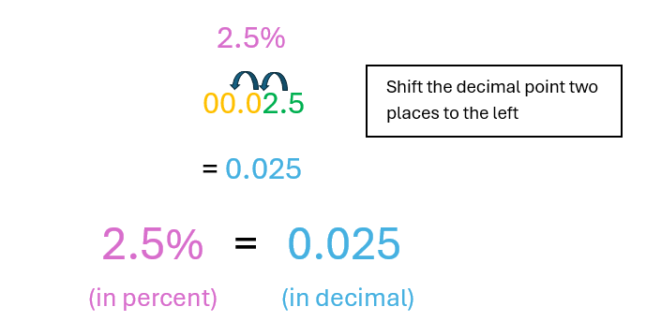
Resource 3: Short video
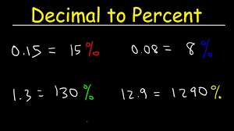
Video source: The Organic Chemistry Tutor, Decimal to Percent (youtube.com)
Complete the table below.
Mathematical Concept | Resource
Finding the mode of a data set
Finding the range of a data set
Finding the mean of a data set
What is an outlier of a data set?
How to calculate the percentage of a number.

Activity 3.2 Act on the mathematics
Part 1: Identifying data from a graph – Look at the graph below which shows the ‘age breakdown’ of the people who completed the ‘Youth Census Survey’. Use the mathematical resources from Activity 3.1 to answer the questions below about the graph. Make sure you show working out or explain each answer.
Graph source: Surf Coast Youth - Surf Coast Shire
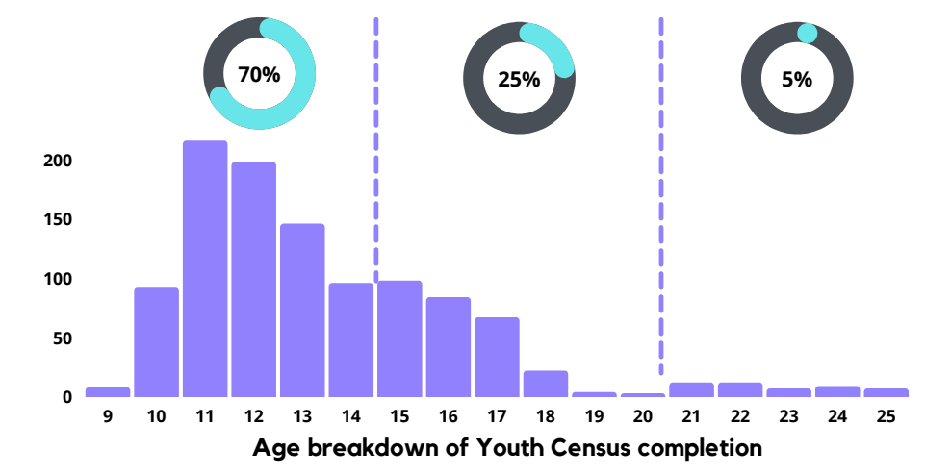
- Mode – What age completed the survey the most?
- Range – What is the youngest age and the oldest age that completed the survey? What is the difference between the ages?
- Mean – By looking at the graph, what do you think the average age of the people who completed this survey is?
- Why do you think that 70% of the people that completed the survey were aged between 9–14 and only 5% were aged 21–25?
Part 2: Analysing information from a graph – Below is a graph showing the locations where the people who completed the census live.
Graph source: Surf Coast Youth - Surf Coast Shire
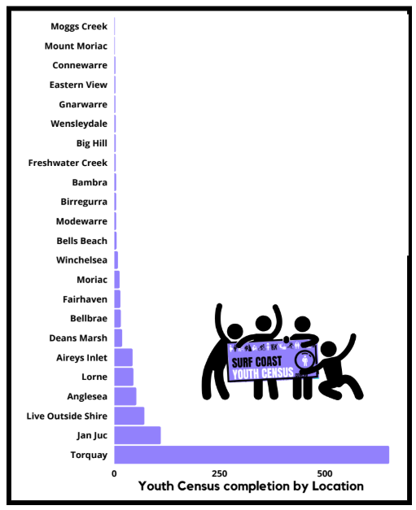
- Identify at least three places that are outliers in this data and give a reason as to why you think they are outliers.
- After analysing the two graphs above, write a summary of the type of people who completed the Surf Coast Shire Youth Census. Make sure you use some of the maths concepts you have used in the summary.
Part 3: Percentages – Below is an infographic displaying the issues of greatest personal concern to young people aged 15–25 years old.
Graph source: Surf Coast Youth - Surf Coast Shire
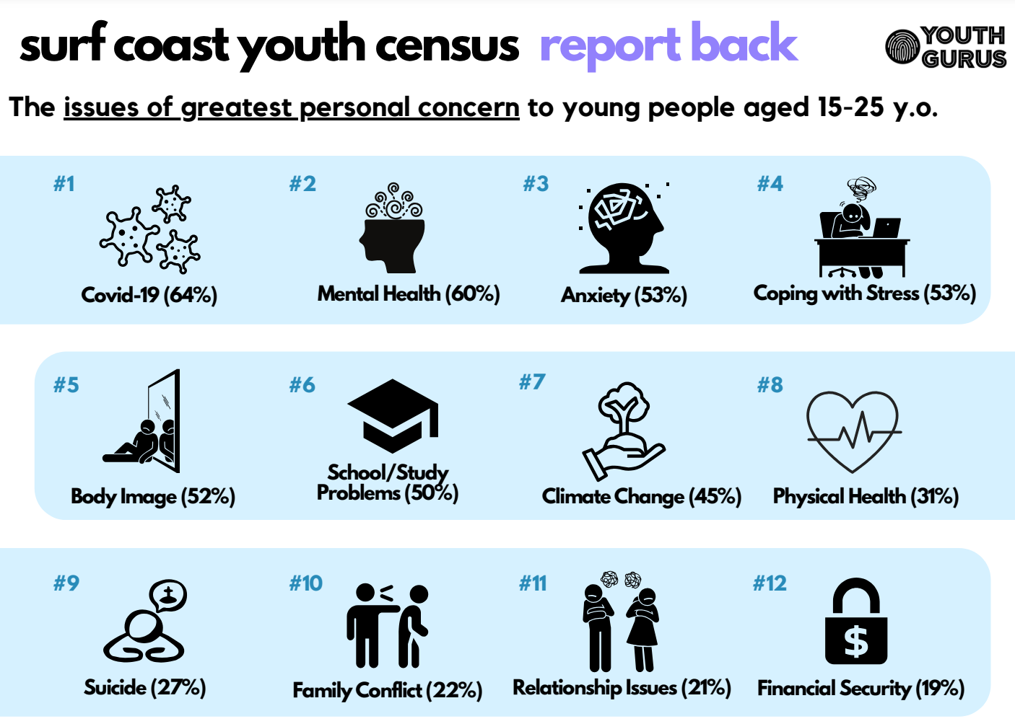
- Complete the table below by putting the percentages from the image above into the table below.
Issue | Percentage
Covid 19
Mental health
Anxiety
Coping with stress
Body image
School / study problems
Climate change
Physical health
Suicide
Family conflict
Relationship issues
Financial issues
- Once you have completed this table, copy and paste it into a Google Sheets/Excel program. You will need to create a graphic representation (graph) of the table. Insert the graph into the space below.
Part 4: Calculating the percentage of a number – We now need to convert these percentages into a number based on the total number of people who responded to the Youth Census. The total number of people who completed the survey was 1,084.
- Complete the table below and include your working out.
Issue | Percentage (%) | Workings out | Total number  (round to the nearest whole number)
Covid 19 | 64 | Convert the percentage into a decimal.  64 / 100 = 0.64  Time the decimal by the number of participants.  0.64 x 1,084 | 694
Mental health
Anxiety
Coping with stress
Body image
School / study problems
Climate change
Physical health
Suicide
Family conflict
Relationship issues
Financial issues
- Graph representation: Use this new data to create another graphic representation.
Hint: You don’t need to include the percentage or working out column in Google Sheets/Excel. Create a different style of graph from the previous one. For example, Pie, line graph.
Insert the screenshot of the graph that you have created below:

Activity 3.3 Evaluate and reflect
Using information to make decisions: The annual budget for the Surf Coast Shire Youth engagement team is $890,000. Use the data for this task to allocate money to help the issues identified in this survey. Provide an example and a reason for the allocation. You need to include at least five different initiatives, including any resources/links to support costing. See the example below.
Information source: Surf Coast Youth - Surf Coast Shire
Issue | Action | Cost | Resource
Example – Physical health | Outdoor gym stations to promote fitness and ease of access to equipment around the local area. These will be placed in five smaller communities where there are no gyms or facilities, e.g. Moriac, and Moggs Creek. This will encourage more young people to become active and improve overall physical and mental health. | $11,000 x 5 stations  Total Cost: $55,000 | https://aspace.com.au/product/5-station-challenge/

Activity 3.4 Communicate and report
Using data and statistics to support proposals: Write a persuasive letter to the Surf Coast Shire about one of your initiatives in the table above. Explain why you have allocated the money to the issue and why it is important. Use the data, graphs and any other resources to justify your decision.
Prompts
- Introduce yourself and give your reason for writing the letter.
- Explain what you notice when looking at the data from the Youth Census. You can include graphs/tables to visualise the data.
- Explain the issue you are focusing on and why it is important, again use the data.
- What idea do you have to solve the problem and how it would work?
- How much money this would cost? How would this money be spent?
- Summarise how your idea would benefit the local community.
- Include persuasive language/techniques.
Insert your letter here.

Task 3: Feedback and assessment
Peer feedback
Activity 3.1 | Identify the mathematics | Choose an item.
Activity 3.2 | Act on the mathematics | Choose an item.
Activity 3.3 | Evaluate and reflect | Choose an item.
Activity 3.4 | Communicate and report | Choose an item.
Peer comment:
Name of peer:

AoS 6 KS 1 Collect, collate and organise data sets and display these in the most appropriate format, including axes and scales.
Student reflection: How well did you go with this step? (Please tick the box below)
☐Not Submitted | ☐Beginning | ☐Consolidating | ☐Achieving | ☐Excelling
Student comment (optional):
Teacher feedback
☐Not Submitted | ☐Beginning | ☐Consolidating | ☐Achieving | ☐Excelling
Not Submitted: No work has been submitted or attempted for this activity. | Beginning: You have attempted to collect, collate and organise some data sets. To bump it up, you need to complete all parts of the activity. | Consolidating: You have shown a basic ability to collect, collate and organise some data sets and display these on a graph. To bump it up, make sure your graph includes axes and scales. | Achieving: You have been able to collect, collate and organise data sets and display these in the most appropriate format, including axes and scales. To bump it up, check over your responses and make sure the information you have provided is correct. | Excelling: You have been able to extensively collect, collate and organise data sets and display these in the most appropriate format, including axes and scales. Well done.
Teacher comment:

AoS 6 KS 2 Choose and find the most appropriate common measures of centre and spread for data sets, such as mean, median and range of data.
Student reflection: How well did you go with this step? (Please tick the box below).
☐Not Submitted | ☐Beginning | ☐Consolidating | ☐Achieving | ☐Excelling
Student comment (optional):
Teacher feedback
☐Not Submitted | ☐Beginning | ☐Consolidating | ☐Achieving | ☐Excelling
Not Submitted: No work has been submitted or attempted for this activity. | Beginning: You have attempted to answer some of the questions. To bump it up, you need to complete all parts of the activity and show that you can solve problems involving fractions, decimals and percentages. | Consolidating: You have shown a basic ability to choose and find the most appropriate common measures of centre and spread for data sets, such as mean, median and range. To bump it up, check over your answers to see if they are correct and include more details of your working out. | Achieving: You have been able to successfully choose and find the most appropriate common measures of centre and spread for data sets, such as mean, median and range of data.To bump it up, recheck your answers to make sure your answers are all correct. | Excelling: You have been able to extensively choose and find the most appropriate common measures of centre and spread for data sets, such as mean, median and range of data. Well done.
Teacher comment:

AoS 6 KS 3 Discriminate between the different measures of centre and spread and understand how they can change conclusions from data, and identify outliers and their implications for the data.
Student reflection: How well did you go with this step? (Please tick the box below)
☐Not Submitted | ☐Beginning | ☐Consolidating | ☐Achieving | ☐Excelling
Student comment (optional):
Teacher feedback
☐Not Submitted | ☐Beginning | ☐Consolidating | ☐Achieving | ☐Excelling
Not Submitted: No work has been submitted or attempted for this activity. | Beginning: You have attempted to answer some of the questions. To bump it up, you need to complete all parts of the activity and show that you can solve problems involving fractions, decimals and percentages. | Consolidating: You have shown a basic ability to identify outliers and understand their implications for the data.To bump it up, check over your answers to see if they are correct and include more details of your working out. | Achieving: You have been able to successfully identify outliers and explain their implications for the data.To bump it up, recheck your answers to make sure your answers are all correct. | Excelling: You have been able to successfully identify outliers and explain in detail their implications for the data. Well done!
Teacher comment:

AoS 6 KS 4 Read and interpret results from data presented in multiple forms of tables, graphs and summary statistics, including to describe patterns, variations and trends in the data.
Student reflection: How well did you go with this step? (Please tick the box below)
☐Not Submitted | ☐Beginning | ☐Consolidating | ☐Achieving | ☐Excelling
Student comment (optional):
Teacher feedback
☐Not Submitted | ☐Beginning | ☐Consolidating | ☐Achieving | ☐Excelling
Not Submitted: No work has been submitted or attempted for this activity. | Beginning: You have attempted to answer some of the questions. To bump it up, you need to complete all parts of the activity and show that you can solve problems involving fractions, decimals and percentages. | Consolidating: You have shown a basic ability to read and interpret results from data presented in multiple forms. To bump it up, check over your answers to see if they are correct and include more details of your working out. | Achieving: You have been able to successfully read and interpret results from data presented in multiple forms in detail. To bump it up, recheck your answers to make sure your answers are all correct. | Excelling: You have been able to successfully read and interpret results from data presented in multiple forms in extensive detail. Well done!
Teacher comment:

AoS 6 KS 5 Draw conclusions from the data analysis.
Student reflection: How well did you go with this step? (Please tick the box below)
☐Not Submitted | ☐Beginning | ☐Consolidating | ☐Achieving | ☐Excelling
Student comment (optional):
Teacher feedback
☐Not Submitted | ☐Beginning | ☐Consolidating | ☐Achieving | ☐Excelling
Not Submitted: No work has been submitted or attempted for this activity. | Beginning: You have attempted to answer some of the questions. To bump it up, you need to complete all parts of the activity and show that you can solve problems involving fractions, decimals and percentages. | Consolidating: You have shown a basic ability to draw conclusions from the data analysis. To bump it up, check over your answers to see if they are correct and include more details of your working out. | Achieving: You have been able to successfully draw conclusions from the data analysis that are all correct. To bump it up, recheck your answers to make sure your answers are all correct. | Excelling: You have been able to successfully draw conclusions from the data analysis with significant detail. Well done!
Teacher comment:

Numeracy task 4: Likelihood and chance

Numeracy context: Personal

Area of Study (AoS) 7: Uncertainty
Key knowledge and key skills
AoS 7 KS 1 Identify possible outcomes of an event and create visual representations of sample spaces or options.
AoS 7 KS 2 Estimate, predict and calculate the likelihood of events occurring using decimals, ratios and percentages.

Task checklist
Students will complete the following for Numeracy context: Personal.
☐ Activity 4.1 Identify the mathematics
☐ Activity 4.2 Act on the mathematics
☐ Activity 4.3 Evaluate and reflect
☐ Activity 4.4 Communicate and report

In this task, you will identify the possible outcomes of a variety of events. In each step, you will identify the possible outcomes and use relevant language and numerical values of chance. Visual representations of sample spaces will also be included.

Activity 4.1 Identify the mathematics
Part 1: Understanding key terms. Research and write in your own words the meaning and an example of the following.
Term | Meaning / Definition | Example
Probability
Likelihood
Chance
Estimate
Predict

Part 2: Provide at least two examples of where probability occurs in your daily life.
For example: weather
Part 3: Why is understanding probability important? Explain in your own words by giving an example. Your example should be two to three sentences minimum.
For example: If you know the odds or chance you are likely to win on the pokie machines, you may be less likely to bet your money.

Activity 4.2 Act on the mathematics
Probability resource
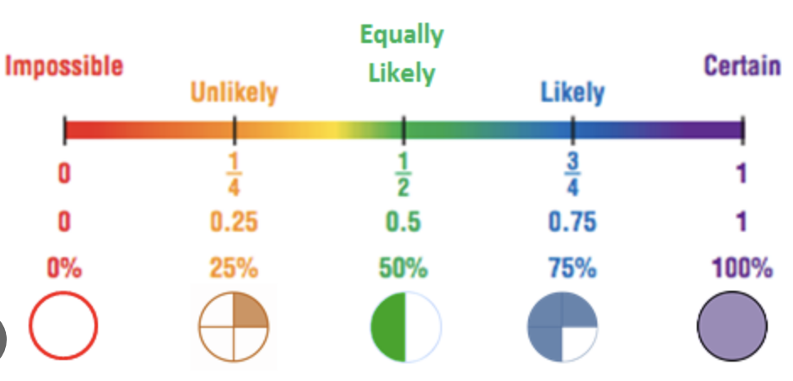
Image source: Learn by Insight, Probability Distribution: An aid to know the data (blog post)
Worked example
You flip a coin:
- Possible outcomes (events) – heads or tails
- Number of possible outcomes (events) – 2
- Visual representation – tree diagram
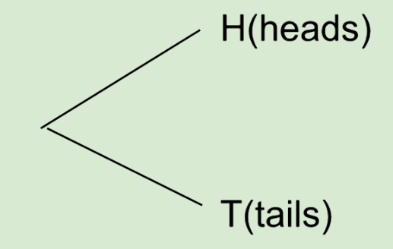
- Numerical value – 50% or ½ or 0.5
- Language of chance – equally likely to be heads or tails.
Part 1: Coin flip activity. You flip the same coin twice.
- Possible outcomes (events).
- Number of possible outcomes (events).
- Create a visual representation using a tree diagram.
- Numerical value.
- Language of chance.
________ to be heads or tails.
Hint: Go back and look at the ‘Probability Resource’ above if you need assistance
Part 2: Spin the wheel using the 1-4 Spin video on YouTube linked below and complete the questions.

Video source: Graham Andanen, 1-4 Spinner (youtube.com)
Worked example
Spin the wheel:
- Possible outcomes (events) – 1, 2, 3, 4
- Number of possible outcomes (events) – 4
- The numerical value of a certain number – 25% or ¼ or 0.25
- Language of chance – unlikely to land on a selected number
You will use the 8-sided wheel for this task which can be found at the link below:
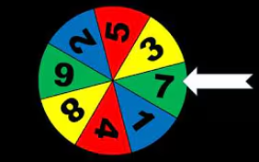
Video source: Becky Foellmer, Spinner 1 – 8 (youtube.com)
- Possible outcomes (events).
- Number of possible outcomes (events).
- Numerical value of landing on number 8.
- Language of chance.
________ to land on number 8
Hint: Go back and look at the ‘Probability Resource’ above if you need assistance.
What about landing on an even number?
- Possible outcomes (events).
- Number of possible outcomes (events).
- Numerical value of landing on an even number.
- Language of chance.
________ to land on an even number
Hint: Go back and look at the ‘Probability Resource’ above if you need assistance.
Part 3: Coin toss
Worked example:
If you flip a coin once, you have a ½ (0.5) chance of getting tails.
Percentage calculation 0.5 x 100 = 50%
If you flip the coin twice you have a ¼ (0.25) chance of getting tails
0.5 x 0.5 = 0.25
This as a percentage: 0.25 x 100 = 25%
Flip the same coin four times. What is the percentage of getting four tails in a row?
- Estimate and predict what you think the percentage is first.
- Working this out.
- Calculate the likelihood of four tails in a row.
_______ %

Part 4: Weather – Complete the questions below.
Worked example
The weather forecast is a 10% chance of rain today.
Possible outcomes (events) – rain, no rain
Number of possible outcomes (events) – 2
The numerical value of rain according to forecast – 10% or 1/10 or 0.1
Language of chance – unlikely to rain today
- How does this weather forecast impact your preparation for a trip to Bendigo today?
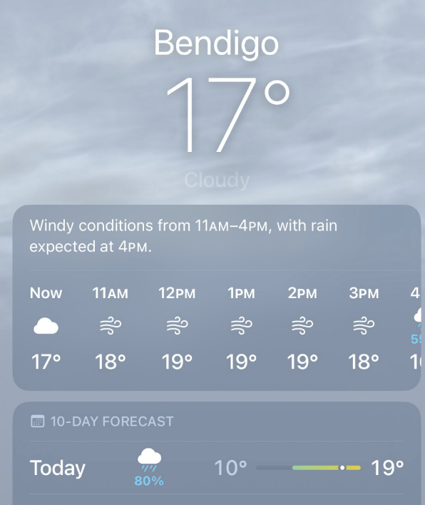
Image source: Apple Inc, Weather (iPhone app)
- Possible outcomes (events).
- Number of possible outcomes (events).
- Numerical value of rain according to the forecast.
- Language of chance.
________ to rain today.
Hint: Go back and look at the ‘Probability Resource’ above if you need assistance.
Part 5: Raffle – You purchase seven tickets in the Meat Raffle at the Bowls Club which is limited to 85 tickets. Complete the questions below.
- Predict your % chance of taking home the tray.
- Possible outcomes for you (events).
- Number of possible outcomes (events).
- Numerical value of landing the winning ticket.
- Language of chance.
________ to win the meat raffle.
Hint: Go back and look at the ‘Probability Resource’ above if you need assistance.

Activity 4.3 Evaluate and reflect
In what areas of your life do you calculate the likelihood of events or occurrences happening? For example, being on time, missing the bus, sports, investment.
List and explain (minimum of three examples):

Activity 4.4 Communicate and report
Tool / Formula used | Explanation | When and how is it used? | Accuracy level | How likely are you to use this tool again? (1-5) | Add to my numeracy toolkit slides.
Probability |  |  |  |  | ☐
Likelihood |  |  |  |  | ☐
Chance |  |  |  |  | ☐
Tree diagram |  |  |  |  | ☐
Estimate |  |  |  |  | ☐
Predict |  |  |  |  | ☐

Task 4: Feedback and assessment
Peer feedback
Activity 4.1 | Identify the mathematics | Choose an item.
Activity 4.2 | Act on the mathematics | Choose an item.
Activity 4.3 | Evaluate and reflect | Choose an item.
Activity 4.4 | Communicate and report | Choose an item.
Peer comment:
Name of peer:

AoS 7 KS 1 Identify possible outcomes of an event and create visual representations of sample spaces or options.
Student reflection: How well did you go with this step? (Please tick the box below)
☐Not Submitted | ☐Beginning | ☐Consolidating | ☐Achieving | ☐Excelling
Student comment (optional):
Teacher feedback
☐Not Submitted | ☐Beginning | ☐Consolidating | ☐Achieving | ☐Excelling
Not Submitted: No work has been submitted or attempted for this activity. | Beginning: You have attempted to identify possible outcomes of events and created a visual representation of sample space. | Consolidating: You have shown an understanding of how to identify possible outcomes of events and created a visual representation of sample space. | Achieving: You have identified possible outcomes of events and created visual representation in the form of tree diagrams. | Excelling: You have identified possible outcomes of events and created visual representations in the form of tree diagrams and demonstrated how you use probability in your life. Great work!
Teacher comment:

AoS 7 KS 2 Estimate, predict and calculate the likelihood of events occurring using decimals, ratios and percentages.
Student reflection: How well did you go with this step? (Please tick the box below)
☐Not Submitted | ☐Beginning | ☐Consolidating | ☐Achieving | ☐Excelling
Student comment (optional):
Teacher feedback
☐Not Submitted | ☐Beginning | ☐Consolidating | ☐Achieving | ☐Excelling
Not Submitted: No work has been submitted or attempted for this activity. | Beginning: You have attempted to estimate and calculate the likelihood of simple unconditional events using decimals, ratios and percentages. | Consolidating: You have shown an understanding of estimating and calculating the likelihood of simple unconditional events using decimals, ratios and percentages. | Achieving: You have estimated and calculated the likelihood of simple unconditional events using decimals, ratios and percentages. | Excelling: You have confidently estimated and accurately calculated the likelihood of simple unconditional events using decimals, ratios and percentages.
Teacher comment:

Numeracy task 5: Festival planning weather

Numeracy context: Personal

Area of Study (AoS) 7: Uncertainty
Key knowledge and key skills
AoS 7 KS 3 Compare different real-life events or probabilities.
AoS 7 KS 4 Make decisions based on inferences about sets of accessible, relevant and appropriate data and information.
AoS 7 KS 5 Evaluate risk in relation to relevant and appropriate problems with reference to likelihood of events occurring.

Task checklist
Students will complete the following for Numeracy context: Personal.
☐ Activity 5.1 Identify the mathematics
☐ Activity 5.2 Act on the mathematics
☐ Activity 5.3 Evaluate and reflect
☐ Activity 5.4 Communicate and report
In this task, you will need to consider the likelihood of events or occurrences happening, consider a range of real-life events relating to festival planning. You will evaluate and report decisions based on accessible, relevant and appropriate data. You will be successful if you are able to make decisions based on likelihood of events, evaluate risk and make comparisons during the problem-solving cycle.
Teacher advice example: School-based and student run festival/market. Change the following task to suit your context and students.
Enquiry question: What is the likelihood of running a successful, safe and profitable festival?

Activity 5.1 Identify the mathematics
Part 1: Complete the following table.
Key areas for a successful festival | Possible outcomes | What is the risk evaluation? (certain, likely, unlikely) | How could decisions be made based on the likelihood of events? | How can data be collected?  Can we make any predictions?
Weather
Stalls
Costing
Attendees $
Risk Assessment
Part 2: Answer the following questions.
- In thinking about this enquiry question, what other questions come to mind?
Examples:
- What are our venue options for all weather types?
- What is our budget?
- What are possible stalls/activities?
- Previous data, statistics if run prior?
- What do we need to know?
- How can we find out?
- What tools do we have access to?
- List the jobs that need to be done here.
Part 3: Weather
What is the likelihood of rain and the need for an indoor option?
In this section, you are going to establish the likelihood of reasonable weather for the month of September.
- What tools are you going to use?
- Are there any useful data sets?
- How will you identify all possible outcomes?
- How will you calculate the likelihood of weather predictions?
- How accurate will you need to be? Justify your answer.
- How accurate will you report your predicted calculations? (e.g. unlikely/likely, percentage)

Activity 5.2 Act on the mathematics
Data collection: Please update the dates in the table/month being examined/link to reflect your school’s location and context (the example given below is set for Torquay).
Complete the following table using the following site: Weather Underground, Torquay weather history September 2023.
September weather:
Date | Temperature | Precipitation (rain) | Wind | Notes / comments
1/9/24
2/9/24
3/9/24
4/9/24
Continue!

Activity 5.3 Evaluate and reflect
Reflection: Considering all the information you have gathered above, answer the following questions.
- What do you think would be a reasonable prediction for the average September temperature?
- What do you think would be a reasonable prediction for the average September rainfall?
- Can you find any long-range weather forecasts for September 2024 that will support your findings?
- Evaluation of weather: Record your decision based on the likelihood of events occurring justifying your evaluation.

Activity 5.4 Communicate and report
Share with two other peers and record their thoughts and findings in the table below.
Peer Name | Feedback

Peer feedback
Activity 5.1 | Identify the mathematics | Choose an item.
Activity 5.2 | Act on the mathematics | Choose an item.
Activity 5.3 | Evaluate and reflect | Choose an item.
Activity 5.4 | Communicate and report | Choose an item.
Peer comment:
Name of peer:

AoS 7 KS 3 Compare different real-life events or probabilities.
Student reflection: How well did you go with this step? (Please tick the box below)
☐Not Submitted | ☐Beginning | ☐Consolidating | ☐Achieving | ☐Excelling
Student comment (optional):
Teacher feedback
☐Not Submitted | ☐Beginning | ☐Consolidating | ☐Achieving | ☐Excelling
Not Submitted: No work has been submitted or attempted for this activity. | Beginning: You have attempted to answer some of the questions. To bump it up, you need to complete all parts of the activity and show that you can compare different real-life events. | Consolidating: You have been able to compare different real-life events in most aspects and the likelihood of success. To bump it up, check over your answers to see if they are correct and include more details of your working out. | Achieving: You have compared different real-life events and the likelihood of success. To bump it up, recheck your answers to make sure your answers are all correct. | Excelling: You have calculated and compared different real-life events and the likelihood of success. You have shown all your workings out and all your answers are correct. Great work!
Teacher comment:

AoS 7 KS 4 Make decisions based on inferences about sets of accessible, relevant and appropriate data and information.
Student reflection: How well did you go with this step? (Please tick the box below)
☐Not Submitted | ☐Beginning | ☐Consolidating | ☐Achieving | ☐Excelling
Student comment (optional):
Teacher feedback
☐Not Submitted | ☐Beginning | ☐Consolidating | ☐Achieving | ☐Excelling
Not Submitted: No work has been submitted or attempted for this activity. | Beginning: You have attempted to answer some of the questions. To bump it up, you need to complete all parts of the activity and show that you can demonstrate the decision-making process based on relevant and appropriate data in most cases. | Consolidating: You have been able to demonstrate the decision-making process based on relevant and appropriate data in most cases. To bump it up, check over your answers to see if they are correct. | Achieving: You have been able to make decisions based on relevant and appropriate data. To bump it up, recheck your answers to make sure your answers are all correct. | Excelling: You have been able to make decisions based on relevant, appropriate and extensive data. All your answers are correct. Great work!
Teacher comment:

Numeracy task 6: Festival planning attendance

Numeracy context: Personal

Area of Study (AoS) 7: Uncertainty
Key knowledge and key skills
AoS 7 KS 3 Compare different real-life events or probabilities.
AoS 7 KS 4 Make decisions based on inferences about sets of accessible, relevant and appropriate data and information.
AoS 7 KS 5 Evaluate risk in relation to relevant and appropriate problems with reference to likelihood of events occurring.

Task checklist
Students will complete the following for Numeracy Context: Personal.
☐ Activity 6.1 Identify the mathematics
☐ Activity 6.2 Act on the mathematics
☐ Activity 6.3 Evaluate and reflect
☐ Activity 6.4 Communicate and report
In this task, you will need to consider the likelihood of events or occurrences happening and consider a range of real-life events relating to festival planning. You will evaluate and report decisions based on accessible, relevant and appropriate data. You will be successful if you are able to make decisions based on the likelihood of events, evaluate risk and make comparisons during the problem-solving cycle.
Teacher advice example: School-based and student run festival/market. Change the following task to suit your context and students.

Activity 6.1 Identify the mathematics
Part 1: Number of attendees and potential profit?
Can we estimate, predict and calculate the number of festival attendees and likely profit made considering our break-even point will be $1500?
- What tools are you going to use?
- Are there any useful data sets or surveys to administer?
- How will you identify all possible outcomes?
- How will you calculate the likelihood of attendee predictions?
- How accurate will you need to be? Justify your answer.
- How accurately will you report your predicted calculations? (For example, unlikely/ likely, percentage)

Activity 6.2 Act on the mathematics
Part 1: Create a survey to calculate the likelihood of attendance / estimated spending amounts.
Worked example: Remember our budget is $1500
After surveying 20 Year 12 students on their attendance and expected ‘spend’ available funds:
Attending - 10 | Would not attend - 10
Estimated spend average = $10 | Estimated spend average = $5
Attendance % estimate 10/20 = 0.5 or 50%
Estimated spend average (10 + 5) divided by 2 = $7.50
Attendance/profit forecast:
100 people x $7.50 = $750 (loss of $750)
200 people x $7.50 = $1500 Break even
Evaluation: 200 attendees spending an average of $7.50 each would ensure costs were covered.
Likelihood: with 1000 students at the school, we can predict from the initial survey that approximately 500 may attend so profit is likely.
Part 2: Insert a screenshot or photo of your survey below.
Part 3: From your survey data, calculate your expected student attendance.
Part 4: What is your estimated spend per person based on your results?

Activity 6.3 Evaluate and reflect
Part 1: Attendance: Using the information gathered from your survey, write a report on the predicted attendance. Use the following points.
- How did you make the prediction of how many attendees would come to the festival/event?
- How accurate do you think the survey method is in predicting the number of attendees coming? Explain.
- Based on the information you have gathered, make an educated prediction on attendance at the festival/event.
- Make a prediction about the profits made.

Activity 6.4 Communicate and report
Part 1: Share back – Share with two other peers, record their thoughts and findings in the table below:
Peer Name | Feedback
Part 2: Comparison table – Compare your results with the two peers you shared back to above.
Similarities | Differences

Peer feedback
Activity 6.1 | Identify the mathematics | Choose an item.
Activity 6.2 | Act on the mathematics | Choose an item.
Activity 6.3 | Evaluate and reflect | Choose an item.
Activity 6.4 | Communicate and report | Choose an item.
Peer comment:
Name of peer:

AoS 7 KS 3 Compare different real-life events or probabilities.
Student reflection: How well did you go with this step? (Please tick the box below)
☐Not Submitted | ☐Beginning | ☐Consolidating | ☐Achieving | ☐Excelling
Student comment (optional):
Teacher feedback
☐Not Submitted | ☐Beginning | ☐Consolidating | ☐Achieving | ☐Excelling
Not Submitted: No work has been submitted or attempted for this activity. | Beginning: You have attempted to answer some of the questions. To bump it up, you need to complete all parts of the activity and show that you can compare different real-life events. | Consolidating: You have been able to compare different real-life events in most aspects and the likelihood of success. To bump it up, check over your answers to see if they are correct and include more details of your working out. | Achieving: You have compared different real-life events and the likelihood of success. To bump it up, recheck your answers to make sure your answers are all correct. | Excelling: You have calculated and compared different real-life events and the likelihood of success. You have shown all your workings out and all your answers are correct. Great work!
Teacher comment:

AoS 7 KS 4 Make decisions based on inferences about sets of accessible, relevant and appropriate data and information.
Student reflection: How well did you go with this step? (Please tick the box below)
☐Not Submitted | ☐Beginning | ☐Consolidating | ☐Achieving | ☐Excelling
Student comment (optional):
Teacher feedback
☐Not Submitted | ☐Beginning | ☐Consolidating | ☐Achieving | ☐Excelling
Not Submitted: No work has been submitted or attempted for this activity. | Beginning: You have attempted to answer some of the questions. To bump it up, you need to complete all parts of the activity and show that you can demonstrate the decision-making process based on relevant and appropriate data in most cases. | Consolidating: You have been able to demonstrate the decision-making process based on relevant and appropriate data in most cases. To bump it up, check over your answers to see if they are correct. | Achieving: You have been able to make decisions based on relevant and appropriate data. To bump it up, recheck your answers to make sure your answers are all correct. | Excelling: You have been able to make decisions based on relevant, appropriate and extensive data. All your answers are correct. Great work!
Teacher comment:

Numeracy task 7: Festival planning risk assessment

Numeracy context: Personal

Area of Study (AoS) 7: Uncertainty
Key knowledge and key skills
AoS 7 KS 3 Compare different real-life events or probabilities.
AoS 7 KS 4 Make decisions based on inferences about sets of accessible, relevant and appropriate data and information.
AoS 7 KS 5 Evaluate risk in relation to relevant and appropriate problems with reference to likelihood of events occurring.

Task checklist
Students will complete the following for Numeracy context: Personal.
☐ Activity 7.1 Identify the mathematics
☐ Activity 7.2 Act on the mathematics
☐ Activity 7.3 Evaluate and reflect
☐ Activity 7.4 Communicate and report
In this task, you will need to consider the likelihood of events or occurrences happening and consider a range of real-life events relating to festival planning. You will evaluate and report decisions based on accessible, relevant and appropriate data. You will make decisions based on the likelihood of events, evaluate risks and make comparisons during the problem-solving cycle.
Teacher advice example: School-based and student run festival/market. Change the following task to suit your context and students.

Activity 7.1 Identify the mathematics
Part 1: You need to consider the activities, stalls and services you are going to have at your festival. Brainstorm these below.
Part 2: It is important that risks and hazards are identified, and strategies are put into place to reduce these risks. From the activities, stalls and services above, brainstorm the potential risks and hazards of the festival.
Part 3: How does risk assessment relate to the likelihood of an event occurring? In your answer, consider how risk assessments evaluate both the probability of an event happening and the potential consequences of that event. Discuss how understanding the likelihood can help in planning and implementing preventative measures, especially in contexts like large-scale events such as a festival. Provide specific examples.

Activity 7.2 Act on the mathematics
Teacher advice: You may wish to share a risk assessment matrix with your students to use for Activity 7.2. Two examples are provided below, or you can choose another one that is more useful/appropriate for your students.
- Risk assessment matrix - what it is and how to use it (Industry Risk website)
- What is a 5x5 Risk Matrix & How to Use it? | SafetyCulture
The following stalls and activities have submitted applications that you need to consider for approval. Consider the likelihood and consequence in making your assessments.
Worked example
Face painting stall – Allergies and reactions to paint.
Likelihood: Rare
Consequence: Moderate
Overall risk rating (using the risk matrix) = LOW level of risk
Statement: Based on the overall risk rating being ‘low’, this activity would be approved for the event.

Application 1: Pony rides
Risks and hazards:
Likelihood:
Consequence:
Overall risk rating (using the risk matrix) =
Statement:
Application 2 – Bungee Jumping
Risks and hazards:
Likelihood:
Consequence:
Overall risk rating (using the risk matrix) =
Statement:
Application 3 – Fireworks Demonstration
Risks and hazards:
Likelihood:
Consequence:
Overall risk rating (using the risk matrix) =
Statement:
Application 4 – BBQ
Risks and hazards:
Likelihood:
Consequence:
Overall risk rating (using the risk matrix) =
Statement:
Application 5 – (Insert your own activity or stall here)
Risks and hazards: (Insert your response here)
Likelihood: (Insert your response here)
Consequence: (Insert your response here)
Overall risk rating (using the risk matrix) = (Insert your response here)
Statement: (Insert your response here)
Application 6 - (Insert your own activity or stall here)
Risks and hazards:
Likelihood:
Consequence:
Overall risk rating (using the risk matrix) =
Statement:

Activity 7.3 Evaluate and reflect
Risk rank – You have now assessed six applications for stalls and activities at the festival. Based on your findings above, rank the stalls and activities based on their overall risk rating.
Overall risk rating | Stall / activity
1 (Most risky)
2
3
4
5
6 (Least risky)

Activity 7.4 Communicate and report
Using likelihood and probability terminology, write a report explaining which activities have been approved and which activities have not been approved. Explain the reasoning behind each application outcome.

Peer feedback
Activity 7.1 | Identify the mathematics | Choose an item.
Activity 7.2 | Act on the mathematics | Choose an item.
Activity 7.3 | Evaluate and reflect | Choose an item.
Activity 7.4 | Communicate and report | Choose an item.
Peer comment:
Name of peer:

AoS 7 KS 3 Compare different real-life events or probabilities.
Student reflection: How well did you go with this step? (Please tick the box below)
☐Not Submitted | ☐Beginning | ☐Consolidating | ☐Achieving | ☐Excelling
Student comment (optional):
Teacher feedback
☐Not Submitted | ☐Beginning | ☐Consolidating | ☐Achieving | ☐Excelling
Not Submitted: No work has been submitted or attempted for this activity. | Beginning: You have attempted to answer some of the questions. To bump it up, you need to complete all parts of the activity and show that you can compare different real-life events. | Consolidating: You have been able to compare different real-life events in most aspects and the likelihood of success. To bump it up, check over your answers to see if they are correct and include more details of your working out. | Achieving: You have compared different real-life events and the likelihood of success. To bump it up, recheck your answers to make sure your answers are all correct. | Excelling: You have calculated and compared different real-life events and the likelihood of success. You have shown all your workings out and all your answers are correct. Great work!
Teacher comment:

AoS 7 KS 4 Make decisions based on inferences about sets of accessible, relevant and appropriate data and information.
Student reflection: How well did you go with this step? (Please tick the box below)
☐Not Submitted | ☐Beginning | ☐Consolidating | ☐Achieving | ☐Excelling
Student comment (optional):
Teacher feedback
☐Not Submitted | ☐Beginning | ☐Consolidating | ☐Achieving | ☐Excelling
Not Submitted: No work has been submitted or attempted for this activity. | Beginning: You have attempted to answer some of the questions. To bump it up, you need to complete all parts of the activity and show that you can demonstrate the decision-making process based on relevant and appropriate data in most cases. | Consolidating: You have been able to demonstrate the decision-making process based on relevant and appropriate data in most cases. To bump it up, check over your answers to see if they are correct. | Achieving: You have been able to make decisions based on relevant and appropriate data. To bump it up, recheck your answers to make sure your answers are all correct. | Excelling: You have been able to make decisions based on relevant, appropriate and extensive data. All your answers are correct. Great work!
Teacher comment:

AoS 7 KS 5 Evaluate risk in relation to relevant and appropriate problems with reference to likelihood of events occurring.
Student reflection: How well did you go with this step? (Please tick the box below)
☐Not Submitted | ☐Beginning | ☐Consolidating | ☐Achieving | ☐Excelling
Student comment (optional):
Teacher feedback
☐Not Submitted | ☐Beginning | ☐Consolidating | ☐Achieving | ☐Excelling
Not Submitted: No work has been submitted or attempted for this activity. | Beginning: You have attempted to answer some of the questions. To bump it up, you need to complete all parts of the activity and show that you can evaluate risk to some problems. | Consolidating: You have been able to  evaluate risk in relation to set problems and reference likelihood of events. To bump it up, check over your answers to see if they are correct and include more details of your working out. | Achieving: You have evaluated risk in relation to set problems and reference likelihood of events. To bump it up, recheck your answers to make sure your answers are all correct. | Excelling: You have comprehensively evaluated risks in relation to a variety of problems and reference likelihood of events. You have shown all your workings out and all your answers are correct. Great work!
Teacher comment:

Numeracy task 8: Festival planning final report

Numeracy context: Personal

Area of Study (AoS) 7: Uncertainty
Key knowledge and key skills
AoS 7 KS 3 Compare different real-life events or probabilities.
AoS 7 KS 4 Make decisions based on inferences about sets of accessible, relevant and appropriate data and information.
AoS 7 KS 5 Evaluate risk in relation to relevant and appropriate problems with reference to likelihood of events occurring.

Task checklist
Students will complete the following for Numeracy context: Personal.
☐ Task 8: Festival Planning final report

Task 8 Festival planning final report
Part 1: Complete a report below using the information you found in the ‘Festival Planning’ tasks.
Refer to the following tasks:
Task 5: Festival planning weather
Task 6: Festival planning attendance
Task 7: Festival planning risk assessment
Include the following in your report:
☐ Suitability of weather in month of September
☐ Estimated numbers and predicted profits
☐ Risk rating of specified stalls/activities
☐ General recommendations based on the likelihood of events
Part 2: Book a time to communicate and report your findings to your teacher.
Student Name:
Teacher Name:
Date:
Checklist: | ☐ Suitability of weather in month of September  ☐ Estimated numbers and predicted profits  ☐ Risk rating of specified stalls/activities  ☐ General recommendations based on the likelihood of events
Teacher sign-off:

Peer feedback
Activity 8.1 | Final report | Choose an item.
Peer comment:
Name of peer:

AoS 7 KS 3 Compare different real-life events or probabilities.
Student reflection: How well did you go with this step? (Please tick the box below)
☐Not Submitted | ☐Beginning | ☐Consolidating | ☐Achieving | ☐Excelling
Student comment (optional):
Teacher feedback
☐Not Submitted | ☐Beginning | ☐Consolidating | ☐Achieving | ☐Excelling
Not Submitted: No work has been submitted or attempted for this activity. | Beginning: You have attempted to answer some of the questions. To bump it up, you need to complete all parts of the activity and show that you can compare different real-life events. | Consolidating: You have been able to compare different real-life events in most aspects and the likelihood of success. To bump it up, check over your answers to see if they are correct and include more details of your working out. | Achieving: You have compared different real-life events and the likelihood of success. To bump it up, recheck your answers to make sure your answers are all correct. | Excelling: You have calculated and compared different real-life events and the likelihood of success. You have shown all your workings out and all your answers are correct. Great work!
Teacher comment:

AoS 7 KS 4 Make decisions based on inferences about sets of accessible, relevant and appropriate data and information.
Student reflection: How well did you go with this step? (Please tick the box below)
☐Not Submitted | ☐Beginning | ☐Consolidating | ☐Achieving | ☐Excelling
Student comment (optional):
Teacher feedback
☐Not Submitted | ☐Beginning | ☐Consolidating | ☐Achieving | ☐Excelling
Not Submitted: No work has been submitted or attempted for this activity. | Beginning: You have attempted to answer some of the questions. To bump it up, you need to complete all parts of the activity and show that you can demonstrate the decision-making process based on relevant and appropriate data in most cases. | Consolidating: You have been able to demonstrate the decision-making process based on relevant and appropriate data in most cases. To bump it up, check over your answers to see if they are correct. | Achieving: You have been able to make decisions based on relevant and appropriate data. To bump it up, recheck your answers to make sure your answers are all correct. | Excelling: You have been able to make decisions based on relevant, appropriate and extensive data. All your answers are correct. Great work!
Teacher comment:

AoS 7 KS 5 Evaluate risk in relation to relevant and appropriate problems with reference to likelihood of events occurring.
Student reflection: How well did you go with this step? (Please tick the box below)
☐Not Submitted | ☐Beginning | ☐Consolidating | ☐Achieving | ☐Excelling
Student comment (optional):
Teacher feedback
☐Not Submitted | ☐Beginning | ☐Consolidating | ☐Achieving | ☐Excelling
Not Submitted: No work has been submitted or attempted for this activity. | Beginning: You have attempted to answer some of the questions. To bump it up, you need to complete all parts of the activity and show that you can evaluate risk in relation to some problems. | Consolidating: You have been able to evaluate risk in relation to set problems and reference likelihood of events. To bump it up, check over your answers to see if they are correct and include more details of your working out. | Achieving: You have evaluated risk in relation to set problems and reference likelihood of events. To bump it up, recheck your answers to make sure your answers are all correct. | Excelling: You have comprehensively evaluated risks in relation to a variety of problems and reference likelihood of events. You have shown all your workings out and all your answers are correct. Great work!
Teacher comment:

Numeracy task 9: Budgeting and logistics for a trip

Numeracy context: Financial

Area of Study (AoS) 8: Systematics
Key knowledge and key skills
AoS 8 KS 1 Choose appropriate technologies such as spreadsheets, software or applications to input or record real-life data and information.
AoS 8 KS 2 Use technology to collect, organise and sort relevant data and information.
AoS 8 KS 3 Use different technology systems to plan and schedule different actions.
AoS 8 KS 4 Make informed decisions on inputs and interpret outputs mathematically such as from interactive maps, PTV, online calculators/applications/planners.
AoS 8 KS 5 Decide, set and adjust parameters of inputs to optimise outputs and solutions for real-life situations and contexts.

Task checklist
Students will complete the following for Numeracy Context: Financial.
☐ Activity 9.1 Identify the mathematics
☐ Activity 9.2 Act on the mathematics
☐ Activity 9.3 Evaluate and reflect
☐ Activity 9.4 Communicate and report
In this task, you will gather all the necessary data to help you make an informed decision about where you would go on an end-of-school trip. You will demonstrate the ability to input data into a range of external websites and use this information to make informed decisions.

Activity 9.1 Identify the mathematics
Enquiry question: What are the costs and logistics associated with organising a school leavers trip?
Part 1: What does the enquiry question mean?
- Spend some time discussing the meaning of the enquiry question.
- What do the following keywords possibly mean in this context? Think – pair – share.
Key areas for a successful festival | Possible outcomes | What units? | How could we measure?  What would we use? | How can data be collected?  Who can collect this data?
Cost
Logistics
(eg – time, dates)
Part 2: Thinking about this enquiry question, select the most important questions that come to mind for you.
Examples
- Do I have enough money to afford an end-of-school trip?
- How much will the accommodation cost?
- What is the weather going to be?

- Add some more questions below.
- From the questions above, how could you find out the answers to some of the questions?
- Select the question you think is most important.
- List some of the mathematical tools/equations that you think you will need to use to solve your question.
- Now thinking about all your important questions, what other tools do you think you are going to need to use?
For example, I will need to use my computer calendar to figure out dates.
- What Numeracy units do you think you will use and why?

Activity 9.2 Act on the mathematics
Work through this activity to gather the key data you need to answer the enquiry question.
Part 1: Accommodation – Now let's gather some accommodation costs. Use the Schoolies website to find your favourite accommodation option for each destination. Use this data to complete the table below.
Resource link: schoolies.com, How to book schoolies (webpage)
Destination | Screenshot of accommodation | Cost
Example: Byron Bay |   Image source: Schoolies.com, Accommodation search (webpage) | $989 per person
Bali
Gold Coast
Your Destination
(Insert one other destination here)
Part 2: Activities – You are now going to research activities that you may decide to part take in whilst you are on your trip. For each destination, research and select a minimum of three activities and their prices.
Destination | Activities | Cost
Example: Byron Bay | Skydive Byron Bay  Eleme Day Spa Byron Bay  Cape Byron Lighthouse Tour | $379  $330  $10
Bali
Gold Coast
Your destination
(Insert one other destination here)
Part 3: Budget – On top of paying for your travel and accommodation, you will also need to consider your total weekly spend. This is the total amount of money you will spend on things like attending events, food, beverages, shopping and anything else you might get up to while you are away. Depending on where you are the prices that you can expect to pay will differ.
Follow the following three steps:
Step 1. Make your own copy of the VCE VM Unit 4 Task 9 Budget template.
Step 2. Using the Trip Budget Calculator fill in the budget for each step.
Step 3. Insert a screenshot of each completed budget into the table below.
BYRON BAY  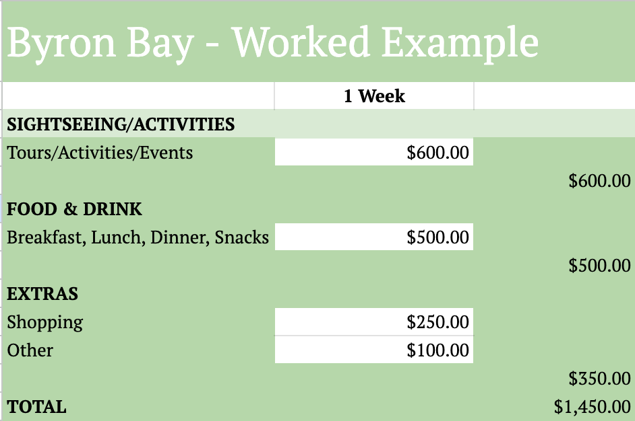  Total Weekly Budget: $1,450  You can also find this worked example in the VCE VM Unit 4 Task 9 Budget template. | BALI  Add screenshot here.  Total Weekly Budget:
GOLD COAST  Add screenshot here.  Total Weekly Budget: | YOUR DESTINATION: __________________  Add screenshot here.  Total Weekly Budget:
Part 4: Weather analysis – In the first step, you are going to analyse the average temperatures of two of the most popular school leavers destinations, Bali and the Gold Coast. Use the Schoolies website to pick another destination of your own.
Once you have chosen an additional location, use Weatherspark or another weather app to find the average temperature in November and December for the destinations. Complete the table below.
Destination | Activities
Example: Byron Bay | November:  HIGH: 25  LOW:19  December:  HIGH: 26  LOW: 20  Formula: Average = Total Sum / Total Numbers  Working out: 25 + 19 + 26 + 20 = 90  90 / 4  22.5 average degrees in November and December.
Bali | November:  HIGH:  LOW:  December:  HIGH:  LOW:  Formula: Average = Total Sum / Total Numbers  Working out:
Gold Coast | November:  HIGH:  LOW:  December:  HIGH:  LOW:  Formula: Average = Total Sum / Total Numbers  Working out:
Your Destination  (Insert one other destination here) | November:  HIGH:  LOW:  December:  HIGH:  LOW:  Formula: Average = Total Sum / Total Numbers  Working out:
Part 5: Transport and travel logistics – Let's gather some information about how you would get to each destination. Use the resources provided to work out logistics such as distance, cost and travel time.
You can use the following dates:
Week 1: 22–29 November 2025
or
Week 2: 27 November–7 December 2025
Destination | Flight  https://www.schoolies.com/flights |  | Transport  Victoria –  Public Transport Victoria  Interstate –  Public Transport Victoria – Interstate travel |  | Driving  https://www.nobirds.com.au/fuel-calculator  (Choose a car that is the nearest match to the car you will be taking) |  | Best travel method:
 | Cost | Time | Cost | Time | Cost | Time | Best travel method:
Example: Byron Bay | $211 | 2:05 hours each way. | $154 each way | 20 hours each way | $480 petrol return | 17.23 hours | Flight
Bali
Gold Coast
Your Destination
(Insert one other destination here)
Part 6: Other considerations – Complete the table below.
Destination | Is a passport needed? | Activities / things to do: | Safety: | Other elements to consider:
Example: Byron Bay | NA | - Beach  - Markets  - Byron Bay Diving Centre  - Surfing Byron Bay  - Cape Byron Kayaks  - Sky diving  - Night events | - Red Frog support team  - Schoolies only events  - 24 Schoolies hotline | Included in the trip:  - Official ID pass  - Fee-Free layby Plans  - Perks – including $150 travel vouchers  - 24-hour hotline  - Local business discounts
Bali
Gold Coast
Your Destination
(Insert one other destination here)

Activity 9.3 Evaluate and reflect
Part 1: The data doesn’t lie! Summary table: It's now time to collate the data so we can make our final decision. Fill the table below, working through each step to input the data that you collected.
 | Example:  Byron Bay: | Bali: | Gold Coast: | Your choice:
Average day temperature:  (November / December) | 22.5 degrees
Cost of travel: | $211 AUD
Chosen accommodation cost: | $989 per person
Required weekly budget: | $1,450
Total cost: | $2,440
Part 2: Summarise the information you have gathered above in the PMI table below.
Destination | Plus | Minus | Interesting
Example:  Byron Bay | - Good average temperature - 22.5 degrees  - Short flight - 2.05 hours  - Plenty of activities | - If flying, I will not have a car.  - If I want a car while I am there and decide to drive, this is time-consuming: 17+ hours and also more expensive than flying: $480 in petrol. | - I have never been to Byron Bay and therefore it would be interesting to explore a new place.  - If booked through Schoolies, there are a lot of additional inclusions that help keep me safe.
Bali
Gold Coast:
Other:

Activity 9.4 Communicate and report
Part 1: Finally, it's time to communicate what we found out doing this task and how we did it. Fill in the table below explaining some of the mathematical tools you used in this task and then, based on our findings, answer the final questions.
Tool / Formula used | Explanation | When and how is it used? | Accuracy level | How likely are you to use this tool again? (1-5) | Add to my numeracy toolkit slides.
Google sheets |  |  |  |  | ☐
Accommodation finder |  |  |  |  | ☐
Weather spark |  |  |  |  | ☐
PTV |  |  |  |  | ☐
Fuel calculator |  |  |  |  | ☐
Averages |  |  |  |  | ☐
Part 2: Final enquiry reflection questions.
- From your data, which location will cost the most?
- From your data, which location will cost you the least?
- Considering everything you have found out, logistically (cost, travel, dates), which location is the most convenient for you? Explain.

Task 9: Feedback and assessment
Peer feedback
Activity 9.1 | Identify the mathematics | Choose an item.
Activity 9.2 | Act of the mathematics | Choose an item.
Activity 9.3 | Evaluate and reflect | Choose an item.
Activity 9.4 | Communicate and report | Choose an item.
Peer comment:
Name of peer:

AoS 8 KS 1 Choose appropriate technologies such as spreadsheets, software or applications to input or record real-life data and information.
Student reflection: How well did you go with this step? (Please tick the box below)
☐Not Submitted | ☐Beginning | ☐Consolidating | ☐Achieving | ☐Excelling
Student comment (optional):
Teacher feedback
☐Not Submitted | ☐Beginning | ☐Consolidating | ☐Achieving | ☐Excelling
Not Submitted: No work has been submitted or attempted for this activity. | Beginning: You have attempted to access the budget planning spreadsheet or transfer real-life data into the table. To bump it up, make sure that all parts are answered correctly. | Consolidating: You have shown evidence of accessing the budget planning spreadsheet; however, your data estimations need review and there are some sections in the weekly budget table that are incomplete. To bump it up, check over your answers and see if you can include more information in each of your answers. | Achieving: You have successfully accessed the budget planning spreadsheet and shown that you can adequately research and input real-life data to create a budget for a week. To bump it up, you could include more information into your responses. | Excelling: You have successfully accessed the budget spreadsheet and shown that you can critically analyse and input real-life data into the spreadsheet to create an accurate budget figure for the week of your trip. Well done!
Teacher comment:

AoS 8 KS 2 Use technology to collect, organise and sort relevant data and information.
Student reflection: How well did you go with this step? (Please tick the box below)
☐Not Submitted | ☐Beginning | ☐Consolidating | ☐Achieving | ☐Excelling
Student comment (optional):
Teacher feedback
☐Not Submitted | ☐Beginning | ☐Consolidating | ☐Achieving | ☐Excelling
Not Submitted: No work has been submitted or attempted for this activity. | Beginning: You have attempted to research and use data from external websites and incorporate them into your tasks. To bump it up, make sure that all parts are answered correctly. | Consolidating: You have shown evidence of accessing some key data research from external websites which you have acted upon in most of your tasks. To bump it up, check over your answers and see if you can include more information in each of your answers. | Achieving: You have been able to research and act upon data from external websites to successfully complete required tasks. To bump it up, you could include more information into your responses. | Excelling: You have shown that you are able to research, identify and act upon key data from external websites to successfully complete tasks to a high standard of competency. Well done!
Teacher comment:

AoS 8 KS 3 Use different technology systems to plan and schedule different actions.
Student reflection: How well did you go with this step? (Please tick the box below)
☐Not Submitted | ☐Beginning | ☐Consolidating | ☐Achieving | ☐Excelling
Student comment (optional):
Teacher feedback
☐Not Submitted | ☐Beginning | ☐Consolidating | ☐Achieving | ☐Excelling
Not Submitted: No work has been submitted or attempted for this activity. | Beginning: You have attempted to access the weather and accommodation resources provided to complete the associated tasks. To bump it up, make sure that all parts are answered correctly. | Consolidating: You have shown some evidence that you can act upon the provided weather and accommodation resources to gather data. To bump it up, fully input this data correctly into the required tasks. | Achieving: You have been able to effectively access the provided weather and accommodation resources to gather data and interpret it. To bump it up, add some more information into each task. | Excelling: You have shown that you can comprehensively identify key data from the provided weather and accommodation resources, reflect upon it and input it into the required tables and tasks accurately. Well done!
Teacher comment:

AoS 8 KS 4 Make informed decisions on inputs and interpret outputs mathematically such as from interactive maps, PTV, online calculators/applications/planners.
Student reflection: How well did you go with this step? (Please tick the box below)
☐Not Submitted | ☐Beginning | ☐Consolidating | ☐Achieving | ☐Excelling
Student comment (optional):
Teacher feedback
☐Not Submitted | ☐Beginning | ☐Consolidating | ☐Achieving | ☐Excelling
Not Submitted: No work has been submitted or attempted for this activity. | Beginning: You have provided some evidence of accessing the provided resources for the trip planning to complete tasks. To bump it up, make sure that all parts are answered correctly. | Consolidating: You have shown some evidence that you can access sites including Skyscanner, PTV and the fuel planner to begin to plan for an end-of-school trip. To bump it up, make sure you use all the accurate information including dates and destinations. | Achieving: You have shown that you can access Skyscanner, PTV and the fuel planner websites to plan for an end-of-school trip. You have shown some correlation between dates and when you would be planning to go on your trip. To bump it up, recheck your dates when planning your trip. | Excelling: You have shown the ability to access Skyscanner, PTV, the fuel planner and other trip planning websites to plan for an end-of-school trip. You have shown a clear correlation between your dates as well as mentioned the practicality of each transportation method. Well done!
Teacher comment:

AoS 8 KS 5 Decide, set and adjust parameters of inputs to optimise outputs and solutions for real-life situations and contexts.
Student reflection: How well did you go with this step? (Please tick the box below)
☐Not Submitted | ☐Beginning | ☐Consolidating | ☐Achieving | ☐Excelling
Student comment (optional):
Teacher feedback
☐Not Submitted | ☐Beginning | ☐Consolidating | ☐Achieving | ☐Excelling
Not Submitted: No work has been submitted or attempted for this activity. | Beginning: You have collected some data. To bump it up, show how you acted upon the mathematics in your enquiry question research. | Consolidating: You have been able to demonstrate that you can use some mathematical processes to collect basic data and act upon it to find enough evidence to make basic responses to the enquiry question. To bump it up, you need to demonstrate you can use a range of mathematical processes. | Achieving: You have been able to demonstrate that you can use a range of mathematical processes to collect sufficient data which you can now draw conclusions from to respond to the enquiry question. To bump it up, you need to expand your responses and include specific details of how you responded to the enquiry question. | Excelling: You have demonstrated a high level of mathematical data gathering, which you have been able to act, manipulate and reflect upon to respond comprehensively to the enquiry question. Well done!
Teacher comment:

