VCE VM and VPC Audit submission

Completing the audit questionnaire
Please read these instructions before you commence the audit questionnaire

General advice
If more than one person teaching this study, please make sure this audit is a collaborative response. Only one response will be considered from each school.
The VCAA understands that information provided may not be final. Please answer each question based on the best available information.

How to submit an audit response
Audit submissions must be made through the online audit questionnaire. A link to the questionnaire is provided in the audit notification email sent to providers that have been selected for audit.

What to submit in your audit response
To prevent avoidable requests for further evidence, please note the following when submitting an audit response:
- Please answer all questions in the audit questionnaire.
- Please check all documents before uploading to ensure the correct documents are submitted.
- When publicly available or commercially produced tasks are used as the basis for your assessment task/s (e.g. commercially produced task, shared task from another school or social media, previous VCAL task), please:
- ensure this is noted in the audit submission
- include the source task with your uploaded evidence (see ‘Uploading evidence’ below).

Time required to complete
It may take between one and three hours to complete the online study-specific audit questionnaire.
Please ensure sufficient time is allowed for collation of resources and completion of survey. To gauge the time necessary to do so, the VCAA recommends reviewing the audit requirements prior to commencing the survey.

Resources
We recommend reviewing the support materials documentation on the relevant VCE Vocational Major (VM) or Victorian Pathways Certificate (VPC) study webpages for explanations and definitions of terms used within the questionnaire.
Before commencing the audit questionnaire, schools are encouraged to refer to the information and resources on the VCE VM and VPC Curriculum and Assessment Audit page on the VCAA website.

PDF available
This audit must be completed online. However, a PDF version of the questionnaire is available for reference purposes on the VCE VM and VPC curriculum and assessment audit page on the VCAA website. If you are unable to access the PDF, please email vcaa.applied.learning@education.vic.gov.au.
The PDF is intended to be used to assist in preparing responses for this audit. Please note that the PDF shows every question contained in the questionnaire. However, the online version of the questionnaire contains in-built logic, which means that based on your selections, some questions will not appear.
The VCAA recommends that providers prepare answers in advance using a text editor such as Microsoft Word. Answers can then be copied and pasted into the online questionnaire from the text document. Please note that only text, bullet points and numbered lists can be pasted into input boxes. Tables and images cannot be pasted into input boxes.

Navigation
To move forward or backward through the online audit questionnaire, use the [PREVIOUS] and [NEXT] buttons displayed in the bottom corners of each page.
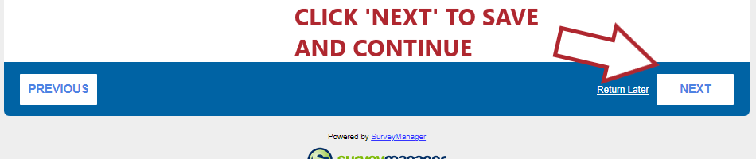
Do not use the arrows in your web browser as this can exit you out of the audit without saving.

Uploading files
Each section of the audit questionnaire requires providers to upload evidence to support their responses to the questions in that section. Only one file can be uploaded in a file upload field. For each upload, documentation must be collated into a single PDF document. If you accidentally upload the wrong file, simply delete it and then upload the correct file. Ensure the document has completed uploading before clicking [NEXT]. Please keep the filename to maximum 20 characters. Files with longer file names cannot be opened.
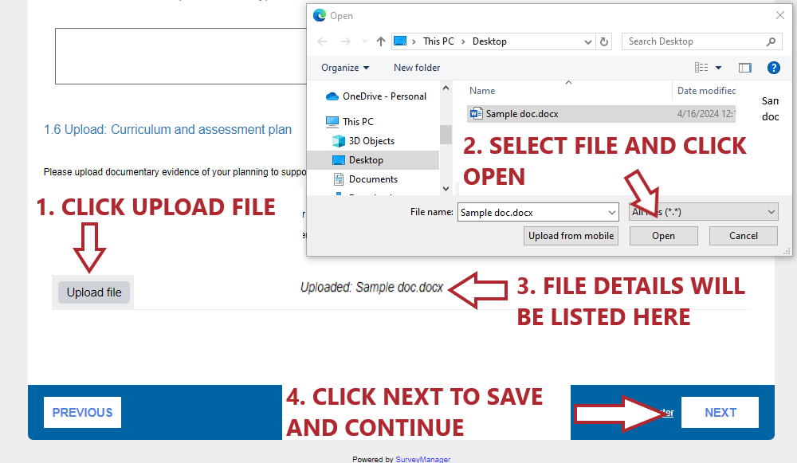
Please DO NOT combine all documentary evidence for the entire audit submission into a single file for upload in your audit questionnaire. Only documentary evidence that is relevant to a particular section of the questionnaire should be uploaded to that section.

Connectivity
To avoid losing information if your internet connection drops out, we recommend that answers are prepared prior to commencing the online audit.
The audit can be completed at a later stage once commenced.
To recommence the audit please ensure you:
- use the [RETURN LATER] button located in the bottom right-hand corner to save entered information
- use the same computer and web browser on which the audit was commenced, as a copy of your responses will have been saved.
In the event there are any technical issues, please contact the Applied Learning Unit team for assistance via email at vcaa.applied.learning@education.vic.gov.au. Generally, 'lost' responses are retrievable.

Input boxes
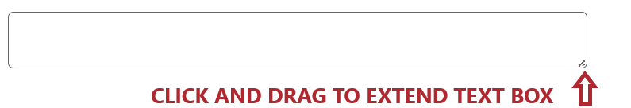
For most input boxes, the size of the box can be extended by dragging the handle in the bottom right-hand corner of the input box. The handle looks like two diagonal lines.

Copy of response
If you would like a copy of your response, there is an [Email your answers] link on the bottom left-hand corner on the ‘Confirmation and submission of audit’ page. Click on this link and enter the email address at which you would like to receive a PDF copy of your responses. Once you have viewed the PDF, you can go back to edit any of the responses provided by using the [PREVIOUS] button.
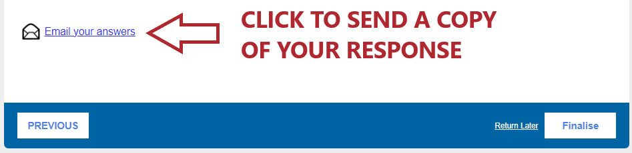
Once you click the [FINALISE] button you will no longer be able to download your responses or edit your submission.

Audit process queries and technical issues
Please contact the VCAA’s Applied Learning Unit at vcaa.applied.learning@education.vic.gov.au for assistance with:
- queries about the audit process (e.g. timelines, clarifying audit requirements)
- troubleshooting issues in completing the survey (e.g. if saved progress is lost, you wish to amend your response after submission, or a copy of the audit response was not saved)
- questions specifically related to the delivery/assessment of the study.
If necessary, your query may be directed to the relevant VCAA Curriculum Manager to address.

