Professional Learning Resources: Victorian Early Years Learning and Development Framework
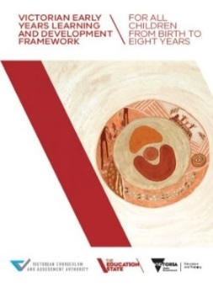
Early childhood professionals, early childhood services, registered training organisations and universities are encouraged to obtain a copy of the framework.
Hard copies of the VEYLDF have been distributed to all services that work with children from birth to eight years. Additional copies can be requested: www.education.vic.gov.au/childhood/providers/edcare/Pages/veyladf.aspx
Online copies of the VEYLDF, appendices and illustrative maps can be downloaded: https://www.vcaa.vic.edu.au/curriculum/earlyyears/veyldf/Pages/Index.aspx

Early Years Alerts
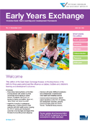
To keep up-to-date with activities and professional learning resources to support implementation of the VEYLDF, subscribe to the Early Years Alert through the Victorian Curriculum and Assessment Authority (VCAA) website.

Early Years Exchange
Latest news and features on research, policy and practice to support implementation of the VEYLDF, published by the VCAA: https://www.vcaa.vic.edu.au/curriculum/earlyyears/early-years-exchange/Pages/Index.aspx

Professional Learning Modules
Four professional learning modules on the VEYLDF are available online:
Module 1: An Introduction to the Victorian Framework and Reflective Practice
Module 2: An Introduction to Collaborative Practice
Module 3: An Introduction to Effective Practice
Module 4: Assessment for Learning & Development: The Early Years Planning Cycle
Each module contains short videos, exercises suitable for individual or team use, and supporting materials.
www.education.vic.gov.au/childhood/providers/edcare/Pages/veyldfproflearn.aspx

Practice Principles – Guides, Evidence Papers and Videos
Evidence Papers, Practice Guides and videos are available for each of the eight Practice Principles. The Evidence Papers document key research and describe what each principle is, why it’s important, and its implications for best practice. The Practice Guides provide advice and activities to support using the principles across a variety of settings. Videos include footage from a range of early childhood education and care (ECEC) settings that exemplify effective ways for supporting children's learning and development, in line with each Practice Principle. A new video has been developed to assist in visualising the Ecological Model.
www.education.vic.gov.au/childhood/providers/edcare/pages/profresource.aspx

Information about the VEYLDF for families
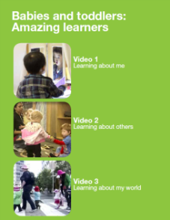
The Department has created a series of information sheets based on the Victorian Early Years and Development
Framework (VEYLDF) to assist all early childhood professionals to support families to understand the VEYLDF and how it relates to their child; and gain a deeper understanding of their children’s learning and development.
www.education.vic.gov.au/childhood/parents/health/Pages/newsletters.aspx

High Expectations for Every Child

VCAA Video Resources
The VCAA, in collaboration with Anne Stonehouse AM and Early Childhood Australia (ECA), has developed two video resources highlighting selected examples of significant learning in the birth-to-three-years period. Both resources include an information booklet used by education leaders to guide and support reflection.

Babies and Toddlers: Amazing learners
This video has three sections: Learning about me; Learning about others; Learning about my world) and an information booklet:

https://www.vcaa.vic.edu.au/curriculum/earlyyears/ey-curriculum-resources/Pages/Birth-to-3years.aspx

What, Why and How? Pedagogy with very young children
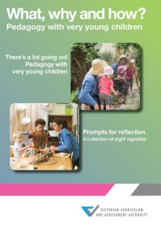
This resource portrays very young children as capable, powerful, active contributors to their own and others’ experience, and as partners who have a right to exercise and strengthen their sense of agency.
There’s a lot going on! Pedagogy with very young children provides an overview of elements of good-quality practice in an education and care service with children aged from around 14 months to almost three years. Prompts for reflection is a collection of eight vignettes that focus on various aspects of an educator’s pedagogy.
https://www.vcaa.vic.edu.au/curriculum/earlyyears/ey-curriculum-resources/Pages/Birth-to-3years.aspx

Making a Difference for Young, Gifted and Talented Children
Information and resources for early childhood professionals to help identify and provide learning for young gifted and talented children (from infancy to eight years old) and their families. www.education.vic.gov.au/giftedchildren

Equity and Diversity

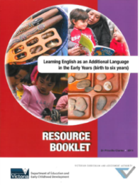
Learning English as an Additional Language
The Learning English as an Additional Language in the Early Years (birth to six years) Resource Booklet provides comprehensive information to support early childhood professionals in their work with young children from culturally and linguistically diverse communities and is linked to the VEYLDF.
https://www.vcaa.vic.edu.au/documents/earlyyears/eyaddlangresource.pdf

Learning and Development Outcome: Children are Confident and engaged Learners

Assessment of Children as Confident and Involved Learners in Early Childhood Education and Care: Literature Review
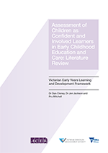
A literature review commissioned from the Australian Council for Educational Research documents the research that underpins and defines learning for children from birth to eight years, and outlines children’s trajectory as confident and involved learners. The resource aims to equip early childhood professionals with the knowledge to identify and assess children’s progress towards the VEYLDF Outcome: Children are confident and involved learners.
https://www.vcaa.vic.edu.au/curriculum/earlyyears/ey-curriculum-resources/Pages/Birth-to-8years.aspx

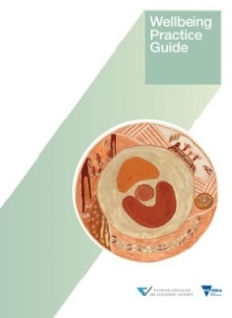
Learning and Development Outcome: Children have a strong sense of wellbeing

Wellbeing Practice Guide
This resource is a practice guide designed to inform a greater understanding of wellbeing and its place as both a prerequisite for, and an outcome of, learning. The Wellbeing Practice Guide provides scenarios and learning activities to support engagement with key concepts of the VEYLDF, including the Learning and Development Outcome: Children have a strong sense of wellbeing.
https://www.vcaa.vic.edu.au/curriculum/earlyyears/ey-curriculum-resources/Pages/Birth-to-8years.aspx

Assessment of Wellbeing in Early Childhood Education and Care: Literature Review
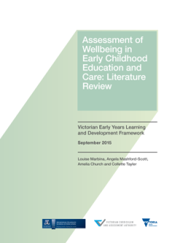
A literature review commissioned from the University of Melbourne is available that documents research that underpins and defines Outcome 3 Wellbeing: Children have a strong sense of wellbeing. The Literature Review defines wellbeing in the birth-to-five-year period; identifies six principles for assessing wellbeing in practice; profiles 10 evidence-based tools for assessment of children’s wellbeing; and outlines children’s trajectory of wellbeing and the learning environments and responsive interactions that support development of wellbeing.
https://www.vcaa.vic.edu.au/curriculum/earlyyears/ey-curriculum-resources/Pages/Birth-to-8years.aspx

Learning and Development Outcome: Children are effective communicators

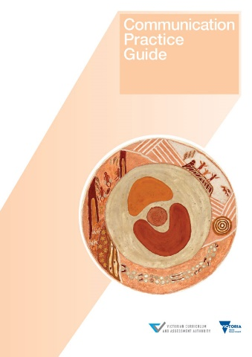
Communication Practice Guide
This resource is a practice guide designed to inform a greater understanding of communication. Children’s wellbeing, identity, sense of agency and capacity to make friends is connected to the development of communication skills and strongly linked to their capacity to express feelings and thoughts, and to be understood (VEYLDF, p22) The Communication Practice Guide provides scenarios and learning activities to support engagement with key concepts of the VEYLDF, including the Learning and Development Outcome: Children are effective communicators.
https://www.vcaa.vic.edu.au/curriculum/earlyyears/ey-curriculum-resources/Pages/Birth-to-8years.aspx

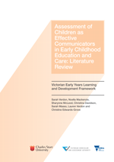
Assessment of Children as Effective Communicators in Early Childhood Education and Care: Literature Review
A literature review commissioned from the Charles Sturt University documents research that underpins and defines the Learning and Development Outcome Children are effective communicators. The Literature Review defines communication in the birth-to-eight-year period; identifies seven principles for assessing communication in practice; profiles 10 evidence-based tools for assessment of children’s communication; and outlines children’s trajectory of communication and the learning environments and responsive interactions that best support development of communication.

https://www.vcaa.vic.edu.au/curriculum/earlyyears/ey-curriculum-resources/Pages/Birth-to-8years.aspx

Assessment for Learning and Development

Planning Cycle Resource
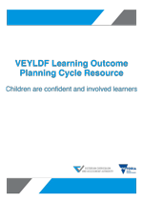
These sample learning and development plans are for educators working with children in early years setting. The plans focus on learning and development in the domains of mathematics and science, and are organised to reflect the age ranges birth to two years, three to five years, and six to eight years. This resource supports an intentional approach to children's learning, and supports educators to achieve National Quality Standard 1: Education program and practice.
https://www.vcaa.vic.edu.au/curriculum/earlyyears/ey-curriculum-resources/Pages/Birth-to-8years.aspx

Becoming a Writer – A Digital Story
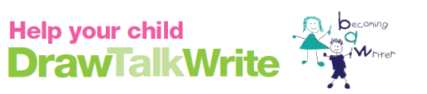
The VCAA, in partnership with Dr Noella Mackenzie (Charles Sturt University), developed this literacy-based resource to support partnerships with families to support children’s learning, and planned and spontaneous opportunities for diverse drawing and writing experiences.
https://www.vcaa.vic.edu.au/curriculum/earlyyears/ey-curriculum-resources/Pages/Birth-to-8years.aspx

transitions

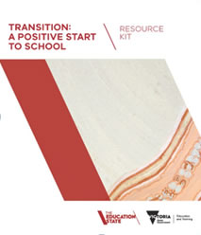
Transition: A Positive Start to School Initiative
Transition: A Positive Start to School is available through the Department’s website. The guide provides information on:
- the transition to school context and approach
- transition to school programs
- the Transition Learning and Development Statement.
- www.education.vic.gov.au/transitiontoschool
Strength-based approach: A guide to writing Transition Learning and Development Statements
www.education.vic.gov.au/Documents/childhood/professionals/learning/strengthbappr.pdf

Transition: A Positive Start to School Resource Kit
www.education.vic.gov.au/childhood/professionals/learning/Pages/transkit.aspx

Transition: A Positive Start to School Resource Kit – Online Appendix
www.education.vic.gov.au/Documents/childhood/professionals/learning/transkitappendix.pdf

Supporting Reciprocal Visits
To strengthen transition-to-school processes for children and families, a series of professional learning sessions and reciprocal visits were delivered across four Victorian sites. Read the reports and watch a three-minute introduction and videos from each site: www.education.vic.gov.au/
childhood/professionals/learning/Pages/transtoschoolreciprocalvisits.aspx

Supporting children and families experiencing vulnerability in early years transitions

Literature and Practice Reviews
These two reports provide evidence-based strategies, programs and practices for supporting children and families experiencing vulnerability in early years transitions:
- Early Years Transitions: Support for Children and Families at Risk of Experiencing Vulnerability, Rapid Literature Review
- Early Years Transitions: Support for Children and Families at Risk of Experiencing Vulnerability, Practice Review
You can access the reports online: www.education.vic.gov.au/
about/research/Pages/transitionresearch.aspx#link1

Professional learning courses: Continuity of Early Learning: Addressing Vulnerability and Disadvantage
Based on the Literature and Practice Reviews, the Department is offering a professional learning program that focuses on supporting children, particularly those who are experiencing vulnerabilities or disadvantage, as they transition from an early years setting to a school setting. This course is designed for staff who support transition to school in early childhood, schools, outside school hours care and support services: www.bastow.vic.edu.au/professional-learning/course?eventtemplate=152-Continuity-of-Early-Learning

Supporting English as an Additional Language (EAL) at transition to school
This resource provides advice and practical examples of how children and families, with English as an additional language (EAL), can be supported to make a successful transition to school. It is designed to assist and guide early childhood professionals and teachers in schools. https://www.vcaa.vic.edu.au/curriculum/earlyyears/ey-curriculum-resources/support-for-eal/Pages/Index.aspx

Information for Families on Transition to School
Moving from kindergarten to primary school can be an exciting time but also a challenging time for children and families. Advice for parents and families on how best to support their child’s transition to school is available at the below link. This also includes an information sheet for families (available in 30 languages) on Transition: A Positive Start to School, and guidelines to help families to understand the Transition Statement as well as complete their section of it. www.education.vic.gov.au/childhood/parents/transition/Pages/default.aspx

Other Resources

National Quality Framework
The National Quality Framework (NQF) applies to long day care, family day care, outside school hours care, kindergartens and preschools. These services are governed by the Education and Care Services National Law Act 2010 and the Education and Care Services National Regulations 2011.
More information about the NQF is available at the Australian Children’s Education and Care Quality Authority (ACECQA) website, which includes links to the legislation; frequently asked questions; resources to support implementation of the National Quality Standard (NQS); and approved learning frameworks.
www.acecqa.gov.au
www.education.vic.gov.au/childhood/providers/regulation/Pages/nqf.aspx

Licensed Children’s Services
The Victorian Children’s Services Act and Regulations continue to apply for services not covered by the NQF. Further information and resources to support children’s services to meet the requirements of this legislation is available online:
www.education.vic.gov.au/childhood/providers/regulation/Pages/vcs.aspx

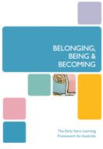
Belonging, Being and Becoming: The Early Years Learning Framework for Australia
The Belonging, Being and Becoming: The Early Years Learning Framework (EYLF) for Australia and The Educators’ Guide to the EYLF for Australia are available online: www.education.gov.au/early-years-learning-framework

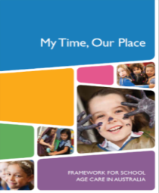
My Time, Our Place: Framework for School Age Care
The My Time, Our Place: Framework for School Age Care is designed for use by school age educators working in partnership with children, their families and the community. It is linked to the EYLF and the VEYLDF.
http://files.acecqa.gov.au/files/National-Quality-Framework-Resources Kit/educators_my_time_our_place.pdf

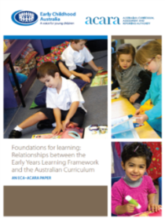
Foundations for Learning: Relationships between the EYLF and the Australian Curriculum
Early Childhood Australia (ECA) in collaboration with the Australian Curriculum, Assessment and Reporting Authority (ACARA) has developed an information paper, Foundations for Learning, which describes the key connections between the Early Years Learning Framework (EYLF) and the Australian Curriculum. It provides a continuum of teaching and learning between the early years’ sector and the first years of school:
http://foundationinquirylearning.global2.vic.edu.au/files/2013/06/ECA
_ACARA_Foundations_Paper-2cq59mi.pdf

Understanding the National Quality Standard
The Early Childhood Resource Hub includes a number of resources to support early childhood educators to become familiar with the National Quality Framework and the National Quality Standard (NQS), and embed the EYLF in daily practice as a key element of achieving the NQS. Resources include:
- Newsletters on the EYLF and NQS
- Connecting with practice – EYLF and NQS practice and training videos
www.ecrh.edu.au/national-quality-standard

