2022 VCE Further Mathematics 2 external assessment report

General comments
Students were required to complete:
- a compulsory Core section of data analysis (worth 24 marks)
- a compulsory Core section of recursion and financial modelling (worth 12 marks)
- two selected modules (worth 12 marks each).
The selection of modules by students in 2022 is shown in the table below.
Module | %
Matrices | 46.4
Networks and decision mathematics | 31.1
Geometry and measurement | 10.4
Graphs and relations | 11.75
Scanned images of examination papers are used for assessing, so students should ensure their answers can be clearly read. Students are urged to take great care with the presentation of their responses. Students should ensure their responses are written clearly in a dark colour (for example, blue or black pen or 2B pencil) so they are readable when scanned.
A formula sheet is provided with the examination. Students should familiarise themselves with this formula sheet before the examination. Students should bring a ruler to accurately draw straight lines, which are often required in both data analysis and graphs and relations.
Fifteen minutes of reading time is available and students should ensure that they are only looking at the sections of the examination they will be completing. It is recommended that when students complete practice examinations at home they allow 15 minutes reading time first.
Throughout the examination, students should carefully read each question a second time to ensure that they are answering appropriately and completely. For example, in Core Question 2ai., students were asked to give two interquartile ranges (IQR) and determine at which time the relative humidity was more variable. Many students gave the two IQR values correctly but did not address the question of variability.
Transcription errors were often seen; students need to take greater care when transferring their answers from the calculator. An extra zero was often seen in answers to the recursion and financial modelling questions.
Where descriptive answers are required to a question, students are strongly advised to keep answers brief. An answer in point form is acceptable and additional information should not be provided. For example, in Core Question 4b., students were only asked to describe the association in terms of strength and direction. It was not appropriate to further comment on form or possible outliers.
For all questions worth more than one mark, students are strongly advised to show their working. An incorrect answer on its own will not be awarded any marks in a two-mark question. A method mark can, on occasions, be awarded to students who have shown the development of their answer. For example, in Matrices Question 4b., a method mark was available if the correct state matrix was identified, even if a clear conclusion was not provided.
A question that asks to ‘show that’ a particular answer could be obtained was a problem for many students. Make sure when doing a ‘show that’ question, any equations or values used to ‘show’ the answer are copied correctly. Students should recall that they cannot simply substitute a value or use the fact they are attempting to ‘show’ as part of this process.
Further to this, Core Question 8a. required students to ‘show recursive calculations’. The mark can only be obtained by showing the step-by-step approach. An answer on its own is not sufficient to attract the marks.
In questions where no instruction to round is given, an exact answer is required as rounding does not apply. For example, in Geometry Question 1a., the required answer was 18.75 square metres; as rounding did not apply, an answer such as 18.8 could not be accepted. In Financial Mathematics, students should only round to the nearest dollar or nearest cent when specified.
In Core questions where a maximum of one rounding error was penalised, a second rounding error would not have resulted in loss of marks if either:
- a correct calculation was shown prior to the final incorrectly rounded answer
- additional correct decimal places could be seen.
This was the last year of the Further Mathematics study design and examination. In 2023, VCE Further Mathematics will be renamed VCE General Mathematics Units 3–4 and will follow the revised study design and examination specifications.

Specific information
This report provides sample answers, or an indication of what answers may have included.
The statistics in this report may be subject to rounding resulting in a total more or less than 100 per cent, where applicable.

Core – Data analysis

Question 1ai.
Marks | 0 | 1 | Average
% | 15 | 85 | 0.9
20

Question 1aii.
Marks | 0 | 1 | Average
% | 21 | 79 | 0.8
60%

Question 1b.
Marks | 0 | 1 | 2 | Average
% | 19 | 16 | 64 | 1.5
Wind speeds of 59 and 70 are outliers as they are greater than the upper fence of 54.5.
The majority of students were able to calculate the upper fence, although some did not go on to explain why the two values were outliers. Some students drew a boxplot and did not include the key calculations.

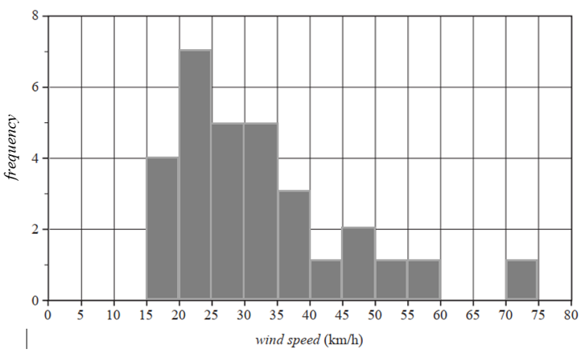
Question 1c.
Marks | 0 | 1 | 2 | Average
% | 28 | 11 | 61 | 1.3
Some students missed one column. The outlier was often not placed correctly.

Question 2ai.
Marks | 0 | 1 | Average
% | 42 | 59 | 0.6
More variable at 9am. IQR at 9am of 35 is higher than IQR of 29 at 3pm.
Some students did not demonstrate which was more variable despite calculating each IQR value correctly. Some stated the values of each IQR but gave no conclusion.

Question 2aii.
Marks | 0 | 1 | Average
% | 30 | 70 | 0.7
75%

Question 2aiii.
Marks | 0 | 1 | Average
% | 10 | 90 | 0.9

Time | Min | Q1 | Med | Q3 | Max
9 am | 40 | 65 | 75 | 100 | 100
3 pm | 27 | 51 | 63 | 80 | 100
Identifying the minimum at 9am appeared to be a problem for some students.

Question 2b.
Marks | 0 | 1 | 2 | Average
% | 36 | 22 | 41 | 1.1
Yes, as the medians differ from 9am to 3pm. The median at 9am of 75 is greater than the median at 3pm of 63.
Many students gave the correct values for each median but did not specifically mention a change or difference.

Question 3ai.
Marks | 0 | 1 | Average
% | 42 | 58 | 0.6
5
6 was a common error by students who had chosen ‘day number’ as a numerical variable.

Question 3aii.
Marks | 0 | 1 | Average
% | 30 | 70 | 0.7
0 was the correct response. Some students appeared to have calculated the mean instead.

Question 3b.
Marks | 0 | 1 | Average
% | 38 | 62 | 0.6

9.236 |  | 1.002
More incorrect responses were seen with the second number, which was often rounded to four decimal places.

Question 3c.
Marks | 0 | 1 | Average
% | 52 | 48 | 0.5
61.1%
0.6 was a common incorrect response.

Question 4a.
Marks | 0 | 1 | Average
% | 7 | 93 | 1.0
Temperature
Some students chose ‘relative humidity’.

Question 4b.
Marks | 0 | 1 | Average
% | 72 | 28 | 0.3
Strong, negative
Many students chose moderate for the strength. Others gave additional answers rather than simply commenting on strength and direction.

Question 4c.
Marks | 0 | 1 | Average
% | 56 | 44 | 0.5
On average, relative humidity decreases by 3.417% for each 1 degree increase in temperature.
Many students gave a response that was close to being correct but did not include the 1 degree increase in temperature. The interpretation of the slope must refer to a change in the response variable for each unit change in the explanatory variable.

Question 4d.
Marks | 0 | 1 | 2 | Average
% | 23 | 23 | 54 | 1.3
–19.4 %
A number of students simply calculated the predicted value and did not go on to determine the residual. Arithmetic or transcription errors were costly for many students.

Question 5a.
Marks | 0 | 1 | Average
% | 60 | 40 | 0.4
Decreasing trend with seasonality.
This question was not answered well. Structural change was often mentioned. Students needed to mention both terms to receive full marks.

Question 5b.
Marks | 0 | 1 | Average
% | 46 | 54 | 0.6
100
A variety of answers were seen. Some students calculated the mean rather than the median.

Question 5ci.
Marks | 0 | 1 | Average
% | 46 | 54 | 0.6
133.5
Reasonably well done by those who attempted it. Students were required to round to one decimal place.

Question 5cii.
Marks | 0 | 1 | Average
% | 66 | 34 | 0.4
28
An incorrect response often seen was 4.

Core – Recursion and financial modelling

Question 6a.
Marks | 0 | 1 | Average
% | 6 | 94 | 1.0
$187 500

Question 6b.
Marks | 0 | 1 | Average
% | 12 | 88 | 1.0
16

Question 6c.
Marks | 0 | 1 | Average
% | 38 | 62 | 0.6
V0 = 200 000 Vn+1 = Vn – 12 500
Notation was a problem for some students. A common error was to finish the recurrence relation with 12500n.

Question 6d.
Marks | 0 | 1 | Average
% | 52 | 48 | 0.5
Reducing balance
Many students answered ‘included flat rate’, while others gave ‘unit cost’.

Question 7a.
Marks | 0 | 1 | Average
% | 14 | 86 | 0.9
$5214.28

Question 7b.
Marks | 0 | 1 | Average
% | 49 | 51 | 0.5
$1330.65
Rounding errors occurred by those students who calculated their own interest rate rather than using the information given in the question. Rounding was required to the nearest cent.

Question 7c.
Marks | 0 | 1 | Average
% | 65 | 35 | 0.4
P0 = 540 000 Pn+1 = 1.0025 × Pn – 5214.28
This question was not answered well. The multiplying factor of 1.0025 was frequently incorrect and often the 5214.28 was added. Notation was a problem, with many students using a mixture of ‘P notation’ and ‘V notation’.

Question 7d.
Marks | 0 | 1 | Average
% | 51 | 49 | 0.5
$1350
Many students were unable to provide the definition of a perpetuity.
The annuity payment of $5214.28 was the most common mistake.

Question 8a.
Marks | 0 | 1 | Average
% | 56 | 44 | 0.5
L1 = 1.002 × 580 000.00 – 3045.26 = 578 114.74
L2 = 1.002 × 578 114.74 – 3045.26 = 576 225.7094… ≈ 576 225.71
Some gave the correct final answer but did not show the recursive calculations as asked. Transcription and rounding errors were common. Rounding to the nearest cent was required.

Question 8b.
Marks | 0 | 1 | Average
% | 49 | 51 | 0.5
2.4%
0.2% was a common incorrect answer.

Question 8c.
Marks | 0 | 1 | Average
% | 77 | 23 | 0.3
$0.15
Finance solver entries to firstly find the term of the loan.
N = 239.99…
I% = 2.4
PV = 580 000
PMT = −3045.26
FV = 0
P/Y & C/Y = 12
Finance solver entries to then find the small amount to be deducted from the final repayment (as it is a positive value).
N = 240
I% = 2.4
PV = 580 000
PMT = −3045.26
FV = 0.1493..
P/Y & C/Y = 12
This question was not answered well; some students did not clearly indicate the small amount less than one dollar as asked.

Question 8d.
Marks | 0 | 1 | Average
% | 81 | 19 | 0.2
1.0016
Finance solver entries to firstly find the interest rate.
N = 228
I% = 1.9466..
PV = 580 000
PMT = −3045.26
FV = 0
P/Y & C/Y = 12
Multiplication factor =
This was a challenging final question for the majority of students.

Module 1 – Matrices

Question 1a.
Marks | 0 | 1 | Average
% | 6 | 94 | 1.0

Question 1b.
Marks | 0 | 1 | Average
% | 40 | 60 | 0.6
Many incorrect answers were seen. Some students interchanged the three numbers.

Question 2a.
Marks | 0 | 1 | Average
% | 14 | 86 | 0.9

Question 2bi.
Marks | 0 | 1 | Average
% | 24 | 76 | 0.8
20 × 50 – 40 × 30
This question was a ‘show that’ question, which required the calculation to be clearly demonstrated.

Question 2bii.
Marks | 0 | 1 | Average
% | 79 | 21 | 0.2
A unique solution exists, as the determinant is not zero.
This question was not answered well, with few students able to demonstrate how to interpret the determinant value. The response also needed both parts.

Question 2c.
Marks | 0 | 1 | Average
% | 41 | 59 | 0.6
Some students were able to answer this correctly, even when previous parts of the question were not correct.

Question 3a.
Marks | 0 | 1 | Average
% | 44 | 56 | 0.6
344
0.7 × 210 + 0.7 × 190 + 0.8 × 80
Numerous incorrect methods were employed here.

Question 3b.
Marks | 0 | 1 | Average
% | 75 | 25 | 0.3
63%
Repeat skiers = 0.8 × 80 = 64
Total advanced skiers = 0.2 × 190 + 0.8 × 80 = 38 + 64 = 102
Percentage =
Whole number rounding applied for this question.
This question was not well answered by many students.

Question 3c.
Marks | 0 | 1 | Average
% | 81 | 19 | 0.2
219
The maximum occurred three days after the original date.
Many students incorrectly assumed that the long run number was required.
Whole number rounding applied for the question.

Question 4a.
Marks | 0 | 1 | Average
% | 68 | 32 | 0.3
146

Question 4b.
Marks | 0 | 1 | 2 | Average
% | 60 | 1 | 39 | 0.8
Ali with 280 votes.
A good number of students correctly gave both the winner and the number of votes. Many students showed no working for this question. Whole number rounding applied for this question.

Module 2 – Networks and decision mathematics

Question 1a.
Marks | 0 | 1 | Average
% | 24 | 76 | 0.8
OABCDEFGO or OGFEDCBAO
Some students did not list the full route starting and finishing at the office.

Question 1bi.
Marks | 0 | 1 | Average
% | 18 | 82 | 0.8
E

Question 1bii.
Marks | 0 | 1 | Average
% | 30 | 70 | 0.7
Eulerian trail
Some students simply gave ‘trail’, while other students described it as a ‘circuit’.

Question 2a.
Marks | 0 | 1 | Average
% | 51 | 49 | 0.5
3
Activities H, I and J .The most common error was two.

Question 2b.
Marks | 0 | 1 | Average
% | 38 | 62 | 0.6
30

Question 2c.
Marks | 0 | 1 | Average
% | 73 | 27 | 0.3

Activity | Reduction
A | 2
I | 1
Many students answered this question incorrectly.

Question 2d.
Marks | 0 | 1 | 2 | Average
% | 7 | 13 | 80 | 1.8

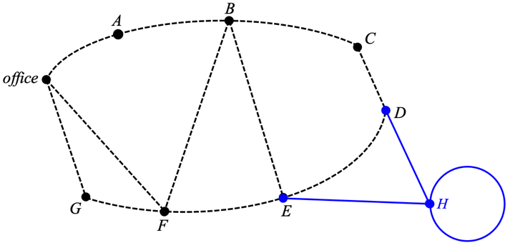
This question was well done by most students.

Question 3a.
Marks | 0 | 1 | Average
% | 38 | 62 | 0.6
74

Question 3b.
Marks | 0 | 1 | Average
% | 63 | 37 | 0.4
44
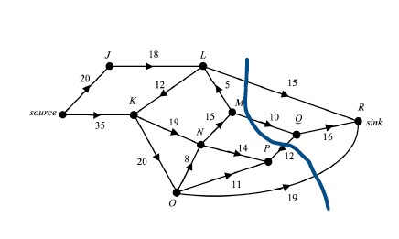
Many students answered this question incorrectly, with many different incorrect approaches shown.

Question 3c.
Marks | 0 | 1 | Average
% | 56 | 44 | 0.5

Q |  | P

Question 3d.
Marks | 0 | 1 | Average
% | 98 | 2 | 0.02

L |  | R |  | 23
Very few students completed the question correctly. Some students listed the vertices correctly, but not the new capacity.

Module 3 – Geometry and measurement

Question 1a.
Marks | 0 | 1 | Average
% | 13 | 87 | 0.9
18.75 m²

Question 1b.
Marks | 0 | 1 | Average
% | 10 | 90 | 0.9
67.5 m³

Question 1c.
Marks | 0 | 1 | Average
% | 44 | 56 | 0.6
2.15 m

Question 1d.
Marks | 0 | 1 | Average
% | 24 | 76 | 0.8
24 m

Question 1ei.
Marks | 0 | 1 | Average
% | 42 | 58 | 0.6
75 m
67.5 was a common incorrect response.

Question 1eii.
Marks | 0 | 1 | Average
% | 74 | 26 | 0.3
3512 m²
A number of incorrect alternatives were seen.

Question 2a.
Marks | 0 | 1 | Average
% | 73 | 27 | 0.3
10:30pm Tuesday
Time zone questions were not well responded to by many students.

Question 2bi.
Marks | 0 | 1 | Average
% | 55 | 45 | 0.5
6400 × cos 27º
This question was a ‘show that’ question, which meant that students could not just write an equation involving r that needed to be solved. An acceptable alternative was 6400 × sin 63º.

Question 2bii.
Marks | 0 | 1 | Average
% | 61 | 39 | 0.4
1194 km

Question 2c.
Marks | 0 | 1 | Average
% | 59 | 41 | 0.4
75º

Question 3a.
Marks | 0 | 1 | Average
% | 58 | 42 | 0.4
1229 km
Some students incorrectly wrote 1129 km.

Question 3b.
Marks | 0 | 1 | Average
% | 91 | 9 | 0.1
44.5 m
A challenging final question that was often not attempted or was incorrectly answered.

Module 4 – Graphs and relations

Question 1a.
Marks | 0 | 1 | Average
% | 5 | 95 | 1.0
$1690

Question 1b.
Marks | 0 | 1 | Average
% | 34 | 66 | 0.7
12
A number of students incorrectly responded with 24.

Question 1c.
Marks | 0 | 1 | Average
% | 60 | 40 | 0.4

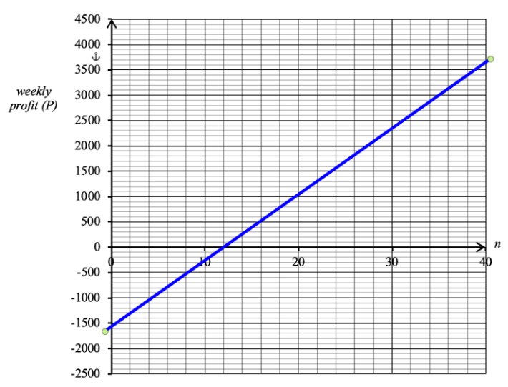
Generally, students who wrote down the coordinates of the endpoints placed their graphs the best.

Question 1d.
Marks | 0 | 1 | Average
% | 78 | 22 | 0.2

220 |  | 1560

Question 2a.
Marks | 0 | 1 | Average
% | 13 | 87 | 0.9
$13 200

Question 2b.
Marks | 0 | 1 | Average
% | 44 | 56 | 0.6
9

Question 2c.
Marks | 0 | 1 | Average
% | 76 | 24 | 0.3
1200

Question 2d.
Marks | 0 | 1 | Average
% | 56 | 44 | 0.5
51.2 mm
Some students found the k value but were unable to proceed further.

Question 3a.
Marks | 0 | 1 | Average
% | 34 | 66 | 0.7
10

Question 3b.
Marks | 0 | 1 | Average
% | 48 | 52 | 0.5
43

Question 3c.
Marks | 0 | 1 | Average
% | 63 | 37 | 0.4
$14 630
A reasonable number of students received full marks. .

Question 3d.
Marks | 0 | 1 | Average
% | 88 | 12 | 0.1
$175
Profit = ax + 350y
and
Giving a < 175
Only a minority of students were able to gain this final mark.

