2022 VCE Further Mathematics 1 (NHT) external assessment report

Specific information
This report provides sample answers or an indication of what answers may have included. Unless otherwise stated, these are not intended to be exemplary or complete responses.
The tables provided indicate the correct answer for each question. This report includes further details for some responses that were not as well answered as others.

Section A – Core

Data analysis
Question | Answer
1 | C
2 | D
3 | C
4 | B
5 | B
6 | D
7 | D
8 | D
9 | B
10 | E
11 | B
12 | C
13 | E
14 | E
15 | A
16 | E

Question 6
Data concerning two categorical variables can be displayed in a two-way contingency table, as presented in the stem of the question, or as a segmented bar chart.
All the other options can be used to present numerical data.

Question 8
A box plot splits data into four sections. The middle box contains the middle 50%, below the box is 25% and above is 25%. Therefore, in this graph 75% of the data is between 26 (Q1) and 38 (maximum). This is equivalent to 33 people. If the three people with bicep muscle circumference above 34 cm are removed, then 30 people between 26 and 34 are left. This is 68.18%.

Question 9
Three steps are required to solve this question.
Step 1: Determine the total bicep muscle circumference for the 44 people
Total bicep muscle circumference 28.16 × 44 = 1239.04
Step 2: Subtract the bicep muscle circumference measures of the four outliers
1239.04 – (21 + 35 + 36 + 38) = 1109.04
Step 3: Divide the adjusted total by 40 (total excluding the outliers)
1109.04 ÷ 40 = 27.73

Question 11
Residual value = actual value – predicted value.
Using the scatterplot and residual line provided, the residual value 10.4 – 10.85 = – 0.45.
This value is closest to –0.5.

Recursion and financial modelling
Question | Answer
17 | B
18 | E
19 | B
20 | D
21 | D
22 | D
23 | C
24 | A

Question 19
Geometric growth refers to the situation where each successive term in a sequence differs by a constant ratio. For growth to occur, the R value must be greater than 1.

Question 21
Two steps are required to solve this question.
Step 1: Determine the interest rate from the amortisation table.
I = PRT
of a year (or three months)
Step 2: If the first payment was on 1 January 2021, then the second payment was on 1 April 2021.

Question 24
Four steps are required, three of which use Finance Solver.
Step 1:  Determine the regular repayment amount.  N = 20 × 52  I% = 3.8  PV = 200 000  PMT = – 274.62  FV = 0  P/Y = 52  C/Y = 52 | Step 2:  Determine the amount owing after 10 years.  N = 10 × 52  I% = 3.8  PV = 200 000  PMT = – 274.62  FV = – 118767.99  P/Y = 52  C/Y = 52
Step 3:  Determine the new time required to fully repay the loan.  N = 478  I% = 3.8  PV = 118767.99  PMT = – 294.62  FV = 0  P/Y = 52  C/Y = 52 | Step 4:  Determine the reduction in time.  10 years = 520 weeks  520 – 478 = 42

Section B – Modules

Module 1 – Matrices
Question | Answer
1 | A
2 | B
3 | B
4 | C
5 | E
6 | E
7 | C
8 | D

Question 7
Using the information from matrix T and the initial state matrix:
1 × 0.4 + 0.15 × 0.2 + 0 × 0.2 + 0.35 × 0.2 = 0.5
Fifty per cent of the rodents will be sheltering at location A.
If 1000 were observed sheltering at location A, the total number of rodents must have been 2000.

Question 8
The answer requires T, U and V to be in the rows. It is necessary to first transpose matrix N.
NT $×$ M

Module 2 – Networks and decision mathematics
Question | Answer
1 | D
2 | E
3 | D
4 | B
5 | C
6 | A
7 | C
8 | C

Question 3
A Eulerian trail exists if every edge of a graph is used once, with no repeating edges.

Question 7
If w = 8, x = 6 and y = 6, the maximum flow would be 34 litres per minute.
If w = 10, x = 4 and y = 7, the maximum flow would be 34 litres per minute.
If w = 10, x = 6 and y = 6, the maximum flow would be 35 litres per minute.
If w = 12, x = 4 and y = 7, the maximum flow would be 34 litres per minute.
If w = 12, x = 4 and y = 6, the maximum flow would be 34 litres per minute.

Question 8
A directed network diagram is useful.
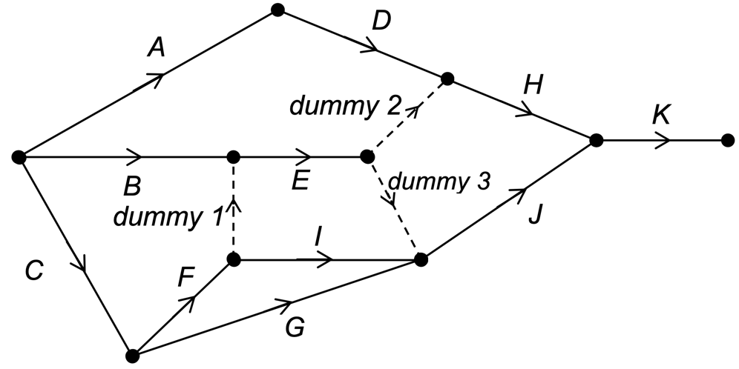
A dummy is required because activity I comes after F but not B.
A second dummy is required because activity H comes after D and E but not I or G.
A third dummy is required because activity J comes after E, I and G but not D.

Module 3 – Geometry and measurement
Question | Answer
1 | C
2 | D
3 | B
4 | B
5 | C
6 | A
7 | A
8 | D

Module 4 – Graphs and relations
Question | Answer
1 | B
2 | D
3 | B
4 | C
5 | D
6 | A
7 | E
8 | A

Question 5
Profit = revenue – cost
2000 > 7.5n – (800 + 3n), gives n > 622.22
The minimum number of smoothies is 623.

Question 6
The relationship between y and x3 is y = x3
Using this relationship, possible points on the curve would be:
x | 2 | 4 | 8
y | 2 | 32 | 128

Question 8
Two steps are required.
Step 1: Determine the time it took for the maximum volume to be reached.
44 + 8x = 12(12 – x), giving x = 5, therefore the maximum volume was achieved after 35 minutes.
Step 2: Use the information that the tank emptied at a rate of 12 litres per minute over a seven-minute period
(42 – 35)
7 $×$ 12 = 84

