2023 VCE Specialist Mathematics 2 (NHT) external assessment report

Specific information

This report provides sample answers or an indication of what answers may have included. Unless otherwise stated, these are not intended to be exemplary or complete responses.

Section A – Multiple-choice questions

| **Question** | **Answer** |
| --- | --- |
| 1 | A |
| 2 | C |
| 3 | E |
| 4 | D |
| 5 | B |
| 6 | E |
| 7 | C |
| 8 | C |
| 9 | D |
| 10 | E |
| 11 | E |
| 12 | C |
| 13 | A |
| 14 | D |
| 15 | B |
| 16 | D |
| 17 | B |
| 18 | A |
| 19 | A |
| 20 | B |

Section B – Extended response questions

Question 1a.



Question 1b.



Question 1c.

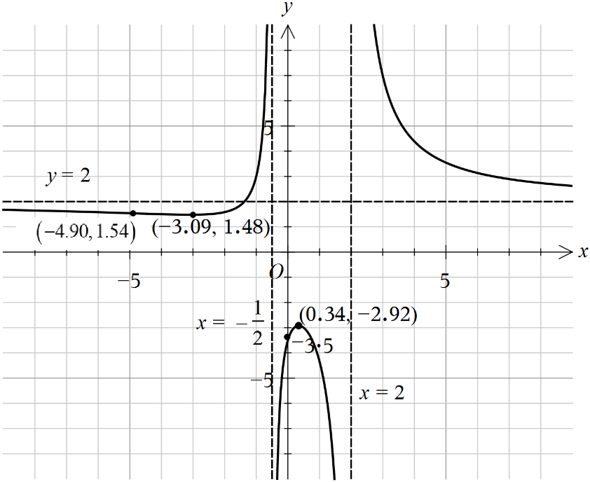

Question 1di.



Question 1dii.



Question 1e.



Question 2a.



Convincing working leading to the given result is required.

Other intercept is at 

Question 2b.

The diagram below shows the solutions to Question 2b. (the upper circle) and Question 2e. (the lower circle).

##### 

Question 2c.



Question 2d.



Question 2e.

Refer to the diagram in Question 2b.

Question 3a.



Convincing working out leading to the given result was required.

Question 3b.

Distance travelled over the first 4 seconds 



Question 3c.

Reflection in the vertical axis: 

followed by

translation 13 units to the right: 

Question 3d.



Accept 

Question 4a.



Question 4b.

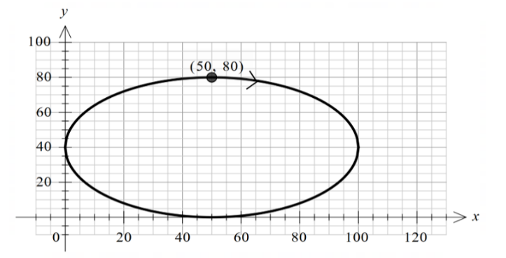

Both the starting point and the direction needed to be shown for full marks.

Question 4ci.

##### (m)

Question 4cii.



Question 4di.



Question 4dii.

Maximum speed is 50 (m/min) which occurs at  and .

Question 4e.



Question 5ai.

Question 5aii.



Question 5b.

##### 

Question 5ci.



Question 5cii.



Maximum height

Question 5ciii.

Vertical:



Required speed

Question 6a.



Question 6bi.



Question 6bii.



Question 6ci.

The diagram below shows the solutions to Question 6ci. (curve) and Question 6cii. (shading).

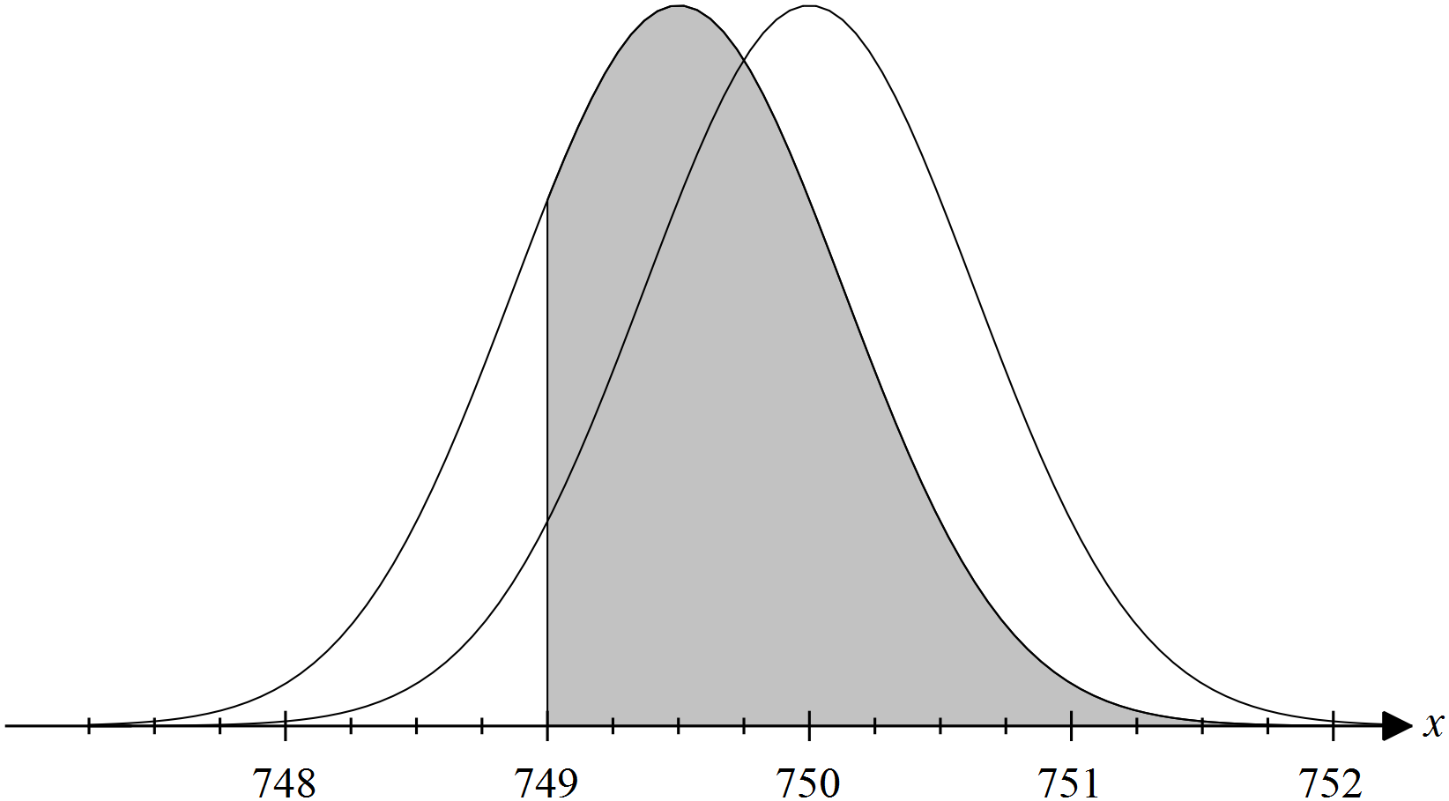

Question 6cii.

Refer to the diagram in Question 6ci.

Question 6d.



Question 6ei.



Question 6eii.

 sample supports rejection of claimed mean

(mean is less than 750 ml)

Question 6f.

