General Mathematics Exam 2 – MA073

2024 VCE Assessment Guide

VCAA Marking Policies and Procedures

Consistency of Marking
The Assessment Guide indicates the basis for awarding marks for each item. This may involve either counting correct answers/features of a response or marking holistically, whereby making a judgement about the overall quality/qualities of a response.
Assessment Guides will demonstrate how marks are to be awarded for a response, not where or how marks are to be deducted. The Assessment Guide will address specific examples and relevant application where appropriate. The following provides a checklist that all assessors should follow for consistent approaches to marking VCE external examinations.
Assessors should contact the Chief Assessor in cases where they believe that by following any of the directions below, a student will not be marked fairly.
Assessors must use the final version of the Assessment Guide as confirmed at the end of the Assessor Training Meeting.
Concern | Advice
Responses ‘off task’ or contradictory | A response that does not address the subject of the question cannot be awarded any marks.  If contradictory responses are given (i.e.: the response conflicts with earlier comments or working out) full marks cannot be awarded.
Responses not addressed in the Assessment Guide | Assessors should refer the matter to the Chief Assessor for determination.
Spelling | Unless otherwise instructed in the Assessment Guide (i.e.: as part of a criteria), incorrect spelling should not affect the scoring of a student’s response.
Specified Number of Examples/Reasons | Where a student provides more than the required number, the assessor should only assess the required number of responses, and these should be assessed in the order in which they appear.
Working Out | Where a question explicitly requires the student to show working out, and this is specified in the examination instructions or in the question, full marks should be awarded if:  - The response is correct and the working out is correct  - Two sets of working out are shown, both attempts are correct, and the answer is correct  Where a question explicitly requires the student to show working out, partial marks should be awarded for correct completion of key steps required to produce the correct answer.
Consequential Errors | If a question requires a series of argued/sequential steps to arrive at the correct response, the Assessment Guide will allocate marks for the key steps required to produce the correct response.  In these cases, the effect of a consequential error on a subsequent response will be considered.
Half Marks | Half marks must not be awarded for a response or carried over to subsequent questions.
Crossing Out | If a student response has been crossed out, the part crossed out should not be considered. If the entire response is crossed out, this is awarded zero (‘0’).
Modules | Where a student responds to more modules than required, the assessor must assess all responses.
Options | Where a student responds to more than one option, the assessor must assess all responses according to the Assessment Guide and award the student the highest score, indicating the option selected.
Not Attempted vs Zero (0) | Where a student has not made a genuine attempt to respond to the question, assessors should score the response as ‘Not Attempted’. This may include:  - Blank responses  - ‘I don’t know’  - Repeating the question, task, source material, or any other text directly from the examination  - A response with no relevance to the question, i.e.: song lyrics  Where a student has made a genuine attempt to respond to the question, assessors should score the response as ‘0’ (zero) where:  - The student has crossed out their whole response or  - The student’s response does not meet the assessment criteria to be awarded any marks

Student Concern
Occasionally, assessors encounter a response that may raise concerns about the welfare of the student. Examples may include:
- suggestions or claims of abuse or neglect
- indications of distress, self-harm or suicidal tendencies
- threats of violence, harm, or criminal acts involving others.
In such cases, assessors should assess the student work in accordance with the Assessment Guide and send the student script/item to be reviewed according to the instruction on the next page.
Any matter of concern that an assessor believes requires urgent attention should be referred to the VCAA immediately via call to the helpdesk.

Sending student responses to review
During marking assessors may identify student responses to be escalated for review by the Chief Assessor or to be noted by VCAA staff. The review categories are:
Category | Description
Assessment guide | There is confusion of how to mark this item.
Image problem | The item cannot be viewed properly, i.e.: folded page, blurry, etc.
Incomplete student work | The student appears to be missing part of their response or has indicated it continues in another area that is not attached
Incorrect writing task | The item is in the wrong place in marking platform or the student has written in the wrong place, i.e.: response to Q5b is written in Q5a
Student concern | There are concerns for the student’s welfare.
Below is a list of common issues that may arise, and how to respond to these:
Issue | Action
Evidence of student distress or concern.  Note: Student concern does not include unfinished work or work that is off-task. | Assess the student response using the Assessment Guide.  Send the student response for review, selecting the ‘student concern’ review category.
The student’s handwriting is too faint to read, and you are unable to read and score the student response accurately.  Note: Some student responses may include different handwriting or typed responses. This is usually due to Special Examination Arrangements and therefore does not need to be reported to the VCAA. | Make every effort to read the student’s work. If unable to read the response, send the script for review, selecting the ‘illegible response’ review category.
The student’s response appears to be unfinished, or they have indicated their response continues on another page that is not attached. | Refer to the Assessment Guide and score this as the student’s response, and send the student response for review, selecting ‘incomplete student work’ review category.
The control of the mechanics of language is not sufficient to communicate a coherent response. | Refer to the Assessment Guide and score this as the student’s response. You may contact the Chief Assessor for advice on how best to score the response.
Responses in Languages other than English | Unless otherwise stated, responses in a language other than English should not be awarded marks and should be scored zero (0).

Assessment Guide
Data analysis
Q | Guide | Answer | Mark | Additional
1ai | 1996 value | 2.39 m | A1
1aii |  | 50% | A1
1b |  | 0.8 | A1
1c | 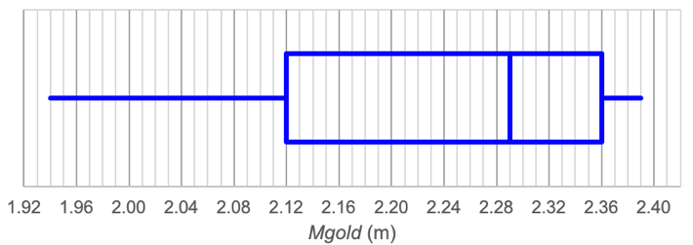 |  | M1  A1 | Complete boxplot with any 3 correct values  ALL values correct on complete boxplot | Min: 1.94  Q1: 2.12  Median: 2.29  Q3: 2.36  Max: 2.39
1d  1d | – 7.97 0.00516 |  | M1  A1 | Evidence of correct “numbers”  FULLY CORRECT
1e | 85.7% of the variation in Mgold can be explained by the variation in year. |  | A1 | ***Accept only 85.7%
2a | Negatively skewed |  | A1 | Accept “negatively skewed with no outliers”
2b | Minimum of one to create a whisker on boxplot | 1 | A1
2ci | IQR = 2.04 – 1.85 = 0.19  Lower fence = 1.85 – 1.5 × 0.19 = 1.565  Upper fence = 2.04 + 1.5 × 0.19 = 2.325 |  | A1 | ***SHOW THAT question  MUST see BOTH fence calculations
2cii | The minimum value is 1.67 and the maximum value is 2.06.  Both these values lie between the lower fence and upper fence so there are NO outliers. |  | A1 | Accept ALL values lie between the fence values.  Accept that NO values lie outside the fence values.

3a | Wbest |  | A1
3b | 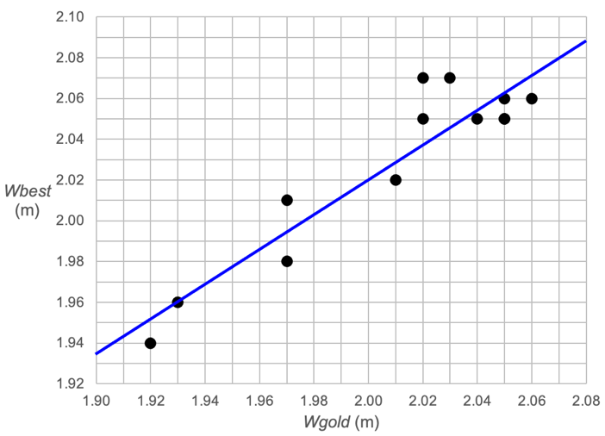 |  | A1 | Edge intercepts.  left side: >1.930, <1.940  right side: >2.08, <= 2.090  Line must cover the range of Wgold values from 1.92 to 2.06 and extrapolate to correct edge intercepts.
3c  3c | r 2 = (0.9318)2 = 0.86825… | 86.8% | A1 | ***Accept only this answer
3d | Strong  Positive |  | A1 | In this order
3e | (On average), for each 1 m increase in Wgold, Wbest increases by 0.860 m |  | A1 | Must be clear reference to the change in both variables
3f | Predicted value = 0.300 + 0.860 × 2.02 = 2.0372  Residual = 2.07 – 2.0372 = 0.0328 |  | M1  A1 | MUST see the predicted value calculation  MUST see residual calculation
3gi | 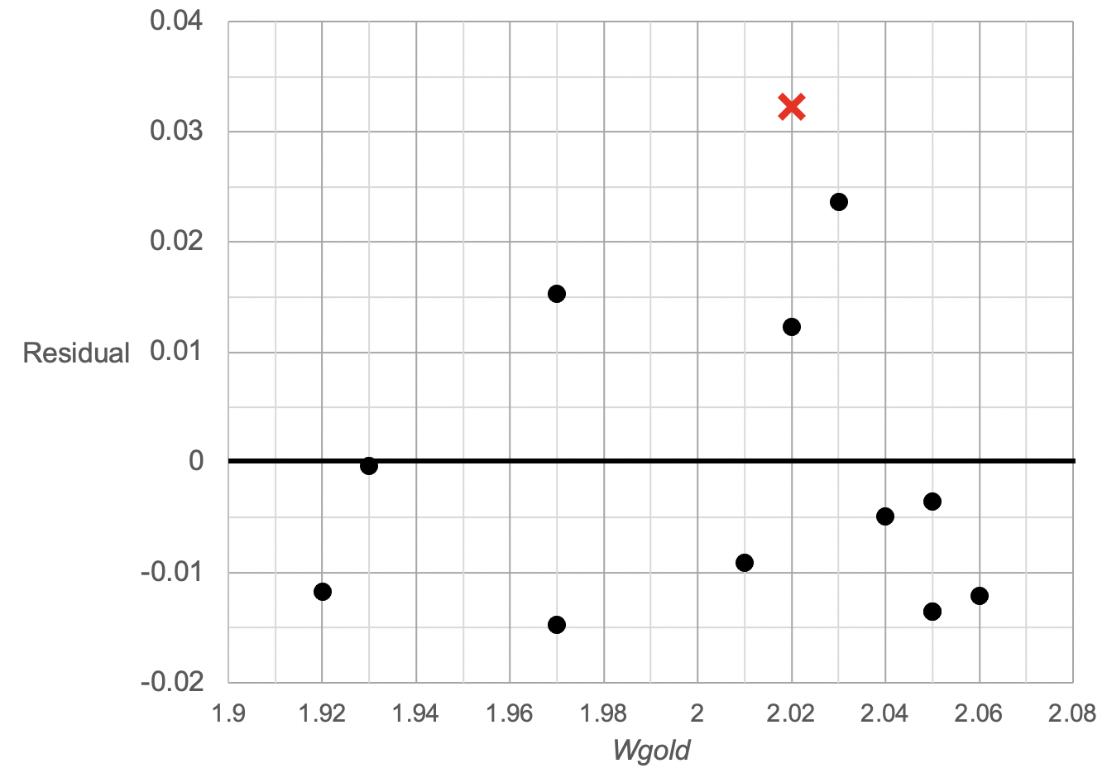 |  | A1 | Actual point is (2.02, 0.0328)  Cross MUST be on the 2.02 m line horizontally  Cross must be ABOVE 0.030 and BELOW 0.035
3gii | Yes, the residual plot shows no clear pattern |  | A1 | MUST say YES, (or implied affirmation)  Accept randomly scattered
3h | extrapolation |  | A1 | 1.90 is outside the data range used to generate the least squares line
4a | 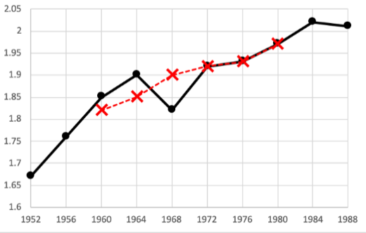 |  | A1 | Last three points MUST be ON TOP of data points  Points must be joined by a dashed line
4b | increasing trend, irregular fluctuations |  | A1 | Accept “upward trend” or “random fluctuations”

Recursion and financial modelling
Q | Guide | Answer | Mark | Additional
5a |  | $60 | A1
5b | $15 000 – 4 × 52 × 60 | $2520 | A1
5c | V0 = 15 000 Vn+1 = Vn – 60 |  | A1
5d |  | 20.8% | A1
6a | (5.07,26) = 4.9503… | 4.95% | A1 | ***Rounding to 2 dp applies
6b | It does not take into account the fortnightly compounding |  | A1
7a  7a | E0 = 300 000  E1 = 1.003 × 300 000.00 – 2159.41 = 298 740.59  E2 = 1.003 × 298 740.59 – 2159.41 = 297 477.40 |  | A1 | ***SHOW THAT question  Show BOTH calculations and final answer is correct
7b | From Finance Solver or Table of values, calculate 180 months | 15 years | A1
7c | (1.003 – 1.000) × 12 × 100 | 3.6% | A1
7d | 0.003 × 300 000 | $900 | A1
8 | N = I% = PV = PMT = FV = P/Y, C/Y = 288 5.3 500000 – 3071.63 0 12 288 5.3 500000 – 3071.63 – 4.1773… 12  Total cost = 288 × $3071.63 + $4.18 | $884 633.62  288 | A1  A1 | *** Rounding to nearest cent applies, providing Finance Solver working shown and additional decimal places shown

Matrices
Q | Guide | Answer | Mark | Additional
9a |  |  | A1
9b |  |  | A1
9c | n = 36  p = 2.5 |  | A1 | Two correct answers
10a |  |  | A1
10b | (1 – 8)2 + 2 × 8 = 49 + 16 | 65 | A1
11ai | 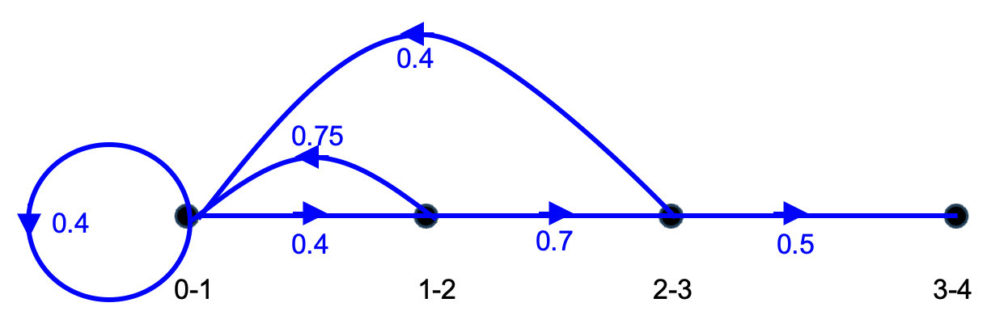 |  | A1 | Accept percentage values  Accept additional edges with zero value
11aii | 0 – 1 1 – 2 2 – 3 3 – 4  initial 70 80 90 40  1 year 124 28 56 45 |  | A1
11b | 131 < 0.5 × 280 | 5 | A1
12a | No. foremen = 43  % decrease = | 14% | A1
12b | Tn×S2023, (for very large n) gives 390 as having left, | 0 | A1
12c | , extra staff = 190 – 89 | 101 | A1
12d | No. foremen in 2027 = 200.54 | 2027 | A1 | Accept fourth year or four years

Networks and decision mathematics
Q | Guide | Answer | Mark | Additional
13a | 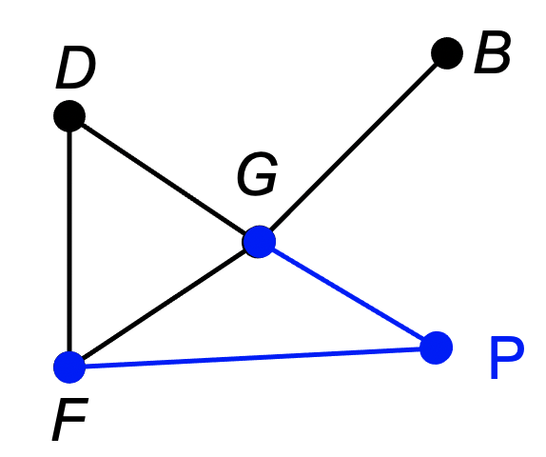 |  | A1 | MUST see two edges and vertex labelled as P.
13bi | P – F – D – G – B | Bakery | A1 | Accept B
13bii | Hamiltonian path |  | A1 | Accept Hamilton path
13c | 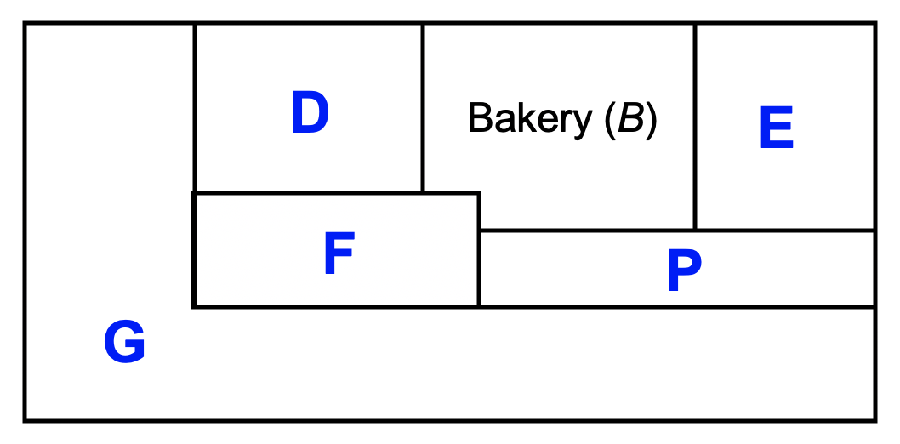 |  | A1
14a | 13 + 18 + 6 + 9 | 46 | A1
14b | Minimum cut = 13 + 5 + 11 + 8 | 37 | A1
14c | R S |  | A1 | This pair in either order
15a | A – C – H – J |  | A1
15b | E can be delayed by 3 weeks | E | A1
15c | 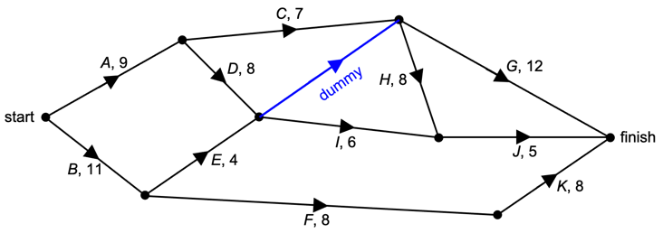 |  | A1 | MUST have correct arrow  Line can be solid or dashed  Label as "dummy" or "d" or “D’ “ or “d’ “.
15d | New critical path is  A – D – H – J | 30 weeks | A1
15e | Activities reduced (weeks):  A (– 2), D (– 1), H (– 1), B (– 1)  Total cost = 5 × $10 000 | $50 000 | A1

