2024 VCE General Mathematics 2 external assessment report

General comments
Students were required to attempt four compulsory sections:
- Data analysis (24 marks)
- Recursion and financial modelling (12 marks)
- Matrices (12 marks)
- Networks and decision mathematics (12 marks).
A formula sheet is provided with the examination. Students should familiarise themselves with this formula sheet well before the examination. Students should bring a ruler to accurately draw straight lines. This is often required in the Data analysis section.
Students should ensure that their responses can be clearly read as scanned images are used for assessing. Students are urged to take great care with the presentation of their responses and to write in a dark colour (for example, blue or black pen or 2B pencil) so they are readable when scanned.
With regards to rounding, the instructions section at the beginning of the examination clearly states that ‘In all questions where a numerical answer is required, you should only round your answer when instructed to do so.’ Students often rounded when an exact answer should have been given. For example, in Question 1e the percentage quoted needed to be 85.7% not 86%.
Students need to be careful that if they provide additional information in their response, it must be correct. For example, in Question 15b only the activity E needed to be written to attract the mark. If the response also included the delayed time correctly as 3 hours, then the mark was still awarded. However, where a student further engaged to provide an incorrect delay time in their response, the mark was not awarded.
Students should read the question carefully, and accept as correct what is specified in the question. For example, in Question 3h some students claimed the prediction would be reliable, despite the question indicating otherwise.
Another example of the importance of reading carefully was in Question 8, with ‘the final repayment amount being slightly different from all the other repayments’. Some students incorrectly used 289 payments to find a final payment of $4.20 (not slightly different) and a total cost of $885 633.64.
Students are strongly encouraged to read the question again after writing their final answer, and consider the following:
- Has the question been fully answered?
- Does the answer match the value provided in a ‘show that ‘question?
- Is the answer reasonable in a practical context?
Students are advised not to write sentences when a numerical answer is asked for. For example, in Question 1a.ii an answer of 50% was sufficient to attract the mark. There was no need to write ‘50% of the Mgold values are greater than 2.25 m’. Similarly, if a variable is defined (such as Wgold), then there is no need to refer to the variable as ‘the gold medal-winning height for the women’s high jump’.
Transcription errors were often seen, and students should take care copying from one line to the next or from their CAS.
In two questions students were required to provide a label on a diagram. This direction meant that the label needed to be drawn on the diagram as indicated.
Students need to be precise when marking a point on a grid. For example, Question 3b required the point (1.9, 1.934). Some students were not as precise as they needed to be when placing 1.934 in the first half of the grid between 1.93 and 1.94.
For questions requiring written responses (rather than calculations or numerical values), it is acceptable to provide written responses in point form. There are many examples of suitable responses in past exams that students can use as exemplars.
Overall, students need to be very clear on the key knowledge and key skills contained in the VCE Mathematics Study Design 2023-2027 for General Mathematics, and to use the formal terminology within the course. For example, Question 4b asked for qualitative features of a time series plot. The possible features are all clearly named within the study design.

Specific information
Note: This report provides sample answers or an indication of what answers may have included. Unless otherwise stated, these are not intended to be exemplary or complete responses.
The statistics in this report may be subject to rounding, resulting in a total more or less than 100 per cent.

Data analysis

Question 1a.i.
Marks | 0 | 1 | Average
% | 4 | 96 | 1.0
2.39 m

Question 1a.ii.
Marks | 0 | 1 | Average
% | 23 | 77 | 0.8
50%
54.54% was the most common response due to the inclusion of 2.25.

Question 1b.
Marks | 0 | 1 | Average
% | 16 | 84 | 0.9

Question 1c.
Marks | 0 | 1 | 2 | Average
% | 6 | 17 | 76 | 1.7

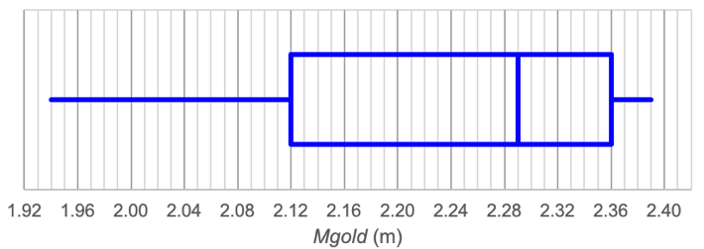
Min: 1.94
Q1: 2.12
Median: 2.29
Q3: 2.36
Max: 2.39
Students who drew a complete boxplot with at least three of the values correct were awarded one mark.

Question 1d.
Marks | 0 | 1 | 2 | Average
% | 35 | 26 | 39 | 1.0
−7.97
0.00516
Significant figures remain a challenge and many students were not able to interpret values from their calculator that were written using exponent notation (5.16E-3).

Question 1e.
Marks | 0 | 1 | Average
% | 48 | 52 | 0.5
85.7% of the variation in Mgold can be explained by the variation in year.
Some students did not reference the variation in both variables. Some rounded to 86% in a question where rounding did not apply.

Question 2a.
Marks | 0 | 1 | Average
% | 14 | 86 | 0.9
Negatively skewed.
It was acceptable to include the absence of outliers.

Question 2b.
Marks | 0 | 1 | Average
% | 97 | 3 | 0.1
1
Students did not recognise that only 1 value is needed to extend the whisker beyond the IQR. The emphasis on ‘smallest’ in the question was overlooked, with most students writing the height of 1.67 m. The question asked for the number of heights, not an actual height.

Question 2c.i.
Marks | 0 | 1 | Average
% | 16 | 84 | 0.9
IQR = 2.04 − 1.85 = 0.19
Lower fence = 1.85 − 1.5 × 0.19 = 1.565
Upper fence = 2.04 + 1.5 × 0.19 = 2.325
This question was generally well done.

Question 2c.ii.
Marks | 0 | 1 | Average
% | 24 | 76 | 0.8
The minimum value is 1.67 and the maximum value is 2.06.
Both these values lie between the lower fence and upper fence so there are no outliers.
Some students did not clearly explain the conditions for an outlier because they tried to combine their explanations for both fences into one, which resulted in a mathematically incorrect statement.

Question 3a.
Marks | 0 | 1 | Average
% | 10 | 90 | 0.9
Wbest

Question 3b.
Marks | 0 | 1 | Average
% | 49 | 51 | 0.5

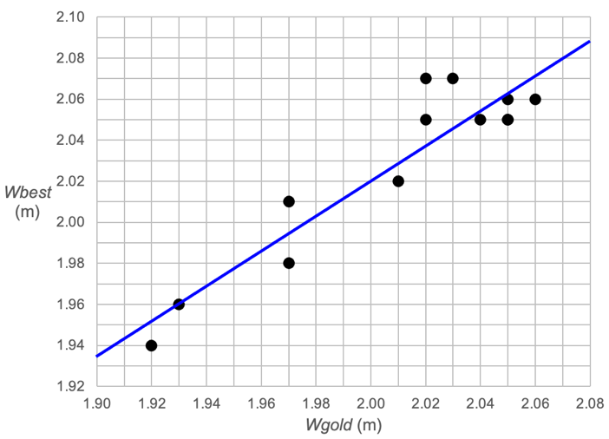
Some students who plotted two points correctly were not as accurate as they needed to be when drawing the line. Some students seem to be drawing a line by eye rather than calculating appropriate points to plot in order to get an accurate line.

Question 3c.
Marks | 0 | 1 | Average
% | 43 | 57 | 0.6
86.8%

Question 3d.
Marks | 0 | 1 | Average
% | 22 | 78 | 0.8

Strong
Positive
Some students wrote the strength as moderate.

Question 3e.
Marks | 0 | 1 | Average
% | 46 | 54 | 0.6
On average, for each 1 metre increase in Wgold, Wbest increases by 0.86 metres.
Students did not always reference the change in each of the two variables.

Question 3f.
Marks | 0 | 1 | 2 | Average
% | 46 | 12 | 42 | 1.0
Predicted value = 0.30 + 0.86 × 2.02 = 2.0372
Residual = 2.07 − 2.0372 = 0.0328

Question 3g.i.
Marks | 0 | 1 | Average
% | 53 | 47 | 0.5

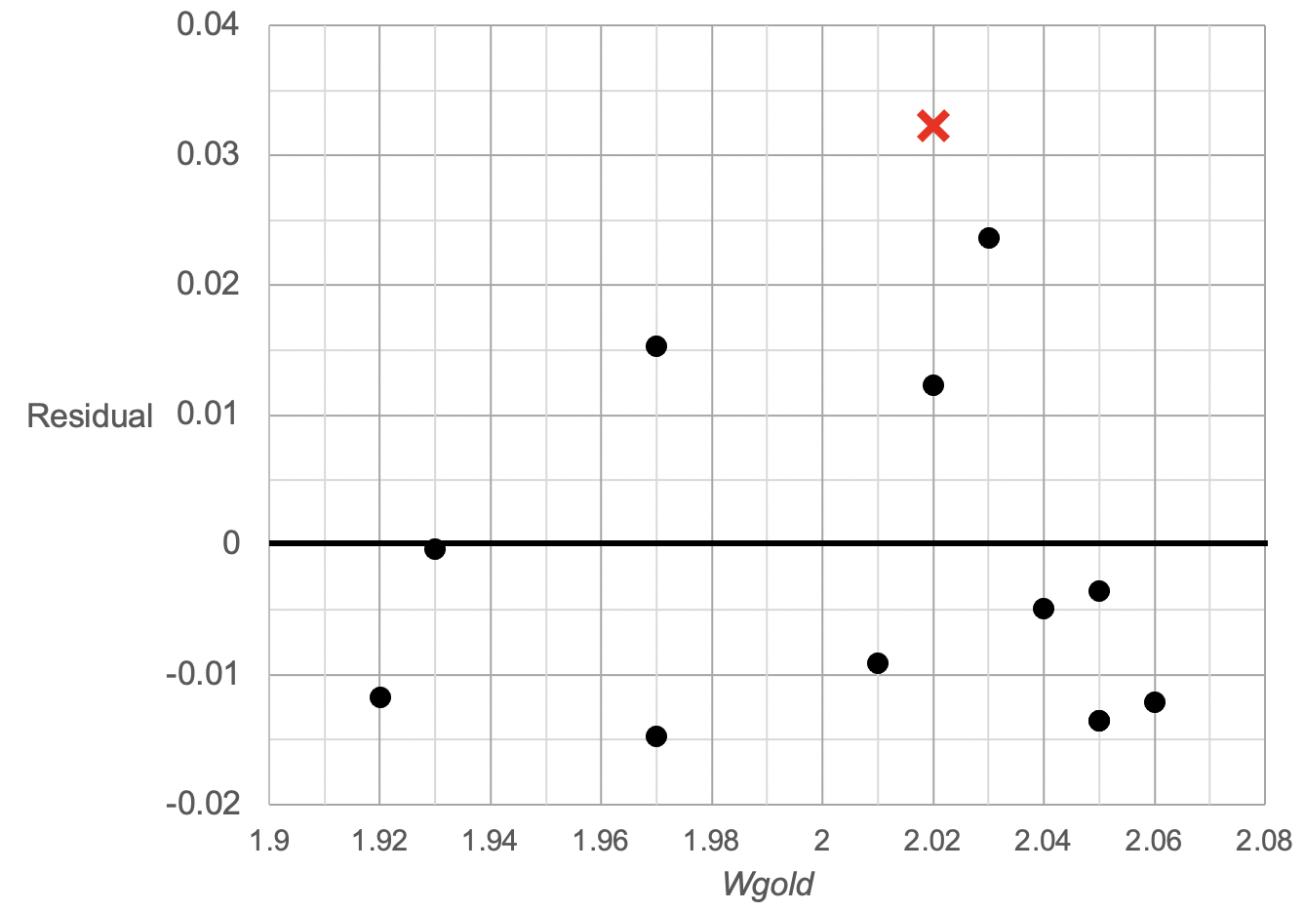
The actual point is (2.02,0.0328).
Some students did not understand the connection between a scatterplot and a residual plot.

Question 3g.ii.
Marks | 0 | 1 | Average
% | 60 | 40 | 0.4
Yes, the residual plot shows no clear pattern.
It was acceptable to say the residuals were randomly scattered. The number of points above and below the line was irrelevant. Some students asserted that the prediction was reliable, despite the question indicating it was not.

Question 3h.
Marks | 0 | 1 | Average
% | 50 | 50 | 0.5
Extrapolation: 1.90 is outside the data range used to generate the least squares line.
While predictions from a regression line focus on the response variable, their effectiveness as interpolation or extrapolation comes from the explanatory variable.
It was not appropriate to refer to either 1964 or 1.934 as being outside the data range.

Question 4a.
Marks | 0 | 1 | Average
% | 45 | 55 | 0.6

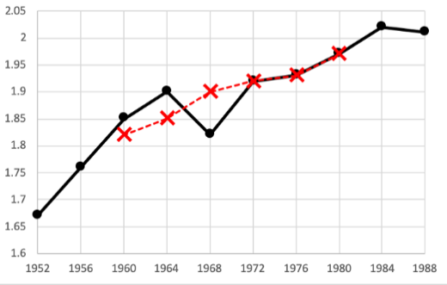

This question was answered more successfuly than previous similar questions.

Question 4b.
Marks | 0 | 1 | Average
% | 76 | 24 | 0.3
Increasing trend and irregular fluctuations.
There was no evidence of an outlier, of seasonality or of structural change. Some students erroneously referred to ‘an irregular fluctuation’. It should be noted that irregular fluctuations are present in all time series plots.

Recursion and financial modelling

Question 5a.
Marks | 0 | 1 | Average
% | 13 | 87 | 0.9
$60

Question 5b.
Marks | 0 | 1 | Average
% | 28 | 72 | 0.7
$2520
$14760 was a common incorrect answer, with some students not accounting for 52 weeks per year.

Question 5c.
Marks | 0 | 1 | Average
% | 41 | 59 | 0.6
Some students incorrectly included an ‘’ on the end of the recurrence relation.

Question 5d.
Marks | 0 | 1 | Average
% | 58 | 42 | 0.4
20.8%
A weekly interest rate of 0.4% was a common incorrect response.

Question 6a.
Marks | 0 | 1 | Average
% | 50 | 51 | 0.5
4.95%

Question 6b.
Marks | 0 | 1 | Average
% | 74 | 26 | 0.3
It does not take into account the fortnightly compounding.
This question was not answered well. Many students had some understanding of the effective interest rate and could even define it, but could not explain in simple terms why the nominal rate was lower.

Question 7a.
Marks | 0 | 1 | Average
% | 51 | 49 | 0.5
E₀ = 300 000
E₁ = 1.003 × 300 000.00 − 2159.41 = 298 740.59
E₂ = 1.003 × 298 740.59 − 2159.41 = 297 477.401 = $297 477.40
Note that an answer of $297 477.4 is not correct to the nearest cent.

Question 7b.
Marks | 0 | 1 | Average
% | 58 | 42 | 0.4
15 years

Question 7c.
Marks | 0 | 1 | Average
% | 44 | 56 | 0.6
3.6%

Question 7d.
Marks | 0 | 1 | Average
% | 53 | 47 | 0.5
$900

Question 8
Marks | 0 | 1 | 2 | Average
% | 55 | 31 | 13 | 0.6
Total cost = $884 633.62
Number of payments = 288
Finance solver entries
N =  I% =  PV =  PMT =  FV =  P/Y, C/Y = | 288  5.3  500000  − 3071.63  0  12 | 288  5.3  500000  − 3071.63  − 4.1773…  12
Many students found the 288 but left the total cost blank. Some students misunderstood the meaning of the total cost of the loan.

Matrices

Question 9a.
Marks | 0 | 1 | Average
% | 12 | 88 | 0.9

Question 9b.
Marks | 0 | 1 | Average
% | 22 | 78 | 0.8
Some had the first matrix correct but an incorrect product.

Question 9c.
Marks | 0 | 1 | Average
% | 30 | 70 | 0.7

Question 10a.
Marks | 0 | 1 | Average
% | 46 | 54 | 0.6
Many students were unable to demonstrate an understanding of the matrix row-column nomenclature used in the question.

Question 10b.
Marks | 0 | 1 | Average
% | 50 | 50 | 0.5
65
Some students who were successful in part a were unable to complete part b, even though the same rule applied.

Question 11a.i.
Marks | 0 | 1 | Average
% | 76 | 24 | 0.3

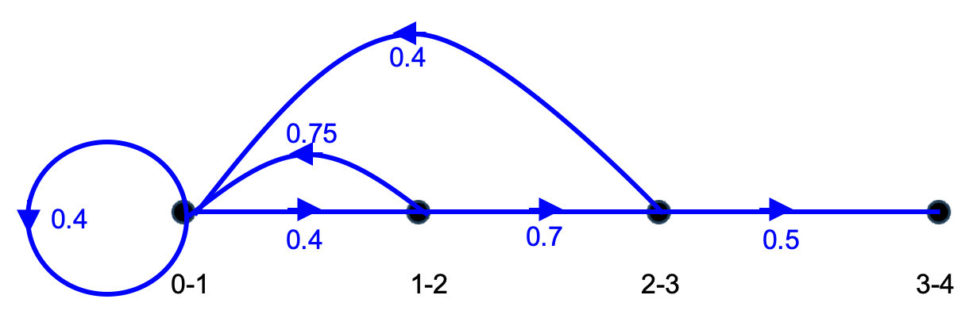
This question was not well answered. All edges required arrows otherwise it is no longer a directed graph.

Question 11a.ii.
Marks | 0 | 1 | Average
% | 39 | 61 | 0.6

 | Age group
 | 0 – 1 | 1 – 2 | 2 – 3 | 3 – 4
Initial population | 70 | 80 | 90 | 40
Population after one year | 124 | 28 | 56 | 45
Many students had all values correct.

Question 11b.
Marks | 0 | 1 | Average
% | 61 | 39 | 0.4
5 years

Question 12a.
Marks | 0 | 1 | Average
% | 75 | 25 | 0.3
14%

Question 12b.
Marks | 0 | 1 | Average
% | 76 | 24 | 0.3
0
Students who recognised that the 1 in the transition matrix would result in an absorbing state performed well on this question.

Question 12c.
Marks | 0 | 1 | Average
% | 88 | 12 | 0.1
101
Some students did not subtract the departed workers and answered 190.

Question 12d.
Marks | 0 | 1 | Average
% | 74 | 26 | 0.3
2027
The fourth year was also an acceptable answer.

Networks and decision mathematics

Question 13a.
Marks | 0 | 1 | Average
% | 12 | 88 | 0.9

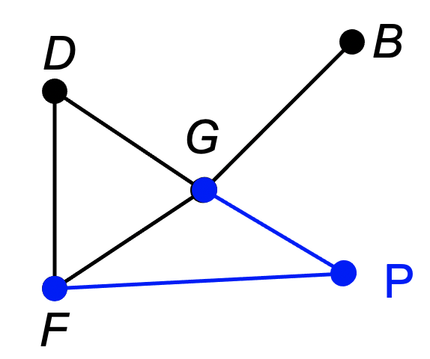

Question 13b.i.
Marks | 0 | 1 | Average
% | 12 | 88 | 0.9
Bakery

Question 13b.ii.
Marks | 0 | 1 | Average
% | 25 | 75 | 0.8
Hamiltonian path
A significant number of students incorrectly wrote ‘path’ only.

Question 13c.
Marks | 0 | 1 | Average
% | 20 | 80 | 0.8

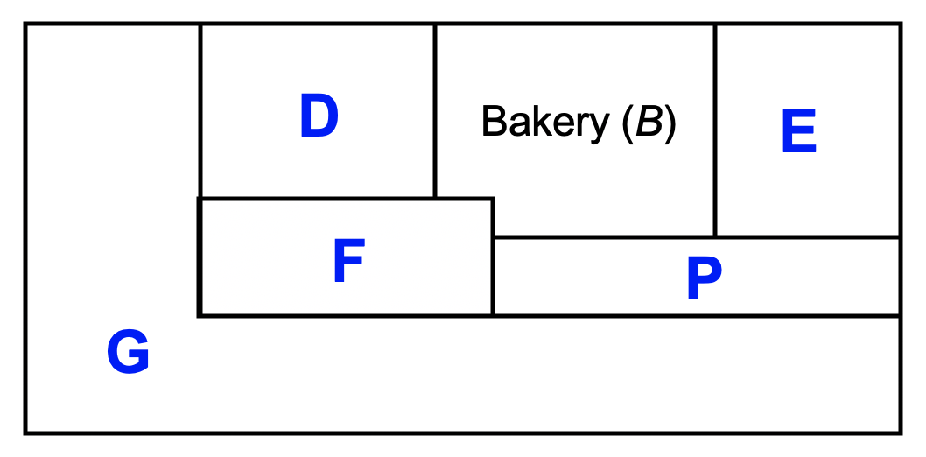
A good proportion of students answered this question successfully.

Question 14a.
Marks | 0 | 1 | Average
% | 22 | 78 | 0.8
46

Question 14b.
Marks | 0 | 1 | Average
% | 71 | 29 | 0.3
37
Some students used a minimum cut, others an exhaustion of paths.

Question 14c.
Marks | 0 | 1 | Average
% | 78 | 22 | 0.2
R
S
This question was not answered well, with many other alternative pairs given by students.

Question 15a.
Marks | 0 | 1 | Average
% | 35 | 65 | 0.7
A – C – H – J

Question 15b.
Marks | 0 | 1 | Average
% | 66 | 34 | 0.4
E

Question 15c.
Marks | 0 | 1 | Average
% | 90 | 10 | 0.1

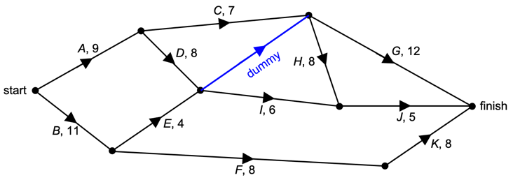

The dummy was often drawn without an arrow or label.
A dashed or solid line was acceptable.

Question 15d.
Marks | 0 | 1 | Average
% | 73 | 27 | 0.3
30

Question 15e.
Marks | 0 | 1 | Average
% | 93 | 7 | 0.1
$50 000

