Specialist Mathematics Exam 1 – MA092

2024 VCE Assessment Guide

VCAA Marking Policies and Procedures

Consistency of Marking

The Assessment Guide indicates the basis for awarding marks for each item. This may involve either counting correct answers/features of a response or marking holistically, whereby making a judgement about the overall quality/qualities of a response.

Assessment Guides will demonstrate how marks are to be awarded for a response, not where or how marks are to be deducted. The Assessment Guide will address specific examples and relevant application where appropriate. The following provides a checklist that all assessors should follow for consistent approaches to marking VCE external examinations.

Assessors should contact the Chief Assessor in cases where they believe that by following any of the directions below, a student will not be marked fairly.

Assessors must use the final version of the Assessment Guide as confirmed at the end of the Assessor Training Meeting.

|  |  |
| --- | --- |
| Concern | Advice |
| **Responses ‘off task’ or contradictory** | A response that does not address the subject of the question cannot be awarded any marks.  If contradictory responses are given (i.e.: the response conflicts with earlier comments or working out) full marks cannot be awarded. |
| **Responses not addressed in the Assessment Guide** | Assessors should refer the matter to the Chief Assessor for determination. |
| **Spelling** | Unless otherwise instructed in the Assessment Guide (i.e.: as part of a criteria), incorrect spelling should not affect the scoring of a student’s response. |
| **Specified Number of Examples/Reasons** | Where a student provides more than the required number, the assessor should only assess the required number of responses, and these should be assessed in the order in which they appear. |
| **Working Out** | Where a question explicitly requires the student to show working out, and this is specified in the examination instructions or in the question, full marks should be awarded if:   * The response is correct and the working out is correct * Two sets of working out are shown, both attempts are correct, and the answer is correct   Where a question explicitly requires the student to show working out, partial marks should be awarded for correct completion of key steps required to produce the correct answer. |
| **Consequential Errors** | If a question requires a series of argued/sequential steps to arrive at the correct response, the Assessment Guide will allocate marks for the key steps required to produce the correct response.  In these cases, the effect of a consequential error on a subsequent response will be considered. |
| **Half Marks** | Half marks must not be awarded for a response or carried over to subsequent questions. |
| **Crossing Out** | If a student response has been crossed out, the part crossed out should not be considered. |
| **Modules** | Where a student responds to more modules than required, the assessor must assess all responses. |
| **Options** | Where a student responds to more than one option, the assessor must assess all responses according to the Assessment Guide and award the student the highest score, indicating the option selected. |
| **Not Attempted vs Zero (0)** | Where a student has **not made a genuine attempt** to respond to the question, assessors should score the response as ‘Not Attempted’. This may include:   * Blank responses * ‘I don’t know’ * Repeating the question, task, source material, or any other text directly from the examination * A response with no relevance to the question, i.e.: song lyrics   Where a student has made a genuine attempt to respond to the question, assessors should score the response as ‘0’ (zero) where:   * The student has crossed out their whole response or * The student’s response does not meet the assessment criteria to be awarded any marks |

Student Concern

Occasionally, assessors encounter a response that may raise concerns about the welfare of the student. Examples may include:

* suggestions or claims of abuse or neglect
* indications of distress, self-harm or suicidal tendencies
* threats of violence, harm, or criminal acts involving others.

In such cases, assessors should assess the student work in accordance with the Assessment Guide and send the student script/item to be reviewed according to the instruction on the next page.

**Any matter of concern that an assessor believes requires urgent attention should be referred to the VCAA immediately via call to the helpdesk.**

Sending student responses to review

During marking assessors may identify student responses to be escalated for review by the Chief Assessor or to be noted by VCAA staff. The review categories are:

|  |  |
| --- | --- |
| Category | Description |
| **Illegible response** | You are unable to read the student’s response. |
| **Incomplete student work** | The student appears to be missing part of their response or has indicated it continues in another area that is not attached as an attachment. |
| Possible connection to student | You recognise the student’s work. Please provide details. |
| Student concern | There is evidence of student distress. |
| Technical Issue (VOSS Helpdesk) | You are not able to continue scoring this exam or item due to a technical issue. Only use this category if you have contacted VOSS support on 1800 820 122. |

Below is a list of common issues that may arise, and how to respond to these:

|  |  |
| --- | --- |
| Issue | Action |
| Evidence of student distress or concern.  Note:  Student concern does not include unfinished work or work that is off-task. | Assess the student response using the Assessment Guide.  Send the student response for review, selecting the ‘student concern’ review category. |
| The student’s handwriting is too faint to read, and you are unable to read and score the student response accurately.  **Note:** Some student responses may include different handwriting or typed responses. This is usually due to Special Examination Arrangements and therefore does not need to be reported to the VCAA. | Make every effort to read the student’s work. If unable to read the response, send the script for review, selecting the ‘illegible response’ review category. |
| The student’s response appears to be unfinished, or they have indicated their response continues on another page that is not attached. | Refer to the Assessment Guide and score this as the student’s response, and send the student response for review, selecting ‘incomplete student work’ review category. |
| The control of the mechanics of language is not sufficient to communicate a coherent response. | Refer to the Assessment Guide and score this as the student’s response. You may contact the Chief Assessor for advice on how best to score the response. |
| Responses in Languages other than English | Unless otherwise stated, responses in a language other than English should not be awarded marks and should be scored zero (0). |

Marking Guide

Question 1 (4 marks)

**a.**  A1 or factorise

**b.**  M1 factorised or divide by , don’t need = 0

May use factorized form from 1(a)



 A1 (must state all solutions)

Don’t award final mark unless an equation =0 presented

**c.**  A1 correctly plotted. Labels not required

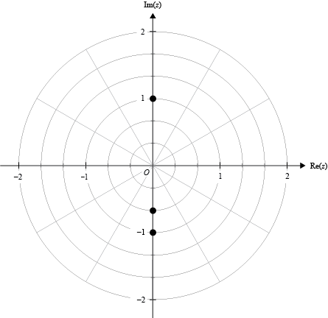

Question 2 (3 marks)

Let  where . M1 (specify  not required)

 M1 substitution.





 which is even A1* answer given

Question 3 (6 marks)

**a.** 

 Must see some correct working

, ,  A1 (there are other methods)

**b.** 

M1 or used quotient rule, might isolate numerator = 0, OR correct reasoning.





Turning point  A1 answer only no working 1 out of 2

**c.** Asymptotes and intercepts **must be labelled with equations and coordinates**

A1 (must have a curve that passes through  and )

Shape LHS:

A1 (top . Lower left , correct asymptotic behaviour)

Shape RHS:

A1(correct TP and intercept, asymptotic behaviour, must have 1st A1)

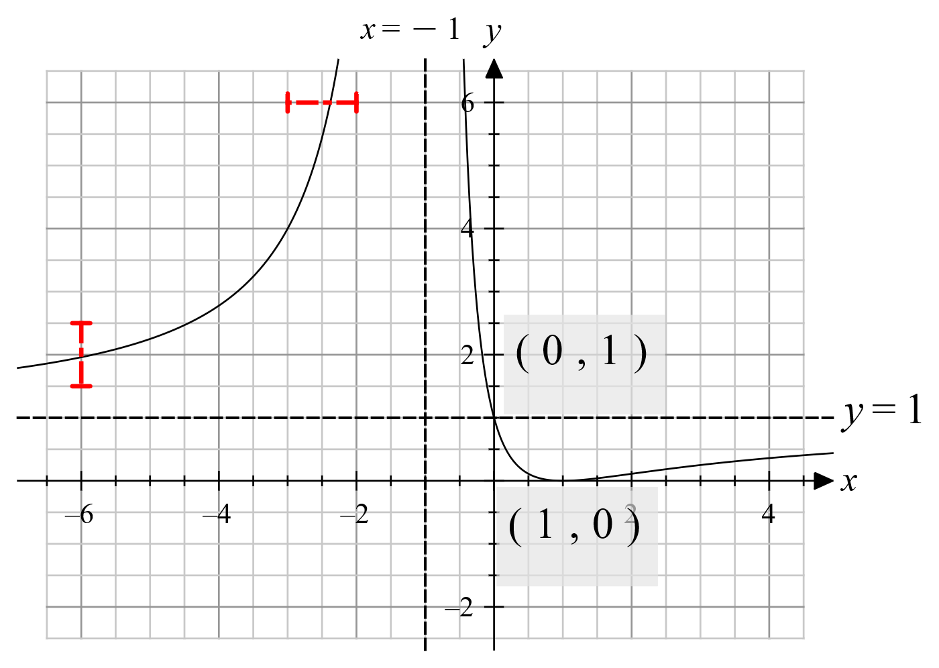

Question 4 (4 marks)

**a.**  M1 attempt dot products **and** norms

 or  A1 reject other angles such as ,  etc.

**b.** 

 M1 (attempt cross product **and** length)

 A1 need both

Question 5 (3 marks)

 M1 (**must** see terminals,  or equivalent, allow one of missing , )



 A1 (with or without , their correct expression in terms of *k*)



 A1* ans. given, working needed

Question 6 (5 marks)

**a.** 



  A1 for both correct (ignore units)

**b.** 



 M1 (must see square of 10, 20, 15)



 or  or  A1 (ignore units)

**c.** Let 



 A1 for both correct, may be implied in their working

(OR standard deviation )





 A1correct to two decimal places, decimal form only

**Don’t award final answer mark here unless first mark is awarded**

Note:



Question 7 (4 marks)

,  M1 separate out *dx*, *dy*



 M1 substitution (can be implied)

 A1 (finding correct )



 A1

Alternatively

**OR**

M1 separate

M1 integrating to get *w*^2, sqrt(*v*^2+1), allow ± error

A1 if their ‘c’ is correct, need different variable in limit

A1 as above



Question 8 (4 marks)

**a.**  M1 product rule. Allow , allow minor slips

Must have zero RHS, 4 parts, 2 instances of 



 as  A1* answer given, must see factorisation, need M1 above

**b.** 

 M1 substitute. into original equation, OR 



Therefore, the points are (1, 1) and (−1, −1). A1 both in coordinates, NOT (±1, ±1), allow *x=*…*y=*…

Note: Answer only no working - award 1 out of 2 marks; any extra 1 out of 2 marks

Question 9 (4 marks)

**a.**  to be fined. (Implied)

At ,  OR 

So yes. A1 with explanation

**b.** 

M1 (Use of **correct** acceleration equivalent and attempt differentiating, allow ½ missing,  etc,

must see , OR use  with )

 **or** 

A1 for **correct** acceleration or equivalent

When ,  A1

Alternatively

Note for 1st M1: 



A1 correctly differentiating 

Then A1 for sub in  to get 

Question 10 (3 marks)

Let , 

, 

 A1 (compute cross product, negative is fine, might see *λ*, *μ*)

 Allow no tildas; allow column/row matrix, triple form

Distance: 

H1 (norm not required, 4+5*m*, their , must see correct )





 A1 for both correct