2024 VCE Specialist Mathematics 2 external assessment report

General comments

The 2024 VCE Specialist Mathematics Examination 2 comprised 20 multiple-choice questions (worth a total of 20 marks) and six extended questions (worth a total of 60 marks). Students were permitted the use of an approved CAS technology and access to a single bound reference.

To ensure their work is clearly visible when scanned, students should write using a pen or a dark lead pencil. Additionally, legible handwriting is crucial; several responses were difficult to read.

Students should note some key instructions for the examination generally:

* Answers must be left in exact form unless a specific number of decimal places is required.
* Students must carefully read the questions and ensure their answers comply with the stated conditions.
* The number of marks allocated to a question indicates the level of detail required in the response. Answers without supporting work will not earn method marks.

The examination highlighted both strengths and weaknesses in student performance. Some areas of strength were:

* identifying asymptotes and demonstrating asymptotic behaviour
* solving problems involving complex numbers
* applying statistical methods.

Areas of weakness were:

* producing accurate graphs
* reading and responding to questions with precision.

Specific information

This report provides sample answers or an indication of what answers may have included. Unless otherwise stated, these are not intended to be exemplary or complete responses.

The statistics in this report may be subject to rounding, resulting in a total more or less than 100 per cent.

Section A – Multiple-choice questions

The table indicates the percentage of students who chose each option. Grey shading indicates the correct response.

|  |  |  |  |  |  |  |
| --- | --- | --- | --- | --- | --- | --- |
| Question | Correct Answer | % A | % B | % C | % D | Comments |
| **1** | C | 20 | 3 | **72** | 6 | Asked for contrapositive – therefore, switch the hypothesis and the conclusion and negate both. |
| **2** | A | **48** | 10 | 4 | 37 |  |
| **3** | C | 13 | 11 | **70** | 6 | Solving  assuming no cancellation yields . For no turning points we require  so . If  or  then  cancels to a linear function which also has no turning points. |
| **4** | A | **27** | 23 | 38 | 10 | Take positive root since  so |
| **5** | C | 13 | 13 | **70** | 4 |  |
| **6** | D | 12 | 6 | 5 | **77** |  |
| **7** | C | 7 | 15 | **72** | 6 |  |
| **8** | C | 7 | 23 | **60** | 9 | Solve  for |
| **9** | A | **45** | 11 | 29 | 14 | Since  for . |
| **10** | A | **74** | 9 | 15 | 2 |  |
| **11** | B | 13 | **58** | 12 | 16 |  |
| **12** | C | 5 | 30 | **50** | 13 |  |
| **13** | B | 4 | **81** | 10 | 4 | Let the two vectors be  and . |
| **14** | B | 14 | **36** | 33 | 17 | Vector resolute of  in the direction of  so  hence .  Scalar resolute or  in the direction of . |
| **15** | A | **36** | 12 | 44 | 8 | The motion has period . Starting at  at , after visiting  at  and  at , the body returns to  at . |
| **16** | A | **43** | 30 | 19 | 7 | is the only solution. |
| **17** | B | 8 | **58** | 28 | 6 |  |
| **18** | D | 8 | 9 | 14 | **68** |  |
| **19** | A | **68** | 8 | 8 | 15 |  |
| **20** | B | 9 | **48** | 25 | 17 |  |

Section B

Question 1a.

| Mark | 0 | 1 | 2 | 3 | Average |
| --- | --- | --- | --- | --- | --- |
| % | 2 | 16 | 65 | 17 | 2.0 |

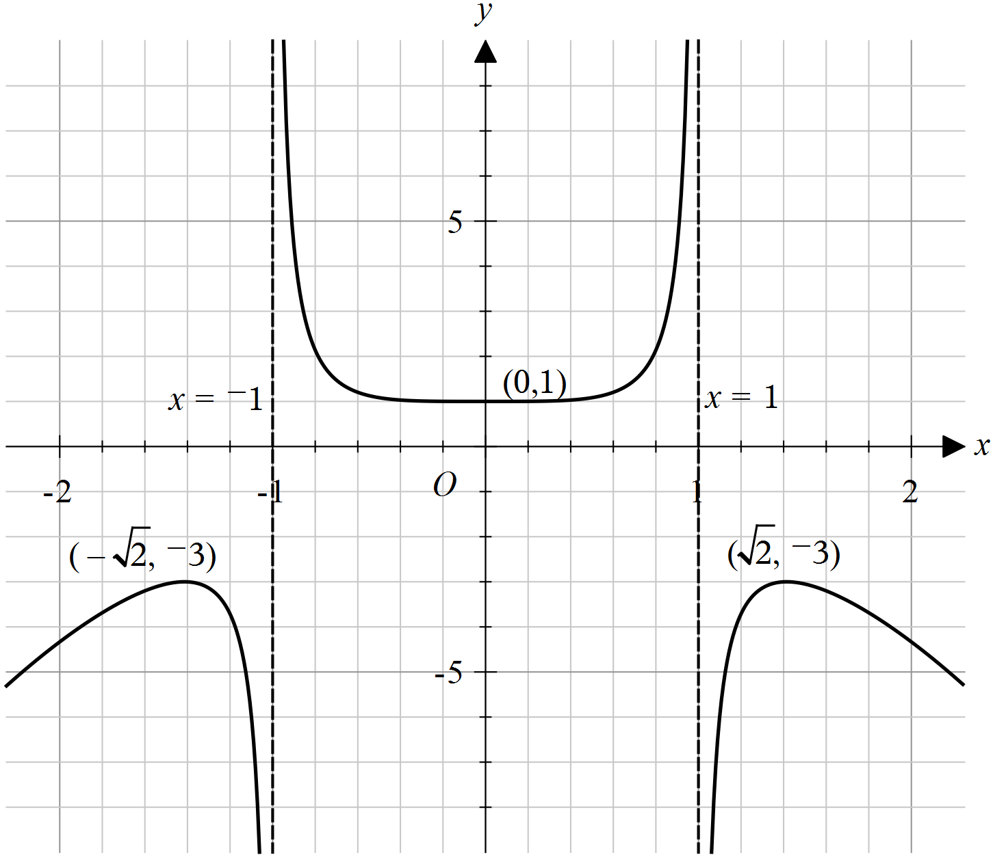

* Many students did not draw this graph accurately. To improve accuracy, students can sketch the function on their CAS calculator and set the domain, range and scale to match those provided in the question.
* The graph must be flatter near the **-intercept, with turning points and end points precisely positioned.
* Students generally succeeded in drawing and labelling the asymptotes and demonstrated asymptotic behaviour effectively.

Question 1b.i.

| Mark | 0 | 1 | 2 | Average |
| --- | --- | --- | --- | --- |
| % | 22 | 22 | 56 | 1.4 |



* Students were expected to write an expression for  within the definite integral instead of stating the generic formula.
* Many students made transcription errors when transferring their answer from their CAS to the script.

Question 1b.ii.

| Mark | 0 | 1 | Average |
| --- | --- | --- | --- |
| % | 44 | 56 | 0.6 |

11.2

Success in part i generally resulted in an accurate answer in this part.

Question 1c.

| Mark | 0 | 1 | Average |
| --- | --- | --- | --- |
| % | 28 | 72 | 0.7 |

Since polynomial division yields  there are no asymptotes precisely when ,

i.e.



Question 1d.i.

| Mark | 0 | 1 | Average |
| --- | --- | --- | --- |
| % | 73 | 27 | 0.3 |

Since g’(0) = 0 $,$ to obtain only one stationary point, there must be no solutions to 

so  (numerator never zero) or  (LHS simplifies to 1). Hence



Of those students who attempted this part, the most frequent incorrect response was .

Question 1d.ii.

| Mark | 0 | 1 | Average |
| --- | --- | --- | --- |
| % | 73 | 27 | 0.3 |

Three stationary points are found when  has precisely two nonzero real solutions.

From above, . We have  so  and .

We must have  to obtain only two nonzero real solutions, i.e.



Many students did not include the equality sign.

Question 1d.iii.

| Mark | 0 | 1 | Average |
| --- | --- | --- | --- |
| % | 75 | 25 | 0.3 |

Five stationary points are found when  has four nonzero real solutions, i.e. all four

possibilities for  are nonzero and real. This happens when  and , i.e.



Question 2a.

| Mark | 0 | 1 | 2 | Average |
| --- | --- | --- | --- | --- |
| % | 13 | 24 | 63 | 1.5 |

The given equation is equivalent to , by collecting real and imaginary components, which simplifies to , or . Writing  in terms of  yields



Alternatively, the line of points equidistance from  and  is their perpendicular bisector.

The line joining  and  has gradient , so their perpendicular bisector has gradient  and

passes through  i.e. . Thus it has equation  where ,

i.e. .

* This question part was generally answered well.
* Some students did not provide sufficient working to gain both marks.
* Several students made sign errors when substituting into the distance formula.
* Students who used the perpendicular bisector method mostly found the gradient correctly. However, some of those students did not correctly use the coordinates of the midpoint to find the equation.

Question 2b.

| Mark | 0 | 1 | 2 | Average |
| --- | --- | --- | --- | --- |
| % | 30 | 26 | 44 | 1.2 |

The centre of the circle is the midpoint of the diameter so .

The radius is half the length of the diameter, .

So the circle has equation



* Students who showed working to find the midpoint and diameter usually answered the question successfully.
* Some students did not divide the diameter by 2 to find the radius.
* Several students did not use the midpoint formula accurately to find the centre of the circle.

Question 2c.

| Mark | 0 | 1 | 2 | Average |
| --- | --- | --- | --- | --- |
| % | 9 | 17 | 74 | 1.7 |

To find imaginary axis intercepts, let  so ,

hence  and .

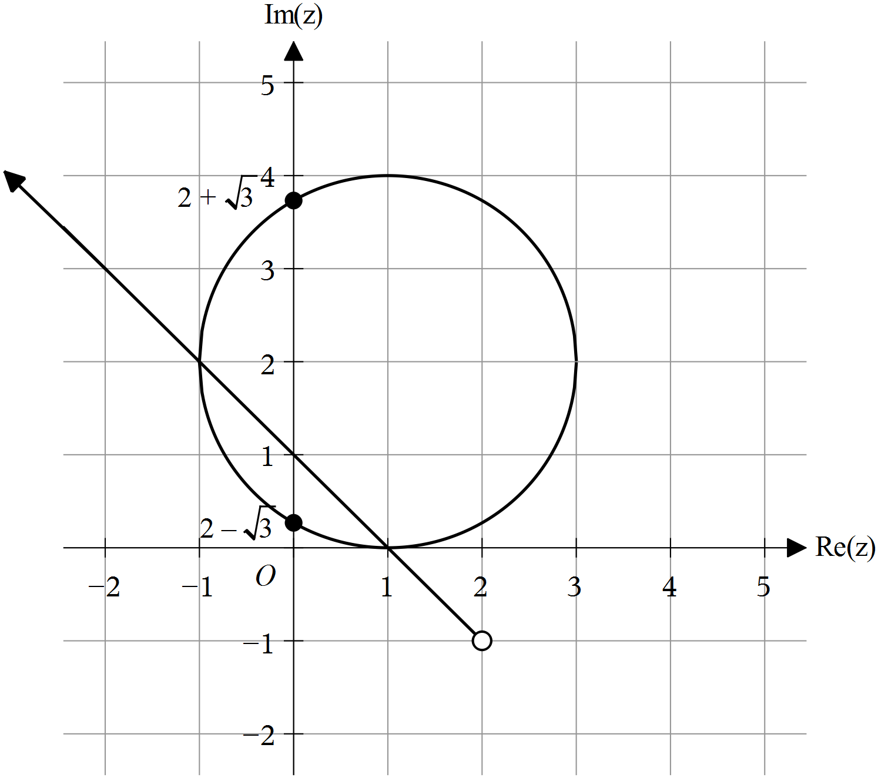

* Students should be mindful that the circle should be drawn smoothly through the four extreme points and should not have a pointed shape.
* Most students correctly labelled the imaginary axis intercepts.

Question 2d.i.

| Mark | 0 | 1 | Average |
| --- | --- | --- | --- |
| % | 41 | 59 | 0.6 |

The position of the ray was generally well done.

Question 2d.ii.

| Mark | 0 | 1 | Average |
| --- | --- | --- | --- |
| % | 44 | 56 | 0.6 |



Most students who were successful in part d.i were able to find the correct equation for the ray.

The most common error was to quote the argument as .

Question 2e.

| Mark | 0 | 1 | 2 | Average |
| --- | --- | --- | --- | --- |
| % | 27 | 21 | 52 | 1.3 |

As the circle has radius  and the minor segment has angle , its area is ,

so



Most students were successful when applying the area formula of a segment. Some students used the incorrect angle.

Question 3a.

| Mark | 0 | 1 | Average |
| --- | --- | --- | --- |
| % | 24 | 76 | 0.8 |

The maximum rate occurs when , so ,

so as  then , at which time  cubic metres per day.

 (cubic metres per day) when 

Question 3b.

| Mark | 0 | 1 | 2 | 3 | Average |
| --- | --- | --- | --- | --- | --- |
| % | 35 | 11 | 17 | 37 | 1.6 |

Let  be the radius in metres, so  and hence .

When  we have .

Also substituting  we obtain  which yields 



* Students who recognised this as a related rates question managed this well.
* Some students did not convert the depth measurement to metres.

Question 3c.i.

| Mark | 0 | 1 | Average |
| --- | --- | --- | --- |
| % | 39 | 61 | 0.6 |

We have  t and , so  and 



Question 3c.ii.

| Mark | 0 | 1 | Average |
| --- | --- | --- | --- |
| % | 45 | 55 | 0.6 |





Students must be careful to write their answers in the required form.

Question 3d.

| Mark | 0 | 1 | 2 | Average |
| --- | --- | --- | --- | --- |
| % | 73 | 10 | 17 | 0.5 |

Since volume = surface area , surface area is given by .

As  the surface area approaches .

181.38

* Many students skipped this question without making an attempt to answer it.
* As the depth of the pond is constant, the surface area can be found by dividing the volume by the depth.

Question 3e.

| Mark | 0 | 1 | 2 | Average |
| --- | --- | --- | --- | --- |
| % | 79 | 17 | 4 | 0.3 |



* Many students skipped this question without attempting to answer it.
* The most common error was not taking the 5-day delay into account.

Question 4a.

| Mark | 0 | 1 | Average |
| --- | --- | --- | --- |
| % | 22 | 78 | 0.8 |



A ‘show that’ question requires logical steps set out to indicate how the solution could be found. In this case an appropriate trigonometric identity like  needed to be used.

Question 4b.

| Mark | 0 | 1 | 2 | Average |
| --- | --- | --- | --- | --- |
| % | 36 | 22 | 41 | 1.0 |

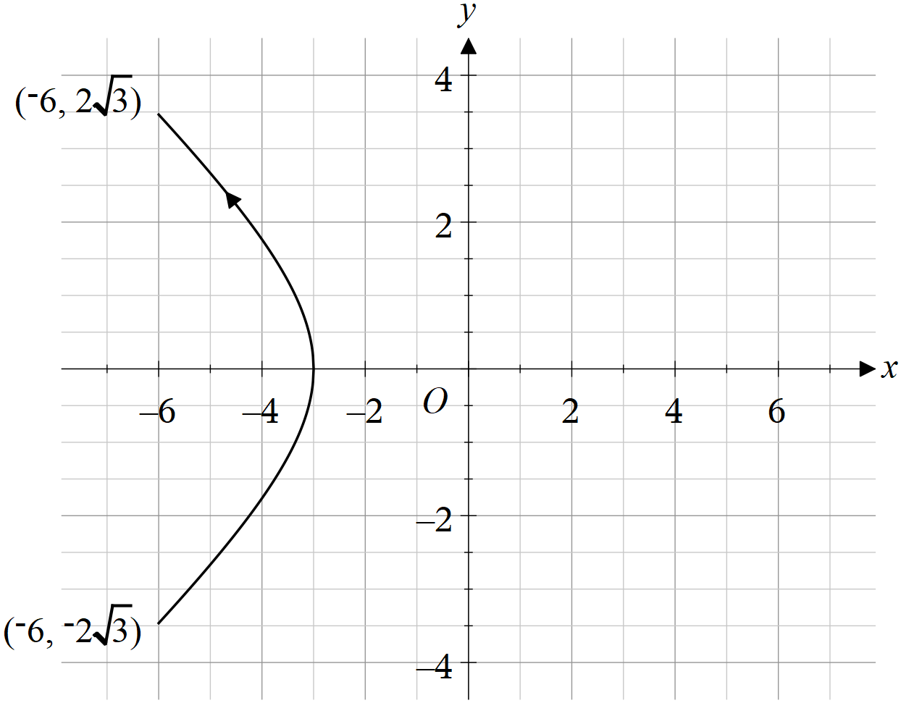

* Students often did not draw this graph well, and it was often not symmetrical over the -axis.
* Negative signs were often left off the coordinates of the end points.
* The direction of the path of the yacht was often left out or in the wrong direction.

Question 4c.i.

| Mark | 0 | 1 | Average |
| --- | --- | --- | --- |
| % | 77 | 23 | 0.3 |

 so 



* Many students did not answer in terms of .
* Several students did not find the square of the speed, but left the answer as a velocity or speed.

Question 4c.ii.

| Mark | 0 | 1 | Average |
| --- | --- | --- | --- |
| % | 39 | 61 | 0.6 |

Differentiating the expression for speed squared from the previous part yields

. The term in brackets is always positive,

and  for  only when , the first derivative test shows it is a minimum.



Some students did not answer in exact form.

Question 4c.iii.

| Mark | 0 | 1 | Average |
| --- | --- | --- | --- |
| % | 52 | 48 | 0.5 |

Substituting  gives speed squared as , so speed is 2 m/min.

2

The common error was that some students forgot to take the square root of the square of the speed.

Question 4c.iv.

| Mark | 0 | 1 | Average |
| --- | --- | --- | --- |
| % | 46 | 54 | 0.6 |





Common errors were due to mistakes such as reversing the coordinates or forgetting the negative sign.

Question 4d.i.

| Mark | 0 | 1 | Average |
| --- | --- | --- | --- |
| % | 39 | 61 | 0.6 |



This question was answered well; however, students need to be careful to use brackets appropriately.

Question 4d.ii.

| Mark | 0 | 1 | Average |
| --- | --- | --- | --- |
| % | 43 | 57 | 0.6 |



Question 4e.

| Mark | 0 | 1 | 2 | Average |
| --- | --- | --- | --- | --- |
| % | 65 | 10 | 24 | 0.6 |

The distance is given by .

Numerically minimising over  gives



This question part was often not attempted. Students who found the correct expression for the distance were generally able to progress.

Question 5a.

| Mark | 0 | 1 | Average |
| --- | --- | --- | --- |
| % | 45 | 55 | 0.6 |

Many correct answers exist, including:

 and 

Some students did not use the correct notation. A common error was to write the vector  rather than the vector equation of the line.

Question 5b.

| Mark | 0 | 1 | 2 | 3 | Average |
| --- | --- | --- | --- | --- | --- |
| % | 26 | 11 | 13 | 50 | 1.9 |



* Students used many different techniques to solve this problem.
* Some students used the wrong line equation, using their answer to part a rather than the one given.

Question 5c.

| Mark | 0 | 1 | 2 | 3 | Average |
| --- | --- | --- | --- | --- | --- |
| % | 15 | 3 | 15 | 67 | 2.4 |



Most students answered this question very well. Students should be aware that their CAS technology can help them find cross products accurately.

Question 5d.i.

| Mark | 0 | 1 | Average |
| --- | --- | --- | --- |
| % | 37 | 63 | 0.7 |

, , 

Question 5d.ii.

| Mark | 0 | 1 | 2 | Average |
| --- | --- | --- | --- | --- |
| % | 44 | 10 | 46 | 1.0 |



Common errors were:

* incorrectly determining the spanning vectors
* omitting the division of the cross product by 2 to find the area
* incorrectly assuming the triangle was either isosceles or right-angled.

Question 6a.

| Mark | 0 | 1 | Average |
| --- | --- | --- | --- |
| % | 9 | 91 | 0.9 |

, 

Question 6b.i.

| Mark | 0 | 1 | Average |
| --- | --- | --- | --- |
| % | 15 | 85 | 0.9 |

Sample mean has standard deviation , so *p*-value = 



Some students did not divide the standard deviation by 3 to account for the sample size.

Question 6b.ii.

| Mark | 0 | 1 | Average |
| --- | --- | --- | --- |
| % | 25 | 75 | 0.8 |

, so pause the machine

This question was generally well done; however, some students did not fully answer the question regarding whether or not the machine should be paused.

Question 6c.

| Mark | 0 | 1 | 2 | Average |
| --- | --- | --- | --- | --- |
| % | 45 | 11 | 44 | 1.0 |

Letting  be the sample mean, the null hypothesis will be rejected when  where

, i.e. , so .

Thus the probability of type II error is 

0.31

Common errors were:

* students sometimes did not find the critical value for when  is true
* students used the wrong tail.

Question 6d.

| Mark | 0 | 1 | Average |
| --- | --- | --- | --- |
| % | 42 | 58 | 0.6 |

The sample mean has mean 1000 and standard deviation 

Solve  and  numerically.

, 

Question 6e.

| Mark | 0 | 1 | Average |
| --- | --- | --- | --- |
| % | 18 | 82 | 0.8 |

95% confidence interval 



Question 6f.

| Mark | 0 | 1 | Average |
| --- | --- | --- | --- |
| % | 49 | 51 | 0.5 |

38

Some students incorrectly used 50 rather than 40 as the number of samples.

Question 6g.

| Mark | 0 | 1 | Average |
| --- | --- | --- | --- |
| % | 54 | 46 | 0.5 |

The confidence interval extends  each side of the mean, so solve .

This yields . As  is an integer, then .

62