2024 VCE Mathematical Methods 1 (NHT) external assessment report

Specific information

This report provides sample answers or an indication of what answers may have included. Unless otherwise stated, these are not intended to be exemplary or complete responses.

Question 1a.

This question involved using the product and chain rules for differentiation. The answer was required to be presented in a factorised form.



Question 1b.

This question involved using either the quotient or product rule for differentiation. Some students did not evaluate the derivative at 



Question 2a.

There were multiple methods that could be employed to approach this question.

The simultaneous linear equations, as they appeared on the examination, are referred to here as E1 and E2:

 E1

 E2

Method 1 – Elimination

 Eqn1

 Eqn2 (formed by )

Eqn1 – Eqn2



Method 2 – Substitution

 Eqn1

 Eqn2

Substitute Eqn2 into Eqn1



Method 3 – Equate gradients/y-intercepts/equating y equations

 Eqn1

 Eqn2

 



Equate coefficients or isolateto get equations as above

Method 4 – Matrix







Method 5 – Ratios



Question 2b.

To exclude values from an interval a backslash \ is needed together with set brackets for the particular values. Curved brackets, as in, changes the meaning of the answer.



Question 2c.



Question 3a.



Question 3b.

Asymptotes should be marked in as dashed or dotted lines and labelled with their equation. Graph lines should be smooth, single stroke constructions and display appropriate asymptotic behaviour. The base of a logarithm needs to be given, as  without a base, has a different meaning to .

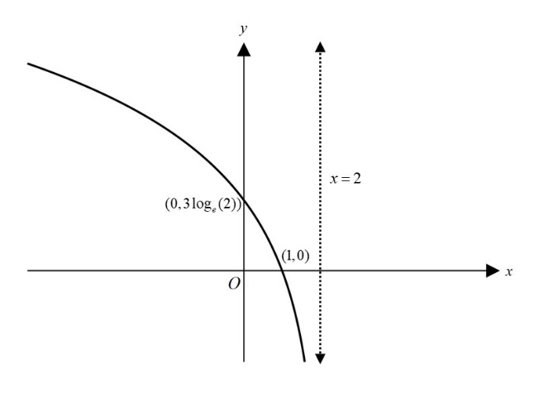

Question 3c.



Question 4a.



 is defined for 





Question 4b.



Question 5a.

The formula for standard deviation is on the formula sheet.



Question 5b.

This question required finding the probability beyond one standard deviation from the mean.



Question 6a.

The formula for finding area using the trapezium rule approximation is on the formula sheet.



Or using three trapezia

Area 

Question 6b.

This question required that calculus be used.



Left hand side gives



Question 7a.



Question 7b.

This question involved setting up and calculating a conditional probability.



Question 8a.

The formula sheet gives the rule.



Question 8b.

The average value of a function for an interval is defined as.



Question 9a.



Question 9b.

In any order, the transformations are:

* Reflection in the *x*-axis
* Dilation from the *x*-axis by a factor of
* Translation in the positive *x*-direction of 1 unit.

Question 9c.

This question was a ‘show that’ question. As such, each line of working needed to demonstrate a clear, logical and explicit progression, leading to the answer.



Question 9d.

This question involved forming the equation of the tangent line and then constructing an integral to find the area of the region bounded by the tangent line, the curve and the line

It was helpful to use the fact that , as established in part 9c., and thus 



Therefore using  gives

The equation of the tangent line is

The area of the region bounded by the tangent line, the curve and the line is:

