2024 VCE Specialist Mathematics 2 (NHT) external assessment report

Specific information

This report provides sample answers or an indication of what answers may have included. Unless otherwise stated, these are not intended to be exemplary or complete responses.

Section A – Multiple-choice questions

| **Question** | **Correct answer** |
| --- | --- |
| 1 | C |
| 2 | E |
| 3 | E |
| 4 | D |
| 5 | A |
| 6 | D |
| 7 | E |
| 8 | B |
| 9 | A |
| 10 | C |
| 11 | D |
| 12 | E |
| 13 | B |
| 14 | B |
| 15 | D |
| 16 | D |
| 17 | A |
| 18 | B |
| 19 | C |
| 20 | A |

Section B – Extended response questions

Question 1a.

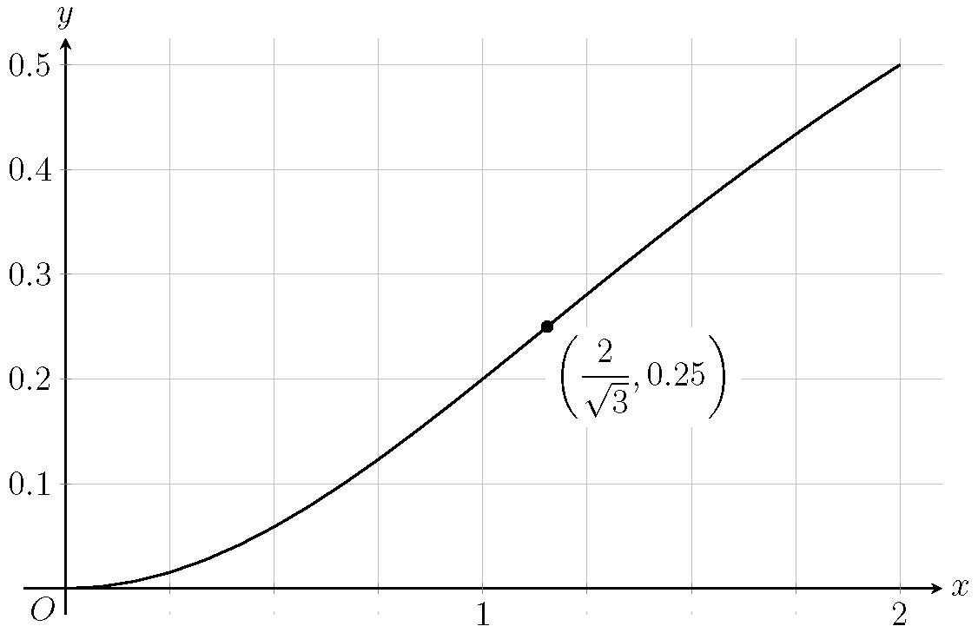

Question 1bi.



Question 1bii.



Question 1c.



Question 1d.



Question 2a.



Question 2b.



Question 2c.



Question 2d.

Point plotted.

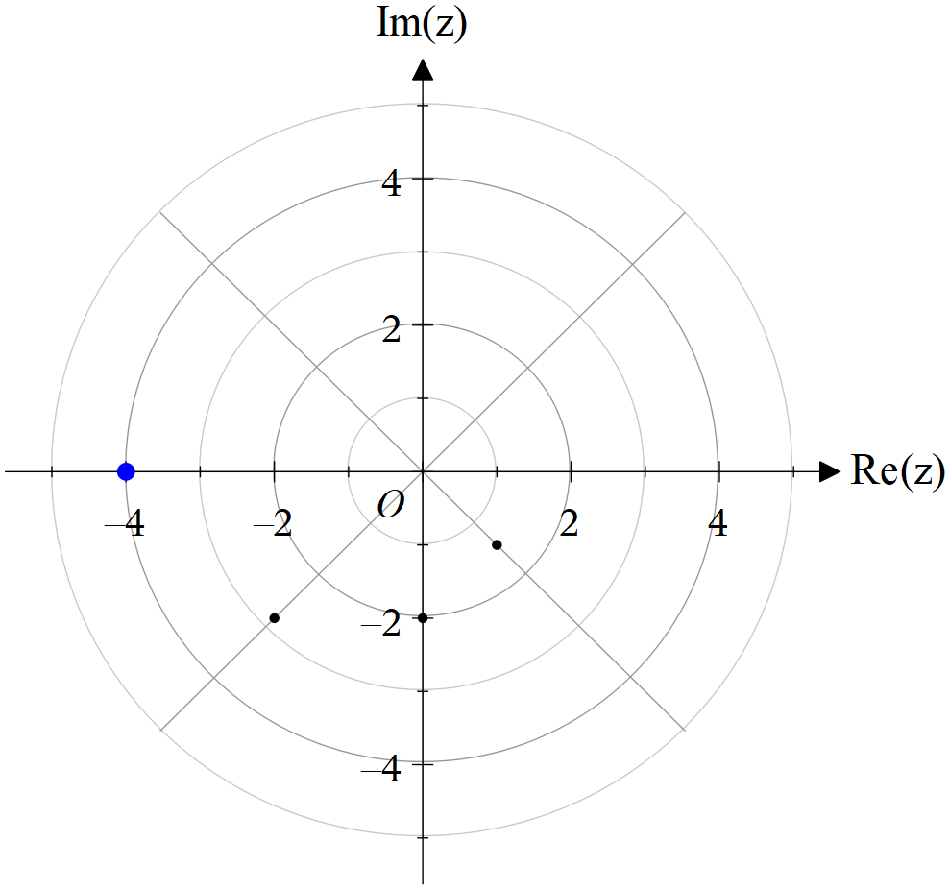

Question 2e.



Question 2f.



Question 2g.



Question 3a.



Question 3bi.



Question 3bii.



Question 3c.

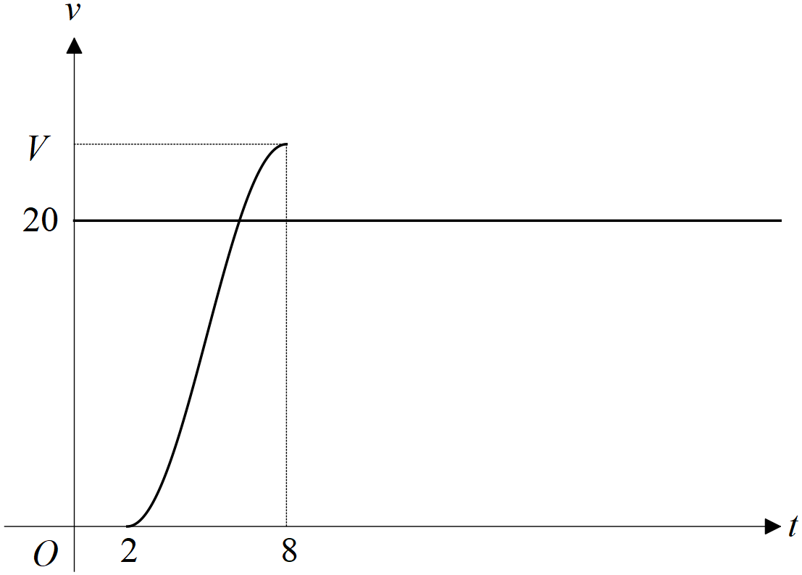

Question 3d.



Question 3e.



Question 3f.



Question 3g.



Question 4ai.



Question 4aii.



Question 4b.



Question 4c.



Question 4d.



Question 4e.



Question 5a.



Other combinations of vectors are suitable. Other correct approaches could include determining magnitudes of vectors, cross product or scalar product.

Question 5b.



Question 5c.



Question 5d.



Question 6a.



Question 6b.



Question 6c.



Question 6di.



Question 6dii.

****reject 

(mean is greater than 0.37)

Question 6e.



Question 6f.

