2021 VCE Product Design and Technology external assessment report

General comments
The 2021 VCE Product Design and Technology exam was based on the VCE Product Design and Technology Study Design 2018–2023.
Areas of strength included:
- understanding of one potential end-user and context of DOC sofa bed
- using the information, including photos provided in the stimulus material
- positive and negatives of
- low and high-volume manufacturing
- planned obsolescence for producer and consumer
- environmental issues
- safety precautions for a tool, piece of equipment or a machine
- how a finished product meets end-user needs
- a majority of students attempted to answer all questions.
Areas for improvement included:
- students unnecessarily rewriting the question
- poor quality of writing and drawing equipment, particularly using pens rather than ‘coloured’ pencils/water-based markers to render the design option drawing
- indecipherable/illegible handwriting
- inadequate knowledge of
- the product design process
- production processes to construct a product
- parameters of the user-centred design factor
- design elements from the visual, tactile and aesthetic product design factor
- sustainability models, systems or strategies
- quality measures and monitoring of production processes.
- emphasising the importance of students to use the 15-minute reading time to read all questions and consider their responses during this time; this is very pertinent for questions that are linked, where students need to refer to their answer to one question when responding to another, such as in Questions 5a. and 6a. in Section B.

Specific information
Note: Student responses reproduced in this report have not been corrected for grammar, spelling or factual information.
This report provides sample answers or an indication of what answers may have included. Unless otherwise stated, these are not intended to be exemplary or complete responses.
The statistics in this report may be subject to rounding resulting in a total more or less than 100 per cent.

Section A

Question 1a.
Mark | 0 | 1 | 2 | Average
% | 1 | 6 | 93 | 1.9
Most students were able to answer this question correctly. Examples of an end user of the DOC sofa included, but were not limited to:
- university students
- children/teenagers
- people who live in a small apartment / have a spare room
- people living alone
- people with long- or short-term rental accommodation
- schools or organisations with dormitories.

Question 1b.
Mark | 0 | 1 | 2 | 3 | 4 | Average
% | 21 | 7 | 18 | 13 | 41 | 2.5
Students were expected to demonstrate their knowledge of the product design process by naming two steps each with an explanation of their goal. Many students were confused between the stages and steps in the product design process and could explain some goals of the stage but could not recall the names of the steps. A large number talked about the aims of the DOC sofa bed, which did not score.
The following is an example of a high-scoring response.
Design brief – a statement which includes all the information about the end user. The problem to be solved and the intended functionality of the piece.
Research – To look into the primary and secondary sources to find more information about the product they intend to create and how it will be created.

Question 1c.
Mark | 0 | 1 | 2 | 3 | 4 | Average
% | 56 | 6 | 10 | 13 | 15 | 1.3
This question required knowledge of the design elements which are parameters of the visual, tactile and aesthetic factors listed in the table on page 11 of the study design.
However, more than half of students were unable to identify a design element and talked about general design aspects. A large number chose the design element of ‘form’ but were unable to explain clearly how it was incorporated to appeal to end-users and incorrectly wrote about the functional aspects, the comfort of the cushions or the size of the bedding.
The following are examples of high-scoring responses.
The design element of line has been incorporated into this design. The DOC Sofabed utilizes harsh, right angle, straight lines in its design. You can see this through both the standard couch's linear structure and the bunk bed with the utilization of the straight line, which follows up the ladder and turns and follows the railing for the bunk.
The form of the bunk beds has been incorporated into the design to give it a simplistic look, but also a nice sleek modern design. This sort of design may appeal to the end-user because it may suit their room design, clean and simple.

Question 1d.
Mark | 0 | 1 | 2 | 3 | 4 | Average
% | 43 | 15 | 19 | 10 | 13 | 1.4
This question required understanding of user-centred design and its parameters from the list of product design factors from page 11 of the study design. However, most students focused on how the bunk beds were designed to satisfy an end-user with limited space, without mentioning any parameters.
The following is an example of a high-scoring response.
User centred design focuses on creating a product that improves well-being and quality of life. This is achieved through the parameters of comfort, anthropometric data and ergonomics. During the design stage, the designers of the DOC sofa bed may have collected anthropometric data regarding the height of a range of potential end users as well as their weight to ensure that the sofa bed was an appropriate length and used appropriate sturdy materials to suit a variety of weights and sizes of people. This helps to achieve an ergonomic and comfortable product enabling individuals to get a good night's sleep.

Question 2a.
Marks | 0 | 1 | 2 | 3 | 4 | 5 | Average
% | 8 | 4 | 14 | 25 | 32 | 17 | 3.2
Many students equated low volume with a product being handmade, a one-off or involving handcrafting, which is possible but not usual. Many students equated high volume with lower quality, which is also not necessarily the case. Considering the economics of either scale in relation to the DOC sofa bed was an area of comparison that scored highly.

The following is an example of a high-scoring response.
Low volume production is fairly flexible, and if any changes in design were required, the production lines would be able to adapt. However, because fewer products are made, the cost of individual units is higher and the retail price will be greater to compensate.
In comparison, high volume production has cheaper production costs per unit and therefore a lower retail price. However, the production line is inflexible and difficult to alter. Additionally, high volume production is riskier because if the product does not sell well, the producer may experience money issues or bankruptcy.

Question 2b.
Mark | 0 | 1 | 2 | 3 | 4 | Average
% | 44 | 7 | 14 | 19 | 17 | 1.6
Students needed to identify one of the sustainability models/systems/strategies from page 23 of the study design. Many talked about methods to reduce waste or be more sustainable without stipulating one of the models/systems/strategies, which meant their response could not be awarded any marks. Others named one model/system/strategy but described aspects belonging to a different one.
The following are examples of high-scoring responses.
Life cycle analysis. Looks at the product's impact on the environment as a whole from the designers, materials used, manufacturing methods, distribution, end-user use and disposal. Evaluating waste produced, carbon footprint and degradable methods of the product in landfill.
Extended producer responsibility: In the context of the bed, continued supply of spare parts and access to repair services for end-users would result in the ability for end-users to repair parts of the product if they break, instead of replacing the entire product and wasting most of it. This is especially important as the bed has multiple moving parts that are susceptible to wear over time.

Question 3a.
Mark | 0 | 1 | 2 | Average
% | 56 | 23 | 21 | 0.7
Many students confused research and development (R&D) with general research, market research or ‘seeing what is on the market’, when R&D is a specific type of research (experimental and for new knowledge). It requires investment and is not generally performed by all manufacturing companies. To obtain a high score the response needed to emphasise that use of R&D knowledge is important for companies to remain competitive in the market or on a global scale.

Question 3b.
Mark | 0 | 1 | 2 | Average
% | 35 | 29 | 36 | 1.0
The response required an explanation of gaining qualitative data on a feature of the lamp. Many students mentioned surveys but made suggestions that would result in quantitative data. More suitable explanations mentioned descriptive information being sought such as through use of focus groups and semi-structured interviews.
The following are examples of high-scoring responses.
Adjustable lighting: The designers could’ve conducted a survey consisting of qualitative questions such as, ‘How would you feel about a desk lamp with adjustable lighting options?’
Built in motion sensor. User trials of the lamp and then being asked open-ended questions could have assisted with development of motion sensor as end-user completing trials may have discussed need for light to ensure safety that they don't run into or trip over anything.
Fast wireless charging: The phone’s fast charge could have been assisted through open-ended interviews on individuals who already use fast wireless chargers.

Question 3c.
Mark | 0 | 1 | 2 | 3 | 4 | Average
% | 39 | 5 | 12 | 22 | 22 | 1.9
This question required students to identify a new and emerging technology from page 23 of the study design and analyse its influence on the lamp’s design. Many students named a piece of hardware that could be incorporated into the design (e.g. LED lights, motion sensors, wireless charging, smart speakers), which was not appropriate. Other students only described the technology rather than analysing its influence on the design of the LumiCharge desk lamp.
The following are examples of high-scoring responses.
Computer aided design. CAD could have allowed designers to create three dimensional images of the lamp on computer software and get exact measurements and rendering. If the designer did not like the look of the lamp on CAD, they may have changed it or certain parts before producing the final lamp.
Rapid 3D prototyping is the use of CAD technology to create mock-up or samples of a whole product or its features. This could have influenced design by identifying possible issues such as the need of an adjustable design or altering the size of the clock face before production to ensure no defects and the highest quality and standard product.

Question 4
Marks | 0 | 1 | 2 | 3 | 4 | 5 | 6 | Average
% | 18 | 6 | 9 | 15 | 23 | 15 | 14 | 3.2
The analysis needed to include a benefit and problem for the producer, and a benefit and problem for the consumer, related to planned obsolescence, with discussion of associated environmental issues. Acceptable issues were waste, landfill, pollution or use of finite resources.
The following is an example of a high-scoring response.
Producer: Planned obsolescence works well for the producer as it creates a need for customers to continue buying their product. By having new styles and technology, they are able to push consumers into feeling like they need a new version of the product, even if they don't. As well as functional obsolescence, which makes the consumer need a new product due to not working anymore.
Consumer: Although planned obsolescence creates new styles and technology for the consumer, it is a negative. Consumers feel the need to buy the new versions of products due to not wanting to seem behind or poor they spend money they do not need to and create waste a lot would rather avoid. Planned obsolescence is bad for the environment too, as most items end up in landfill which deteriorates the land of the consumer.

Question 5a.
Marks | 0 | 1 | 2 | 3 | 4 | 5 | 6 | Average
% | 6 | 4 | 14 | 18 | 24 | 13 | 21 | 3.8
Students needed to choose two features that existed in the Multifunctional LED lamp and compare them with similar features of the LumiCharge lamp. Most were able to identify one or two features. However, many students only discussed general aspects of both lamps by referring to incomparable features.
The following are examples of high-scoring responses.
The Multifunctional LED charging port allows for multiple devices to be charged at once, one wireless and the other on port. This is compared to the LumiCharge which can only charge one device at a time, making the multi-functional lamp more appealing to consumers.
The adjustable brightness hue. The multifunctional lamp allows for consumers to switch the brightness depending on the room. However, the LumiCharge lamp has this feature, as well as a memory store for the last brightness used. Making the LumiCharge lamp more desirable.
Both of the desk lamps can charge mobile phones by applying ‘a 10-watt wireless' fast charger. However, the Multifunctional LED desk lamp can charge two devices and use the desk lamp at the same time. LumiCharge desk lamp only includes one placement for charger. For this feature Multifunctional LED desk lamp is better than LumiCharge.
Both of the desk lamps can adjust the hue and brightness of the light. Multifunctional LED desk lamp has a touch-sensitive switch panel to adjust them. Conversely, LumiCharge desk lamp function is smarter as there is a memory setting to remember the last hue and brightness that end-users have used. As a result, this is more convenient than the last one.

Question 5b.
Mark | 0 | 1 | 2 | Average
% | 4 | 6 | 91 | 1.9
Most students were able to identify a feature of the LED desk lamp from the information given and explain why it may be valued by end-users.
Acceptable answers included:
- The ability to charge two devices wirelessly at the same time. They don’t have to wait for one device to be charged before putting another one on for charging.
- Flicker free light that won’t damage your eyes so you can be confident of reading and studying longer without harm.
- Multi-angle adjustment of the Multi-functional LED desk lamp allows it to be adjusted to suit any angle you want so can be used in many situations.
- Foldable design means user can store the product when not needed or they can transport it to different locations easily.
- A touch-sensitive switch panel on the base allows colour and brightness adjustment to suit different users’ individual needs with regards to light.

Section B

Question 1
Marks | 0 | 1 | 2 | 3 | 4 | 5 | 6 | 7 | 8 | Average
% | 4 | 2 | 4 | 6 | 14 | 14 | 18 | 18 | 20 | 5.5
Most students were able to write evaluation questions that accurately reflected the list of requirements in the left column. However, many struggled with identifying how this could be checked or tested on the finished product. Instead of focusing on the finished product, some students mentioned research before production or testing of materials before/during production. This was particularly evident in the third requirement from the scenario of ‘use materials that are suitable for the product’s function’. One way to do this could be to involve the end-user in a trial of the product or to engage them in a discussion after inspecting or viewing the product in order to get feedback.
Many students asked questions starting with ‘How does’ or ‘How will the (product)’ or ‘What materials can be used to’, which are not suitable opening phrases for evaluating a finished product.
Acceptable answers were a version of the following:
- Do the aesthetics suit luxury accommodation?
- Does it reflect organic shapes and forms of chosen location?
- Are the materials suitable for its function?
- Is it suitable for adults?

Question 2a.
Marks | 0 | 1 | 2 | 3 | Average
% | 22 | 21 | 30 | 27 | 1.7
Most students could not identify a relevant characteristic or property needed in the materials for their product. Many applied the term to the product instead of a suitable material. Many students outlined a test in a very general sense such as ‘conduct research’, but neglected to describe a specific test. The question asked for the description of one test; however, if two tests were described, only the first test listed in the student response was considered for assessment. Students sometimes used the word ‘ensure’ as a result in their description of testing, rather than ‘to see if’ or to ‘see whether’.
The following are examples of high-scoring responses.
Vic Ash wood’s durability. To test the durability of this wood it could be left in the conditions it would be used in to see how the timber copes with the heat, the sunlight and the water concentration in the air.
Heat resistance: heat resistance could be tested before production by holding the material roughly 5cm away from a blowtorch at 150 deg C for 1 minute to observe any changes in the materials strength, stiffness or plasticity.
Durability - this can be tested by trying out the potential fabrics in equal sizes, and running a sanding block along each one, and looking at the effect on the fabric to test surface durability.

Question 2b.
Mark | 0 | 1 | 2 | Average
% | 16 | 18 | 66 | 1.5
Overall, students were able to nominate a relevant area for research related to their chosen product and the scenario. Possible areas included sizing, construction, the chosen theme, other luxury products, similar luxury glamping products and safety.

Question 3
Mark | 0 | 1 | 2 | 3 | 4 | Average
% | 3 | 10 | 21 | 27 | 39 | 2.9
Most students were able to create one visualisation. Assessors were looking for quick, freehand drawings of one idea of the envisaged product, clarity in the design, and the suitability/function for the intended use of the product.

Question 4
Marks | 0 | 1 | 2 | 3 | 4 | 5 | 6 | 7 | 8 | 9 | 10 | 11 | 12 | Average
% | 4 | 1 | 3 | 5 | 6 | 10 | 12 | 13 | 13 | 12 | 11 | 7 | 3 | 7.0
Students were asked to draw one annotated view based on the visualisation in Question 3 to provide enough detail to show what the whole product would look like. Many drawings were too small to provide the detail required.
Annotations were required to indicate how the drawing met the design brief, and should not have dominated the page. Many students did not render or add any colour to their drawing to enhance its communication or indicate the texture of materials. Others left out part of the requirements from the scenario, such as having a cover for the fire pit if they selected Product 3.
The following are examples of high-scoring responses.
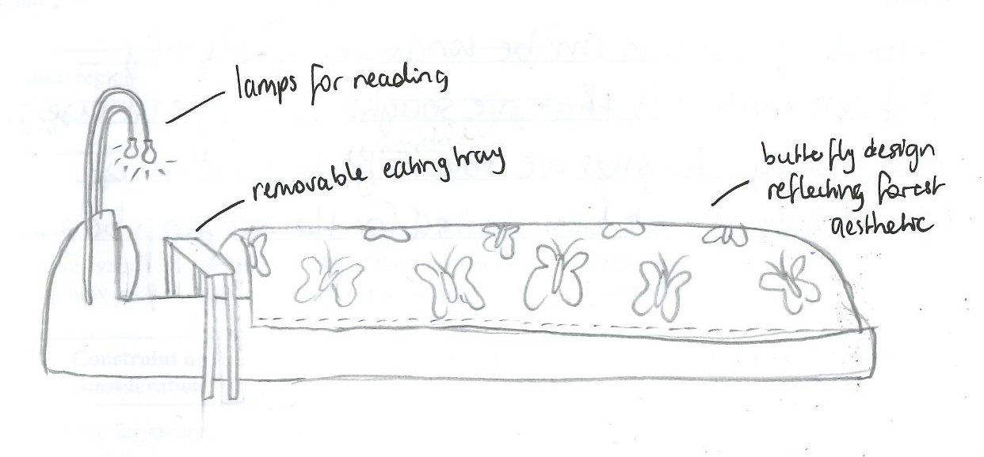
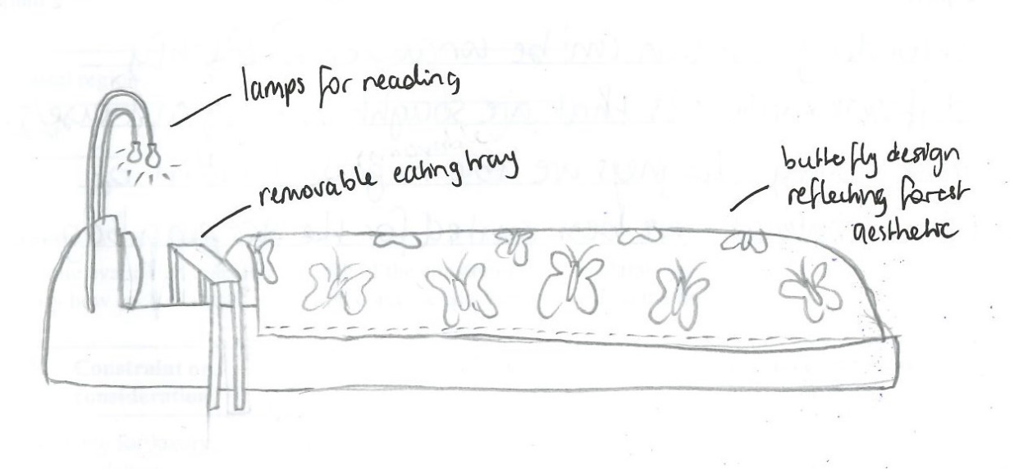
Question 3: Visualisation for a sleeping bag

Question 4: Design option drawing for the sleeping bag
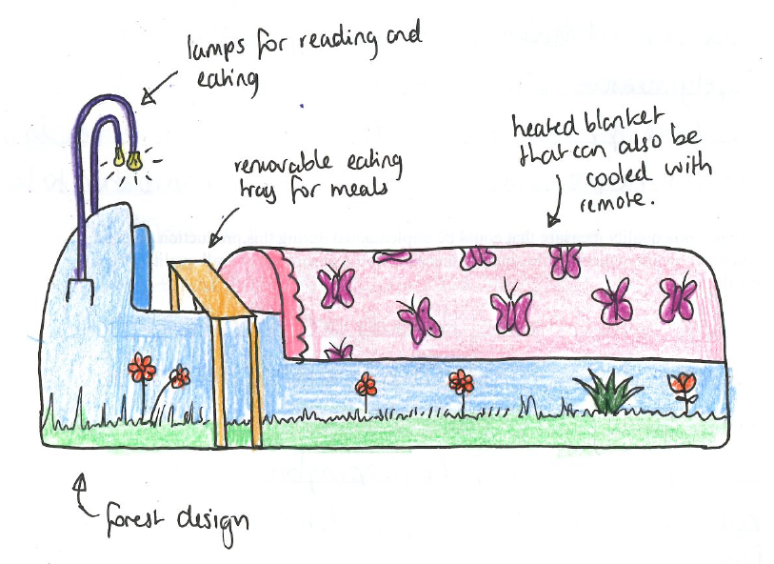
Question 3: Visualisation for a bedhead
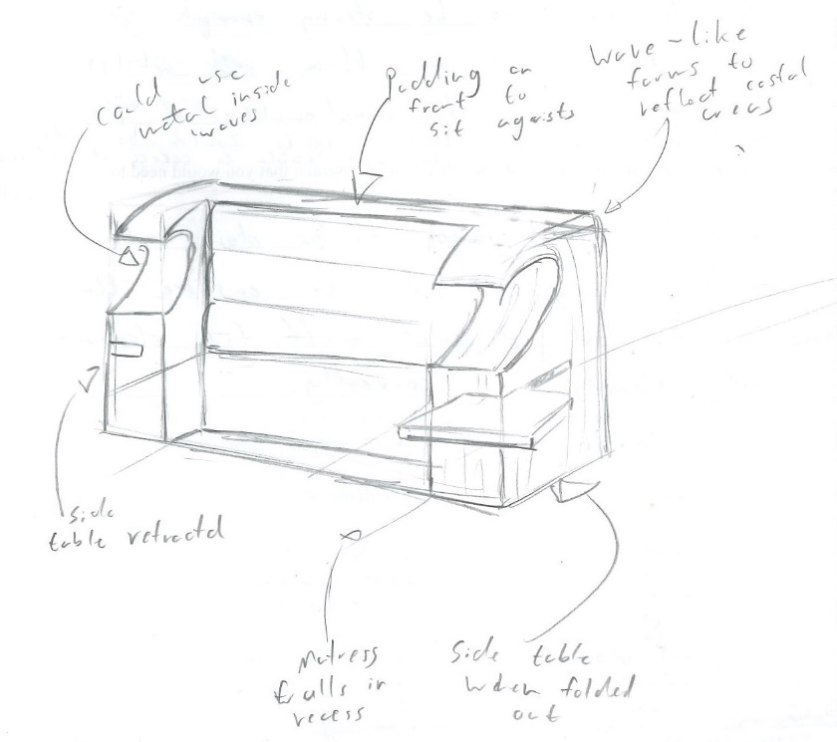
Question 4: Design option drawing for the bed head
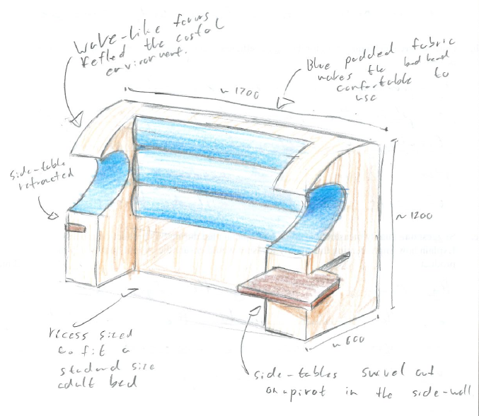

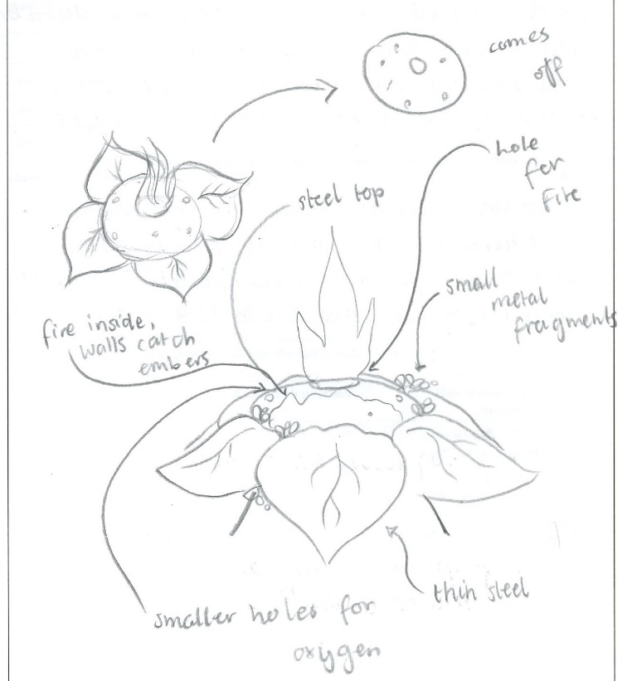
Question 3: Visualisation for a fire pit
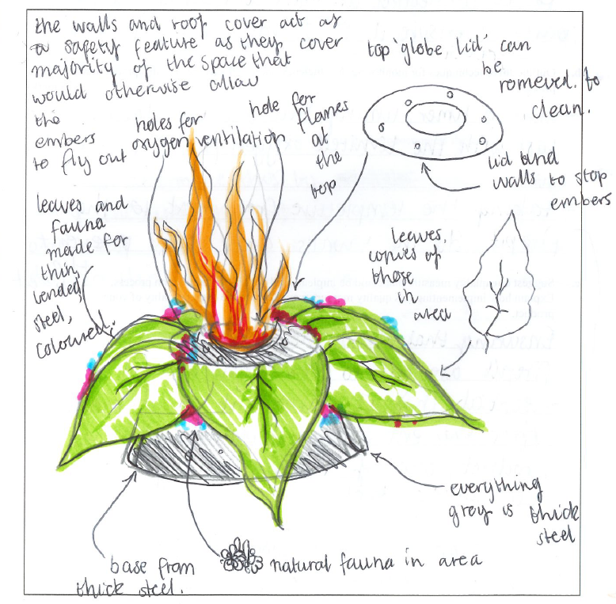
Question 4: Design option drawing for the fire pit

Question 5a.
Mark | 0 | 1 | 2 | 3 | Average
% | 40 | 8 | 17 | 35 | 1.5
A large proportion of students did not interpret this question as being about a production process to construct their product. Many students wrote the scheduled production plan, a planning component, a step in the product design process or a scale of manufacturing, suggesting they were unclear on the different ‘processes’ in this study. The term ‘production process’ referred to a process undertaken to construct the product.
The responses here reinforced the importance of students using the 15-minute reading time to read all questions and consider their responses. In this case, Question 6 was related, and clearly asked for a tool or equipment from Question 5. Some students missed the connection between the questions.
The following is an example of a high-scoring response.
Sewing the seams. Sewing the seams aims to join all parts of the sleeping bag together. This is important for the product I am creating because it ensures the end-user will have a complete functional sleeping bag for their glamping trip.

Question 5b.
Mark | 0 | 1 | 2 | 3 | Average
% | 50 | 19 | 18 | 13 | 1.0
Techniques that outlined various monitoring methods for the construction process named in Question 5a. were required. Acceptable answers included:
- creating a timeline and checking that the process in Question 5a. is completed within the allocated time
- visually checking quality/tasks as you go
- use of templates/jigs to check accuracy/consistency
- measuring for accuracy as you go (trying for size)
- making a model/sample/prototype to check suitability (e.g. of size, processes)
- double-checking each process (e.g. measure twice, cut once OR check joins)
- using instruments to check (i.e. for squareness, symmetry, alignment, dimensions)
- making mock-ups to check the quality or that things work
- end-user feedback/expert opinion before progressing
- materials/tools/equipment list for preparedness/availability
- risk assessment/management for checking controls to avoid accidents
- recording progress in a log/journal or keeping a work record.
Many students could not correctly outline a monitoring technique. Many wrote a description of the process or steps to complete the process. Others wrote checking or testing methods for the finished product.

Question 5c.
Mark | 0 | 1 | 2 | 3 | Average
% | 52 | 15 | 15 | 17 | 1.0
More than half of the students could not answer this question correctly. To score well they needed to include a quality measure – an expected standard for the process that the student had named in Question 5a.
The following are examples of high-scoring responses.
For biscuit jointing: Repeatedly making sure that all the holes on both sides of the pieces line up by looking at them and testing if they fit before applying the glue. Doing this prevents risk of doing it in an undesired spot.
For laser welding: A quality measure in this process is to check that there are no breaks or holes in the steel pit. This measure ensures quality for the product as the aim is to be above ground and have no embers fall onto the ground.
One quality measure that could be implemented is ensuring all seams are straight. This ensures overall quality because it means there will be no puckers in the sewing and it makes it look aesthetically pleasing.

Question 6a.
Mark | 0 | 1 | 2 | Average
% | 31 | 19 | 50 | 1.2
Students must use the 15-minute reading time to read all questions and note questions that are linked. This is an example of a sequential/linked question as students needed to refer to their response for Question 5a. to answer this question. Some students incorrectly answered Question 5a. and did not correctly link that response to Question 6a. Many named tools or equipment not related to their response for Question 5, and others did not respond to Question 5 but named a tool/equipment here.

Question 6b.
Mark | 0 | 1 | 2 | Average
% | 32 | 20 | 48 | 1.2
Most students were able to outline how to manage the potential risk. Accepted responses included:
- securing the work (by clamp/vice)
- wearing safety googles/glasses/gloves or other specific PPE
- safety training/signage about the risk.

Question 7
Mark | 0 | 1 | 2 | 3 | Average
% | 23 | 17 | 28 | 33 | 1.7
Overall, this question was answered well.
Some students interpreted the question as to how their design from Question 4 met the user’s needs, but the question was asking how it would be determined that the needs were met. Acceptable answers included gathering feedback from the end user about the finished product, and using the evaluation criteria to determine if the finished product met the requirements of the design brief.
The following is an example of a high-scoring response.
By using the evaluation criteria to determine if the product meets all of the requirements set out in the design brief. By determining how many of these factors it meets can determine how successful the product followed them. Feedback from the end user can also be gathered for this.

