2023 VCE VET Engineering Studies external assessment report

General comments
The 2023 Engineering Studies examination assessed the following units of competency:
- MEMPE006A Undertake a basic engineering project
- VU22333 Perform intermediate engineering computations.
All questions in the 2023 VCE VET Engineering Studies exam were attempted by the majority of students.
Overall, safety was a topic answered well, and students appear to have good understanding of third-angle projection when sketching.
While calculations were handled well, students should focus more on ensuring they are using the correct units. As an example, generally all dimensions in the exam are given in millimetres (mm), but some questions require the answer to be in metres. In these cases, it would be easier to convert dimensions to metres before adding or multiplying so as not to end up with large numbers in mm where it’s easier to make conversion errors.
Other areas for improvement:
- Students need to take into account all the information included in a question, including the details in drawings, in order to avoid incorrect assumptions about the required responses. For example, in Question 10, the type/thickness of the different materials was sometimes not taken into consideration, leading to more general responses that did not correctly answer the question.
- Students need to read the questions more carefully and take note of what is required. An example is Question 27, where some design details were required. Almost all students identified that a rolling element was required, but most did not have any or enough detail on the practical aspect of how the rolling element is held in or any details of materials used.
- Correct drawing convention is an area requiring major improvement. There appears to be little knowledge of correct dimensioning techniques, use of centre lines etc.
- Another area requiring attention is correct terminology of basic engineering tools. There was a large number of incorrectly named basic items such as scribers, vee blocks and basic parts of a lathe.

Specific information
The statistics in this report may be subject to rounding, resulting in a total of more or less than 100 per cent.

Question 1a.
Marks | 0 | 1 | 2 | Average
% | 5 | 37 | 59 | 1.5
Any two of:
- no damage to cord
- drill bit tightened
- tag test date
- damage to body/casing.
This question was answered well by most students. Generic answers such as ‘make sure drill functions safely’ were not accepted.

Question 1b.
Marks | 0 | 1 | Average
% | 16 | 84 | 0.8
One of the following:
- plate could spin and cut hand
- cut hand on sheet metal
- drill slips and cuts hand.
The question was well answered.

Question 1c.
Marks | 0 | 1 | Average
% | 51 | 49 | 0.5
Clamp sheet metal onto piece of timber (or similar).
Some students responded with ‘holding in vise’, which is not practical for sheet metal.

Question 2a.
Marks | 0 | 1 | Average
% | 33 | 67 | 0.7
Two of the following:
- lathe
- milling machine
- pedestal drill.
A majority of students answered this question well.

Question 2b.
Marks | 0 | 1 | Average
% | 10 | 90 | 0.9
Gloves could get caught in the spinning parts and drag the hand in.
The question was answered well by most students.

Question 3a.
Marks | 0 | 1 | 2 | Average
% | 57 | 41 | 3 | 0.5

Tool | Name of tool
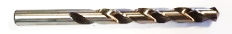 | twist drill
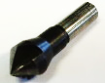 | countersink
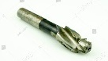 | counterboring tool
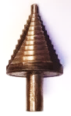 | step drill
Many students did not know the correct names for tools. Some responses indicated students did not know the purpose of the tools.

Question 3b.
Marks | 0 | 1 | 2 | Average
% | 31 | 53 | 16 | 0.8

Hole | Use
 | D
 | A & C
 | A & B
 | A
For the counterbore and countersink, some students did not include the twist drill as part of the answer. This is possibly due to not reading the question carefully.

Question 4
Marks | 0 | 1 | 2 | Average
% | 8 | 52 | 39 | 1.3
Any two of the following:
- two-person lift
- don’t bend back
- check the path is clear
- check condition of box (sharp objects, stable)
- hold load close to body.
Most students answered this question well. Generic answers such as ‘lift safely’ were not accepted.

Question 5
Marks | 0 | 1 | 2 | Average
% | 12 | 19 | 69 | 1.6

Item | Process
1000 flat washers | stamping
gate | fabrication
aluminium post | extrusion
plumb bob | machining
This question was well answered.

Question 6
Marks | 0 | 1 | 2 | 3 | Average
% | 0 | 2 | 33 | 65 | 2.6

 | No naked flames / No fires
 | Hearing protection must be worn.
 | First aid room / First aid cabinet
The question was answered well by most students.

Question 7a.
Marks | 0 | 1 | Average
% | 62 | 38 | 0.4
pedestal grinder / off-hand grinder
Many students did not know the correct name of the piece of equipment. Incorrect responses included ‘grinding stones’ and ‘bench grinder’.

Question 7b.
Marks | 0 | 1 | 2 | Average
% | 28 | 52 | 20 | 0.9
Two of the following:
- position of rest correct (not too far from wheels)
- no damage to grinding wheels
- guards in place / not loose.
Many students came up with one correct response but struggled with a second response.

Question 8
Marks | 0 | 1 | Average
% | 41 | 59 | 0.6
3200 / 77 = 41 pieces
This question was answered correctly by most students. Some students failed to consider the thickness of the saw blade.

Question 9a.
Marks | 0 | 1 | Average
% | 24 | 76 | 0.8
TPI: teeth per inch
This question was answered correctly by most students.

Question 9b.
Marks | 0 | 1 | Average
% | 58 | 42 | 0.4
hacksaw blade: 32 TPI
Reason: More teeth in contact with sheet metal / easier to cut / doesn’t jam (or similar).
Some students failed to make the connection between the thickness of sheet metal and spacing of teeth.

Question 9c.
Marks | 0 | 1 | 2 | Average
% | 15 | 39 | 46 | 1.3
- correct direction of blade
- correct tension on blade / tight
Some responses such as ‘pick the correct blade’ suggest that students did not read the question carefully.

Question 10
Marks | 0 | 1 | 2 | 3 | 4 | 5 | 6 | Average
% | 4 | 8 | 28 | 24 | 23 | 11 | 2 | 3.0
Any two joining methods for each material.
Materials to be joined | Joining methods
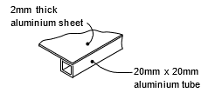 | - pop rivet  - TIG welding / welding  - self-tapping screws  - adhesive
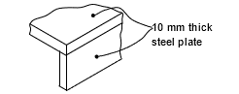 | - welding  - spray transfer  - bolts (drill and tap)  - screws (drill and tap)
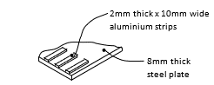 | - adhesive  - pop rivets  - screws (drill and tap)
Students needed to pay more attention to details in this question, such as thicknesses and types of materials.

Question 11
Marks | 0 | 1 | Average
% | 52 | 48 | 0.5
The most common cause is that the cutting tool is not on centre height.
Many students used incorrect terminology in their response.

Question 12a.
Marks | 0 | 1 | Average
% | 12 | 88 | 0.9
165 − 90 = 75mm
This question was answered correctly by most students.

Question 12b.
Marks | 0 | 1 | 2 | Average
% | 43 | 13 | 44 | 1.0
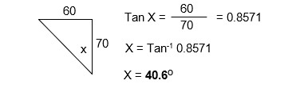
A common error was using the incorrect trigonometric ratio.

Question 13
Marks | 0 | 1 | 2 | 3 | 4 | 5 | Average
% | 1 | 13 | 57 | 19 | 7 | 2 | 2.3

Tool | Name | Common use
 | scriber | marking lines
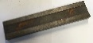 | parallel strip | keeping work piece parallel in vise / supporting work in vise
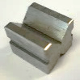 | vee block | holding round bar
 | centre punch | centre punching holes before drilling
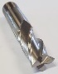 | end mill | milling slots / milling flat surfaces
Many students were not able to use the correct terminology for these tools. Some answers indicated that students were not familiar with some of these tools, in particular the parallel strips and vee block.

Question 14
Marks | 0 | 1 | 2 | 3 | 4 | 5 | Average
% | 6 | 11 | 10 | 23 | 36 | 15 | 3.2

Common errors included:
- incorrect position of views
- re-drawing some views in isometric
- missing centre lines
- broken lines.

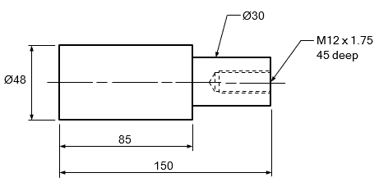
Question 15
Marks | 0 | 1 | 2 | 3 | 4 | Average
% | 12 | 7 | 18 | 49 | 14 | 2.5

Few students used correct drawing convention such as correct extension lines and arrows.

Question 16
Marks | 0 | 1 | 2 | 3 | 4 | 5 | Average
% | 42 | 11 | 13 | 12 | 13 | 9 | 1.7

Shape | Name
SHS / square hollow section
square tube
 | angle iron
 | tube / round tube / pipe
RHS / rectangular hollow section
rectangular tube
solid round bar
round bar

Very few students knew the correct names of these standard metal shapes. Some students misread the question and just put down the basic shape such as ‘circle’ / ‘square’.

Question 17a.
Marks | 0 | 1 | Average
% | 38 | 62 | 0.6
10 × 5 = 50 discs
The question was answered correctly by most students. A common error was to calculate the area of one circle and divide this into the total sheet metal area.

Question 17b.
Marks | 0 | 1 | 2 | 3 | Average
% | 36 | 35 | 8 | 20 | 1.1
Disc area:
πr2 × 50 3.142 × 552 × 50
9504.55 × 50 = 475,227.5 mm2
Plate area:
1200 × 600 = 720,000 mm2
Scrap:
720,000 - 475,227.5 = 244,772.5
244,772.5 / 720,000 = 0.3399 = 34%
Many students correctly calculated the area of the sheet metal, but then struggled to complete the percentage.

Question 18a.
Marks | 0 | 1 | 2 | 3 | Average
% | 13 | 29 | 35 | 23 | 1.7

Part | Name | Main function
A | chuck | Holds work.
B | tool post | Holds tool.
C | tailstock | Holds centre / drills / supports long work.
Most students seemed familiar with the chuck, but few correctly named the tailstock and tool post.

Question 18b.
Marks | 0 | 1 | 2 | 3 | Average
% | 29 | 21 | 31 | 18 | 1.4

Part | Function
D | cross slide / moves tool for depth of cut / facing off (Y axis)
E | engage auto feed / feed lever
F | carriage handwheel / moves tool along work / along bed / towards chuck (X axis)
Few students could adequately describe the functions. Some gave answers that were not specific enough, such as ‘moves cutter’.

Question 19
Marks | 0 | 1 | 2 | 3 | 4 | Average
% | 3 | 10 | 26 | 55 | 6 | 2.5

Part | Machine | Work-holding method
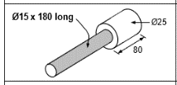 | lathe | three-jaw chuck and centre / between centres
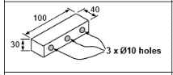 | drill | vise
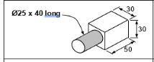 | lathe | four-jaw chuck
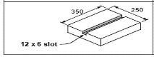 | milling machine | bolted to table / using clamps
This question was answered well overall. Some students put down vise for milling the slot in the 350 × 250, without considering the size.

Question 20
Marks | 0 | 1 | 2 | 3 | 4 | Average
% | 27 | 11 | 17 | 19 | 25 | 2.0
overall area: 2.4 × 1.6 = 3.84
circle area = π × 0.2² = 0.126
rectangle = 0.7 × 0.6 = 0.42
triangle = (0.6 × 0.6) / 2 = 0.18
area = 3.84 - (0.126 + 0.42 + 0.18)
3.84 - 0.726 = 3.114 m2
With this type of question, students would benefit from systematically laying out the working out, and converting the sizes to metres before beginning to calculate. This would avoid mistakes in converting large numbers at the end.

Question 21
Marks | 0 | 1 | 2 | 3 | Average
% | 58 | 15 | 3 | 24 | 0.9
(700 × 2) + (400 × 2) = 2200
π × 100 = 314.2
perimeter = 2200 + 314.2 = 2514.2 mm
The most common error was not subtracting the radii from the lengths.

Question 22
Marks | 0 | 1 | 2 | Average
% | 26 | 12 | 62 | 1.4
A = $\sqrt{60^{2}+100^{2}}$
A = $\sqrt{3600 + 10000}$
A =$\sqrt{ 13600}$
A = 116.62

A
100
60

This question was answered correctly by many students.

Question 23a.
Marks | 0 | 1 | 2 | 3 | Average
% | 5 | 17 | 30 | 48 | 2.2

Step | Operation
1 | Square off ends to 140 mm length.
2 | Mark out.
3 | Drill both holes.
4 | Tap both holes.
5 | Cut out excess material from corners.
6 | Mill corners to size.
7 | De-burr.
Drilling and tapping after milling were also accepted.
Basic impractical mistakes made were tapping holes before drilling, and milling corners before cutting excess.

Question 23b.
Marks | 0 | 1 | 2 | Average
% | 5 | 43 | 52 | 1.5
Four of the following:
- scriber
- rule
- protractor
- hammer
- centre punch
- square
- vernier height gauge.
While the majority of students answered this question well, some students included answers which are not marking out tools (e.g. drill), possibly not reading the question correctly.

Question 23c.
Marks | 0 | 1 | Average
% | 44 | 56 | 0.6
One of the following:
- break the chip
- prevent tap from breaking
Many students answered this question correctly.

Question 23di.
Marks | 0 | 1 | Average
% | 50 | 50 | 0.5
major diameter

Question 23dii.
Marks | 0 | 1 | Average
% | 43 | 57 | 0.6
pitch
This question in two parts was answered correctly by approximately 50% of students, showing a lack of understating of basic engineering terms.

Question 24
Marks | 0 | 1 | 2 | 3 | Average
% | 41 | 11 | 11 | 37 | 1.4
1.8 × 1.2 x 0.9 = 1.944
(1.8 × 1.2 x 0.4) / 2 = 0.432
volume = 1.944 + 0.432 = 2.376 m3
Common errors included calculating the area instead of the volume, and incorrectly calculating the sloped area.

Question 25
Marks | 0 | 1 | 2 | 3 | Average
% | 20 | 43 | 24 | 12 | 1.3
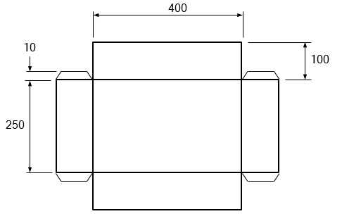

Common errors in students’ answers were missing tabs, or not showing all the required dimensions.

Question 26
Marks | 0 | 1 | 2 | 3 | Average
% | 42 | 34 | 15 | 9 | 0.9

Bearing | Name | Load
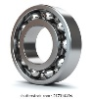 | ball bearing
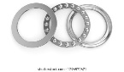 | thrust bearing
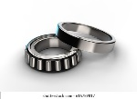 | tapered roller bearing
Few students used correct terminology when naming bearings.

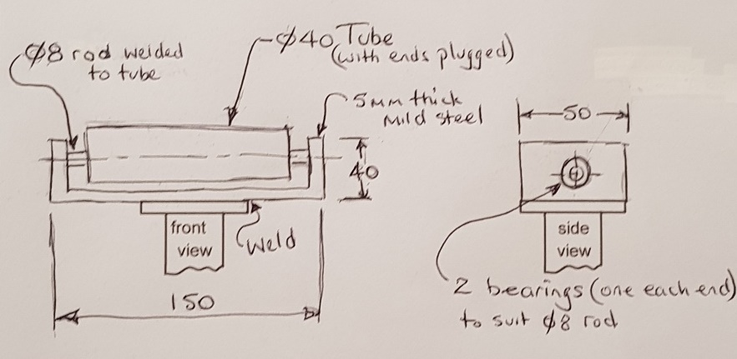
Question 27
Marks | 0 | 1 | 2 | 3 | 4 | 5 | 6 | Average
% | 31 | 16 | 23 | 13 | 9 | 6 | 2 | 1.8
Students seem to not have read this question fully and noted what details were required. Details such as material type, sizes and basic descriptions were often left out.
Students would benefit from using the dot points in the question as a check list for their response.

