2023 VCE VET Furnishing external assessment report

Section A
Correct answers in the table below are in bold with grey shading.
Question | Correct answer | % A | % B | % C | % D | Comments
1 | D | 2 | 7 | 8 | 84
2 | A | 70 | 15 | 15 | 0
3 | C | 5 | 5 | 62 | 28
4 | D | 11 | 3 | 8 | 77
5 | C | 64 | 0 | 31 | 5
6 | B | 26 | 56 | 18 | 0
7 | D | 0 | 10 | 7 | 84
8 | B | 7 | 89 | 3 | 2
9 | C | 5 | 10 | 85 | 0
10 | A | 46 | 18 | 0 | 36
11 | C | 0 | 3 | 87 | 10
12 | B | 31 | 66 | 2 | 2
13 | D | 0 | 0 | 2 | 98
14 | D | 20 | 18 | 33 | 30
15 | B | 3 | 64 | 13 | 20
16 | A | 57 | 0 | 34 | 8
17 | C | 2 | 0 | 80 | 18
18 | A | 98 | 2 | 0 | 0
19 | B | 5 | 72 | 0 | 0
20 | ABCD | 39 | 15 | 46 | 0

Section B
The statistics in this report may be subject to rounding resulting in a total more or less than 100 per cent.

Question 1
Mark | 0 | 1 | 2 | Average
% | 89 | 5 | 6 | 0.2
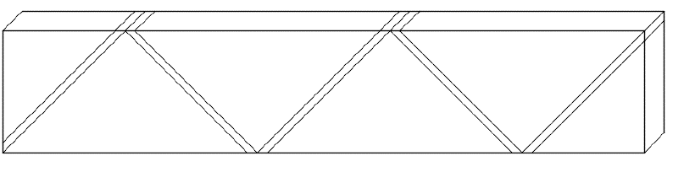

Question 2
Mark | 0 | 1 | 2 | 3 | 4 | 5 | Average
% | 0 | 3 | 34 | 28 | 0 | 34 | 3.3

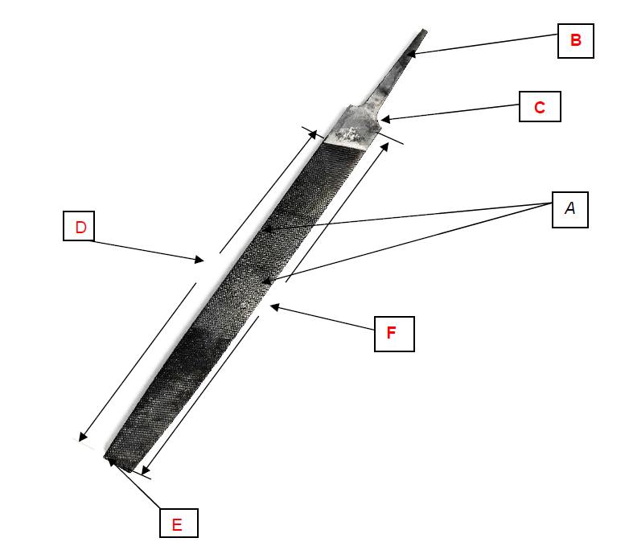

Question 3
Mark | 0 | 1 | 2 | 3 | Average
% | 2 | 67 | 26 | 5 | 1.3
Joint 1: glued rebate joint
Joint 2: glued tongue and groove joint
Reason: greater long-grain gluing surface

Question 4a.
Mark | 0 | 1 | 2 | Average
% | 67 | 4 | 29 | 0.6
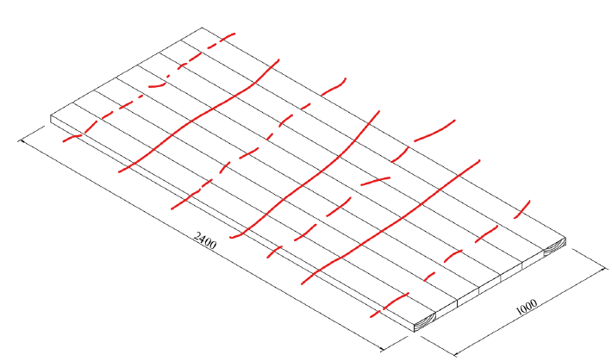
Show between five and seven clamps across the top.

Question 4b.
Mark | 0 | 1 | 2 | Average
% | 41 | 59 | 0 | 0.6
The heart side of the board of the first and last board to allow the top to pull down to the table legs and rails. 2 marks
Statement about cupping or keeping flat. 1 mark

Question 5
Mark | 0 | 1 | 2 | 3 | Average
% | 39 | 2 | 7 | 53 | 1.7
Cabinet A: 1.65 m²
Cabinet B: 0.935 m²
Cabinet C: 1.62 m²
If rounding, must be rounded up and show at least two decimal places

Question 6
Mark | 0 | 1 | 2 | 3 | 4 | 5 | 6 | Average
% | 5 | 8 | 8 | 11 | 38 | 2 | 28 | 3.9
Task No. 2: secure benchtop to saw stools
Task No. 4: mark out position of sink as per template on the benchtop
Task No. 5: put on PPE
Task No. 7: drill 10 mm hole in each corner
Task No.9: plus jigsaw into power source
Task No. 10: cut out shape with jigsaw

Question 7
Mark | 0 | 1 | 2 | 3 | Average
% | 61 | 8 | 0 | 31 | 1.0
Drill bit to use: machine twist bit
Reason: It’s the only bit that will centre in the existing hole as the others all have a centre point.

Question 8
Mark | 0 | 1 | 2 | Average
% | 40 | 29 | 30 | 0.9
Drill through the face until the point goes through to the other side, then flip the timber over and drill the other side until through. One mark was awarded for describing a method for reducing chip-out on the top surface only.

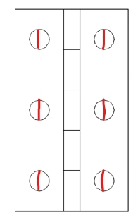
Question 9
Mark | 0 | 1 | 2 | Average
% | 82 | 7 | 11 | 0.3

Question 10a.
Mark | 0 | 1 | 2 | 3 | 4 | Average
% | 0 | 3 | 3 | 51 | 43 | 3.3
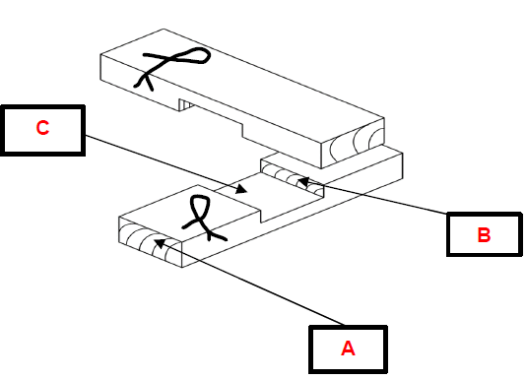

Cross halving joint / halving joint

Question 10b.
Mark | 0 | 1 | 2 | Average
% | 68 | 23 | 9 | 0.4
With the try square, square only from the face and edge surface.

Question 11a.
Mark | 0 | 1 | Average
% | 92 | 8 | 0.1
Full size set-out

Question 11b.
Mark | 0 | 1 | Average
% | 28 | 72 | 0.7
Loose tenon, domino or dowel joint

Question 11c.
Mark | 0 | 1 | 2 | Average
% | 77 | 10 | 13 | 0.4
2-3 mm chamfer, arris or bevel to all lower ends of legs; fit domes to end of legs to prevent chipping of the timber legs.

Section C

Question 1
Mark | 0 | 1 | 2 | 3 | 4 | 5 | Average
% | 2 | 5 | 12 | 34 | 37 | 9 | 3.3
2. Bottom: Length = 1060
7. Back panel: Material = Vic ash ply
9. Front rail: Length = 980
19 Drawer side: Thickness = 18
21. Draw runner

Question 2a.
Mark | 0 | 1 | Average
% | 87 | 13 | 0.1
A shadow line helps to obscure timber movement between the carcase and undercarriage frame.

Question 2b.
Mark | 0 | 1 | 2 | 3 | Average
% | 57 | 20 | 8 | 15 | 0.8
Tools: Trimmer or router
Process: Insert a rebate cutter with the correct cut depth or fit a straight cutter and fence. Run the shadow line with the trimmer on the top of the undercarriage.

Question 3a.
Mark | 0 | 1 | Average
% | 76 | 24 | 0.2
Cut on table saw, biscuit jointer or compound mitre saw. Equipment used to produce the joint must be identified.

Question 3b.
Mark | 0 | 1 | Average
% | 50 | 50 | 0.5
To minimise the visible end grain. Allow the grain to follow around the corner.

Question 4
Mark | 0 | 1 | 2 | 3 | 4 | 5 | 6 | 7 | 8 | Average
% | 19 | 2 | 11 | 3 | 26 | 6 | 23 | 1 | 9 | 3.8

Step No. | Description of step | Tool(s) and/or equipment required
1 | mark taper on both faces | combo square and 600 mm ruler
2 | cut using the jigsaw | jigsaw and PPE
3 | plane taper | No.7 hand plane
4 | sand all parts | sandpaper and block

Question 5a.
Mark | 0 | 1 | Average
% | 31 | 69 | 0.7
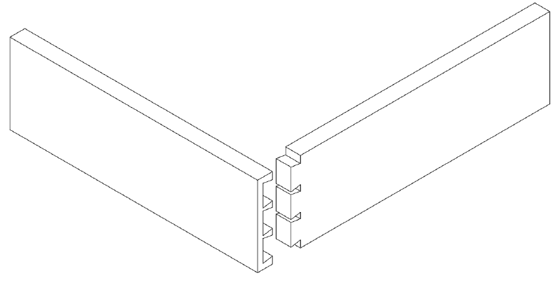
Front to back, along the length of the side

Question 5b.
Mark | 0 | 1 | Average
% | 39 | 61 | 0.6
There’s no chip-out to the drawer front and it’s safer to plane from front to back while fitting the drawer. Strength: it stops timber breaking.

Question 6
Mark | 0 | 1 | 2 | Average
% | 89 | 5 | 6 | 0.2
Draw a slot cutter with 3–5 mm depth of cut and 3 mm groove width OR 3mm diameter cutter to be used with a fence.

Question 7
Mark | 0 | 1 | 2 | 3 | 4 | Average
% | 2 | 2 | 19 | 3 | 75 | 3.5
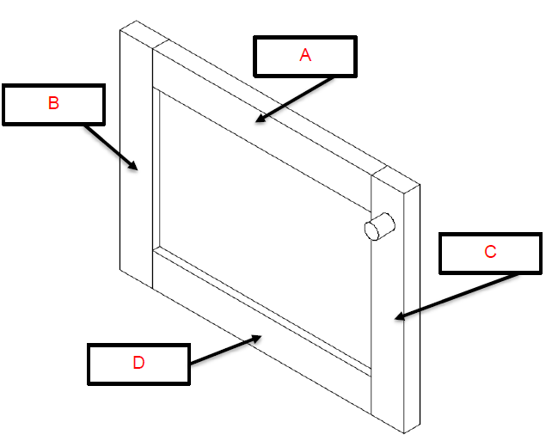

Question 8
Mark | 0 | 1 | 2 | 3 | 4 | Average
% | 24 | 23 | 29 | 14 | 11 | 1.7
Dowel joint advantages: dowels are low cost; simple tools. Disadvantages: not as strong
Other joint, loose tenon M&T advantages: strong; quick to mark and make. Disadvantages: costly tools; costly loose tenons

Question 9a.
Mark | 0 | 1 | 2 | Average
% | 93 | 7 | 0 | 0.1
The diameter of the dowel should not be greater than ⅓ to ½ the thickness of the timber, and 2 to 2½ times the diameter in length into each piece of timber

Question 9b.
Mark | 0 | 1 | Average
% | 57 | 43 | 0.4
50mm x 10mm

Question 10
Mark | 0 | 1 | 2 | 3 | Average
% | 19 | 36 | 25 | 20 | 1.5
4: insert all eight dowels into dowel holes
6: place on clamps and position correctly with clamping block
9: check for squareness

Question 11
Mark | 0 | 1 | 2 | 3 | Average
% | 66 | 22 | 6 | 5 | 0.5
Adjustment for screw A: Adjust the door slightly to the left of the cabinet or the right of the cabinet.
Adjustment for screw B: Adjust the door by moving it up or down on the cabinet.
Adjustment for screw C: Adjust the inward or outward movement of the door on the hinging side.

