2022 VCE VET Integrated Technologies external assessment report

General comments
The 2022 VCE VET Integrated Technologies examination consisted of two sections: Section A, which comprised 20 multiple-choice questions; and Section B, which comprised 10 questions that required students to provide a combination of written explanations and show working and state the correct units of measurements for the given problems. Through circuit schematic diagrams analysis, the students needed to complete the design of a PCB (Printed Circuit Board) artwork drawing, identify environmental benefits, and provide the performance and efficiency benefits of different renewable energy technologies.
Although most students performed well, it was apparent that many students needed to prepare better for the examination by confidently applying Ohm’s law in equations and consistently applying engineering notation. Students need to know and apply the commonly used engineering notations of pico, nano, micro, milli, kilo and mega.
Students who followed the correct methodology of showing their working with correct calculations and units gained full marks for these questions. If a student made an incorrect mathematical calculation in the initial stage, it was allowed that they could use the incorrectly calculated answer in any subsequent questions, which were assessed as separate questions.
Students should always provide an answer, even when unsure.
It is highly recommended that students familiarise themselves with the standard table of electronic symbols as used in these examinations and published online by the VCAA.

Specific information
Note: This report provides sample answers, or an indication of what answers may have included. Unless otherwise stated, these are not intended to be exemplary or complete responses.
The statistics in this report may be subject to rounding resulting in a total more or less than 100 per cent.

Section A – Multiple-choice questions
The table below indicates the percentage of students who chose each option. Grey shading indicates the correct response.
Question | Correct answer | %A | %B | %C | %D | Comment
1 | C | 0 | 0 | 71 | 29
2 | A | 71 | 0 | 29 | 0 | 2 × 10 nF in parallel = 20 nF. Therefore 2 × 20 nF in series = 10 nF and the voltage rating is 2 × 15 V = 30 V.
3 | A | 29 | 14 | 57 | 0 | As the diode is reverse biased no current will flow in this circuit.
4 | B | 14 | 57 | 14 | 14
5 | D | 29 | 14 | 0 | 57
6 | A | 86 | 14 | 0 | 6
7 | A | 29 | 14 | 0 | 57 | Optical fibre is commonly made from glass.
8 | C | 14 | 0 | 86 | 0
9 | D | 0 | 29 | 0 | 71
10 | C | 71 | 0 | 29 | 0 | Binary Coded Decimal (BCD) 853  8 = 1000, 5 = 0101, 3 = 0011
11 | D | 0 | 0 | 0 | 100
12 | D | 29 | 0 | 29 | 43 | From the graph, R1 thermistor @ 30 OC = 20 kΩ. The voltage divider circuit, R1 = 20 kΩ and R2 = 20 kΩ across the 5 V supply, therefore the voltage at the analogue input (A1) would be 2.5 V.
13 | D | 0 | 0 | 0 | 100
14 | B | 0 | 86 | 14 | 0
15 | C | 0 | 43 | 57 | 0
16 | B | 0 | 86 | 0 | 14
17 | C | 14 | 0 | 86 | 0
18 | B | 0 | 86 | 14 | 0
19 | A | 29 | 29 | 14 | 29 | P = V × I. The concept is that for a cable with a known power rating, if the voltage increases the cross-sectional thickness (gauge) can be decreased. The example is the larger gauge of the power cables in the USA or Japan with the 110 V supply, compared to Australia’s 240 V, where the CSA of the cable size for heavy current machines is less.
20 | D | 14 | 14 | 29 | 43 | 2n2 F = 2.2 x 10-9 = 0.0000000022 F  Comprehensive knowledge of engineering notation is essential in this VET sector.

Section B

Question 1
Marks | 0 | 1 | 2 | Average
% | 8 | 8 | 83 | 1.8
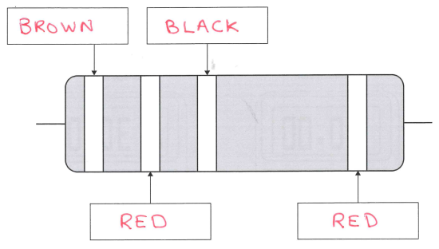
Some students referred to the formula sheet for application of the resistor colour codes. The third band is the multiplier band often referred to as ‘the number of zeros added’. In this case it was ‘black’ as it is only 12 Ω, and consequently the number of zeros are included.

Question 2a.
Marks | 0 | 1 | 2 | 3 | Average
% | 42 | 25 | 0 | 33 | 1.3
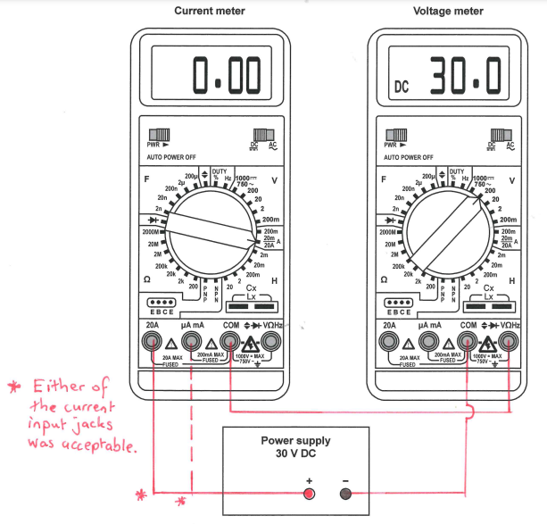

Question 2b.
Marks | 0 | 1 | 2 | 3 | Average
% | 58 | 8 | 8 | 25 | 1.0
When the DMM is set to read the current (20 A) and is connected it would effectively have zero ohms internal resistance.
The DMM connected in series to the current meter is the voltmeter (200 V), which would effectively have an extremely high resistance (nominally 20 MΩ), so when connected in series to 30 V no current would flow. However, 30 V would be displayed on the voltmeter.

Question 2c.
Marks | 0 | 1 | 2 | Average
% | 50 | 25 | 25 | 0.75
0.00 indicates a short-circuit condition. This is the opposite to what should be actually shown on the meter. The DMM should display an open circuit condition which is often shown on the screen as ‘OL’ (OverLoad), or some DMMs display a ‘1’ for an open circuit.
Different brands of meters may indicate ‘open circuits’ with different messages displayed.

Question 3a.
Marks | 0 | 1 | 2 | 3 | Average
% | 8 | 42 | 0 | 50 | 1.9
Series cct.: R3 + R4 = 5 + 5 = 10 Ω (1)
Parallel cct.: R1 // R2 // (R3 + R4) = 10 // 10 // 10
= 3.334 Ω

Question 3b.
Marks | 0 | 1 | 2 | Average
% | 25 | 17 | 58 | 1.3
V = I × R
V= 2 × 10 = 20 V

Question 3c.
Marks | 0 | 1 | 2 | 3 | Average
% | 25 | 0 | 25 | 50 | 2.0
3 circuits of 2 A each
3 × 2 A
= 6 A
‘A’ or ‘Amps’ needed to be shown.
1+1+1 = 2 marks
Alternatively, it could be determined
I = V/R
= 20/3.33
= 6 A

Question 4a.
Marks | 0 | 1 | Average
% | 91 | 9 | 0.1
6 cells as (6 × 2 V = 12 V)

Question 4b.
Marks | 0 | 1 | 2 | Average
% | 55 | 18 | 27 | 0.7
The reading of 12.82 V indicates that the battery is fully charged, and this is a reasonable indication that the battery is likely to be fully serviceable.

Question 4c.
Marks | 0 | 1 | 2 | Average
% | 73 | 18 | 9 | 0.4
A variety of suitable answers are:
- Although 12.82 V indicates a good performance, a ‘load test’ needs to be performed on the battery to check that it can deliver a large current of approximately 200 A required to start the car.
- The easiest test would be to either just start the car or use a load test meter on the battery in order to prove that the battery condition is good.
- A load test is more conclusive as the battery is under stress; it would show if the required current can be supplied by the battery.

Question 5a.
Marks | 0 | 1 | 2 | 3 | 4 | Average
% | 0 | 17 | 33 | 25 | 25 | 2.6
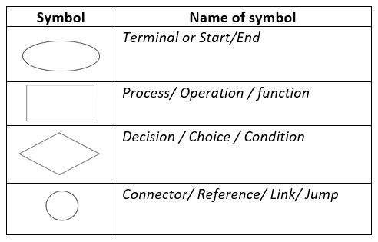
The students provided a variety of commonly used names for the flow chart symbols.

Question 5b.
Marks | 0 | 1 | Average
% | 67 | 33 | 0.3
Visio, PowerPoint, Smartdraw or any other suitable application that has specific function to draw flowcharts.

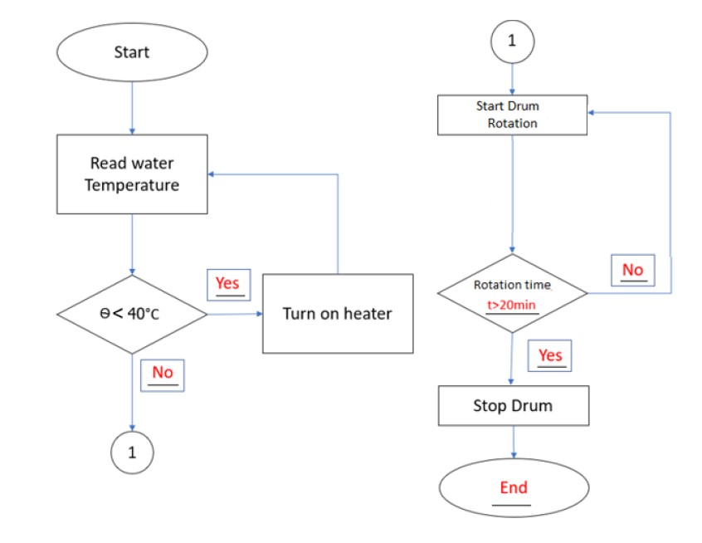
Question 5c.
Marks | 0 | 1 | 2 | 3 | 4 | 5 | Average
% | 25 | 8 | 0 | 17 | 25 | 25 | 2.8

Question 6a.
Marks | 0 | 1 | Average
% | 33 | 67 | 0.7
Any digital device involving a transducer is likely to have an ADC circuit.
Suitable examples include a digital voice recorder, camera, mobile phone, phone, digital multimeter.

Question 6b.
Marks | 0 | 1 | Average
% | 17 | 83 | 0.8
Analogue (to) Digital Converter

Question 6c.
Marks | 0 | 1 | 2 | Average
% | 50 | 0 | 50 | 1
28
= 256 (255 was also accepted.)

Question 6d.
Marks | 0 | 1 | 2 | Average
% | 8 | 0 | 92 | 1.8
Students were not penalised for using an incorrect calculation from Question 6c. that was subsequently used in Question 6d.
12 / 28 or 12 / 256
0.04706 V or 4.706 mV (acceptable to 2 decimal places).

Question 7a.
Marks | 0 | 1 | 2 | 3 | 4 | Average
% | 8 | 0 | 0 | 0 | 92 | 3.7
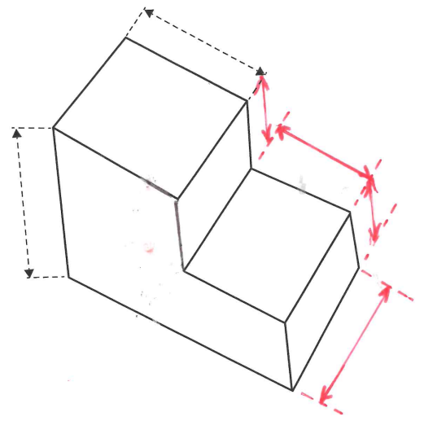
While only three additional dimensions were required to potentially know the dimensions to manufacture the item, most students correctly opted for the four obvious dimensions of the height of either step, together with the length of the lower tread and the overall width. Students would have been awarded full marks for identifying the significant three dimensions, as directly commented on by a couple of students, demonstrating their comprehensive understanding.

Question 7b.
Marks | 0 | 1 | Average
% | 25 | 75 | 0.75
millimeters or mm

Question 7c.
Marks | 0 | 1 | 2 | Average
% | 0 | 8 | 92 | 1.9
A prototype is a test or trial item, or otherwise a first version produced, which often can be altered or improved upon in later production.

Question 7di.
Marks | 0 | 1 | Average
% | 17 | 83 | 0.8
Using rapid prototyping technique of a 3D printer to directly produce the part, or a CNC machine was also acceptable.

Question 7dii.
Marks | 0 | 1 | 2 | Average
% | 0 | 25 | 75 | 1.8
Discussion that identifies factors. For example:
The outcome can be significantly improved as the process will be sped up, as the back and forward with different people involved in different aspects of the production cycle is removed. This reduces the chance of error, speeds up the detection of errors and changes can be made quickly.

Question 8.
Marks | 0 | 1 | 2 | 3 | 4 | 5 | 6 | Average
% | 0 | 8 | 8 | 0 | 17 | 0 | 67 | 4.9
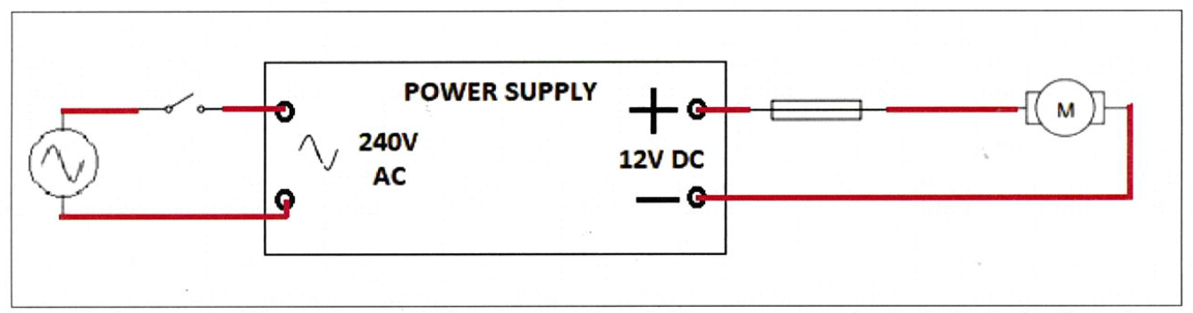

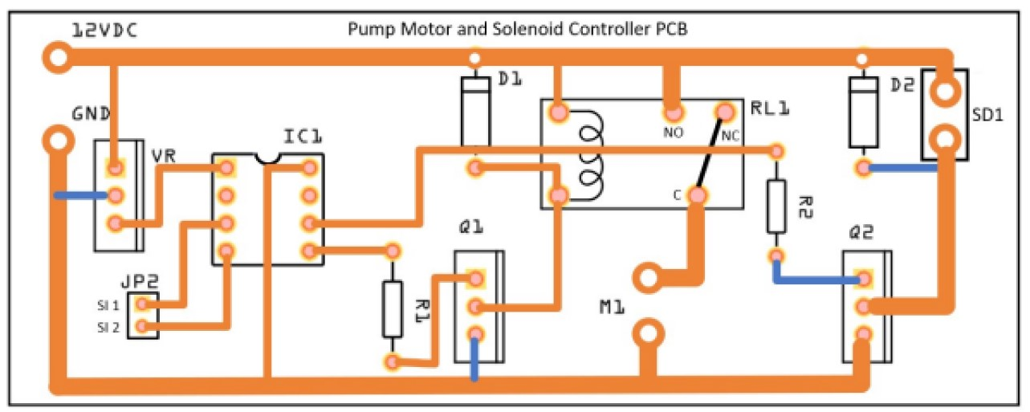
Question 9a.
Marks | 0 | 1 | 2 | 3 | 4 | Average
% | 8 | 8 | 0 | 17 | 67 | 3.2

Question 9b.
Marks | 0 | 1 | 2 | Average
% | 50 | 33 | 17 | 0.7
The wider tracks can carry more current and the larger donuts will allow for a good solder joint with the thicker higher current wires that are going to the motor and solenoid.

Question 9c.
Marks | 0 | 1 | 2 | Average
% | 50 | 25 | 25 | 0.75
The easiest way would be to just measure the electrical resistance or conductivity of the soil between two known points. Dry soil would have high resistance and poor conductivity while moist soil would have low resistance or good conductivity.

Question 9d.
Marks | 0 | 1 | 2 | Average
% | 67 | 8 | 25 | 0.6
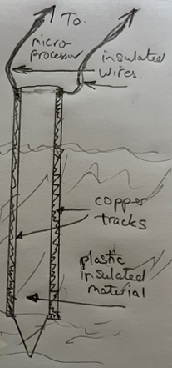
A great range of probes were provided.

Question 9e.
Marks | 0 | 1 | Average
% | 58 | 42 | 0.4
It means it is connected into the circuit in opposite direction to the normal DC current flow direction, that is in reverse, which means it is not usually conducting during normal circuit function.

Question 9f.
Marks | 0 | 1 | 2 | Average
% | 33 | 42 | 25 | 0.9
When the solenoid coil is de-energised, the collapsing magnetic field produces a reverse polarity spike of electricity. The diode provides a path to safely dissipate the electrical spike, thus avoiding damage to the surrounding electronic components.

Question 9g.
Marks | 0 | 1 | 2 | Average
% | 33 | 33 | 33 | 1.0
The purpose of the solenoid is to control the flow of water by either opening or closing the water valve. This is achieved when power is applied to it, creating a very strong magnetic field which, depending on the design, either pulls open or closes the valve.

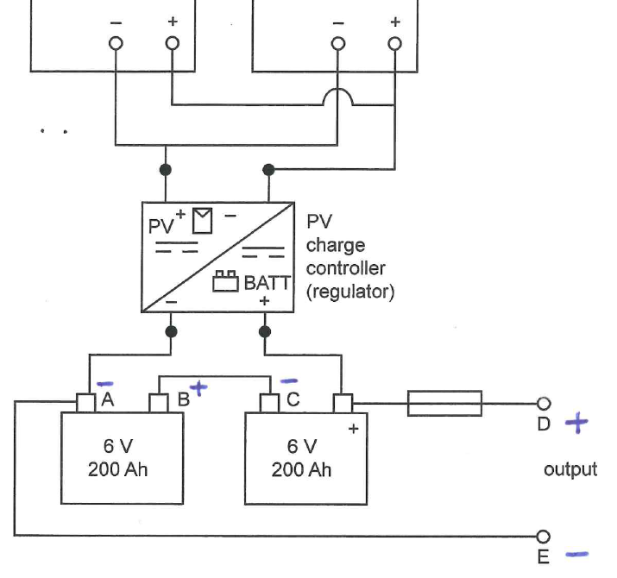
Question 10a.
Marks | 0 | 1 | 2 | Average
% | 25 | 42 | 33 | 1.1

Question 10b.
Marks | 0 | 1 | 2 | Average
% | 67 | 0 | 33 | 0.7
The two batteries are connected in series. This is required because the batteries are both 6 V and the system requires 12 V to operate.

Question 10c.
Marks | 0 | 1 | 2 | Average
% | 0 | 17 | 83 | 1.8
Environmental benefits included (one of):
- The watering system is now fully powered with renewable energy.
- The mains overhead wires to the shed could be removed and trees won’t need to cut back.
- It’s a lower carbon emissions solution.
Efficiency benefits included (one of):
- The watering system is now self-sufficient.
- Consistent performance is assured even during power failures in extreme weather events, potentially when the watering is most needed.
- The integrated technologies system has increased efficiency as it is directly using the PV energy produced on site at 12 VDC.
- It requires no electricity distribution with the associated losses, transforming and/or conversion from 230 VAC mains electricity to 12 VDC.

Question 10d.
Marks | 0 | 1 | 2 | Average
% | 33 | 17 | 50 | 1.2
The maximum power would be 2 × 150 W = 300 W. This would only occur during the time of day when the sunlight was bright and falling directly onto the panels.

Question 10e.
Marks | 0 | 1 | 2 | Average
% | 8 | 42 | 50 | 1.4

The solar charge controller functions very similarly to a regular battery charger in that it regulates the current from the PV panels through to the battery bank avoiding overcharging or damage to them.

