Insight Assessment Platform
Government School Administrator User Guide

Authorised and published by the Victorian Curriculum and Assessment Authority
Level 7, 2 Lonsdale Street
Melbourne VIC 3000
ISBN: 978-1-925867-42-8
© Victorian Curriculum and Assessment Authority 2023

No part of this publication may be reproduced except as specified under the Copyright Act 1968 or by permission from the VCAA. Excepting third-party elements, schools may use this resource in accordance with the VCAA educational allowance. For more information go to https://www.vcaa.vic.edu.au/Footer/Pages/Copyright.aspx.
The VCAA provides the only official, up-to-date versions of VCAA publications. Details of updates can be found on the VCAA website at www.vcaa.vic.edu.au.
This publication may contain copyright material belonging to a third party. Every effort has been made to contact all copyright owners. If you believe that material in this publication is an infringement of your copyright, please email the Copyright Officer vcaa.copyright@education.vic.gov.au
Copyright in materials appearing at any sites linked to this document rests with the copyright owner/s of those materials, subject to the Copyright Act. The VCAA recommends you refer to copyright statements at linked sites before using such materials.
The VCAA logo is a registered trademark of the Victorian Curriculum and Assessment Authority.

Contact us if you need this information in an accessible format - for example, large print or audio.
Telephone (03) 9032 1635 or email vcaa.media.publications@education.vic.gov.au

Contents
Introduction 2
About the Insight Assessment Platform 2
About this user guide 2
Additional user guides 2
Section 1: Setting up your school 3
Section 2: Log in 3
Section 3: Managing staff and classes 3
Creating ad hoc classes and co-teachers 4
For Principal only (Manage Staff) 8
Section 4: Assessment delivery 10
Section 5: System support 10

Introduction

About the Insight Assessment Platform
The Insight Assessment Platform (Insight) is an online assessment platform. It assists teachers to assess student progress and apply more targeted teaching practices through its powerful data analytics and reporting capabilities. Teachers can review student assessment data for diagnostic, formative and summative purposes.
Insight has seven assessment instruments, with more under development, as follows:
- English Online Interview (EOI), targeting Years F–2
- Mathematics Online Interview (MOI), targeting Years F–2
- Fractions and Decimals Online Interview (FDOI), targeting Years 5–10
- Transition Learning and Development Statement (TLDS), targeting Kindergarten–Year F
- Reading and Vocabulary Assessment for English as an Additional Language students (RVEAL)
- Diagnostic Assessment Tools in English (DATE), targeting Years F–4
- Abilities Based Learning and Education Support (ABLES), targeting students with disabilities and additional learning needs
- Intercultural Capabilities, targeting Years F–10.
For more information about these instruments, see the Assessment Tools section of the Insight webpage.

About this user guide
This guide provides Insight School Administrators and Principals in Government schools information and support to use Insight, including:
- Adding non-homeroom classes (known on Insight as ad hoc classes) and co-teachers.

Additional user guides
The following additional user guides are available for Government schools to learn more about using Insight:
- Technical Support Staff User Guide
- Teacher – Assessment Delivery User Guide.
- Insight Platform Reporting Guide.
For more information see the Government section of the Insight webpage.

Section 1: Setting up your school
Before you are able to log in and use Insight, your school must be registered, and the staff, students and classes set up.
As all Government schools use CASES21, your school will be automatically set up for using Insight, and your staff, students and homeroom classes immediately available. The accuracy of this data on Insight will be determined by the accuracy of the data entered into CASES21.

Section 2: Log in
Chrome or Firefox are the recommended internet browsers to access Insight.
To log in:
- Open your internet browser.
- Copy and paste https://www.vcaa.vic.edu.au/assessment/f-10assessment/insight/Pages/login.aspx or click here. The Insight Log In screen will appear.
- Select the Government Schools button. The Insight Home screen will appear (see Figure 2.0).
If the Insight Home screen does not appear, a Log In screen will appear, where you will enter your credential (as each sector is different) and associated password.
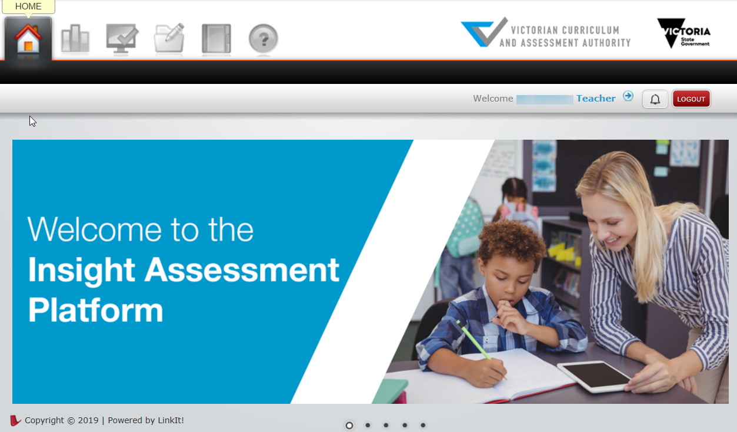
Figure 2.0: Insight Home screen
Once you have logged into Insight, your name will appear on the top right corner of the Insight Home screen. If this is not the case, contact DET IMTD Service Desk or 1800 641 943.

Section 3: Managing staff and classes
Principals and Insight School Administrators have the ability to perform a range of functions, including managing staff, class and student information on Insight.
As your school uses CASES21,the staff, class and student data are managed for you by CASES21. Any edits made in Insight to staff, class or student data will be overridden by a CASES21 update that occurs daily. All changes to CASES21 before 4pm will appear in Insight the next day.
Principals and Insight School Administrators can still create ad hoc (non-homeroom) classes and co-teachers and change user roles.

Creating ad hoc classes and co-teachers
Adding a co-teacher to a class is required when an assessment is being delivered by a teacher who is not the homeroom teacher or when there is a team-teaching environment. Ad hoc classes can be created when a class that has students from different homerooms is required.
To create an ad hoc class:
- On the Insight Home screen, select the Data Admin icon. The Data Admin options will appear.
- Select Manage Classes. The Manage Classes screen will appear (see Figure 3.0).

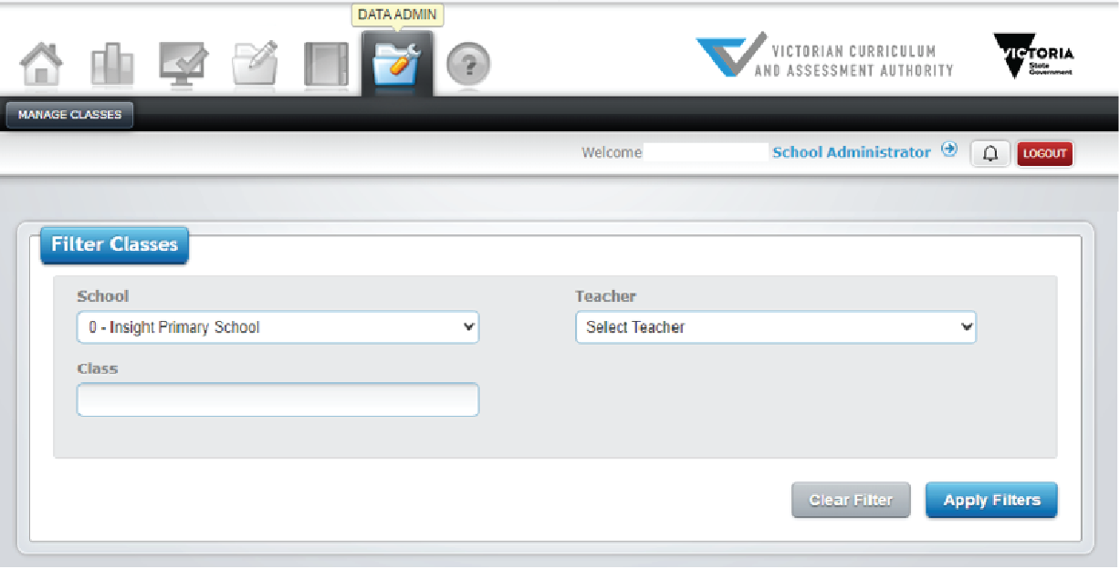
Figure 3.0 Manage Classes screen
- Select the required teacher from the Teacher drop-down box and click on the Apply Filters button. The Teachers class details will appear in the Classes window (see Figure 3.1)
- Click on the Add New Class button in the Classes window. The Add Class screen will appear.
- Type in the name of the class in the Group/Course Name text box.
- Select the required teacher from the Teacher drop-down box.
- Select the class type from the Class Type drop-down box.
- Click on the Submit button. The class will be created.
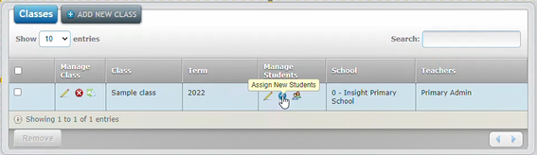
Figure 3.1 Classes window
Principals and Insight School Administrators have the ability to add students to ad hoc classes across all year levels and homeroom classes. Homeroom teachers can also create ad hoc classes however, they can only add students to it that that are in their homeroom class. Ad hoc classes are not affected by the CASES21 update that occurs daily.
To add students to an ad-hoc class:
- On the Insight Home screen, select the Data Admin icon. The Data Admin options will appear.
- Select Manage Classes. The Manage Classes screen will appear (see Figure 3.0).
- Select the year level from the Setting drop-down box.
- Select the teacher from the Teacher drop-down box.
- Click on the Apply Filters button. The class lists will appear in the Classes window below.
- Select the class you would like to add students to by clicking on the Assign New Students icon (see Figure 3.1). The Assign New Students screen will appear (see Figure 3.2).
- Using the grey check boxes in the far left select the students you wish to add to the class.
- Once the relevant students have been selected, click on the Add Student(s) to Class button (see Figure 3.2). The updated students will be stored.
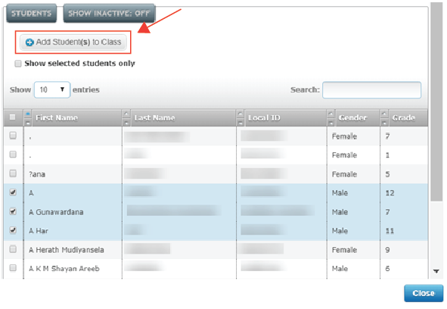
Figure 3.2 Assign New Students screen
To remove students from an ad hoc class:
- Follow the above steps 1–5.
- Under the class list, select Manage Current Students (see Figure 3.3)

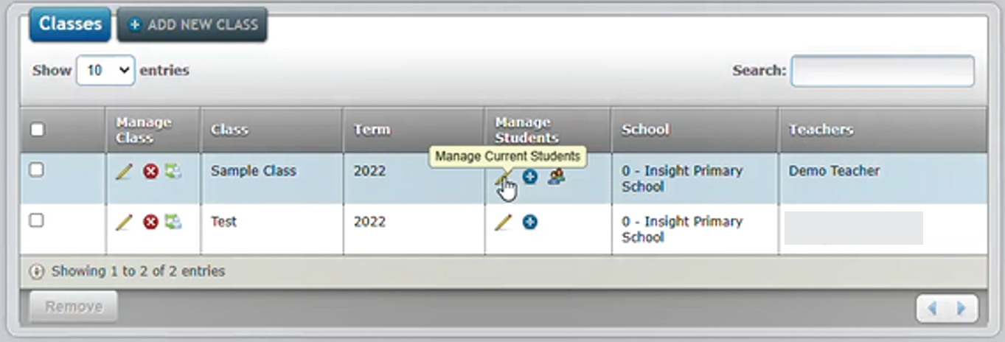
Figure 3.3 Manage Classes screen

- Click on the Remove button on the far left next to the students name you wish to remove from the class (see Figure 3.4). Confirm by clicking ok or cancel to finalise your response. The updated class list will be stored.

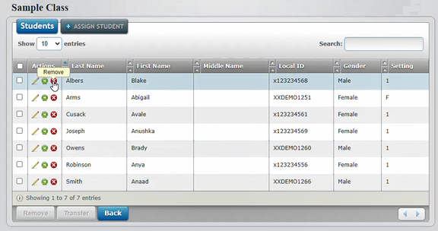
Figure 3.4 Manage Classes screen

To delete an ad-hoc class:
- You can only delete class when all students in the selected class are removed.
- Click on the Delete button on the far left next to the class you wish to remove (Figure 3.5)
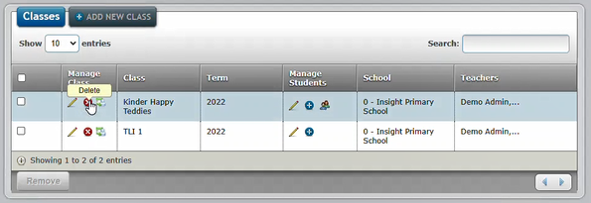
Figure 3.5 Manage Classes screen

To add a co-teacher:
- On the Insight Home screen, select the Data Admin icon. The Data Admin options will appear.
- Select Manage Classes. The Manage Classes screen will appear (see Figure 3.0).
- Click on the Apply Filters button. The class details will appear in the Classes window (see Figure 3.1).
- Click on the Assign Teacher icon under the Manage Classes column (see Figure 3.1). The Assign Teacher screen will appear (see Figure 3.4).
- Select the Teacher from the Teacher drop-down box.
- Select Co-teachers from the Level of Engagement drop-down box.
- Click on the Submit button. The co-teacher will be added to the class. As many co-teachers as required can be added to a class.
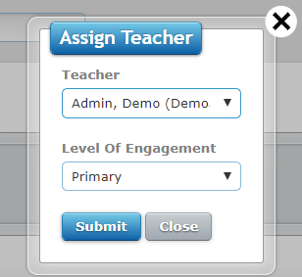
Figure 3.6 Assign Teacher screen

To remove a co-teacher:
- Click on the Edit icon (the pencil) under the Manage Classes column (see Figure 3.1). The Edit Class screen will appear.
- Click on the Remove from Class icon (the red circle with a white cross). A prompt will appear asking if you are sure you want to remove this teacher. Click on the OK button.
- Select Co-teachers from the Level of Engagement drop-down box.
- Click on the Submit button. The co-teacher will be removed from the class.

For Principal only (Manage Staff)
To change a user role:
- On the Insight Home screen, select the Data Admin icon. The Data Admin options will appear.
- Select Manage Users. The Manage Users screen will appear (see Figure 3.5).
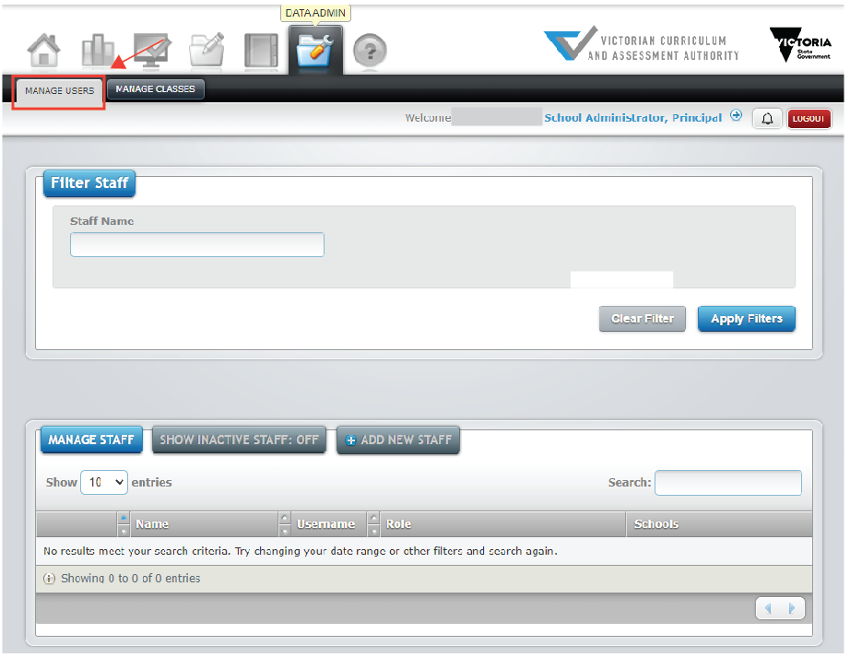
Figure 3.7 Manage Users screen
- Click on the Apply Filters button. The staff list will appear in the Manage Staff window below.
- Select the staff member you would like to edit by clicking on the Edit icon (see Figure 3.6). The Edit Staff screen will appear (see Figure 3.7).
- Select the role you would like to assign from the Role drop-down list. Note: only Role should be amended. Any other changes will be overwritten in the nightly CASES21 data upload.
- Once the relevant changes have been made, click on the Submit button. The updated details will be stored.
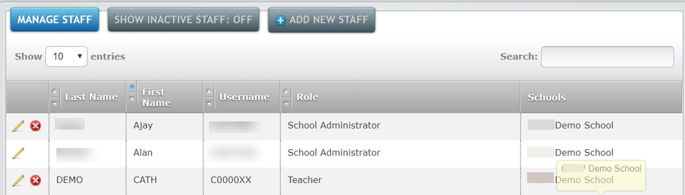
Figure 3.8 Manage Staff window

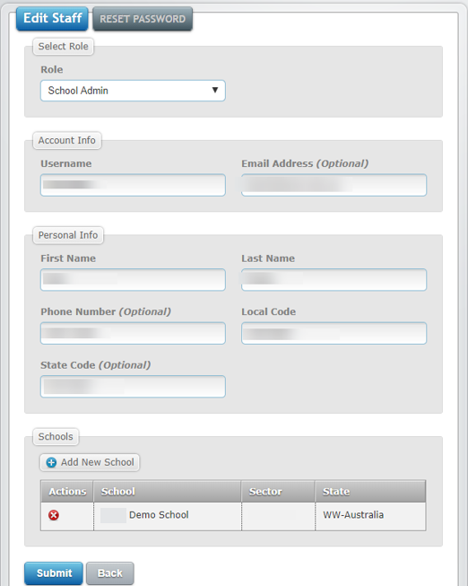
Figure 3.9 Edit Staff screen

Section 4: Assessment delivery
For instructions on how to set up assessments for delivery to students and conducting assessments please see the Government School Assessment Delivery and Reporting User Guide.
For instructions on how to access reporting options:
- Assessment Tools – Insight Platform Reporting Guide
- Transition Learning and Development Statements (TLDS) - School User Guide

Section 5: System support
It is possible to get on-screen help for Insight. This help consists of being directed to the Insight Assessment Platform webpage, where information about Insight and the assessments it houses can be accessed.
To access Insight support:
- On the Insight Home screen, select the Help icon. The Help Resources tab will appear.
- Click on the Help Resources tab. The Insight Assessment Platform Web page will appear.
For further support, contact DET IMTD Service Desk or 1800 641 943.

