Insight Assessment Platform

Independent School Teacher Assessment Delivery User Guide

Authorised and published by the Victorian Curriculum and Assessment Authority
Level 7, 2 Lonsdale Street
Melbourne VIC 3000
ISBN: 978-1-925867-32-9
© Victorian Curriculum and Assessment Authority 2023

No part of this publication may be reproduced except as specified under the Copyright Act 1968 or by permission from the VCAA. Excepting third-party elements, schools may use this resource in accordance with the VCAA educational allowance. For more information go to: www.vcaa.vic.edu.au/Pages/aboutus/policies/policy-copyright.aspx.
The VCAA provides the only official, up-to-date versions of VCAA publications. Details of updates can be found on the VCAA website: www.vcaa.vic.edu.au.
This publication may contain copyright material belonging to a third party. Every effort has been made to contact all copyright owners. If you believe that material in this publication is an infringement of your copyright, please email the Copyright Officer: vcaa.copyright@education.vic.gov.au.
Copyright in materials appearing at any sites linked to this document rests with the copyright owner/s of those materials, subject to the Copyright Act. The VCAA recommends you refer to copyright statements at linked sites before using such materials.

The VCAA logo is a registered trademark of the Victorian Curriculum and Assessment Authority.

Contents
Introduction 3
About the Insight Assessment Platform 3
About this user guide 3
Additional user guides 3
Section 1: Setting up your school 4
Section 2: Log in 4
Section 3: Functionality 5
Section 4: Setting up an assessment session 6
Assigning students to an assessment 6
Assigning a class to an assessment 8
Assigning a group to an assessment 8
Reviewing assessment codes 8
Section 5: Printing and reviewing assessments 10
Section 6: Conducting an assessment 12
Accessing the Test Taker 12
Completing an assessment 13
Section 7: Accessing an assessment for marking 15
Section 8: Marking assessments 16
Section 9: Printing marked assessments 19
Section 10: System help 19

Introduction

About the Insight Assessment Platform
The Insight Assessment Platform (Insight) is an online assessment platform. It assists teachers to assess student progress and apply more targeted teaching practices through its powerful data analytics and reporting capabilities. Teachers can review student assessment data for diagnostic, formative and summative purposes.
Currently the Platform has six instruments, with more under development:
- English Online Interview (EOI), targeting Years F–2
- Mathematics Online Interview (MOI), targeting Years F–2
- Fractions and Decimals Online Interview (FDOI), targeting Years 5–10
- Transition Learning and Development Statement (TLDS), targeting Kindergarten–Year F
- Reading and Vocabulary Assessment for English as an Additional Language students (RVEAL)
- Diagnostic Assessment Tools in English (DATE), targeting Years F–4
- Intercultural Capabilities, targeting Years F–10.
For more information about these instruments, see the Assessment Tools section of the Insight webpage.

About this user guide
This guide provides teachers in Government schools with information and support to use Insight, including:
- Setting up assessments for delivery to students.
- Assessment delivery.
- Reporting on assessments.

Additional user guides
The following user guides are available for Government schools to learn more about using Insight:
- Technical Support Staff User Guide.
- School Admin - Administrator User Guide.
- Insight Platform Reporting Guide.
For more information see the Non-government section of the Insight webpage.

Section 1: Setting up your school
Before you log in, your school must be registered on Insight, and teachers, students and classes set up.
Independent schools must be registered, and staff, students and classes set up before able to log in and use Insight. You must contact insight@education.vic.gov.au and request your school to be registered. You will then receive instructions about how to set up your staff, students, and classes for using Insight.
For information regarding this set up, refer to the School Administrator Guide.

Section 2: Log in
Chrome or Firefox are the recommended internet browsers to access Insight.
To log in:
- Open your internet browser.
- Copy and paste https://www.vcaa.vic.edu.au/assessment/f-10assessment/insight/Pages/login.aspx or click here. The Insight Log In screen will appear.
- Select the Independent Schools button. A Log In screen will appear (see Figure 2.0).
- Enter the user name and temporary password provided in the email received from insight@linkit.com. The Insight Home screen will appear (see Figure 2.1).
- The Account Details screen will appear and you will be prompted to change and confirm your new password. Once you have updated your password the Insight Home screen will appear.
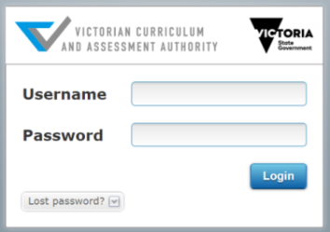
Figure 2.0: Log In screen
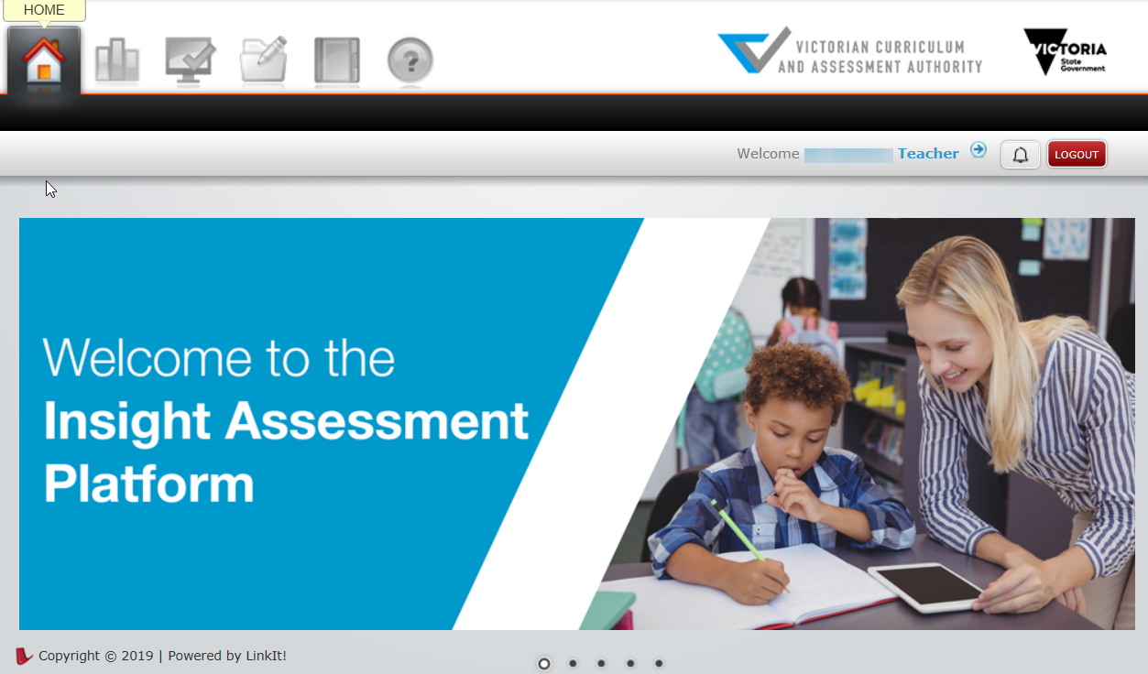
Figure 2.1: Insight Home screen
Once you have logged into Insight, your name will appear on the top right corner of the Insight Home screen. If this is not the case, contact insight@education.vic.gov.au or your Insight School Administrator.

Section 3: Functionality
Insight allows a teacher to:
- assign students to test sessions
- display past and existing assignment codes, and modify existing ones as required
- conduct assessments
- produce reports on students’ submitted assessments
- print assessments
- access help.
Access to this functionality is via the five active icons at the top of the Insight Home screen (see Figure 2.1), as follows:
- Home – returns the user to the home screen.
- Reporting – allows the user to access the reporting function of Insight.
- Online Testing – allows the user to assign assessments to students, monitor assignment codes and conduct assessments.
- Test Management – allows the user to print assessments.
- Help – allows the user to access help on using Insight and the assessments it houses.
Once an icon is selected, the corresponding options will appear. To move between functions, select the required icon.

Section 4: Setting up an assessment session
In order to effectively conduct an assessment:
- your school must be registered on Insight
- teachers, classes and students must have been set up
- students must have been assigned to the assessment.
Refer to Section 1.

Assigning students to an assessment
In order for a student, or group of students, to complete an assessment, they must be assigned to it. Assigning a student or group to an assessment creates an assignment code, which must be selected or entered into the system in order to commence an assessment session.
Students can be assigned to an assessment:
- individually.
- as a sub-set of a class
- by entire class
- by group, consisting of more than one class or selected students from more than one class. A group must be created by the user before an assignment code can be created.
When assigning students to an assessment, the following options are available for selection:
- Student Level Assignment – allocate a unique assignment code to each student within a class or group.
- Use Class List at Time of Test Taking – automatically add students to an assignment code if they are added to the class after the assignment code was created. To assign an individual student to an assessment:
- On the Insight Home screen, select the Online Testing icon. The Online Testing options will appear.
- Select Assign Tests. The Assign Online Test screen will appear (see Figure 4.0).

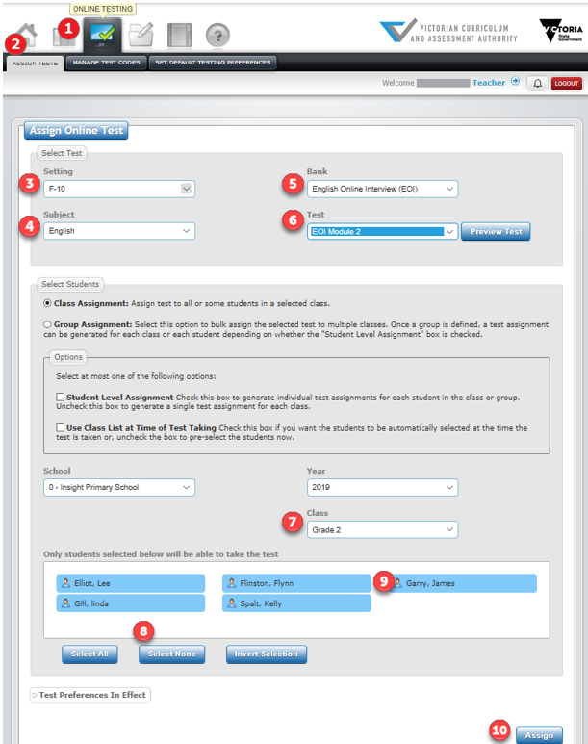
Figure 4.0 Assign Online Tests Screen

- Select the required setting from the Setting drop-down box.
- Select the required subject from the Subject drop-down box.
- Select the required test bank from the Bank drop-down box.
- Select the required test from the Test drop-down box.
- Select the class the student is in from the Class drop-down box. The records of all current students within the selected class will be highlighted to indicate that they are to be assigned to the test (Figure 4.0 number 8-10).

Assigning selected students within a class to an assessment
To assign selected students within a class to an assessment, follow the above steps 1–7 and then:
- Click on the Select None button. All student records will be deselected, indicating that none of them will be assigned to the test.
- Click on one or more student to be assigned to the test. It will become highlighted.
- Click on the Assign button. An assignment code will be created for the student, and will appear in the Test Assignment Codes box at the base of the screen.

Assigning a class to an assessment
To assign a class to an assessment, follow the above steps 1–7 and then:
- Select the student’s class from the Class drop-down box. The records of all students within the selected class will appear, highlighted to indicate that they are to be assigned to the test.
- Click on the Assign button. An assignment code will be created for the students within the class, and will appear in the Test Assignment Codes box at the base of the screen.

Assigning a group to an assessment
A group consists of more than one class, and must be created by the user before an assignment code can be created for it.
To create a group, follow the above steps 1–6 and then:
- In the Select Students section of the screen, select Group Assignment. The Add New Group button will appear.
- Click on the Add New Group button. The Add New Group pop-up box will appear.
- Enter a group name in the Name box.
- Click on the school record in the Schools column.
- Click on the year in the Terms column.
- Click on the teacher record in the Teachers column.
- Click in the box to the left of the classes required in the group in the Classes column.
- Click on the Add Classes button.
- Click on the Continue button. The group will be created.

Reviewing assessment codes
You can review existing assessment codes for a school for selected periods of time. Details of each assessment code that can be viewed include:
- date of assignment
- assessment name
- teacher
- assigned class
- status of assessment completion by student, i.e. not started, in progress, pending review or completed.
To view a list of assignments:
- On the Insight Home screen, select the Online Testing icon. The Online Testing options will appear.
2. Select Manage Test Codes. The Filter Test Assignments screen will appear.

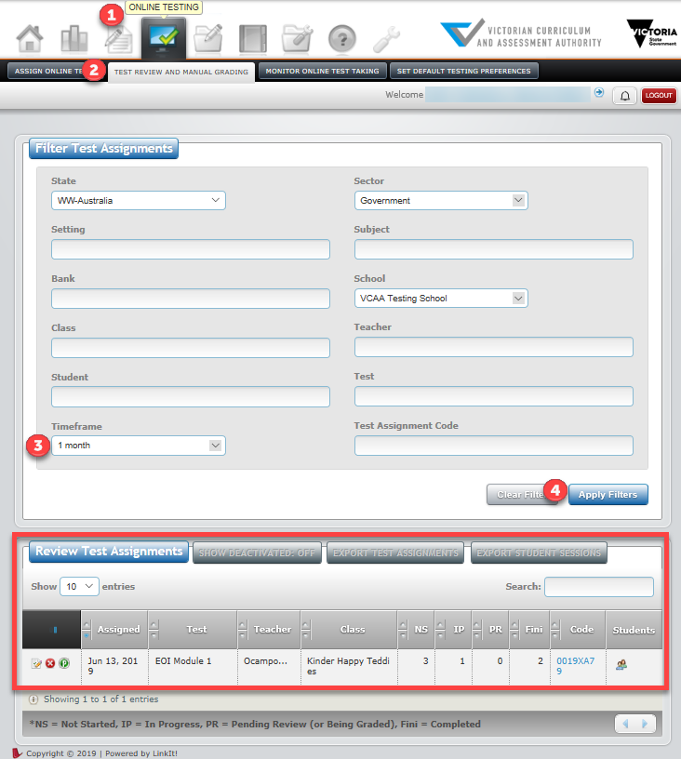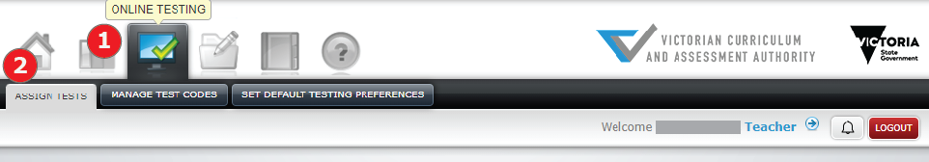
Figure 4.1: Filter Test Assignments screen
- Select the required length of time to be reported on using the Timeframe drop-down box.
- Click on the Apply Filters button. The test assignments created within the period of time entered will appear.

The Review Test Assignments icons:
The first icon is used to review test responses. When you select this icon, the Assignment Reviewer screen will appear.
The second icon is used to deactivate and hide test codes from view, to eliminate any confusion with old and current codes. When you select this icon, a prompt screen will appear, asking if you want to change the status of the assessment to inactive.
The third icon is used to adjust test settings (only for this test code), such as auto advance to next question, time limits and calculators. When you click on this icon, the Test Setting screen will appear.

Section 5: Printing and reviewing assessments
To view and print an assessment:
- On the Insight Home screen, select the Test Management icon. The Print Test option will appear.
- Click on the Print Test button. The Print Test screen will appear (see Figure 5.0).

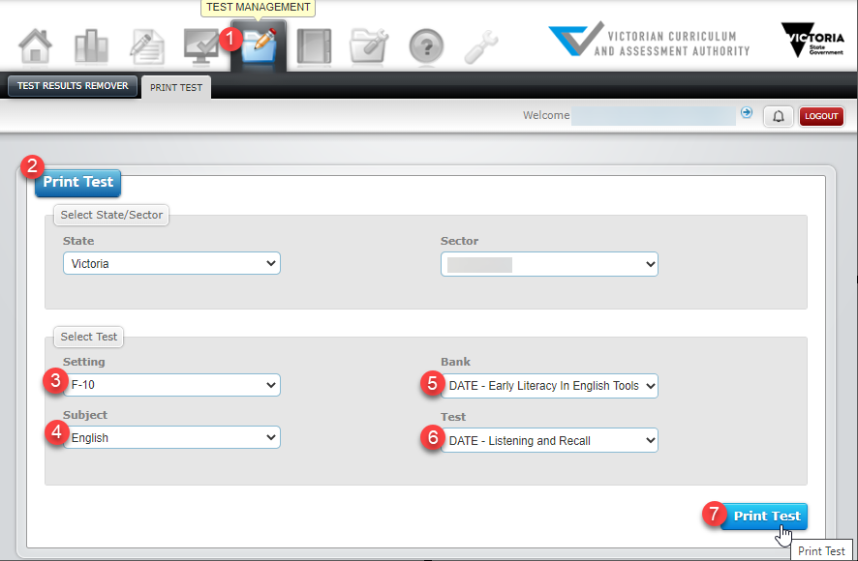
Figure 5.0: Print Test screen
- Select the required setting from the Setting drop-down box.
- Select the required subject from the Subject drop-down box.
- Select the required bank from the Bank drop-down box.
- Select the required test from the Test drop-down box.
- Click on the Print Test button. The Test Print screen will appear (see Figure 5.1).

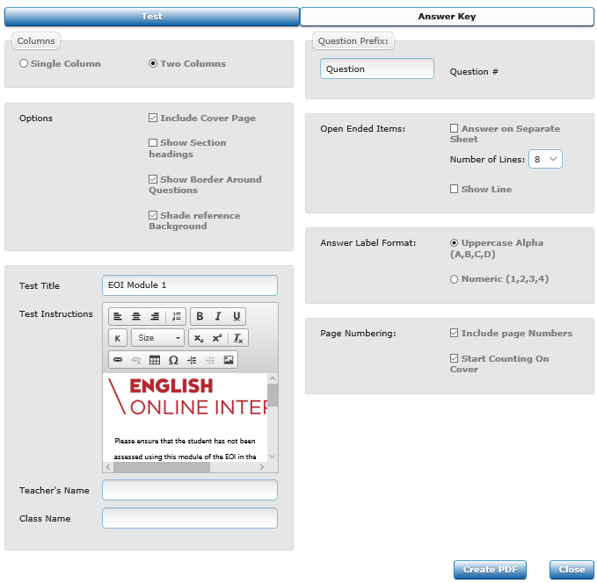
Figure 5.1: Test Print screen
- Make changes to the print settings, as required.
- Click on the Create PDF button. The PDF of the assessment will be generated and the Create PDF pop-up box will appear.
- Click on the OK button. The PDF of the assessment will appear on screen, which you can print to paper if required.

Section 6: Conducting an assessment
In order to effectively conduct an assessment:
- your school must have been registered on Insight
- teachers, classes and students must have been set up
- students must have been assigned to the assessment.
Refer to Section 1 regarding steps 1 and 2 and to Section 4 regarding step 3.

Accessing the Test Taker
Teachers and students complete assessments using the Test Taker function. There are three ways to access the Test Taker:
- From the Assign Tests screen (see Section 4 Figure 4.0) using the Assignment code hyperlink. This method is generally used to commence assessing immediately after students have been assigned to an assessment.
- From the Filter Test Assignments screen (see Figure 6.0).
- From the URL http:/test.linkitau.com. If this method is used, the appropriate assignment code must be entered.
To access the Test Taker via the Assign Online Test screen:
- On the Insight Home screen, select the Online Testing icon. The Online Testing options will appear.
- Select Assign Tests. The Assign Online Test screen will appear (see Figure 4.0).
- Create an assignment code for the required students and assessment, as outlined in Section 4. The assignment code will appear in the Test Assignment Codes box at the base of the screen.
- If available, click on the Assignment Code hyperlink (see Figure 6.0). The Student Name screen, including the list of students assigned to that assignment code, will appear (see Figure 6.1). If the Assignment Code is not able to be selected, follow the instructions below to access the test via the URL.

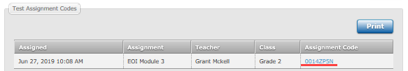
Figure 6.0: Test Assignment Codes
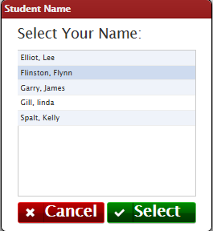
Figure 6.1 Student Name screen

To access the Test Taker via the Filter Test Assignments screen:
- On the Insight Home screen, select the Online Testing icon. The Online Testing options will appear.
- Select Manage Test Codes. The Filter Test Assignments screen will appear (see Figure 4.1).
- If available, click on the required Assignment code. The Student Name screen, including the list of students assigned to that assignment code, will appear (see Figure 6.1).
To access the Test Taker via the URL:
- Open your internet browser.
- Copy and paste or click on http:/test.linkitau.com. The Test Taker Login screen will appear. Manually enter the relevant Assignment code and select submit (see Figure 6.2).
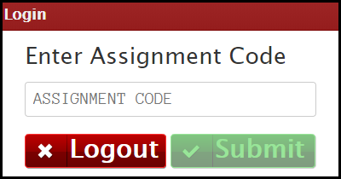
Figure 6.2 Test Taker Login screen
- The Student Name screen, including the list of students assigned to that assignment code, will appear (see Figure 6.1).

Completing an assessment
To complete an assessment when accessing the Test Taker via the Assign Online Test or the Filter Test Assignment screen:
- Access the Test Taker, using one of the screens. The Student Name screen, which includes the list of students assigned to the assignment code, will appear (see Figure 6.1).
- Select the name of the student to be assessed, then click the Select button. The Begin/Continue Assessment screen will appear (see Figure 6.3).
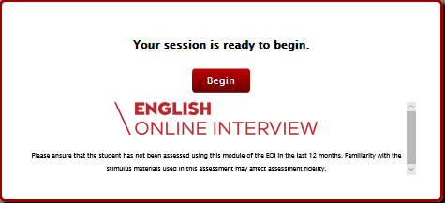
Figure 6.3 Begin Assessment screen
- Click on the Begin/Continue button. The assessment will begin.

To complete an assessment when accessing the Test Taker via the URL:
- Access the Test Taker as outlined above. The Test Taker Login screen will appear (see Figure 6.2).
- Enter the assignment code in the Assignment Code box and click on the Submit button. The Student Name screen, including the list of students assigned to the assignment code, will appear (see Figure 6.1).
- Select the name of the student to be assessed, then click on the Select button. The Begin/Continue Assessment screen will appear (see Figure 6.3).
- Click on the Begin/Continue button. The assessment will begin.
- The icons at the top of the assessment screen are numbered within Figure 6.4. Available icons vary between assessments. They are as follows:
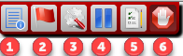
Figure 6.4 Icons at the top of the assessment screen
- Instruction icon. Clicking on this icon causes a pop-up box to appear, which contains any instructional information that has been entered for the assessment.
- Flags icon. Clicking on this icon will flag the current question as one that requires revisiting. Clicking on the icon when a question has already been flagged will ‘unflag’ it.
- Tools icon. Clicking on this icon makes ‘zoom in’ and ‘zoom out’ functions available, i.e. the content of the question can be made to appear larger or smaller.
- Pause icon. Clicking on this icon will allow the user to pause the assessment, with a view to revisiting it later.
- Questions/Section icon. Clicking on this icon will do different things, depending on the type of assessment being completed, as follows:
- For an assessment that does not include sections, a list of questions within the assessment will appear. Those questions that have been flagged will appear with a flag against them.
- For an assessment that does include sections, a list of those sections will appear and which questions have a response and any that have not been attempted yet..
- Submit icon. Clicking on this icon, when allowed, causes that assessment session to be flagged as completed and submitted.

Section 7: Accessing an assessment for marking
In order to effectively manually mark a student assessment, the following must have occurred:
- Your school must have been registered on Insight.
- Teachers, classes and students must have been set up.
- Students must have completed an assessment that includes at least one question that requires manual marking.
Certain question types, such as multiple-choice, are automatically marked by Insight. Any question that can be automatically marked is marked when the student assessment is submitted. There is no need to access the Manual Grading function for an assessment that contains only automatically marked questions.
Other question types, such as extended response, must be manually marked in order for a student to obtain a complete result set for an assessment that contains at least one question of these types. The Manual Marking function must be used to mark these questions.
Reports for submitted assessments cannot be generated until all required manual grading has been completed.
To access an assessment for marking:
- On the Insight Home screen, select the Online Testing icon. The Online Testing options will appear.
- Select Manage Test Codes. The Filter Test Assignments screen will appear (see Figure 2.0).
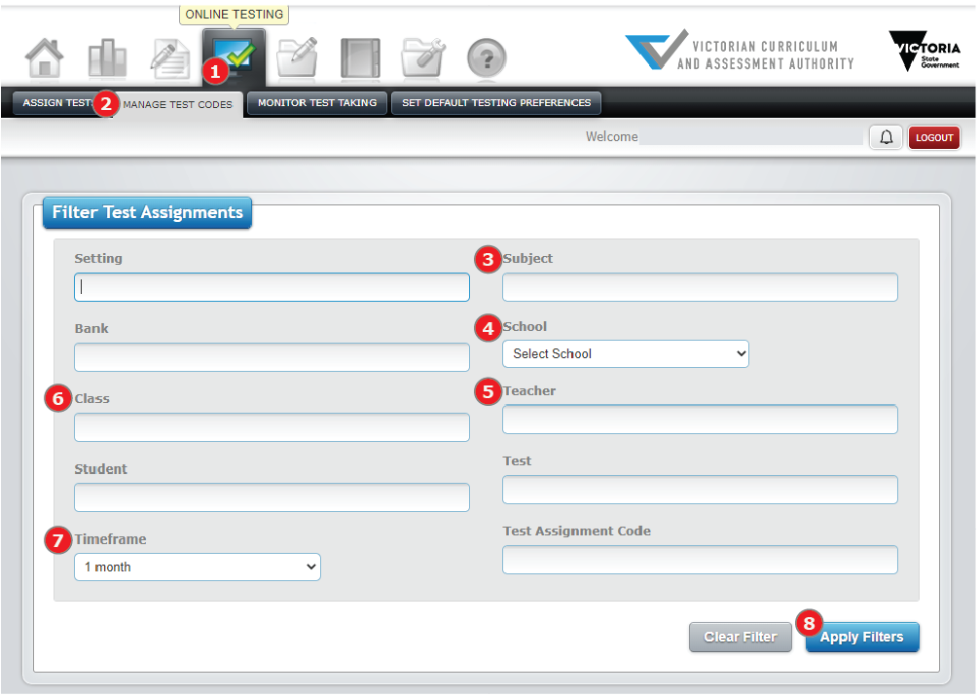
Figure 2.0 Filter Test Assignments screen

- Select the required school (if required) from the School drop-down box.
- Select the required timeframe from the Timeframe drop-down box.
- Fill in the field from 3 – 7 in Figure 2.0. Click on the Apply Filters button. Tests that have been completed by students will appear on the Review Test Assignments table of the screen (see Figure 2.1). The Review button will appear against assessments that require manual marking.
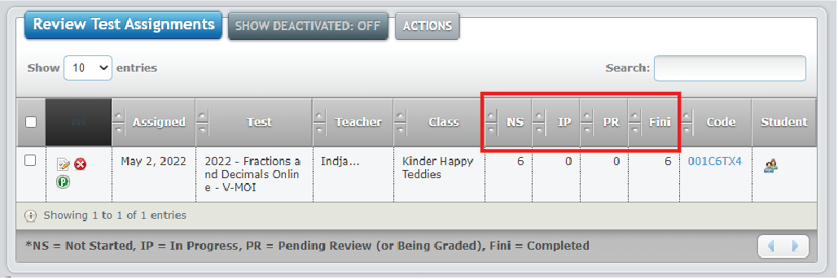 Figure 2.1 Review Test Assignments table
- Click on the Review button in the PR (Pending Review) column for the required assessment. The Assignment Review screen will appear.

Section 8: Marking assessments
The Manual Grading function of Insight allows a teacher to input scores against student assessments, where manual marking is required. Teachers are able to allocate marks for any item within an assessment that requires manual grading. Students can be allocated full, partial or no marks for an item, depending on the strength of their response.
Points to note before commencing marking are:
- Manual marking is done by test session, that is all students who completed items that require manual marking within a test session will need their assessments fully marked before marking is considered complete.
- Markers are strongly advised to moderate marks allocated with any other markers at their or other schools before considering marking complete.
- Once all marking within a test session is complete, in order for the results to be complete the marking must be submitted. However, once submitted marks entered cannot be changed. Do not submit a test until you are sure the marks you have entered will not change.
- Rubrics (marking guides) for each assessment are accessible within this section and should be referred to by teachers when marking student work.
To access the rubric for an assessment:
- On the Assignment Reviewer screen, click on the View Rubric button.
- Click on the Open tab. The rubric will appear.
In the Assignment Reviewer screen, you can choose to mark assessments either by student (the default) or by item. If choosing to mark by student, each of the questions requiring marking pertaining to each student will appear (see Figure 3.0), allowing you to mark each student’s work separately. If choosing to mark by item, each student’s response to that item will appear consecutively for marking (see Figure 3.1).
While entering marks, it is possible to annotate a mark using the Save Feedback function.
If marking by student you can:
- Select the required student to review from the Select Student to Review drop-down box.
- Select the required question to mark from the Question List. (See Figure 3.0).

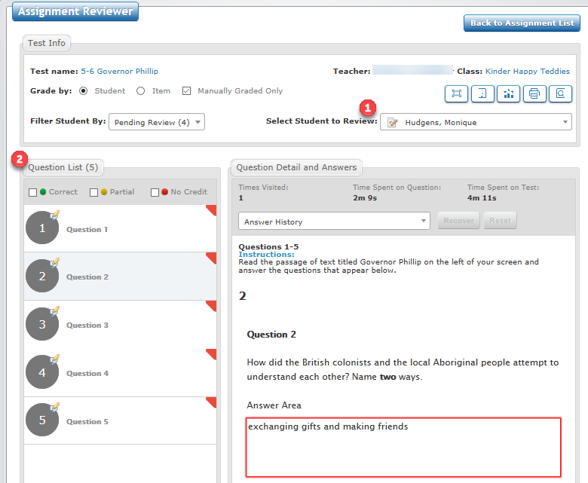
Figure 3.0 Assignment Reviewer screen by Student
To mark an item:
- On the Assignment Reviewer screen, accept the default of marking by student, or click on the Item radio button.
- Select the student and/or item to review.
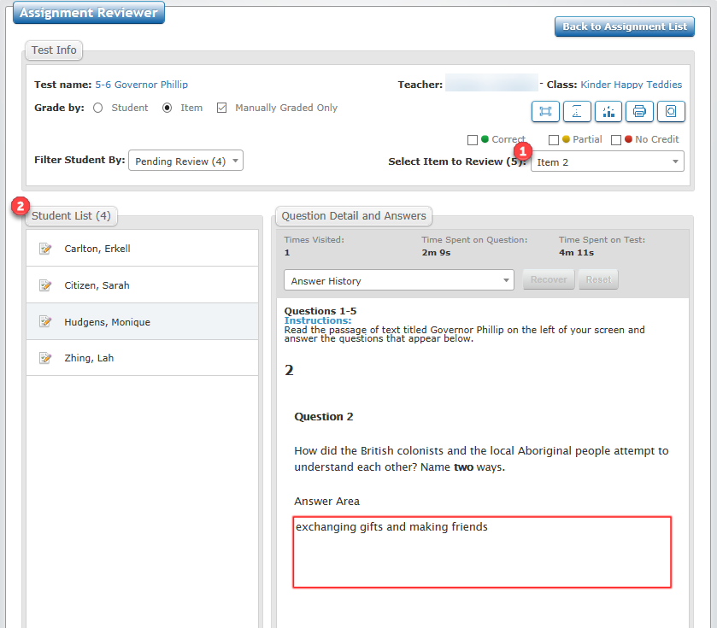
Figure 3.1 Assignment Reviewer screen by Item
- In the Grading and Feedback for Question box, accept the default mark or use the up arrow to select an alternative mark.
- If required, enter feedback in the feedback box and click on the Save Feedback button.
- Click on the Apply Grade button. The mark will be saved, and the next item to be marked will appear.
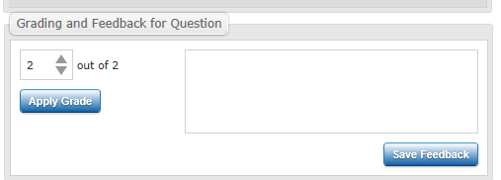
Figure 3.2 Grading and Feedback for Question
Once all required marks have been entered for the students within the selected test session, a pop-up box will appear at the bottom of the Assignment Reviewer screen. Tests must be submitted for the student assessments to become finalised and reportable. Once marks within a test session are submitted, they cannot be modified.
To submit a test:
- On the Assignment Reviewer screen, click on the Yes button within the Submit Test pop-up box. The marks will be submitted and will be reportable.

Section 9: Printing marked assessments
If required, it is possible print marked assessments. To print a marked assessment:
- On the Assignment Reviewer screen, select the print icon (Figure 3.0). The Print Options screen will appear.
- Select from the available options.
- Click on the Create PDF button. The PDF of the assessment will be generated and the Create PDF pop-up box will appear.
- Click on the OK button. The PDF of the assessment will appear on screen, which can be printed to paper, if required.

Section 10: System help
It is possible to get on-screen help for Insight. This help consists of being directed to the Insight Assessment Platform webpage, where information about Insight and the assessments it houses can be accessed.
To access help about Insight:
- On the Insight Home screen, select the Help icon. Click on the Help Resources tab. The Insight Assessment Platform Web page will appear.
For further support, contact insight@education.vic.gov.au

