Insight student user guide
Student user guide

Authorised and published by the Victorian Curriculum and Assessment Authority
Level 7, 2 Lonsdale Street
Melbourne VIC 3000
ISBN: 978-1-74010-048-9
© Victorian Curriculum and Assessment Authority 2020

No part of this publication may be reproduced except as specified under the Copyright Act 1968 or by permission from the VCAA. Excepting third-party elements, schools may use this resource in accordance with the VCAA educational allowance. For more information go to: www.vcaa.vic.edu.au/Pages/aboutus/policies/policy-copyright.aspx.
The VCAA provides the only official, up-to-date versions of VCAA publications. Details of updates can be found on the VCAA website: www.vcaa.vic.edu.au.
This publication may contain copyright material belonging to a third party. Every effort has been made to contact all copyright owners. If you believe that material in this publication is an infringement of your copyright, please email the Copyright Officer: vcaa.copyright@edumail.vic.gov.au.
Copyright in materials appearing at any sites linked to this document rests with the copyright owner/s of those materials, subject to the Copyright Act. The VCAA recommends you refer to copyright statements at linked sites before using such materials.

The VCAA logo is a registered trademark of the Victorian Curriculum and Assessment Authority.

Contact us if you need this information in an accessible format - for example, large print or audio.
Telephone (03) 9032 1635 or email vcaa.media.publications@edumail.vic.gov.au

Contents
Introduction 1
About the Insight Assessment Platform 1
About this user guide 1
Section 1: The Student Portal 2
Section 2: Accessing the Student Portal 2
Section 3: The Test Taker 2
Completing a practice examination 4
Section 4: Your results 5
Accessing results 5
Viewing results 5
Section 5: Support 6

Introduction

About the Insight Assessment Platform
The Insight Assessment Platform (Insight) is an online assessment platform. It houses 2019 VCE examinations in an online format to assist students with their revision and preparation for the VCE Examinations.

About this user guide
This guide provides students with information and support to use Insight, including:
- logging in to the student portal
- accessing the test taker, which will allow you to access 2019 VCE examinations
- reviewing reports on your performance.

Section 1: The Student Portal
Access to practice examinations are provided via Insight for revision only, you will only see the examinations for studies you are enrolled in, your performance on these will have no impact on your final VCE results. Your practice examination results will only be visible to your study teacher.
The Student Portal allows students to:
- access and complete practice examinations online
- instantly receive a score if a multiple choice only test is done
- view your results after practice examinations have been marked by the study teacher.
Access to this functionality is via the two active icons at the top of the Insight Home screen (see Figure 1.0), as follows:
- Online Testing – allows you to complete practice examinations that have been made available to you
- Reporting – allows the you to access your results for practice examinations.
Once an icon is selected, the corresponding options will appear. To move between functions, select the required icon.
Figure 1.0 Insight home screen icons

Section 2: Accessing the Student Portal
Chrome or Firefox are the recommended internet browsers to access Insight.
To log in:
- Open your internet browser.
- Copy and paste or click on https://vce.linkitau.com/student. The Insight Log In screen will appear.
- Enter your VCAA candidate number as the username the password. The Student Portal screen will appear.

Section 3: The Test Taker
Examinations are completed using the Test Taker. There are two ways to access the Test Taker:
- From the Online Testing screen in the Insight Student Portal (see Figure 3.0) by clicking on Launch in the action column.
- From the URL http:/test.linkitau.com. If this method is used, the appropriate assignment code must be entered. The assignment code will be provided to you by your teacher.

To access the Test Taker via the Online Testing screen:
- On the Insight Student Portal screen, select the Online Testing icon. The Online Testing screen will appear (see Figure 2.0).
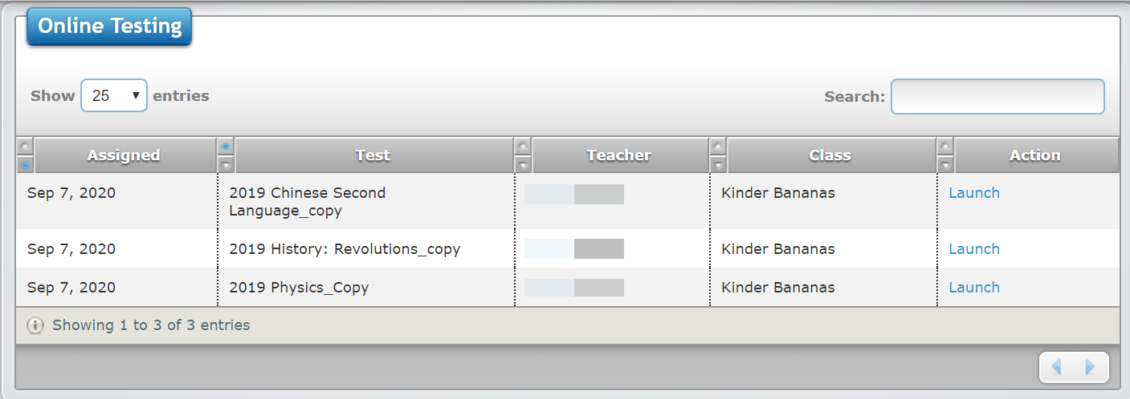
- Under the Actions column select Launch. The Test Taker screen will appear with the practice examination you have chosen (see Figure 3.3).
Figure 3.0 Online Testing screen
To access the Test Taker via the URL:
- Open your internet browser.
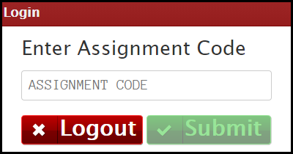
- Copy and paste or click on http:/test.linkitau.com. The Test Taker Login screen will appear. Enter the assignment code provided by your teacher and select submit (see Figure 3.1).
Figure 3.1 Test Taker Login screen
- The Student Name screen, with the list of students who have been assigned the practice examination, will appear (see Figure 3.2).
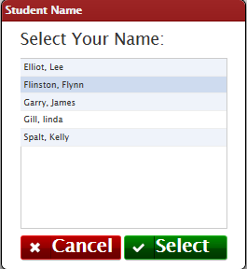
- Click on your name and and then on the select button. The Test Taker screen will appear.
Figure 3.2 Student Name screen

Completing a practice examination
- Access the Test Taker, using one of the above methods.
- The Begin/Continue Assessment screen will appear (see Figure 3.3).
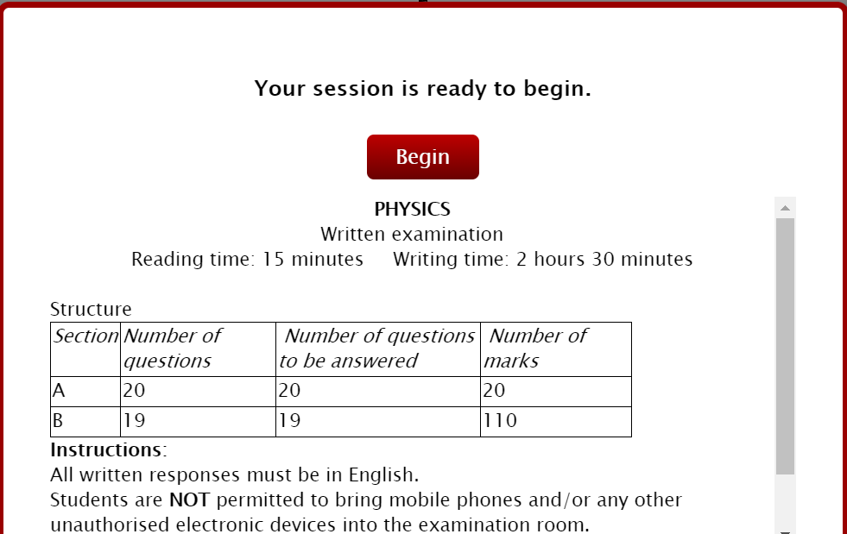
- Click on the Begin/Continue button. The practice examination will begin.
Figure 3.3 Begin Assessment screen

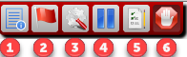
The icons at the top of the assessment screen are numbered within Figure 3.4. Available icons vary between practice examinations. They are as follows:
Figure 3.4 Icons at the top of the assessment screen
- Instruction icon: Clicking on this icon causes a pop-up box to appear, which contains any instructional information that has been entered for the practice examination.
- Flags icon: Clicking on this icon will flag the question as one that requires revisiting. Clicking on the icon when a question has already been flagged will ‘unflag’ it.
- Tools icon: Clicking on this icon makes ‘zoom in’ and ‘zoom out’ functions available, i.e. the content of the question can be made to appear larger or smaller.
- Pause icon: Clicking on this icon will allow the you to pause the practice examination, with a view to revisiting it later.
- Questions/Section icon: Clicking on this icon will do different things, depending on the type of practice examination being completed, as follows:
For a practice examimation that does not include sections, a list of questions will appear. Those questions that have been flagged will appear with a flag against them.
A list of sections will appear and which questions have a response and any that have not been attempted yet.
- Submit icon. Clicking on this icon, when allowed, causes that practice examination to be completed and submitted.

Section 4: Your results
You can view your results for practice examinations in the reporting section of the Insight Sudent Portal. If you have completed a multiple choice only examination, these results will be instantly available for you to view. If the practice examination you have done has short and/or extended answer questions, they must first be reviewed and marked by your teacher. Once your teacher has marked the practice examination, the results will become available for you to view.
Please note: any results will only be available for the calendar year plus three months.

Accessing results
- On the Insight Student Portal Home screen, select the Reporting icon. The Test Results button will appear.
- Select Test Results. The Test Results screen will appear (see Figure 4.0).
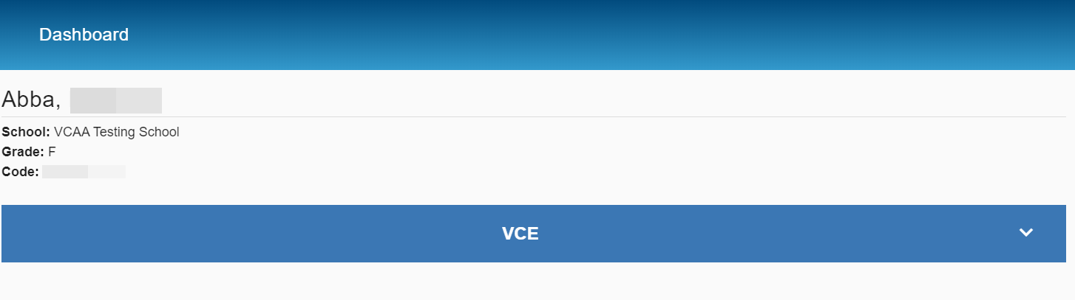
- Click on the blue VCE banner. A list of your completed practice examinations will appear below.
Figure 4.0 Reporting Dashboard

Viewing results
The following result options exist for each completed examination:
- Item review allows you to view a copy of your completed examination.
- Item detail allows you to view detailed information about your results for each individual question.
- A summary provides a brief overview of your total score in both percentage and raw score.
Remember with the exception of multiple choice only practice examinations, a practice examination will not be visible in the results screen unless your teacher has marked it.
To access the Item review, follow the above steps 1–3, then:
- Click on the practice examination you want to review.
- Click on the red icon, the Item review screen will appear. Navigation of the Item review is the same as the Test taker. Refer to Section 3 of this guide for instructions.

To access Item detail, follow the above steps 1–3, then:
- Click on the practice examination you want to review.
- Click on the purple icon , the Item detail screen will appear (see Figure 4.1).
To view your response to a question click on the question number in the scoring table and the answer screen will appear.
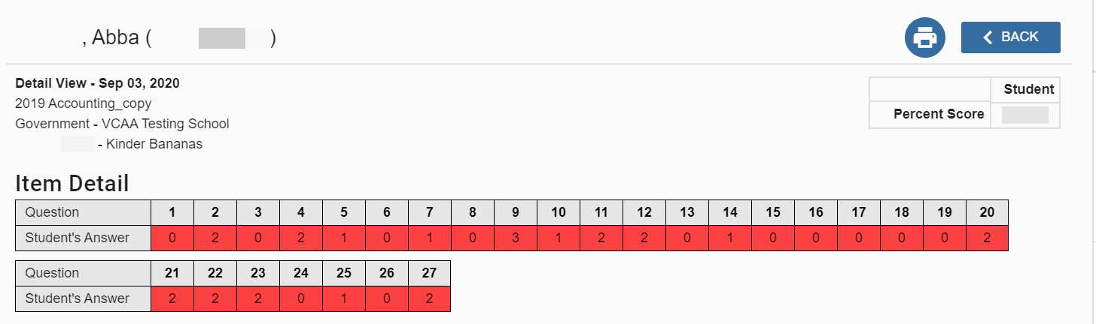
To navigate back to your results screen, click on the blue back button (see Figure 4.1).
Figure 4.1 Item detail screen

Section 5: Support
Support for students using Insight is provided by your classroom teachers. If you are unsure of something or experiencing technical issues, please make contact with your school.

