Student eligibility to complete VM programs

VCE VM eligibility
The VCE VM eligibility report must be run for all Year 12 students intending to complete their VCE VM this year using the menu: Student Program > VCE Reports > VCE Student Eligibility and selecting VCE VM as the Certificate type in the parameter screen.
Schools are reminded that the VCE VM eligibility program must be re-run whenever enrolment changes are made or following the entry of ‘N’ or ‘J’ results, particularly for VCE English group studies, Unit 3 results and other units required to receive a VCE VM as it is likely this will affect a student’s eligibility to complete their VCE VM in 2023.
All students who are enrolled in a VCE VM program must meet the requirements of the VCE before they can achieve the VCE VM.
For VCE VM students who have completed VCAL Intermediate or Senior in 2022, the existing satisfactory completion rules for obtaining the VCE after completing a VCAL at Senior or Intermediate apply with the addition of the following requirement:
- One of the Unit 3-4 sequences required must be a VCE VM or a prescribed Senior VCAL sequence being delivered as part of a VCE VM program as per the 2023 transition arrangements.
For students who have partially completed VCE, a VCAL certificate at any level or completed VCAL Foundation, the existing satisfactory completion rules for obtaining the VCE apply with the addition of the following requirements to obtain the VCE VM:
- 2 VCE VM Numeracy or VCE Mathematics units
- 2 VCE VM Work Related Skills units
- 2 VCE VM Personal Development Skills units
- 2 VET units at Certificate II level or above (180 nominal hours)
This includes Senior VCAL units being delivered as part of a VCE VM program as per the 2023 transition Arrangements.
The VCE VM eligibility report will identify students not eligible to complete their programs this year and provide the reason(s) why which must be investigated and actioned immediately.

How to read the VCE VM eligibility report
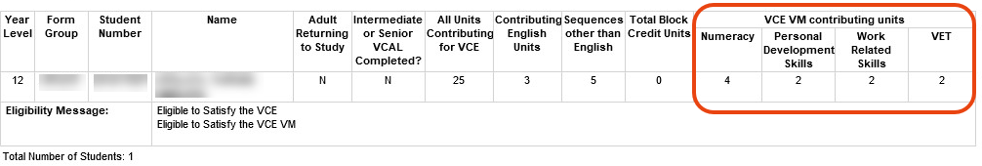
‘Contributing VCE VM Units’ for each stream can have the value 0, 1 or 2 or above as follows:
- Where report count is 0 or 1
- Student has 0 or 1 units contributing to the required stream
- E.g., ‘Student does not have student does not have sufficient PERSONAL DEVELOPLMENT SKILLS units’
- ‘Ineligible to satisfy the VCE VM’
- Where report count is 2 or more in each required stream
- ‘Eligible to satisfy the VCE VM’

Transition credit arrangements
The VCAA has approved credit arrangements for all known cases where students are carrying forward a Unit 3-4 sequence from their satisfied 2022 VCAL Intermediate program. The credit will appear on the students’ Student Full Details Report as ‘VCE VM Transition Credit’. If you believe you have any students that fall into this category that have not received credit, please contact Student Records and Results (SRRU)
Additionally, the following transition credit arrangements for 2023 combinations are not accommodated in the VCE eligibility program and will be manually applied to students’ programs at the end of the year where necessary.
Any Senior VCAL Numeracy Unit and 90 nominal hours
of VET at Australian Qualifications Framework (AQF) level II or above
Senior VCAL Personal Development Skills Unit 1 or 2
and 90 nominal hours of VET at AQF level II or above
Senior VCAL Work Related Skills Unit 1 or 2 and 90 nominal hours of VET at AQF level II or above

Schools who believe a student should be eligible to achieve the VCE or VCE VM and are showing as ineligible must be investigated and schools should contact SRRU for advice if required. For further information on transition arrangements, please refer to the transition webpage < https://www.vcaa.vic.edu.au/victorianseniorsecondarycertificatereform/Pages/Index.aspx#AwardingVCAL2023>
Other eligibility reports

VCE eligibility
The VCE eligibility report MUST be run for all Year 12 students intending to complete their VCE this year using the menu: Student Program > VCE Reports > VCE Student Eligibility.
The minimum requirement for satisfactory completion of the VCE is 16 units, which must include:
- three units from the English group, including a Unit 3–4 sequence
- at least three sequences of Unit 3–4 studies other than English, which may include any number of English sequences once the English requirement has been met.
The reports will identify students not eligible to complete their programs this year and provide the reason(s) why and must be investigated and actioned immediately.

VPC eligibility
The eligibility report MUST be run for students in any year level who intend to complete the VPC Certificate this year using the menu: STUDENT PROGRAM > VPC/VCAL Reports > Student Eligibility. Students identified as Not Eligible to complete (Eligible? N) will also list the reason(s) why.

VCAL Intermediate eligibility
The eligibility report MUST be run for students in any year level who intend to complete a VCAL Certificate this year using the menu: STUDENT PROGRAM > VPC/VCAL Reports > Student Eligibility. Students identified as Not Eligible to complete (Eligible? N) will also list the reason(s) why.

Removing non-current students from VASS
Year 11 and 12 students appearing on the Students Without a Program Report who are not at your school this year should be removed by entering an Exit Date in menu Student ADMIN > Student Exit > Student Exit clicking on [Save] then [Delete]. This process will assist schools in maintaining a current student database.

