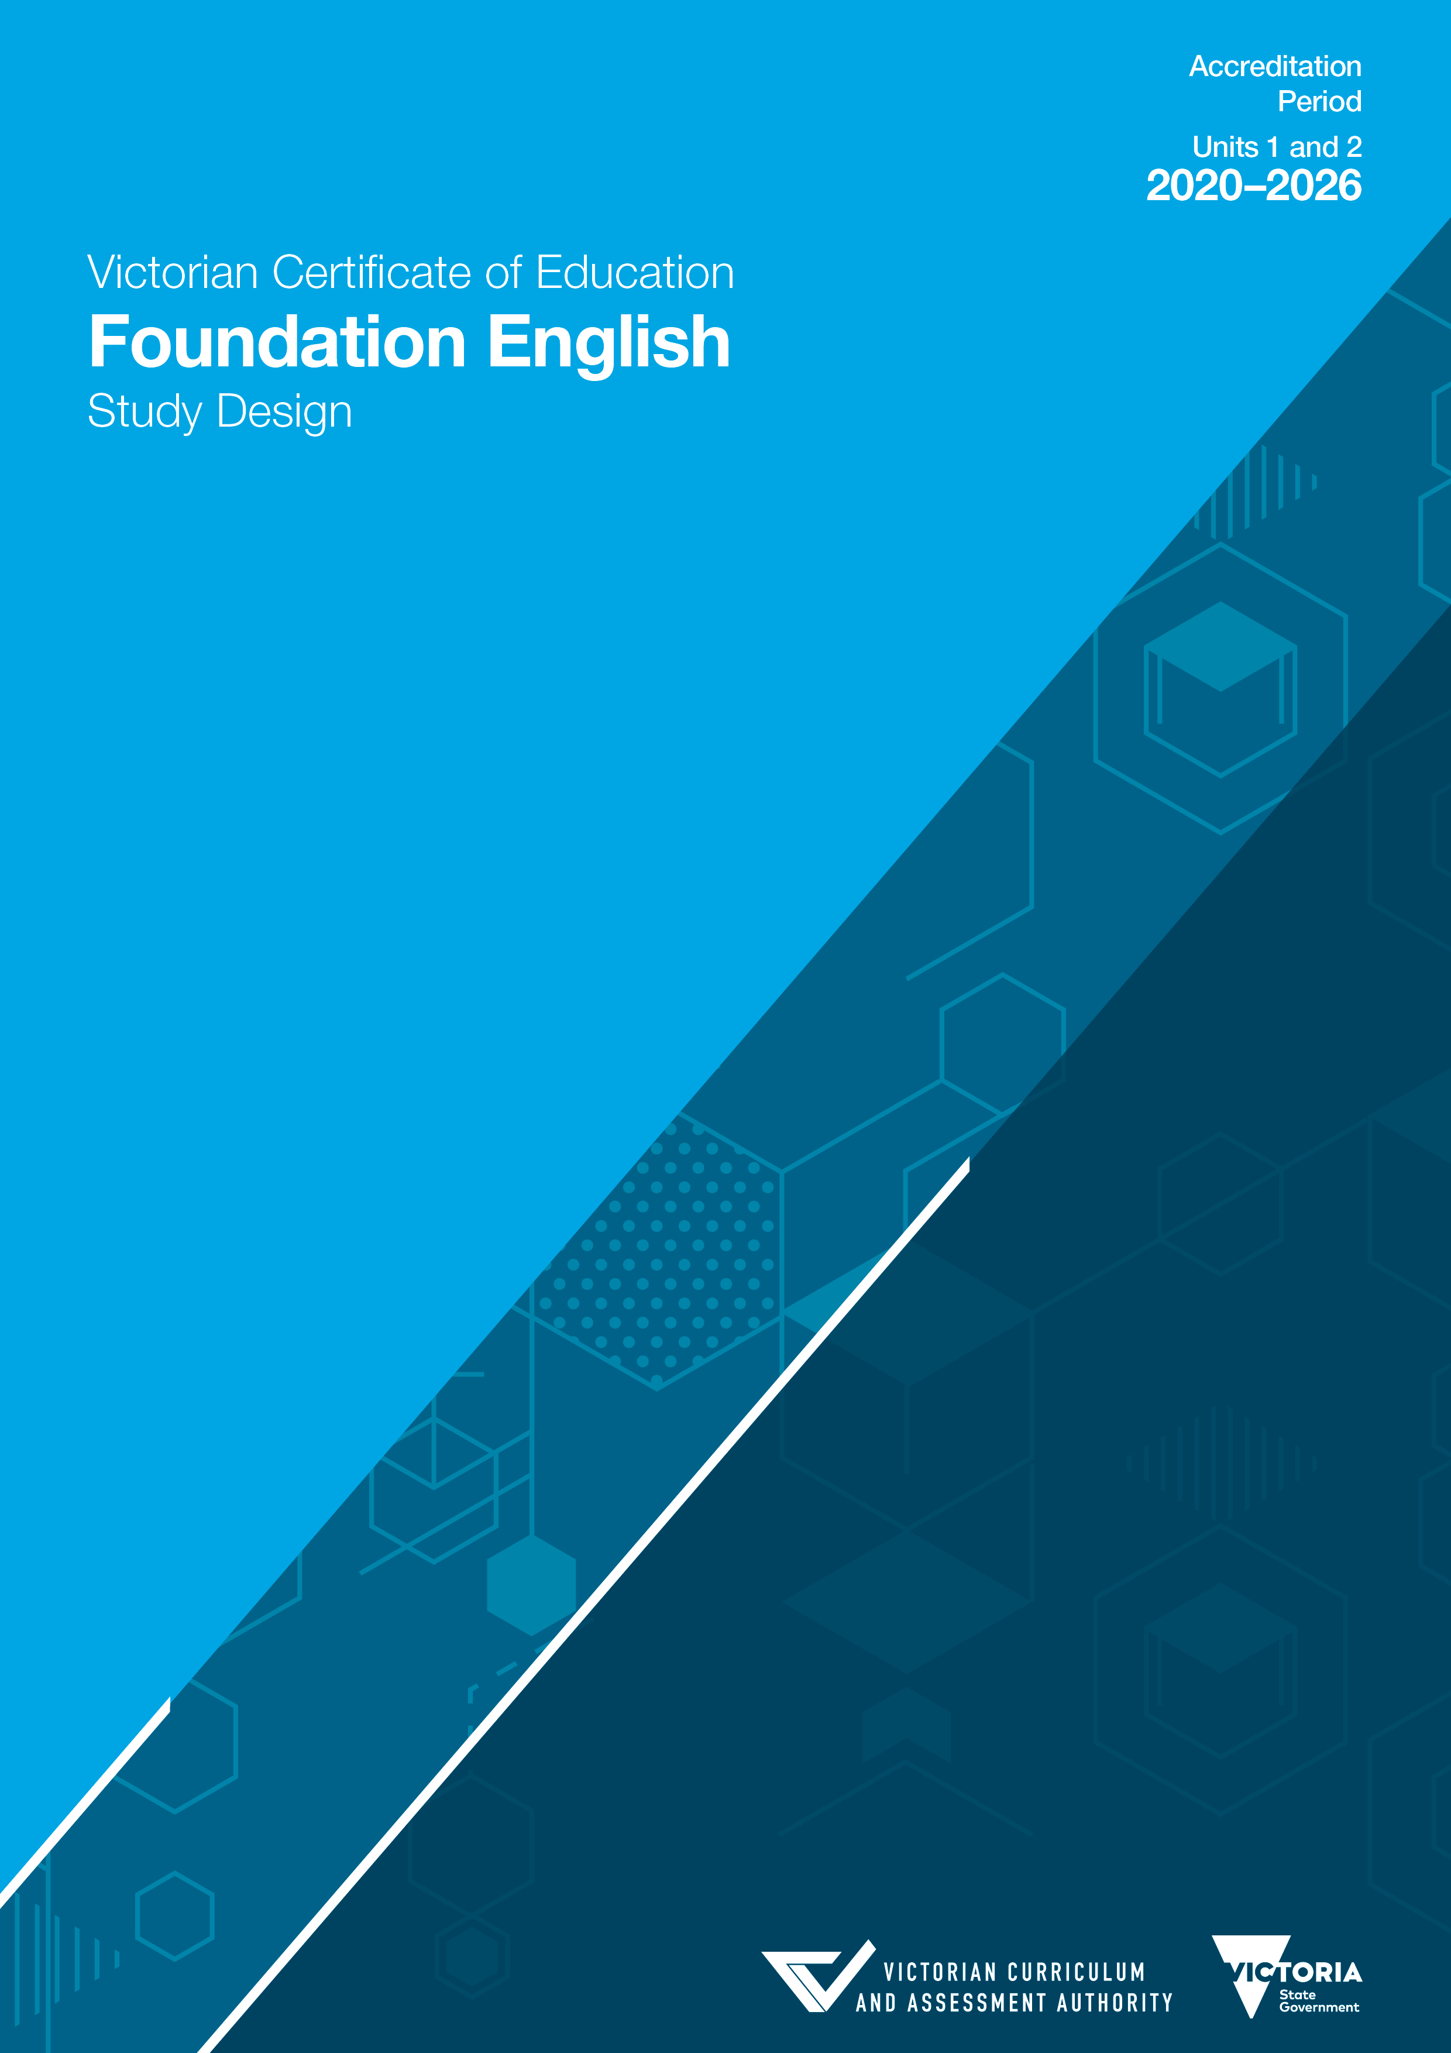
Authorised and published by the Victorian Curriculum and Assessment Authority
Level 7, 2 Lonsdale Street
Melbourne VIC 3000
Accredited by the Victorian Registration and Qualifications Authority
Level 4, 2 Lonsdale Street, Melbourne VIC 3000
ISBN: 978-1-925676-90-7
© Victorian Curriculum and Assessment Authority 2018

No part of this publication may be reproduced except as specified under the Copyright Act 1968 or by permission from the VCAA. Excepting third-party elements, schools may use this resource in accordance with the VCAA educational allowance. For more information go to: www.vcaa.vic.edu.au/Footer/Pages/Copyright.aspx.
The VCAA provides the only official, up-to-date versions of VCAA publications. Details of updates can be found on the VCAA website: www.vcaa.vic.edu.au.
This publication may contain copyright material belonging to a third party. Every effort has been made to contact all copyright owners. If you believe that material in this publication is an infringement of your copyright, please email the Copyright Officer: vcaa.copyright@edumail.vic.gov.au
Copyright in materials appearing at any sites linked to this document rests with the copyright owner/s of those materials, subject to the Copyright Act. The VCAA recommends you refer to copyright statements at linked sites before using such materials.

The VCAA logo is a registered trademark of the Victorian Curriculum and Assessment Authority.

Contents
Important information 1
Introduction 2
Scope of study 2
Rationale 2
Aims 2
Structure 3
Entry 3
Duration 3
Changes to the study design 3
Safety and wellbeing 3
Employability skills 3
Legislative compliance 3
Assessment and reporting 4
Satisfactory completion 4
Levels of achievement 4
Authentication 4
Unit 1: English for practical purposes 5
Area of Study 1 5
Area of Study 2 6
Area of Study 3 7
Assessment 8
Unit 2: Thinking and learning through English 9
Area of Study 1 9
Area of Study 2 10
Area of Study 3 10
Assessment 11

Important information
Accreditation period
Units 1 and 2: 1 January 2020 – 31 December 2026
Implementation of this study commences in 2020.
Other sources of information
The VCAA Bulletin is the only official source of changes to regulations and accredited studies. The Bulletin also regularly includes advice on VCE studies. It is the responsibility of each VCE teacher to refer to each issue of the Bulletin. The Bulletin is available as an
e-newsletter via free subscription on the VCAA’s website at: www.vcaa.vic.edu.au.
To assist teachers in developing courses, the VCAA publishes online the Advice for teachers, which includes teaching and learning activities for Units 1 and 2, and advice on assessment tasks.
The current VCE and VCAL Administrative Handbook contains essential information on assessment processes and other procedures.
VCE providers
Throughout this study design the term ‘school’ is intended to include both schools and other VCE providers.
Copyright
VCE schools may reproduce parts of this study design for use by teachers. The full VCAA Copyright Policy is available at: www.vcaa.vic.edu.au/Footer/Pages/Copyright.aspx.

Introduction
Scope of study
VCE Foundation English focuses on how English is used to communicate through written, spoken and multimodal texts of varying complexity.
Teachers may select a range of texts for study from the past and from the present, from Australia and from other cultures. Other texts may be selected for the analysis and presentation of a persuasive text. The study is intended to meet the needs of students with a wide range of expectations and aspirations, including those for whom English is an additional language.
Rationale
The Foundation English study is designed for students who may require a more vocationally orientated approach to English or may be aiming to directly enter the workforce upon completing their senior secondary studies. It may also be suited to students who need additional time and assistance to strengthen and refine their literacy skills to support their study in VCE English and English as an Additional Language (EAL), VCE Literature, or VCE English Language Units 1–4 and in other VCE studies.
Foundation English enables students to improve their skills in comprehending and responding to a variety of texts, and to enhance their overall communication skills. The study may be taken as a bridging course into the VCE or by students completing technically orientated courses. Foundation English also provides an opportunity for students to develop stronger connections between the Australian Core Skills Framework and their English studies. Each area of study offers scope for teacher discretion to tailor the course to the needs of their cohort. This can be done, for instance, through the selection of appropriate texts. For students in vocational courses, more emphasis can be given to workplace texts. For students using Foundation English as a bridge into VCE English, greater prominence can be given to literary works. The flexibility in assessment tasks also enables teachers to cater for the needs of their students.
Aims
This study enables students to:
- strengthen and extend their competence and confidence in using Standard Australian English in meeting the demands of further study, the workplace and their own needs and interests
- strengthen and extend their language skills through thinking, reading, writing, speaking and listening
- communicate ideas and information effectively using the conventions of written and spoken language
- listen and speak in a range of informal and formal settings for different audiences and purposes
- read a range of texts to construct personal, creative, comparative and critical responses
- read accurately to locate, extract, understand, organise and synthesise ideas and information
- control the conventions of Standard Australian English in order to edit and proofread their writing to enhance accuracy of expression and clarity of meaning
- acquire a vocabulary to talk precisely about language and texts.
Structure
The study is made up of two units:
Unit 1: English for practical purposes
Unit 2: Thinking and learning through English
Each unit deals with specific content contained in areas of study and is designed to enable students to achieve a set of outcomes for that unit. Each outcome is described in terms of key knowledge and key skills.
Entry
There are no prerequisites for entry to Units 1 and 2. All VCE studies are benchmarked against comparable national and international curriculum.
Duration
Each unit involves at least 50 hours of scheduled classroom instruction.
Changes to the study design
During the period of accreditation minor changes to the study will be announced in the VCAA Bulletin. The Bulletin is the only source of changes to regulations and accredited studies. It is the responsibility of each VCE teacher to monitor changes or advice about VCE studies published in the Bulletin.
Safety and wellbeing
It is the responsibility of the school to ensure that duty of care is exercised in relation to the health and safety of all students undertaking the study.
Employability skills
This study offers a number of opportunities for students to develop employability skills. The Advice for teachers provides specific examples of how students can develop employability skills during learning activities and assessment tasks.
Legislative compliance
When collecting and using information, the provisions of privacy and copyright legislation, such as the Victorian Privacy and Data Protection Act 2014 and Health Records Act 2001, and the federal Privacy Act 1988 and Copyright Act 1968, must be met.

Assessment and reporting
Satisfactory completion
The award of satisfactory completion for a unit is based on the teacher’s decision that the student has demonstrated achievement of the set of outcomes specified for the unit. Demonstration of achievement of outcomes and satisfactory completion of a unit are determined by evidence gained through the assessment of a range of learning activities and tasks.
Teachers must develop courses that provide appropriate opportunities for students to demonstrate satisfactory achievement of outcomes.
The decision about satisfactory completion of a unit is distinct from the assessment of levels of achievement.
Levels of achievement
Units 1 and 2
Procedures for the assessment of levels of achievement in Units 1 and 2 are a matter for school decision. Assessment of levels of achievement for these units will not be reported to the VCAA. Schools may choose to report levels of achievement using grades, descriptive statements or other indicators.
Authentication
Work related to the outcomes of each unit will be accepted only if the teacher can attest that, to the best of their knowledge, all unacknowledged work is the student’s own. Teachers need to refer to the current VCE and VCAL Administrative Handbook for authentication procedures.

Unit 1: English for practical purposes
In this unit, students focus on developing language and communication skills, primarily through the study of a variety of texts. They develop communication skills in order to listen, speak, read and write effectively in academic, workplace and social contexts.
Area of Study 1
Reading and viewing texts
In this area of study students read a variety of academic, workplace or everyday texts to identify key information and ideas. They recognise the purposes, structures and features of different text types, for example narratives, arguments, reports, recounts and procedures. Students extend their knowledge of the layout and format of a range of texts and use indexes, headings, subheadings, chapter titles, section summaries, blurbs, menus, links and hyperlinks to locate, read and extract information and ideas. They employ reading strategies, such as skimming and scanning, identifying and selecting, visualising, inferring, interpreting, comparing and predicting. In addition, students learn to organise and synthesise information using strategies such as paraphrasing, summarising and note-taking, and techniques, such as bullet points, tables, concept maps and flow charts.
Students utilise a range of reading and viewing strategies to encourage the understanding and appreciation of both literary and non-literary texts. They develop their ability to access and navigate digital texts.
Outcome 1
On completion of this unit the student should be able to produce prose and graphic summaries and explanations of specified texts.
To achieve this outcome the student will draw on key knowledge and key skills outlined in Area of Study 1.
Key knowledge
- the structures and features of different text types, such as narratives, poetry, media articles, blogs, e-zines, letters, emails, reports, films and documentaries
- literary and stylistic devices and the vocabulary used to discuss the language and meaning of literary texts, such as short stories, poetry, novels and film
- strategies used in reading for different purposes, such as skimming, scanning, paraphrasing, note-taking and summarising
- the process of planning, drafting, revising, editing and proofreading written texts.
Key skills
- identify the layout, design and structural elements of print and digital texts
- identify the purpose and target audience of a range of print and digital texts
- paraphrase sections of a text to identify and communicate the main ideas efficiently
- understand the way visual and auditory cues, language techniques and other strategies are used to convey meaning in texts
- read written and visual texts in print and digital formats for information and to identify opinion and bias
- create digital and hand-written graphic outlines, concept maps, bullet points and flow charts to summarise and organise the main ideas or elements of texts.
Area of Study 2
Creating texts
In this area of study students focus on the structures and features of written language in both handwritten and digital texts. They examine how purpose, context and audience influence the structure and language of texts. Students increase their understanding of spelling conventions, punctuation, syntax and paragraphing. They extend their knowledge of vocabulary commonly used in academic, workplace and social contexts. Students use processes of planning, drafting, revising, editing and proofreading written work for clarity, coherence, style and structure.
Outcome 2
On completion of this unit the student should be able to produce different text types for different purposes and audiences in response to academic, workplace or social contexts.
To achieve this outcome the student will draw on key knowledge and key skills outlined in Area of Study 2.
Key knowledge
- the structures and features of narratives, informative texts, arguments, letters, emails, reports, procedures, resumes, blogs and web pages
- the ways in which purpose, context, audience and content influence the structure and language of print, visual and digital texts
- the ways in which tone and style can be created in writing
- the process of planning, drafting, revising, editing and proofreading both handwritten and digital texts
- the conventions of spelling, punctuation and syntax of Standard Australian English.
Key skills
- select the appropriate text type for the purpose and audience of a piece of writing
- use appropriate vocabulary for the topic, purpose and intended audience
- adopt the appropriate tone and style for the intended purpose and audience
- use planning and reviewing strategies to select, organise and present ideas and information in a cohesive and effective way
- apply the conventions of language, including spelling, punctuation and syntax of Standard Australian English.
Area of Study 3
Listening to and presenting persuasive texts
In this area of study students focus on the structures and features of spoken language, including listening for gist and for detail, speaking in formal situations, such as oral presentations, and leading or actively participating in discussion groups.
Students examine how purpose, context and audience influence the structure and language of spoken texts. They focus on the conventions of speaking to an audience in a formal context, making oral presentations and actively participating in group discussions. Students increase their ability to understand and employ a wide lexis commonly used in academic, workplace and social contexts. They develop skills in speaking with clarity and coherence to communicate information and ideas to a given audience.
Outcome 3
On completion of this unit the student should be able to listen, interact and speak in different formal contexts, for a range of audiences and persuasive purposes.
To achieve this outcome the student will draw on key knowledge and key skills outlined in Area of Study 3.
Key knowledge
- the conventions of different types of spoken texts such as podcasts, speeches, interviews and group presentations
- the features of formal and informal spoken texts
- the features of spoken texts which interest and engage audiences, including verbal and paralinguistic cues
- strategies for listening for information and main ideas
- the ways in which spoken language is different from written language
- techniques for listening actively and responding appropriately in academic, workplace or social interactions.
Key skills
- comprehend aural texts of moderate complexity
- listen to a spoken text and take notes
- adjust the tone, language and register of speech to suit different purposes, contexts and audiences
- convey information, ideas or instructions clearly, using audio-visual or other aids, as appropriate, to clarify and support meaning
- respond appropriately to the views and ideas of others, for example interacting with an audience, responding to questions and building on the ideas of others in discussion
- take turns in group discussions.

Assessment
The award of satisfactory completion for a unit is based on whether the student has demonstrated the set of outcomes specified for the unit. Teachers should use a variety of learning activities and assessment tasks that provide a range of opportunities for students to demonstrate the key knowledge and key skills in the outcomes.
The areas of study, including the key knowledge and key skills listed for the outcomes, should be used for course design and the development of learning activities and assessment tasks. Assessment must be a part of the regular teaching and learning program and should be completed mainly in class and within a limited timeframe.
All assessments at Units 1 and 2 are school-based. Procedures for assessment of levels of achievement in Units 1 and 2 are a matter for school decision.
For this unit students are required to demonstrate three outcomes. As a set these outcomes encompass the areas of study in the unit.
Suitable tasks for assessment in this unit may be selected from the following:
Outcome 1
- prose summaries
- digital or handwritten graphic representations
- tabulated summaries of specific elements of a text
- an oral or written explanation of an aspect or aspects of a text.
Outcome 2
- a business letter
- a resume
- a cover letter
- a blog
- a review
- a piece of instructional writing
- a piece of informative writing.
Outcome 3
- a role-play of an interview or a problem-solving situation
- an oral presentation of a book, film or game review
- an oral presentation and explanation of a workplace, scientific, practical or other issue for a specified audience
- active participation in or leadership of a discussion.
Where teachers allow students to choose between tasks they must ensure that the tasks set are of comparable scope and demand.

Unit 2: Thinking and learning through English
In this unit students develop a range of literacy skills and learning strategies. They extend the understandings and processes required to read and write effectively. Students employ learning strategies designed to enhance their achievement in and enjoyment of the English language.
Area of Study 1
Reading and viewing texts
In this area of study students read literary texts for enjoyment, insight and critical analysis. A literary text may be any text that is primarily creative and imaginative in nature, and could therefore include short stories, novels, poetry, films, or any other creative form. Students examine the generic conventions of different texts to identify and discuss purpose and intended audience. They explore techniques for identifying and discussing the themes, issues, ideas, characters and arguments in texts. Depending on the needs and interests of a particular cohort, students can study one text in depth, or a number of shorter texts, which may allow for comparisons.
Outcome 1
On completion of this unit the student should be able to produce analytical or creative responses to a literary text.
To achieve this outcome the student will draw on key knowledge and key skills outlined in Area of Study 1.
Key knowledge
- strategies for developing a personal response to a literary text
- the structures and features of different kinds of literary texts
- the language used for discussing different literary works
- ways of structuring a considered opinion and supporting it with evidence
- the language used for comparing ideas, themes and issues in different texts.
Key skills
- develop a personal response to a text
- use accurate terms to talk about the structures and features of texts
- use suitable detail and evidence to justify the interpretation of a text
- use appropriate conventions to present an oral or written response
- use comparative language to discuss the similarities and differences between texts.

Area of Study 2
Creating texts
In this area of study students develop skills in writing for different purposes and audiences in a variety of forms. They examine the ways in which purpose, context and audience influence the structure and language of texts that entertain, explain, analyse and persuade.
Students develop the ability to use the appropriate language, tone and style to construct coherent, fluent and effective written texts for different purposes and audiences. They employ strategies for planning, drafting, editing and proofreading to achieve intended purposes through the conventions of Standard Australian English.
Outcome 2
On completion of this unit the student should be able to communicate ideas and information appropriately in writing for a particular target audience and purpose.
To achieve this outcome the student will draw on key knowledge and key skills outlined in Area of Study 2.
Key knowledge
- the conventions, structures and purposes of a range of texts
- the process of planning, drafting, revising, editing and proofreading written work and presenting for clarity
- the conventions of spelling, punctuation and syntax of Standard Australian English.
Key skills
- identify the audience and purpose and select the appropriate text type
- use appropriate language, tone and style for the audience and purpose
- select appropriate and relevant subject matter and content when creating a text
- plan, draft, revise, edit and proofread to ensure correct language, structure, spelling and punctuation.
Area of Study 3
Listening to and presenting persuasive texts
In this area of study students explore the structures and features of spoken language for formal situations such as leading and participating in discussion groups, public speaking, debates and online presentations.
Students examine how purpose, context and audience influence the structure and language of spoken texts. They focus on the conventions of public speaking and discussion, and develop their ability to speak formally using a wide lexis commonly found in academic, workplace or social contexts. They extend their ability to speak with clarity and coherence when communicating a reasoned and informed opinion to a given audience.

Outcome 3
On completion of this unit the student should be able to present a spoken or multimodal text to a specified audience, which conveys a reasoned and informed opinion on a topic of interest.
To achieve this outcome the student will draw on key knowledge and key skills outlined in Area of Study 3.
Key knowledge
- the variety of listening and speaking contexts, such as formal and informal, interviews, debates, small and large group discussions, oral presentations, podcasts and webinars
- features of formal spoken texts, for example register, tone, vocabulary and grammar
- techniques for planning an oral presentation, for example knowing the topic well, organising key points, creating cue cards and visual supports, and practising and editing the speech
- the conventions of oral presentations, for example intonation, stress, rhythm, pitch, timing, volume, gesture and eye contact.
Key skills
- select and develop the appropriate spoken or multimodal text type to achieve a particular purpose within a given context
- plan a speech, podcast, webinar or other formal oral presentation
- use examples, quotes and concepts to develop and substantiate ideas
- engage an audience through interesting and varied language use and non-verbal strategies.
Assessment
The award of satisfactory completion for a unit is based on whether the student has demonstrated the set of outcomes specified for the unit. Teachers should use a variety of learning activities and assessment tasks that provide a range of opportunities for students to demonstrate the key knowledge and key skills in the outcomes.
The areas of study, including the key knowledge and key skills listed for the outcomes, should be used for course design and the development of learning activities and assessment tasks. Assessment must be a part of the regular teaching and learning program and should be completed mainly in class and within a limited timeframe.
All assessments at Units 1 and 2 are school-based. Procedures for assessment of levels of achievement in Units 1 and 2 are a matter for school decision.
For this unit students are required to demonstrate three outcomes. As a set these outcomes encompass the areas of study in the unit.

Suitable tasks for assessment in this unit may be selected from the following:
Outcome 1
- written responses to analytical questions on a given literary text
- an extended written analytical text response to a literary text
- a creative written or oral response to a literary text
- a written or oral comparative analysis of two texts.
Outcome 2
- a piece of personal writing
- a piece of narrative writing
- a piece of argumentative writing
- a piece of informative writing.
Outcome 3
- responses to short-answer questions about an audio or audio-visual persuasive text
- a presentation of a role-play plus a short oral commentary
- a persuasive oral presentation on a selected local, national or global issue.
Where teachers allow students to choose between tasks they must ensure that the tasks they set are of comparable scope and demand.

