General Mathematics Unit 4

Networks and decision mathematics sample modelling or problem-solving task – one way travel through streets
The modelling or problem-solving task is to be of 2–3 hours duration over a period of 1 week.

Introduction
Travelling along a network of one-way streets requires planning and preparation to efficiently reach a destination. Navigating a well populated inner-city precinct consisting of one-way streets requires a good knowledge of the general road network and the direction of travel along each road.

Part 1
Consider a single rectangular city block surrounded by roads where vehicles are only permitted to travel one-way.
a. Draw and describe one journey a vehicle could travel around this block so that each corner could be visited.
Expand the precinct to include four connected rectangular city blocks, each surrounded by roads where vehicles can only travel one-way. Consider different configurations of the four rectangles. Some examples might be:
 | 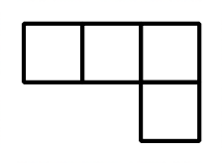 | 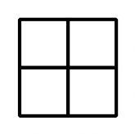
b. For several selected chosen configurations, explore different combinations of one-way roads that would make a corner inaccessible. Summarise findings and justify any possible combinations that are found.
c. Explore other networks of city blocks made up of at least nine connected rectangles with each single city block being surrounded by one-way roads. Develop configurations that make some corners inaccessible. Describe and justify any patterns that are found.

Part 2
Traffic calming devices such as reduced speed limits, raised platforms and pinch points control the vehicle capacity on each inner-city road. Consequently, these traffic calming devices influence the time taken to reach a destination.
Consider an inner-city network of nine connected rectangular blocks surrounded by roads having one-way travel and weights indicating the time to travel each section, in seconds, like the example started as shown below. Complete the image or construct a new directed and weighted network.
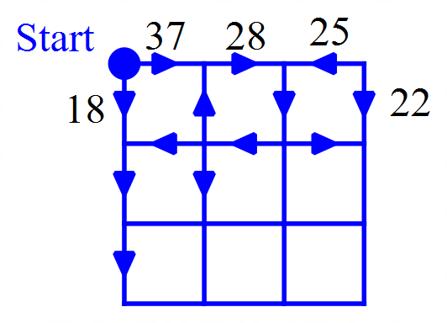

a. Choose a finish (destination) within the network and calculate the shortest time to complete a journey from start to finish.
b. Reverse the direction of three roads. Calculate the shortest time to complete a journey from start to finish. Also include a justification of the longest time taken to complete the journey and the relevant path.
c. Explore other journeys by changing times and directions along selected sections of road. Include both the shortest and longest times to reach the chosen destination point. Summarise and justify any patterns found.
d. Consider other inner-city networks containing more than nine connected rectangular blocks surrounded by roads having one-way travel. Investigate shortest and longest routes as described in previous parts. Discuss and justify any findings.

Areas of study
The following content from the areas of study is addressed through this task.
Area of study | Content dot points
Discrete Mathematics – Networks and decision mathematics:  Graphs and networks | 1
Discrete Mathematics – Networks and decision mathematics:  Flow problems | 1, 2
Discrete Mathematics – Networks and decision mathematics:  shortest path problems | 1, 2

Outcomes
The following outcomes, key knowledge and key skills are addressed through this task.
Outcome | Key knowledge dot point | Key skill dot point
1 | 1, 4, 5, | 1, 4, 5
2 | 1, 2, 3, 4 | 1, 2, 3, 4
3 | 1, 2, 4, 5, 6 | 1, 2, 5 8, 9, 10, 11, 12

