Mathematical Methods Units 3 and 4

Sample modelling or problem-solving task – height distributions

Introduction
This modelling or problem-solving task considers distributions of human heights in several contexts, using normal distributions of the random variable. Related data can be obtained from Tall.life.
The task assumes a normally distributed population for both males height$,$M, in cm, and females height,
F, in cm, with the following parameters at a given period in time:
 | $$μ$$ | $$σ$$
M | 176 | 7.5
F | 162 | 7
The standard normal distribution $Z\sim N(0, 1)$ has the probability density function:
$$g:R → R, g(x)=\frac{1}{\sqrt{2π}}e^{-\frac{1}{2}x^{2}}$$
The normal distribution $X\sim N(μ, σ^{2})$ has the probability density function:
$$f:R →R, f(x)=\frac{1}{σ\sqrt{2π}}e^{-\frac{1}{2}{\left(\frac{x-μ}{σ}\right)}^{2}}$$

Part 1
a. Graph $g$ and $f$ for several different sets of values of the parameters for $f$and in each case interpret the graph of $f$ in terms of transformations of the graph of $g$.
Now consider the distributions of M and F
b. Graph the probability density functions for M and F on the same set of axes and identify their key features.
c. For each of M and F, identify symmetrical intervals one, two and three standard deviations either side of the mean, and calculate the corresponding areas.
d. For each of M and F, find the interval corresponding to the middle 50% of the population heights. Find several other non-symmetrical intervals that also contain 50% of the respective population heights.

Part 2
The following graph shows the distribution of height for a group of females in a particular year.
If there are many such measurements taken in the context of distributions of human heights in several contexts, using normal distributions of the random variable, a histogram would look like the bell-shaped graph shown.
Imagine this histogram below showing the heights of 180 females in 1970.
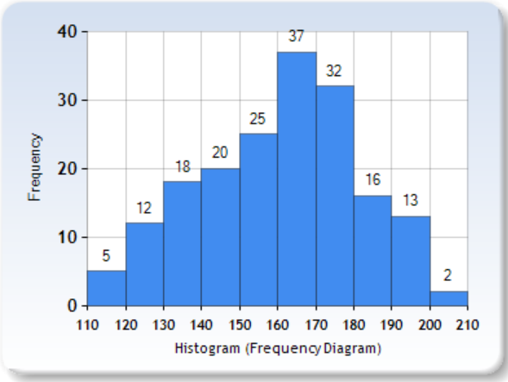
Social Science Statistics
a. Use the graph to estimate the mean and variance for this distribution.
People today are taller, on average, than their ancestors 100 years ago. This is true for every country in the world. But how much have human heights changed, and how does this vary across the world? The average young adult today is around 8 or 9 cm, or about 5%, taller than their ancestors 100 years ago.
From Our World in Data.
In a different year, a 95% confidence interval for the proportion of females with a mean height of 155 cm metres or more is given by (0.047, 0.219)
b. Determine the proportion and sample size used to generate this confidence interval
c. Explore a range of different confidence intervals for females and males.

Part 3
Consider the discrete probability distribution for a group of female students having a measured height of at least 130 cm, where the random variable H represents the number of students in the group with this measured height.
A group of 30 female students is randomly selected from a secondary school population, and the probability of any student in this group having a measured height of at least 130 cm is approximately 0.25, independent of the measured height of any other student in the group.
a. Identify the probability distribution, find the mean and standard deviation of H and evaluate $\operatorname{Pr}\left(H=h\right)$ and $\operatorname{Pr}\left(H<h\right)$for several different values of $h$.
b. Graph the probability function for the distribution of H and comment on its key features.
c. Repeat a. and b. with several different values for the probability and draw the corresponding graphs on the same set of axes.
d. Repeat a. and b. with several different values for n, the size of the group.
One of this group of 30 students, has her height measured several times, with the probability of measuring a height at any time of at least 130 cm approximately 0.25, independent of any other measurement.
a. If the student’s height is measured five times determine the probability that it is less than 130 cm on the first $k$ consecutive measurements in a row.
b. Determine the probability that the student’s height is measured less than 130 cm for exactly/ at least $k$measurements.
c. Formulate and solve a conditional probability problem related to this context.

Areas of study
The following content from the areas of study is addressed through this task.
Area of study | Content dot point
Functions and graphs | 4, 5, 6
Algebra | 4
Calculus | 3, 4, 9, 10
Probability and statistics | 2, 3, 4

Outcomes
The following outcomes, key knowledge and key skills are addressed through this task.
Outcome | Key knowledge dot point | Key skill dot point
1 | 1, 2, 4, 7, 12, 14, 16, 17 | 1, 2, 9, 12, 15, 16, 18, 20
2 | 1, 2, 3, 5 | 1, 3, 6, 7
3 | 2, 3, 4, 5, 8 | 2, 3, 4, 5, 6, 7, 8, 9, 11, 12, 13

