VCE Mathematical Methods Unit 2

Sample investigation: Impact of rising sea levels on coastal towns
The investigation is to be conducted over a period of 1–2 weeks.

Introduction
This task involves students modelling an approximate tidal pattern for a chosen coastal town to explore the effect rising sea levels might have on their chosen location, with consideration of the increased reach of high tide.
Students are encouraged to use online elevation maps and predictive maps to help them assess the potential impact of rising sea levels; several relevant links are provided below.
- Australian tide information
- Elevation finder map
- Interactive maps indicating potential impact of rising sea levels:
- Climate Central (enter the chosen location in the search bar at the top right-hand of the screen, and select different data sets by selecting ‘Choose Map’ at the top left-hand of the screen)
- How will rising sea level impact Australia’s iconic coastal cities?

Formulation
Overview of the context or scenario, and related background, including historical or contemporary background as applicable, and the mathematisation of questions, conjectures, hypotheses, issues or problems of interest.
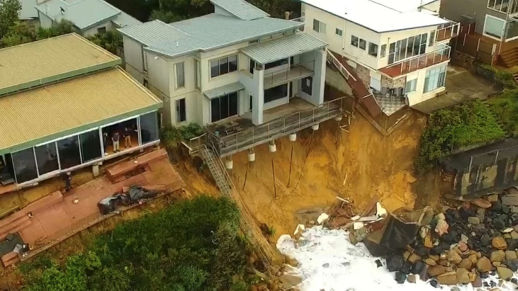
Source (image): Maani Truu, ‘Will climate change spell the end of coastal living as we know it?’, ABC News, 17 January 2022
Investigate how rising sea waters might impact a particular coastal town.
Consider the following:
- Australian coastal town to be investigated
- heights of rising sea levels to be explored
- local details of the terrain: for example, buildings, cliffs and possible impacts on these.

Exploration
Investigation and analysis of the context or scenario with respect to the questions of interest, conjectures or hypotheses, using mathematical concepts, skills and processes, including the use of technology and application of computational thinking.
- Using the function: $f:R→R,f\left(x\right)=Af\left(nx\right)+c$ where $f$ is the sine or cosine function, and $A, n, c∈R$ with $A, n≠0$, develop a model that approximates the current tide pattern for the chosen location.
- Revise the approximate tide function developed in step a. to reflect a range of increases in sea level and describe the effect on low and high tides.
- Use interactive predictive and elevation maps to explore the potential effect of different possible sea level rises at your location.
- Consider which other factors might have an impact at the chosen location.

Communication
Summary, presentation and interpretation of the findings from the mathematical investigation and related applications.
Summarise findings and interpret them with respect to the context, stating clearly any assumptions that have been made along the way, and discuss any limitations of the model.

Areas of study
The following content from the areas of study is addressed through this task.
Unit 2
Area of study | Content dot point
Functions and graphs | 5
Algebra | –
Calculus | –
Probability and statistics | –

Outcomes
The following outcomes, key knowledge and key skills are addressed through this task.
Outcome | Key knowledge dot points | Key skill dot points
1 | 3, 4, 5, | 2, 3, 6
2 | 1, 5 | 1, 2, 5, 6
3 | 2, 3, 8 | 6, 11, 13

