VCE Mathematical Methods Units 3 and 4

Area of Study 3: Calculus

Example of learning activity: Exploring approximation of a definite integral

Introduction
Informal exploration of the area under a curve specified by the graph of a function, and approximation of definite integrals using upper and lower rectangles, and trapeziums.

Part 1
The area between the graph of a function and the horizontal axis can be approximated by dividing it into a series of smaller areas and calculating the area of each of these. Several approaches can be used resulting in different levels of accuracy. Technology applications use this concept to calculate the area under the curve (definite integral) for functions that do not have simple anti-derivative functions.
Use the graph of $f:R→R,f\left(x\right)=x^{2}$ from $0≤x ≤1$, to calculate the approximate area under the curve for $f\left(x\right)$ with each of the following approaches:
- The area within the given interval has been divided into four rectangles of equal width, with the intersection of the righthand side of the rectangle and the graph $f\left(x\right)$ defining the height of each rectangle.
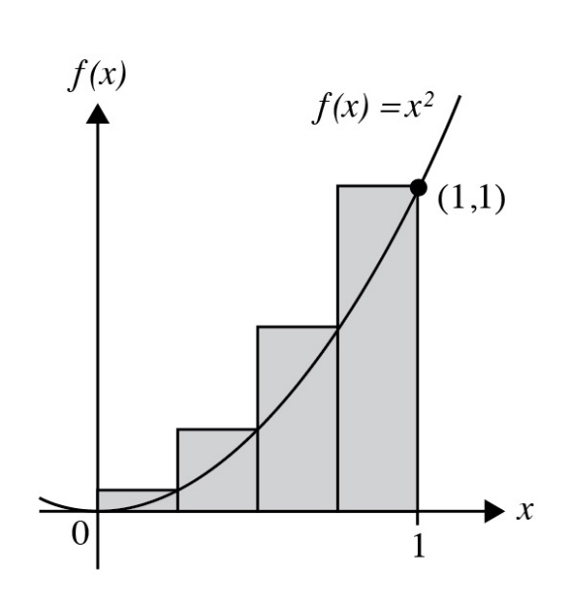

- Calculate the approximate area under the curve.
- Consider whether the approximate area is an under or overestimate of the actual area under the graph and whether this would be the case for all functions, when this approach is used.
- Estimate the percentage error between the approximate area calculated and the exact answer.

- The area within the given domain has been divided into four rectangles of equal width, with the intersection of the left-hand side of the rectangle and the graph $f\left(x\right)$ defining the height of each rectangle.
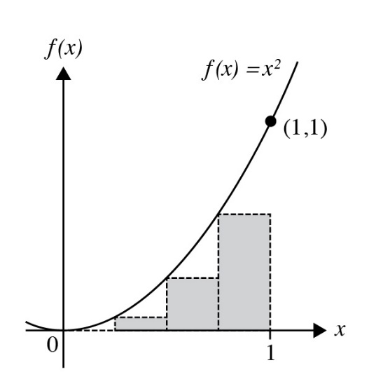
- Calculate the approximate area under the curve.
- Estimate the percentage error between the approximate area calculated and the actual answer.
- Divide the area under the graph of $f\left(x\right)$ from $0≤x ≤1$ into eight rectangles of equal width and using either the approach in a. or b. calculate the approximate area under the curve.
Estimate the percentage error. Compare it to the estimation when four rectangles of equal width where used.

Part 2
- An alternative approach to rectangles is using trapeziums, which offers an increased accuracy. Each trapezium has two of its vertices on the $x$-axis and the other two at intersection points with the graph of $f\left(x\right)$.
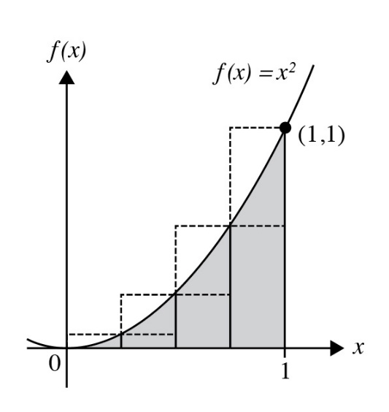
- Using four trapeziums of equal width, calculate the approximate area under the curve.
- Consider whether the approximate area is an under or overestimate of the actual area under the curve and whether this would be the case for other functions and intervals.
- Estimate the percentage error between the approximate area calculated and the actual answer.
- Compare this estimate to the estimates calculated in Part 1 a., b. and c.
- Construct a general rule based on using any number,$n$, of trapeziums to approximate the area under a curve specified by the graph of a function.
Use technology to implement a suitable algorithm and compare results obtained using the algorithm with those from symbolic integration for some other functions.

Areas of study
The following content from the areas of study is addressed through this task.
Units 3 and 4
Area of study | Content dot point
Functions, relations and graphs | -
Algebra, number and structure | -
Calculus | 7
Data analysis, probability and statistics | -

Outcomes
The following outcomes, key knowledge and key skills are addressed through this task.
Outcome | Key knowledge dot points | Key skills dot points
1 | 13 | 14
2 | 1, 2, 4, 5 | 1, 2, 3, 4, 5, 6
3 | 1, 2 | 5, 11, 13

