VCE Specialist Mathematics   
Units 3 and 4

Sample modelling or problem-solving task – double Ferris wheel

Introduction

This modelling or problem-solving task considers a range of problems related to vector calculus. A carnival ride is designed as shown in the diagram:

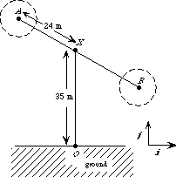

The central rod *AB* revolves about *X*. Mini Ferris wheels are rotating about *A* and *B*.

The vector equation describing the motion of *A* *t* minutes after the ride starts is   
***r*** (*t*) = 24 sin (2πt) ***i*** + (–24cos (2πt) + 35)***j*** where all distances are measured in metres.

Part 1

1. Where is *A* when the ride starts? Find the position vector of *A* for *t* = 0.25, 0.75.

In which direction is *A* rotating and how long does it take for *A* to complete one revolution?

1. Find vector equations for the velocity and acceleration of the point *A* at time *t.*Find the speed of *A* at time *t*.
2. Find the cartesian equation of the path of *A* and find the distance *OA* when *t* = 0.25.
3. State the position vector of point *B* at time *t* minutes.
4. State the position vector for the motion of *A* if when *t* = 0 the position vector of *A* is   
   24***i*** + 35***j*** and *AB* is revolving about *X* in a clockwise direction at the same speed in part b.

Part 2

The motion of the mini Ferris wheel is now to be considered.

The mini Ferris wheel rotates once every 12 seconds.

The radius of the Ferris wheel is 5 m. The wheel rotates in a clockwise direction. Initially *V* is vertically below *A.*

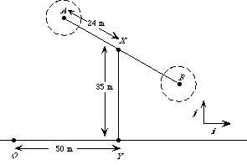

1. Give the position vector of *V*, relative to *A* as a function of *t* (*t* is measured in minutes).
2. By considering the vector sum find the position vector of *V* relative to *O* at time *t*. (Initial position of *V* as described above and initial conditions for *A* as in Part 1.)

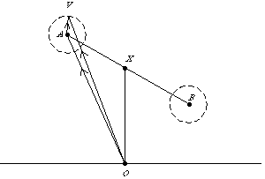

Plot the graph of the path of *V* and comment.

1. Find the velocity of point *V* as a vector function of *t*.
2. Find the speed of point *V* at time *t* and hence find the maximum and minimum speeds of point *V* and the times at which these occur in the first revolution of rod *AB* (exact values required).
3. Describe the position of point *V* at these times of maximum and minimum speeds. Plot the graph of speed against time for 0 ≤ *t* ≤ 1.
4. Find an expression for the distance *d*(*t*) of *V* from *X* at time *t* and plot the graph of *d*(*t*) against *t.*

Part 3

Investigate the motion of the mini Ferris wheel if:

1. The mini Ferris wheel moves in an anticlockwise direction.
2. The mini Ferris wheel revolves once every 20 seconds in an anticlockwise direction.

Areas of study

The following content from the areas of study is addressed through this task.

|  |  |  |
| --- | --- | --- |
| **Areas of study** | **Topics** | **Content dot point** |
| Space and measurement | Vector and cartesian equations | 1, 2, 3 |
| Space and measurement | Vector calculus | 1, 2, 3 |

Outcomes

The following outcomes, key knowledge and key skills are addressed through this task.

|  |  |  |
| --- | --- | --- |
| **Outcome** | **Key knowledge dot point** | **Key skill dot point** |
| **1** | 10, 11 | 11, 12 |
| **2** | 1, 2, 3, 4, 5 | 1, 2, 3, 5, 6 |
| **3** | 1, 2, 3, 5, 6, 7 | 1, 2, 3, 4, 5, 6, 8, 9, 10, 11 |