VCE Specialist Mathematics   
Units 3 and 4

Sample modelling or problem-solving task – Globe of Steel

Introduction

This task considers a set of motion contexts involving vector calculus. The *Globe of Steel* is a circus and carnival stunt where stunt riders ride motorcycles inside a mesh sphere. The *Globe of Steel* is produced using several segmented, bowed portions of welded mesh where sections of material are fitted together and riveted. One panel of steel at the bottom of the globe acts as a trap door where riders and their bikes can enter and exit. The rider’s initial position is at the centre bottom of the globe. Riders can loop vertically as well as horizontally.

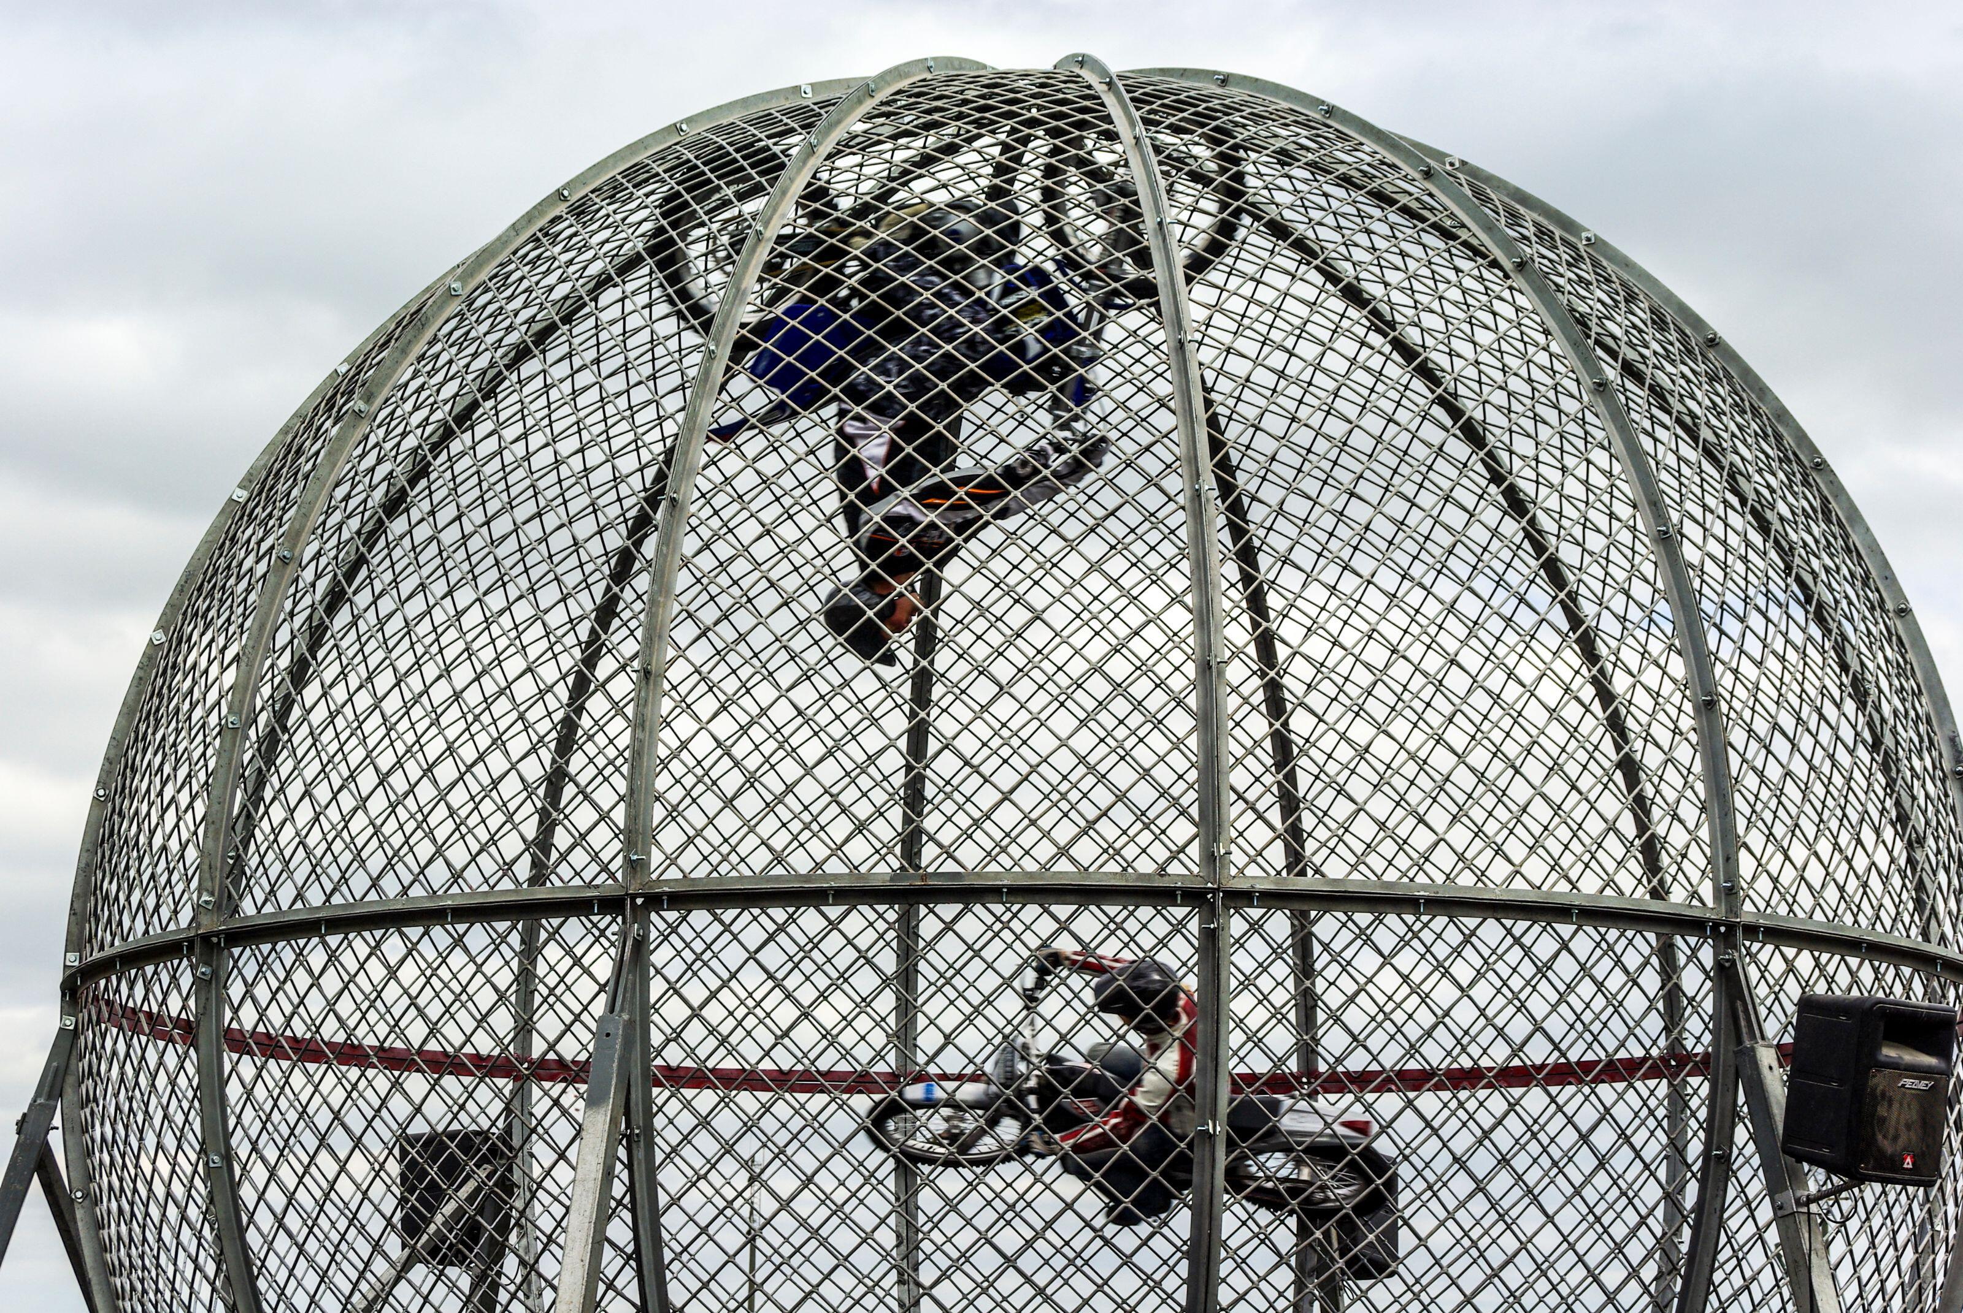

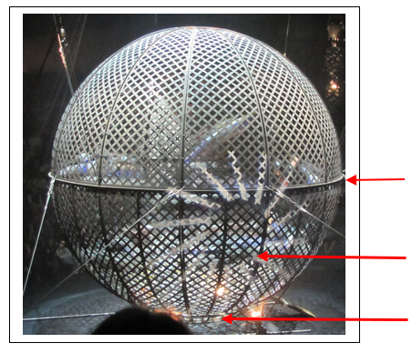

***Equator***

***Trap door***

***Rider’s initial***

***position***

***Fig. 2.***

***Fig. 1.***

Consider a vector coordinate system in three-dimensions where the unit vectors  and  represent the locations in the  plane and the unit vector , which is also known as the  axis, gives a vertical position above or below the plane. The origin of the vector coordinate system is located at the centre of the *Globe of Steel*.

Part 1

Consider a scenario where the motion of a single rider is modelled by the vector equation:

******, 

where *t* is the time in seconds, after the rider enters the *Globe of Steel*, and all distances are measured in metres.

***Fig. 1.*** *Source:* [*Alamy Stock Photo*](https://www.alamy.com/globe-of-death-motorcycle-riders-stunt-riding-inside-a-globe-motorbike-stunt-motorcyclists-inside-a-mesh-sphere-ball-circus-carnival-show-display-image427045661.html)

***Fig. 2.*** *‘Globe of death performance’ adapted with annotation. Retrieved from* [*https://commons.wikimedia.org/wiki/User:Dontworry*](https://commons.wikimedia.org/wiki/User:Dontworry)

a. Find the cartesian equation of the path of the rider and graph this path, indicating the direction of the rider’s travel and the distance the rider has covered.

b. Find the velocity of the rider as a function of time, and the distance the rider has travelled as a function of time.

c. Find the speed and the distance the rider has covered in the first  seconds.

d. Given that the total weight of the rider and the motorcycle is 185 kg, find the magnitude of the net force acting on the rider in newtons, and graph this as a function of time.

Part 2

Now consider an alternative scenario where the rider takes  seconds to reach the Equator of the *Globe*

*of Steel* and then instantly proceeds to ride around the Equator.

The motion of the rider from the moment they reached the Equator of the *Globe of Steel* is modelled by the vector equation:

***,*** for 

All distances are measured in metres and time in seconds.

a. Find the vector equations for the velocity and acceleration of the rider at time *t* and describe the motion of the rider.

b. Calculate the rider’s speed and the distance the rider has covered after a 2-minute stunt. How many loops has the rider made in the 2 minutes?

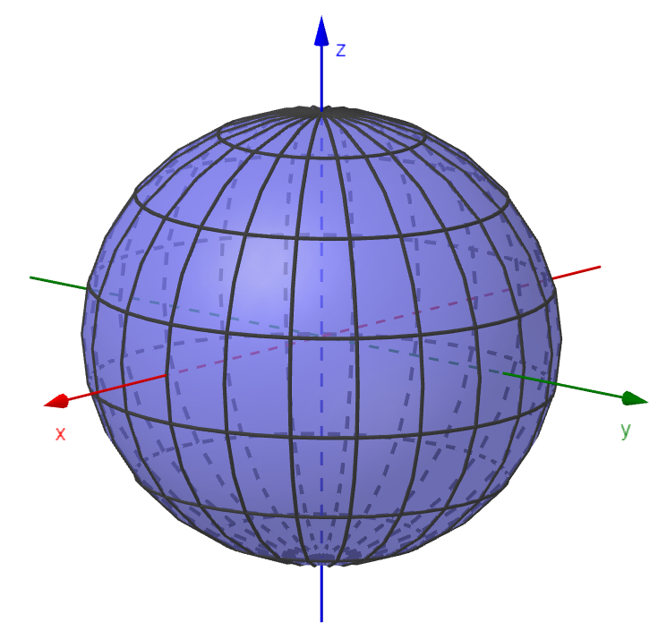Part 3

***Fig. 3****. Image created with GeoGebra (© International GeoGebra Institute, 2013; licensed* [*CC-BY-NC-SA 3.0*](https://aus01.safelinks.protection.outlook.com/?url=http%3A%2F%2Fcreativecommons.org%2Flicenses%2Fby-nc-sa%2F3.0%2Flegalcode&data=04%7C01%7CRuta.Marcinkus%40education.vic.gov.au%7C821c059e1e794c92d15708d9314ff58a%7Cd96cb3371a8744cfb69b3cec334a4c1f%7C0%7C0%7C637595041766083694%7CUnknown%7CTWFpbGZsb3d8eyJWIjoiMC4wLjAwMDAiLCJQIjoiV2luMzIiLCJBTiI6Ik1haWwiLCJXVCI6Mn0%3D%7C1000&sdata=vxaOtYqnA8Z5QufyiubC2kNiF84S6Nu29v5pHfcPTHo%3D&reserved=0)*)*

Develop and explore a model for a scenario involving a pair of riders where one is looping vertically and the other horizontally with the following conditions:

* the mesh sphere ball has a diameter between 4 to 6 metres
* the speed of the rider is between 15m/s to 25m/s
* the riders performed a 3-minute stunt
* the total weight of the rider and the motorcycle is between 160 kg to 190 kg.

After both riders enter the *Globe of Steel,* they could start riding at the same time or with a delay. The model should include a description and a graph of the path of each rider, the calculations of each rider’s speed, the distance each rider has covered, and consideration of how collisions are avoided.

Areas of study

The following content from the areas of study is addressed through this learning activity.

|  |  |  |
| --- | --- | --- |
| **Areas of study** | **Topics** | **Content dot point** |
| Calculus | Differential and integral calculus | 2, 3 ,4, 5 |
| Space and measurement | Vector and cartesian equations | 1 |
| Space and measurement | Vector calculus | 1, 2, 3 |

Outcomes

The following outcomes, key knowledge and key skills are addressed through this task.

|  |  |  |
| --- | --- | --- |
| **Outcome** | **Key knowledge dot point** | **Key skill dot point** |
| **1** | 3, 6, 7, 8, 9, 10, 11, 12 | 7, 8, 10, 12, 13 |
| **2** | 1, 2, 3, 4, 5 | 1, 2, 3, 4, 5, 6, 7 |
| **3** | 1, 2, 3, 4, 5, 6 | 1, 2, 3, 4, 5, 6, 7, 8, 9, 10, 11 |