VCE Specialist Mathematics Unit 2

Mathematical investigation 3: Rotating conic sections around any given point

Formulation
In this course you have studied circles, ellipses, parabolas and hyperbolae. Their equations all could be expressed in the form ax² + by² +2gx + 2fy + c = 0 where a, b, g, f and c are real constants. For the basic cases for ellipses and circles where the x and y axes are the axes of symmetry, equations are ax² + by² = e.
We can use the general rotation matrix to obtain the formula for ellipses, hyperbolas and parabolas and plot them after a rotation.

Exploration
Rotate ellipses, hyperbolae and parabolas, and find the Cartesian equation of the images. Use a suitable graphing package to illustrate.
The graph shown here is that of $x^{2}+\frac{y^{2}}{4}=1$ rotated by π in an anticlockwise direction:
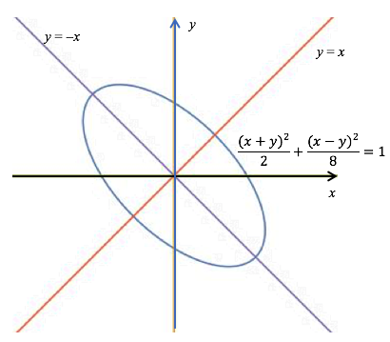
The simplified formula is 5x² + 6xy + 5y² = 8.
If the rotation from the original conic was θ we have
x´ = x cos θ – y sin θ and y´ = x sin θ +y cos θ
There are now many questions which can be considered using your knowledge of matrices, transformations and trigonometric identities.

Conclusions
Discuss your findings for a specific example and the variations you have tried. You may have started with ellipses and hyperbolas which are of the form ax² + by² + c = 0. Rotate other conic sections. Discuss what happens where the initial graph is translated ‘away’ from the origin. Use graphs, tables and equations to summarise your observations.

Areas of study
The following content from the areas of study is addressed through this learning activity.
Area of study | Topic | Content dot point
Space and measurement | Transformations | 1, 2, 3, 4, 5

Outcomes
The following outcomes, key knowledge and key skills are addressed through this task.
Outcome | Key knowledge dot point | Key skill dot point
1 | 7, 8, 9, 10 | 1, 2, 3
2 | 1, 2, 3 | 1, 2, 3, 4, 6
3 | 1, 2, 6 | 1, 2, 4, 5, 7, 10, 11

