VCE Specialist Mathematics
Units 1 and 2

Mathematical investigation 3: Rotating conic sections around any given point

Formulation
In this course you have studied circles, ellipses, parabolas and hyperbolae. Their equations all could be expressed in the form ax² + by² +2gx + 2fy + c = 0 where a, b, g, f and c are real constants. For the basic cases for ellipses and circles where the x and y axes are the axes of symmetry, equations are ax² + by² = e.
We can use the general rotation matrix to obtain the formula for ellipses, hyperbolas and parabolas and plot them after a rotation.

Exploration
Rotate ellipses and hyperbolae and find their Cartesian equations and use a suitable graphing package to illustrate.
The graph shown here is that of $x^{2}+\frac{y^{2}}{4}=1$ rotated by π in an anticlockwise direction:
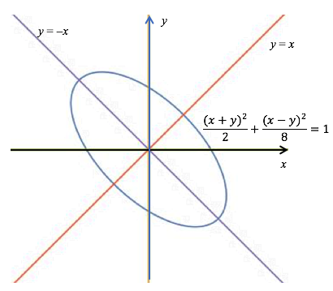
The simplified formula is 5x² + 6xy + 5y² = 8.
If the rotation from the original conic was θ we have
x´ = x cos θ – y sin θ and y´ = x sin θ +y cos θ
There are now many questions which can be considered using your knowledge of matrices, transformations and trigonometric identities.

Conclusions
Discuss your findings for a specific example and the variations you have tried.

