VCE Psychology
Units 3 and 4, 2023–2027

Supplementary material:
Conversations about social and emotional wellbeing (SEWB)
We acknowledge and pay our respects to the sovereign custodians of the lands where this factsheet was written and produced, Noongar Country, Wurundjeri Country and Dja Dja Wurrung Country, and their Elders past and present. We also wish to acknowledge and respect the continuing culture, strength and resilience of all Aboriginal and Torres Strait Islander peoples and communities.

Introduction
This companion document has been developed in collaboration between the Transforming Indigenous Mental Health and Wellbeing (TIMHWB) project, the Australian Indigenous Psychology Education Project (AIPEP) and the Victorian Curriculum and Assessment Authority (VCAA). It provides supplementary material to the webinar Conversations about Social and Emotional Wellbeing (SEWB) presented by Belle Selkirk and
Dr Joanna Alexi (TIMHWB, AIPEP). In addition, there is the reflective worksheet listing the exercises that were presented in the webinar on 30 March 2023. While the intended audience is Victorian educators who are teaching SEWB as part of VCE Psychology (2023–2027), we acknowledge and hope that the webinar and this companion document will benefit a range of audiences in both the education and workforce spaces.

Context
Aboriginal and Torres Strait Islander peoples are the first peoples and sovereign custodians of Australia, with a continuous cultural and spiritual connection to the land for more than 65,000 years. There are more than 260 distinct language groups, each with their own rich histories and stories, beliefs systems and cultural practices, and laws/Lores governing responsibilities. Aboriginal and Torres Strait Islander ways of knowing, being and doing are complex and sophisticated; they ensured a harmonious and sustainable way of life that facilitated equitable and reciprocal relationships between cultural groups, kinship, land, waterways, skies, plants, animals and ancestry. It is within these complex Indigenous knowledge systems that Aboriginal and Torres Strait Islander peoples thrive and flourish (Dudgeon et al. 2020, Dudgeon, Wright et al. 2014, Gee et al. 2014).
The devastating and pervasive impact of historical and contemporary coloniality on Aboriginal and Torres Strait Islander peoples’ lives is well known (Australian Government Australian Institute of Health and Welfare, 2020; Healing Foundation, 2021; Sherwood, 2013). The deliberate and violent disruption of Indigenous knowledge systems, family and kinship networks, and connection to culture and Country has left an enduring legacy of ill physical health, emotional and psychological suffering, intergenerational and transgenerational trauma, and social and political disadvantage. Coloniality continues to be woven through the fabric of Australian society whereby power and privilege is afforded to some members of society over others (Cruz & Sonn 2011). This imbalance of power and privilege, and ongoing social, political and cultural oppression has been identified as a key determinant of health for Aboriginal and Torres Strait Islander peoples (Paradies 2016, Paradies et al. 2015, Paradies et al. 2008, Sherwood 2013). This historical and contemporary mistreatment towards Aboriginal and Torres Strait Islander peoples is and remains a clear violation of the UN Declaration on the Rights of Indigenous Peoples (UNDRIP).

Coloniality in Psychology and Indigenous Psychology
Psychology as a global discipline has played a role in colonialism and has contributed to systemic oppression of Aboriginal and Torres Strait Islander peoples (Carey et al. 2017, Dudgeon, Rickwood et al. 2014). Eurocentric colonialism led to a hierarchical positioning that privileged Western epistemologies over and above other knowledges (Cruz & Sonn 2011). Through this positioning Western psychology has positioned itself as universal and therefore righteous in speaking on behalf of all peoples and cultures (Bhatia & Priya 2021, Breen & Darlaston-Jones 2010). Put simply, the dominance of Western knowledges undermines and denies Aboriginal and Torres Strait Islander knowledge systems that underpin wellness and flourishing. The historic Australian Psychological Society (APS) Apology to Aboriginal and Torres Strait Islander peoples (Australian Psychological Society 2016), recognised the contribution the profession of psychology in Australia has made in the oppression of Aboriginal and Torres Strait Islander peoples, and expressed an ongoing commitment to system-wide change needed as a matter of human rights.
Aboriginal and Torres Strait Islander critical theorists, leaders and allies have suggested that decolonising the discipline of psychology is necessary to address the power differentials and Western hegemony in psychology (Dudgeon & Walker 2015, Edwige et al. 2022). Indigenous standpoint theory (IST) is at the heart of decolonising practices and seeks to understand how power functions in the construction of knowledge, and how this affects Aboriginal and Torres Strait Islander peoples (Dudgeon et al. 2020, Dudgeon & Walker 2015, Nakata 2007). As a decolonising practice, IST decentres Western epistemologies and privileges Indigenous ways of being (ontology), knowing (epistemology) and doing (axiology) as a matter of self-determination and sovereignty (Dudgeon 2020, Dudgeon et al. 2020, Moreton-Robinson 2013).
Self-determination and a human-rights approach that upholds Indigenous knowledge systems is the path to healthy and flourishing lives for Aboriginal and Torres Strait Islander peoples (Dudgeon et al. 2023, Milroy et al. 2014, Parker & Milroy 2014). This is at the core of the rapidly growing global discipline of Indigenous Psychology that promotes cultural continuity and reclamation that is central to healing and flourishing (Dudgeon 2020, Dudgeon et al. 2023). The American Psychological Association (APA) Indigenous Psychology Taskforce has been instrumental in the Indigenous Psychology movement.
The American Psychological Association Indigenous Taskforce defines Indigenous psychology (www.indigenouspsych.org) as:
- A reactive stance against the colonisation and hegemony of Western psychology.
- The need for non-Western cultures to solve their local problems through Indigenous practices and applications.
- The importance of non-Western culture to recognise itself in the constructs and practices of psychology.
- The use of Indigenous philosophies and concepts to generate theories of global discourse (American Psychological Association 2010).

This definition supports the centrality of Aboriginal and Torres Strait Islander voices and knowledge systems in the discipline of psychology in Australia. Specifically, that Aboriginal and Torres Strait Islander peoples are experts in their lived experience and have a right to self-determination to define psychology from an Indigenous standpoint (Dudgeon & Walker 2015). The following section will introduce one example of Indigenous knowledge systems in Indigenous Psychology that has become widely accepted and used by Aboriginal and Torres Strait Islander communities and in policy frameworks across Australia.

Social and emotional wellbeing
Aboriginal and Torres Strait Islander peoples have held the holistic view of health and wellbeing for tens of thousands of years. It is predicated on the understanding that balance and harmony exist between all aspects of the self/person; that is, people are interconnected by the collective wellness of family, community, environment and spirituality. Swan and Raphael (1995) articulated health and wellness from an Indigenous standpoint in the landmark document Ways Forward: National Consultancy Report on Aboriginal and Torres Strait Islander Mental Health:
The Aboriginal concept of health is holistic, encompassing mental health and physical, cultural and spiritual health. This holistic concept does not just refer to the whole body but is in fact steeped in harmonious interrelations, which constitute cultural wellbeing. These interrelating factors can be categorised largely into spiritual, environmental, ideological, political, social, economic, mental and physical. Crucially, it must be understood that when the harmony of these interrelations is disrupted, Aboriginal ill health will persist (Swan & Raphael 1995).
The Ways Forward Report (Swan & Raphael 1995) was a watershed document in the articulation of wellness and mental health for Aboriginal and Torres Strait Islander peoples. This document also articulated nine guiding principles that encapsulate the strengths-based, whole-of-life view of social and emotional wellbeing. The principles acknowledge the impacts of racism, intergenerational trauma, and the necessity for self-determination and a human-rights approach to improving wellbeing. These guiding principles continue to be relevant and impactful today. They are underpinned by the National Strategic Framework for Aboriginal and Torres Strait Islander Peoples’ Mental Health and Wellbeing 2004–2009 (Social Health Reference Group 2004), as well as the later 2017–2023 revision of the framework (Australian Health Ministers’ Advisory Council 2017).

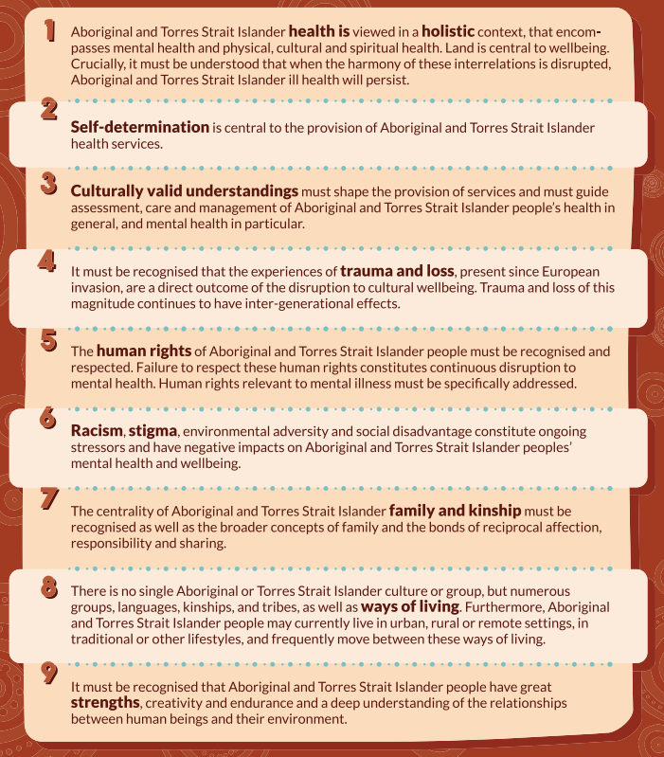

Nine guiding principles, drawn from the Ways Forward report (Swan & Raphael, 1995).
Image credit: TIMHWB.

Building on the seminal work from the Ways Forward Report (Swan & Raphael 1995) and through the work of the National Empowerment Project (NEP) (Dudgeon, Cox et al. 2014), the Social and Emotional Wellbeing (SEWB) model was developed in 2013 by a team of Indigenous psychologists to further articulate the complex and multidimensional facets of wellness for Aboriginal and Torres Strait Islander peoples. The SEWB model was endorsed by 457 Aboriginal and/or Torres Strait Islander community members in 11 communities across Australia that were involved in the consultations for the NEP (Dudgeon, Cox et al. 2014, Mia et al. 2017). SEWB has become a widely accepted term and paradigm in Aboriginal and Torres Strait Islander health discourse (Australian Health Ministers’ Advisory Council 2017).

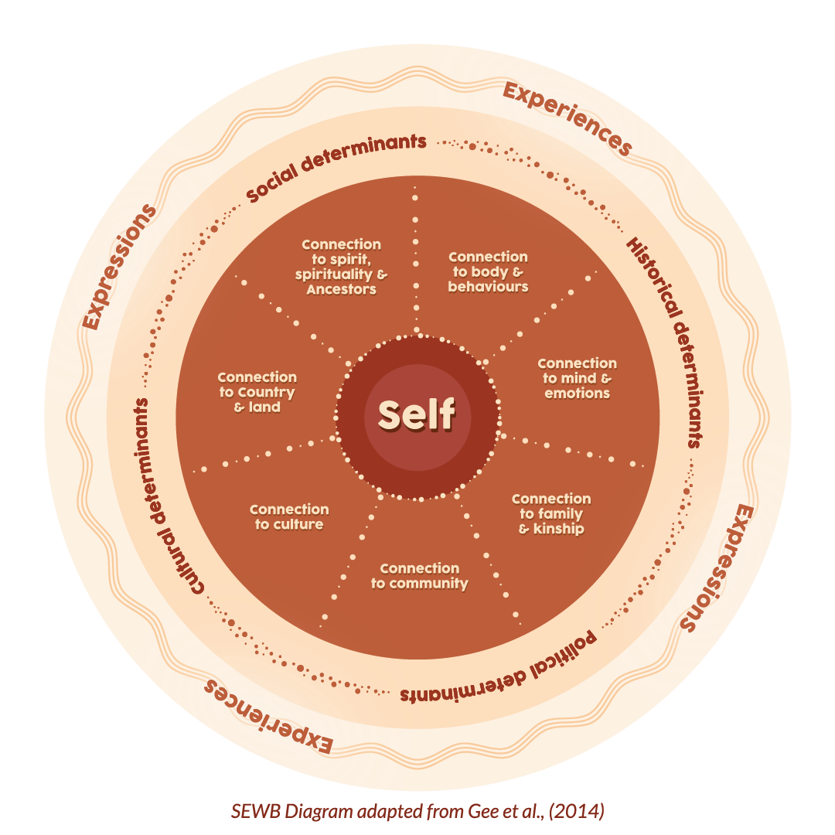

Image credit: TIMHWB

Social and emotional wellbeing is a strength-based, whole-of-life model grounded in Indigenous knowledge systems (ways of knowing, being, doing). The model recognises that Aboriginal and Torres Strait Islander health is interconnected and multifaceted, extending across time, person, place; living and inanimate. Social and emotional wellbeing encompasses seven inextricably interconnected domains of wellness, including health and body, mind and emotions, family and kinship, connections to Land and Country, culture and community, and spirituality and ancestors. Uniquely, it describes a collective and relational self that exists in the ecological context of the other domains, and determinants of health (Gee et al. 2014). Therefore, psychological wellbeing and mental health comprise one aspect of SEWB that needs to be conceptualised within a broader context. Definitions of SEWB will vary across Aboriginal and Torres Strait Islander language groups, and will also change throughout a lifespan. Therefore, taking time to understand the unique facets of SEWB for each person, family and community is vital in promoting optimal wellness (Dudgeon et al. 2016, Gee et al. 2014, Parker & Milroy 2014). As illustrated in Tables 1 and 2, drawing on the strength and resilience of Aboriginal and Torres Strait Islander peoples and culture will not only strengthen protective factors, but also mitigate risk factors (Australian Health Ministers’ Advisory Council 2017).

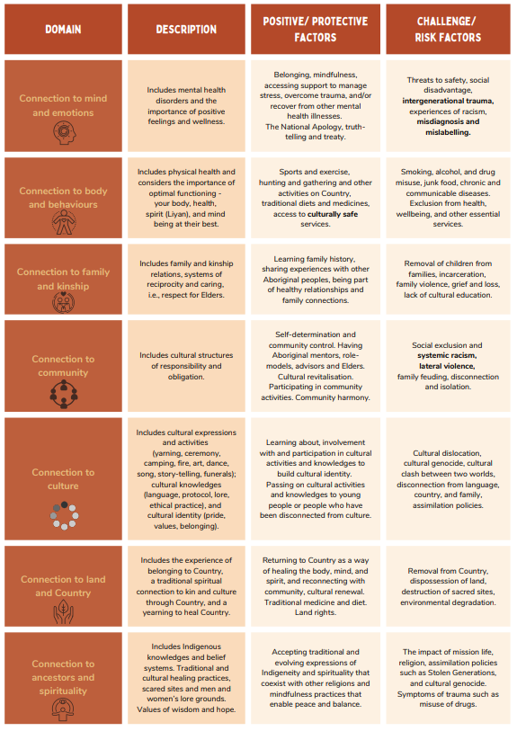
Table 1. Summary of protective factors and challenges across SEWB domains
Image credit: TIMHWB

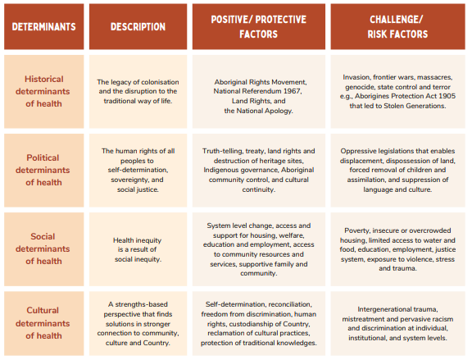
Table 2. Summary of protective factors and challenges across determinants of health
Image credit: TIMHWB
Understanding the broader ecological context impacting the health and wellbeing of Aboriginal and Torres Strait Islander peoples and communities is an integral part of the SEWB model. It is well known that the context and circumstances in which we live have a large bearing on health outcomes and wellbeing. Structural determinants of health (historical, political, social) in society shape the distribution of power and resources, as well as the human rights and social justice of diverse peoples within that society (Pearson et al. 2020, World Health Organisation 2023). Coloniality and the Western hegemony in psychology is an example of a historical, political and social determinant of health that directly impacts the health and wellbeing of Aboriginal and Torres Strait Islander peoples. On the other hand, Indigenous Psychology and the privileging of Indigenous knowledge systems in psychology facilitate cultural determinants of health. Cultural determinants of health have been found to be among the strongest protective factors for Aboriginal and Torres Strait Islander wellness, resilience and flourishing (Dudgeon et al. 2020, The Lowitja Institute 2020, Verbunt et al. 2021).
An important take-home message here is that individuals, communities, organisations and systems within a society have a direct impact on the determinants of health for all the individuals in that society. Therefore, the beliefs, choices and actions we make as individuals and as a collective have a direct impact on the health and wellbeing of Aboriginal and Torres Strait Islander peoples. The next section discusses the importance of cultural safety as a determinant of health for individuals, organisations and systems.

Cultural safety is key
At its core, cultural safety is about addressing racism, upholding human rights and cultural respect for Aboriginal and Torres Strait Islander peoples. Cultural safety is determined by Aboriginal and Torres Strait Islander peoples based on their experiences with other individuals, organisations and systems. Processes of cultural safety are typically multifaceted and complex. Cultural safety is more likely when individuals, organisations and systems critically examine and challenge biases, prejudices and power differentials that perpetuate inequalities. It requires a sophisticated understanding of the determinants of health (such as historical and contemporary colonialism) and its impact on the wellbeing of Aboriginal and Torres Strait Islander peoples (Australian Health Ministers’ Advisory Council’s National Aboriginal and Torres Strait Islander Health Standing Committee 2016, Curtis et al. 2019). Consistent with this, the Australian Health Practitioner Regulation Agency (Ahpra) defines culturally safe practice as ‘the ongoing critical reflection of health practitioner knowledge, skills, attitudes, practising behaviours and power differentials in delivering safe, accessible and responsive healthcare free of racism’ (Australian Health Practitioner Regulation Agency 2020, p. 9). Ahpra outlines several principles for culturally safe practice:
Acknowledge colonisation and systemic racism, social, cultural, behavioural and economic factors which impact individual and community health.
Acknowledge and address individual racism, their own biases, assumptions, stereotypes and prejudices and provide care that is holistic, free of bias and racism.
Recognise the importance of self-determined decision-making, partnership and collaboration in healthcare which is driven by the individual, family and community.
Foster a safe working environment through leadership to support the rights and dignity of Aboriginal and Torres Strait Islander peoples and colleagues (Australian Health Practitioner Regulation Agency 2020, p. 9).
Cultural responsiveness refers to processes and practices that are respectful and relevant to the beliefs, cultures and linguistic needs of Aboriginal and Torres Strait Islander peoples (Australian Health Ministers' Advisory Council 2016). Culturally responsive practice has been described as a cyclical, recursive and dynamic process of one’s inner process and self-inquiry that translates into proactive responses towards cultural safety (Australian Health Ministers’ Advisory Council’s National Aboriginal and Torres Strait Islander Health Standing Committee 2016, Smith et al. 2021), rather than a linear process based on acquiring competencies. Culturally responsive practice has been described as the integration of knowledge of Aboriginal and Torres Strait Islander culture (knowing), a deep awareness of oneself (being), and committed action towards social justice and equity (doing) (Indigenous Allied Health Australia 2019).
Inherent in processes of cultural safety and responsiveness is reflexivity (Smith et al. 2022). Reflexivity is concerned with deeply understanding the positionalities, privileges and power (whether at an individual, organisation or system level) in relation to others, and the interplay with determinants of health (Dawson et al. 2022). As articulated by Pete Smith and colleagues (2022, pp. 2–3):
[Reflexivity] critically examines one’s own attitudes, values and biases, with a view to engaging with people in a manner that is culturally safe, meaning free of racism and attitudes of superiority (Wilson 2014). For mental health professionals, reflexivity is about looking closely at one’s own practice (Bennett et al. 2018) and becoming aware of power and privilege and how they have impacted Indigenous people in the past and present (Bennett & Gates 2019). Instead of asking what is this information and how can I acquire it, reflexivity asks who am I in response to this information and what is it asking of me? (Kilcullen et al. 2018).

All professionals, including educators, practitioners, researchers, service industry workers and policy makers, can engage in reflexive practice to the benefit of themselves and Aboriginal and Torres Strait Islander peoples. Examples of reflexive questions include:
- Who am I in this space?
- How am I positioning myself?
- What is coming up for me?
- What resonates with me?
- What is making me uncomfortable?
- What is my understanding of (my) power and privilege?
- Whose voice is being privileged?
- What am I assuming?
- Where are my knowledge gaps?
- What learning do I need to do?

Your learning journey
This supplementary resource has covered a broad range of topics essential in the teaching and understanding of SEWB, Indigenous Psychology, and cultural safety. It is an introduction only, and your learning will continue and expand beyond this resource. The learning journey is dynamic and ongoing. We have summarised below some key messages to take with you on your learning journey.
Learn about Aboriginal and Torres Strait Islander peoples and culture. Learn about your local context, the sovereign custodians, language groups and history.
Learn about Australia’s history of colonisation, determinants of health, and the importance of a human rights approach to health and wellbeing.
Honour Aboriginal and Torres Strait Islander voices, experiences and knowledge systems. These have equal epistemological value to Western knowledge systems.
Where possible build relationships with local Aboriginal and Torres Strait Islander community members, Elders, cultural mentors and colleagues.
Seek out cultural safety training and learning opportunities.
Educate yourself on SEWB and Indigenous Psychology.
Look carefully for Aboriginal and Torres Strait Islander-led research and resources.
Be open to questioning knowledges in psychology that claim universal application to all peoples and cultures, or that privilege one culture or knowledge system at the detriment of another.
Be willing to look inwards (self-reflexivity, positionality, privilege, power).
Be willing to address power differentials and racism in yourself, your teaching practice and your environment.
Challenge your organisations and systems to be on this journey too. Remember that individuals, organisations and systems must work in unison for long-lasting change to occur.

Glossary
Axiology The nature and study of values.
Coloniality/Colonialism The process of one nation establishing a colony in another land and exerting control over the land and people living on it.
Cultural responsiveness Processes and practices that are respectful and relevant to the beliefs, cultures, and linguistic needs of Aboriginal and Torres Strait Islander peoples.
Cultural safety An environment in which an Aboriginal and Torres Strait Islander person feels safe, free from racism, assault, challenge or denial of a person’s identity or their needs. As such, cultural safety is determined by Aboriginal and Torres Strait Islander peoples based on their experiences with individuals, organisations and systems. Cultural safety is more likely when individuals, organisations and systems critically examine and challenge biases, prejudices and power differentials that perpetuate inequalities.
Decolonise/Decolonising The undoing of colonialism, whereby colonised groups break free from physical, psychological, social and cultural colonial oppressors, and begin a process of recentering of pre-colonial ways of knowing, being and doing.
Determinants of health The conditions in which people are born, live, grow and work, and the wider set of structural systems that shape their everyday life. These structural systems include, but are not limited to, economics, political systems and social norms.
Epistemology The nature of knowledge.
Eurocentric A worldview centered on Western culture and belief systems.
Hegemony The dominance of one state over another.
Holistic The understanding that the parts of something are interconnected and inseparable from one another.
Human rights approach An approach whereby oppression and discrimination are actively prevented and eliminated. This may include actions of equity where priority is given to marginalised individuals who face the biggest barriers in the realisation of their human rights.
Indigenous knowledge systems Knowledges that are unique to a culture, and belong to a particular community, family or cultural group.
Indigenous Psychology A growing global movement and discourse of self-determination that strives to decolonise and emancipate people from the domination of Western psychology. Indigenous Psychology as a discipline promotes psychologies that have been developed and determined within a group’s cultural context.
Indigenous standpoint theory (IST) An analytical tool to understand how power functions in the construction and representation of knowledge and, in turn, how this effects Aboriginal and Torres Strait Islander peoples. As a decolonising practice, IST decentres Western epistemologies and privileges Indigenous ways of knowing, being and doing.
Intergenerational / transgenerational trauma Collective or historical memories of traumatic events that persist beyond the direct survivors of the event, continuing throughout time and, if not healed, can negatively impact on subsequent generations.
Ontology The nature of reality.
Reflexivity A practice of inner-inquiry and self-examination that seeks to understand the emotions, beliefs, motivations, positionalities, privileges and power (at an individual, organisation or system level) in relation to others and the interplay with determinants of health.

Self-determination The ability for Aboriginal and Torres Strait Islander peoples to freely decide and govern their own political, social, cultural and economic needs and rights.
Social and emotional wellbeing Reflects the holistic understanding of wellness for Aboriginal and Torres Strait Islander peoples and includes intrinsic connections between the relational-self, mind-emotions, body, Country, community, culture, kinship and ancestry. These domains are situated in the broader social, political, historical and cultural determinants of health.

Recommended resources
In additional to the information provided in this document, the following resources are provided to support teachers and other interested professionals in their learning journey and professional practice.

Books
Dudgeon, P., Milroy, H., & Walker, R. (2014). Working Together: Aboriginal and Torres Strait Islander Mental Health and Wellbeing Principles and Practice (Second Edition). (2nd edition ed.). Commonwealth of Australia.
Dudgeon, P., Alexi, J., Selkirk, B., & Derry, K. (2022). Chapter 3: Indigenous Psychology in Australia. In D. W. L. Burton, R. Kowalski (Ed.), Psychology, Sixth Australian and New Zealand Edition (Vol. 6). John Wiley & Sons.

Fact sheets
SEWB fact sheet
Dance of Life
National Empowerment Project
Empowering the Workforce

Online learning
Video: Journey of Health & Wellbeing. Department of Health, WA
Video: Intergenerational Trauma. Healing Foundation
Video: Improving the social and emotional wellbeing of First Nations children. Healing Foundation
Video: Working with Aboriginal people: Enhancing clinical practice in mental health care. NSW Government
Video: Emerging minds
Podcast: Australian Psychology Accreditation Council. Developing Cultural Responsiveness
Webinar series: Community Identity & Displacement Community Network

Webinar: APS e-learning on demand. What does decolonisation within psychology mean to me?
Webinar: APS e-learning on demand. Cultural safety in Trauma-Informed Practice: What’s culture got to do with it?
Webinar: APS e-learning on demand. Indigenous psychology and decolonising neuropsychology in Australia

Acknowledgements
These supplementary materials were written by Belle Selkirk and Dr Joanna Alexi, Research Fellows with the Australian Indigenous Psychology Education Project (AIPEP) and the Transforming Indigenous Mental Health and Wellbeing (TIMHWB) grant at the School of Indigenous Studies, University of Western Australia. We would like to acknowledge the profound leadership of Indigenous Psychologist and Bardi woman, Professor Pat Dudgeon AM, who has been a pioneer in the development of Indigenous Psychology and Social and Emotional Wellbeing in Australia. We thank Professor Dudgeon AM for her teachings and mentoring to the authors over many years and in the development and review of this resource.

References
American Psychological Association 2010, Task force on Indigenous Psychology.
Australian Government Australian Institute of Health and Welfare 2020, Social determinants and Indigenous health.
Australian Health Ministers' Advisory Council 2016, Cultural Respect Framework 2016–2026 for Aboriginal and Torres Strait Islander Health.
Australian Health Ministers’ Advisory Council 2017, National Aboriginal and Torres Strait Islander Health Workforce Strategic Framework 2016–2023.
Australian Health Ministers’ Advisory Council’s National Aboriginal and Torres Strait Islander Health Standing Committee 2016, Cultural Respect Framework For Aboriginal And Torres Strait Islander Health 2016–2026: A National Strategy For Building Culturally Respectful Health System. A.H.M.A. Council.
Australian Health Practitioner Regulation Agency 2020, The National Scheme’s Aboriginal and Torres Strait Islander Health and Cultural Safety Strategy 2020–2025, A.H.P.R. Agency.
Australian Psychological Society 2016, The APS Apology to Aboriginal and Torres Strait Islander people.
Bhatia, S & Priya, KR 2021, 'Coloniality and Psychology: From Silencing to Re-Centering Marginalized Voices in Postcolonial Times', Review of general psychology, 25(4), 422–436.
Breen, LJ & Darlaston-Jones, D 2010, 'Moving beyond the enduring dominance of positivism in psychological research: Implications for psychology in Australia', Australian Psychologist, 45(1), 67–76.
Carey, T, Dudgeon, P, Hammond, S, Hirvonen, T, Kyrios, M, Roufeil, L & Smith, P 2017, 'The Australian Psychological Society's Apology to Aboriginal and Torres Strait Islander People' [Internet], Australian Psychologist, 52, 261–267.
Cruz, MR & Sonn, CC 2011, '(De)colonizing Culture in Community Psychology: Reflections from Critical Social Science', American journal of Community Psychology, 47(1–2), 203–214.
Curtis, E, Jones, R, Tipene-Leach, D, Walker, C, Loring, B, Paine, S-J & Reid, P 2019, 'Why cultural safety rather than cultural competency is required to achieve health equity: a literature review and recommended definition', International Journal for Equity in Health, 18(1), 1–17.
Dawson, J, Laccos-Barrett, K, Hammond, C & Rumbold, A 2022, 'Reflexive Practice as an Approach to Improve Healthcare Delivery for Indigenous Peoples: A Systematic Critical Synthesis and Exploration of the Cultural Safety Education Literature', Int J Environ Res Public Health, 19(11), 6691.
Dudgeon, P 2020, 'Decolonising Psychology: Self-determination and Social and Emotional Wellbeing' In B Hokowhitu, A Moreton-Robinson, L Tuhiwai-Smith, C Andersen & S Larkin (Eds.), The Routledge Handbook of Critical Indigenous Studies (1st ed., pp. 100–113), Routledge.
Dudgeon, P, Bray, A, Darlaston-Jones, D & Walker, R 2020, Aboriginal Participatory Action Research: An Indigenous Research Methodology Strengthening Decolonisation and Social and Emotional Wellbeing, Lowitja Institute.
Dudgeon, P, Bray, A, Smallwood, G, Walker, R & Dalton, T 2020, Wellbeing and Healing Through Connection and Culture, Lifeline.
Dudgeon, P, Bray, A & Walker R 2023, 'Embracing the emerging Indigenous psychology of flourishing', Nature Reviews Psychology, 2, 259–260.
Dudgeon, P, Cox, A, Walker, R, Scrine, C, Kelly, K, Blurton, D, Boladeras, J, Bracknell, C, Brennan, T, Butorac, A, Charles, A, Collard, L, Crane, S, Caulfield, V, D'Costa, B, Duffin, W, Grogan, G, Hams, K, Hansen, C, Holland, C, Ingram, D, Mascall, C, Mia, T, Miller, D, McGuire, V, Munnich, M, Murray, B, McGrady, G, Peckham, M, Riley, B, Ryder, A, Sloan, A, Swift, S, Taylor, N, Watson, J & Woods, C 2014, Voices of the Peoples: The National Empowerment Project Research Report, The National Empowerment project, University of Western Australia.
Dudgeon, P, Rickwood, D, Garvey, D & Gridley, H 2014, 'A History of Indigenous Psychology' In P Dudgeon, H Milroy & R Walker (Eds.), Working Together: Aboriginal and Torres Strait Islander Mental Health and Wellbeing Principles and Practice (pp. 39–54). Commonwealth of Australia.
Dudgeon, P & Walker, R 2015, 'Decolonising Australian psychology: Discourses, strategies, and practice' [Internet], Journal of Social and Political Psychology, 3(1), 276-297.
Dudgeon, P, Wright, M, Paradies, Y, Garvey, D & Walker, I 2014, 'Aboriginal Social, Cultural and Historical Contexts' In P Dudgeon, H Milroy & R Walker (Eds.), Working Together: Aboriginal and Torres Strait Islander Mental Health and Wellbeing Principles and Practice (pp. 3–24), Commonwealth of Australia.
Edwige, V, Alexi, J, Selkirk, B & Dudgeon, P 2022, 'Australia needs to decolonise its mental health system and empower more Indigenous psychologists', The Guardian.

Gee, G, Dudgeon, P, Schultz, C, Hart, A & Kelly, K 2014, 'Aboriginal and Torres Strait Islander Social and Emotional Wellbeing' In P Dudgeon, H Milroy & R Walker (Eds.), Working Together: Aboriginal and Torres Strait Islander Mental Health and Wellbeing Principles and Practice (pp. 55–68), Commonwealth of Australia.
Healing Foundation 2021, Make Healing Happen: It's Time to Act, Aboriginal & Torres Strait Islander Healing Foundation.
Indigenous Allied Health Australia 2019, Cultural Responsiveness in Action: An IAHA Framework, Indigenous Allied Health Australia.
Mia, T, Dudgeon, P, Mascall, C, Grogan, G, Murray, B & Walker, R 2017, 'An evaluation of the national empowerment project cultural, social, and emotional wellbeing program' [Internet], Journal of Indigenous Wellbeing, 2(2).
Milroy, H, Dudgeon, P & Walker, R 2014, 'Community Life and Development Programs – Pathways to Healing' In P Dudgeon, H Milroy & R Walker (Eds.), Working Together: Aboriginal and Torres Strait Islander Mental Health and Wellbeing Principles and Practice (pp. 419–436), Commonwealth of Australia.
Moreton-Robinson, A 2013, 'Towards an Australian Indigenous Women's Standpoint Theory', Australian Feminist Studies 28(78), 331–347.
Nakata, M 2007, 'The Cultural Interface', The Australian Journal of Indigenous Education, 36(Supplementary) 7–14.
Paradies, Y 2016, Colonisation, racism and indigenous health', Journal of population research (Canberra, A.C.T.) 33(1), 83–96.
Paradies, Y, Ben, J, Denson, N, Elias, A, Priest, N, Pieterse, A, Gupta, A, Kelaher, M & Gee, G 2015, 'Racism as a Determinant of Health: A Systematic Review and Meta-Analysis', PloS One, 10(9).
Paradies, Y, Harris, R Anderson, I 2008, The Impact of Racism on Indigenous Health in Australia and Aotearoa: Towards a Research Agenda (Discussion Paper Series: No. 4, Issue. C.R.C.f.A. Health.
Parker, R & Milroy, H 2014, 'Aboriginal and Torres Strait Islander Mental Health: An overview' In P Dudgeon, H Milroy & R Walker (Eds.), Working Together: Aboriginal and Torres Strait Islander Mental Health and Wellbeing Principles and Practice (pp. 25–38), Commonwealth of Australia.
Pearson, O, Schwartzkopff, K, Dawson, A, Hagger, C, Karagi, A, Davy, C, Brown, A & Braunack-Mayer 2020, 'Aboriginal community controlled health organisations address health equity through action on the social determinants of health of Aboriginal and Torres Strait Islander peoples in Australia', BMC Public Health, 20(1), 1859–1859.
Sherwood, J 2013, 'Colonisation – It's bad for your health: The context of Aboriginal health, Contemporary nurse: a journal for the Australian nursing profession, 46(1), 28–40.
Smith, P, Rice, K, Schutte, N & Usher, K 2022, 'Reflexivity: a model for teaching and learning cultural responsiveness in mental health', Australian Psychologist.
Smith, P, Rice, K, Usher, K & Schutte, N 2021, 'Cultural responsiveness for mental health professionals working with Aboriginal and Torres Strait Islander clients: a concept analysis', Australian Psychologist 56(6), 446–457.
Social Health Reference Group 2004, National Strategic Framework for Aboriginal and Torres Strait Islander Peoples' Mental Health and Social and Emotional Wellbeing 2004–2009, Australian Department of Health and Ageing. Canberra.
Swan, P & Raphael, B 1995, Ways Forward: National consultancy report on Aboriginal and Torres Strait Islander mental health. Commonwealth of Australia.
The Lowitja Institute 2020, Culture is Key: Towards cultural determinants-driven health policy – Final Report. Lowitja Institute.
Verbunt, E, Luke, J, Paradies, Y, Bamblett, M, Salamone, C, Jones, A & Kelaher, M 2021, 'Cultural determinants of health for Aboriginal and Torres Strait Islander people – a narrative overview of reviews', International journal for equity in health, 20(1), 1–181.
World Health Organisation 2023, Social determinants of health. World Health Organisation.

Suggested citation: Selkirk, B & Alexi, J 2023, Conversations About Social and Emotional Wellbeing (SEWB): Supplementary Material for VCE Psychology Units 3 and 4, Victorian Curriculum and Assessment Authority, Melbourne.

