Workplace Learning Record

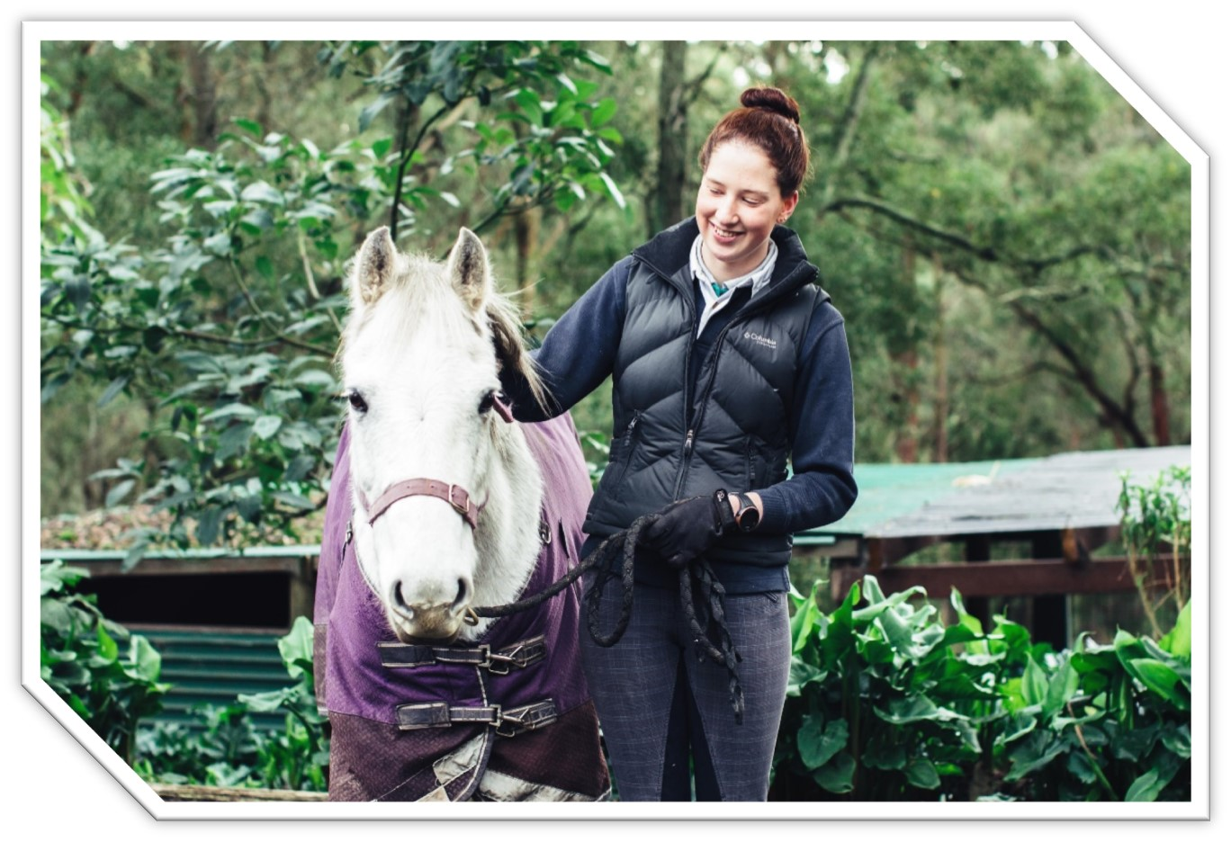VCE VET Equine Studies

22513VIC Certificate III in Equine Studies

**Student name:**

Authorised and published by the Victorian Curriculum and Assessment Authority  
Level 7, 200 Victoria Pde  
East Melbourne VIC 3002

© Victorian Curriculum and Assessment Authority 2024

No part of this publication may be reproduced except as specified under the *Copyright Act 1968* or by permission from the VCAA. Excepting third-party elements, schools may use this resource in accordance with the [VCAA educational allowance](https://www.vcaa.vic.edu.au/Footer/Pages/Copyright.aspx). For more information go to <https://www.vcaa.vic.edu.au/Footer/Pages/Copyright.aspx>.

The VCAA provides the only official, up-to-date versions of VCAA publications. Details of updates can be found on the VCAA website at [www.vcaa.vic.edu.au](https://www.vcaa.vic.edu.au/Pages/HomePage.aspx).

This publication may contain copyright material belonging to a third party. Every effort has been made to contact all copyright owners. If you believe that material in this publication is an infringement of your copyright, please email the Copyright Officer [vcaa.copyright@edumail.vic.gov.au](mailto:vcaa.copyright@edumail.vic.gov.au)

Copyright in materials appearing at any sites linked to this document rests with the copyright owner/s of those materials, subject to the Copyright Act. The VCAA recommends you refer to copyright statements at linked sites before using such materials.

The VCAA logo is a registered trademark of the Victorian Curriculum and Assessment Authority.

|  |
| --- |
| Contact us if you need this information in an accessible format - for example, large print or audio.  Telephone (03) 9032 1635 or email [vcaa.media.publications@edumail.vic.gov.au](mailto:vcaa.media.publications@edumail.vic.gov.au) |

Structured Workplace Learning Recognition

[VCE Structured Workplace Learning Recognition for VET](https://www.vcaa.vic.edu.au/curriculum/vce/vce-study-designs/SWLRforVET/Pages/Index.aspx) provides students with the opportunity to gain credit towards their VCE (including the VCE VM) or VPC by undertaking a Structured Workplace Learning (SWL) placement that is aligned to their VE1 VCE VET program or VE2 School-based Apprenticeship or Traineeship (SBAT).

To receive credit, students are required to demonstrate satisfactory achievement of the outcomes for the relevant unit of the *VCE Structured Workplace Learning Recognition for VET* study design.

Students must maintain a Workplace Learning Record (WLR) for each placement. In the WLR students must reflect on a minimum of six units of competency (UoCs) from their program, including a workplace health and safety (WHS) UoC.

About this workplace learning record

Students undertaking this study must maintain a Workplace Learning Record (WLR) related to the SWL placement for recording, authentication and assessment purposes.

Student reflections on their SWL placement are to be recorded in the three sections of this WLR to document the skills and knowledge learned, employability skills developed, and industry experience gained relating to the VET qualification being undertaken.

Students must undertake a work placement in a different workplace setting or context for each VCE unit and maintain a separate WLR per placement.

The WLR is divided into three sections.

**Section 1**: Learner profile

**Section 2**: Learning about VET units of competency (UoCs) in the workplace

**Section 3**: Post-placement reflections

Please complete the details of your workplace.

|  |  |
| --- | --- |
| **Employer/Company/Business** |  |
| **Supervisor name** |  |
| **Contact phone number** |  |

|  |  |
| --- | --- |
| **Employer/Company/Business** |  |
| **Supervisor name** |  |
| **Contact phone number** |  |

|  |  |
| --- | --- |
| **Employer/Company/Business** |  |
| **Supervisor name** |  |
| **Contact phone number** |  |

Section 1: Learner profile

Complete the learner profile and discuss this with your host employer on or before your first day of SWL placement.

|  |  |
| --- | --- |
| **Student Name** |  |
| **School** |  |
| **Phone number** |  |
| **Email** |  |
| **Explain why you decided to undertake this VET certificate?** | |
|  | |
| **List the other studies that you are undertaking.** | |
|  | |
| **Explain why you have chosen this overall program.** | |
|  | |
| **Outline what interests you about the industry.** | |
|  | |
| **What is your planned career path or future career aspiration?** | |
|  | |
| **Describe any workplace skills you have developed through previous work experience, SWL or part time employment.** | |
|  | |
| **How have you developed these skills?** | |
|  | |

Section 2: Learning about VET units of competency in the workplace

This section of the WLR will contain three key questions per unit of competency (UoC) designed to draw out related experiences you may be exposed to in a workplace.

This does not cover all the elements or performance criteria within the units and is not designed as a UoC assessment tool.

You should comment on the UoCs you have experienced in the workplace and reflect on actual observations or activities that you have been exposed to. Your observations will:

* reinforce the training you have undertaken
* identify differences in practice or equipment
* identify areas requiring further training or practical experience.

You are encouraged to take photos and/or video where appropriate to showcase learning in the workplace. Evidence you collect can include:

* observations
* descriptions of activities and tasks
* conversations with employers and other staff
* participation in meetings
* workplace documents
* research in the workplace
* photos of equipment/processes/events
* video of workplace activities.

**Note**: please speak to your host employer before taking photos or video. Do not use the names or details of any clients/stakeholders external to the organisation/other. This record does not require identifying actual people or events, as this may breach confidentiality.

Program outline

22513VIC Certificate III in Equine Studies

The compulsory UoCs and a selection of electives are listed in the table below. You may list any additional UoC(s) relating to your experiences in the workplace in the table. Indicate the year in which you are undertaking each UoC. You must reflect on a minimum of six UoCs from your program, including a workplace health and safety (WHS) UoC.

|  |  |  |  |  |
| --- | --- | --- | --- | --- |
| UoC code | UoC title | Nominal hours | Year | Page |
| **Work, Health and Safety** | | | | |
| ACMEQU201 | Work safely in industries with horses | 40 |  | 9 |
| **Compulsory** | | | | |
| ACMEQU202 | Handle horses safely | 100 |  | 10 |
| ACMEQU205 | Apply knowledge of horse behaviour | 60 |  | 11 |
| VU22681 | Work effectively in an equine organisation | 50 |  | 12 |
| VU22682 | Implement horse health and welfare practices | 50 |  | 13 |
| VU22683 | Implement and monitor horse feeding programs | 50 |  | 14 |
| VU22684 | Relate equine form to function | 50 |  | 15 |
| VU22685 | Identify equine anatomy | 30 |  | 16 |
| VU22686 | Identify and describe equine physiology | 50 |  | 17 |
| **Elective** | | | | |
| HLTAID011 | Provide First Aid | 18 |  | 18 |
| VU22688 | Assist in the preparation of a horse for an event | 40 |  | 19 |
| VU22689 | Assist in the conduct and organisation of an event in the equine industry | 40 |  | 20 |
| VU22690 | Examine horse breeding principles and practices | 40 |  | 21 |
| VU22691 | Prepare for the care of pregnant mares, foals and young horses | 40 |  | 22 |
|  |  |  |  |  |
|  |  |  |  |  |
|  |  |  |  |  |

Reflect on the UoCs you have experienced in the workplace on the following pages.

VCE VET units of competency

ACMEQU201 - Work safely in industries with horses

This unit of competency describes the skills and knowledge required to work safely and sustainably in industry sectors that use horses. It covers knowledge of potential risks when working with and around horses and following industry guidelines and procedures to ensure the welfare and safety of the individual and the horse.

|  |  |
| --- | --- |
| Respond to the following | Comments/observations |
| What work, health and safety (WHS) procedures did you follow in the workplace? |  |
| How did your workplace manage environmental hazards? |  |
| What equipment, tools and gear did you use to complete tasks in your workplace? |  |

ACMEQU202 - Handle horses safely

This unit of competency describes the skills and knowledge required to identify, safely catch, control and handle calm, consistent and obedient horses educated for the relevant activity. It covers knowledge of potential risks working with and around horses and following industry guidelines and procedures to ensure the welfare and safety of the individual, other workers and the horse.

|  |  |
| --- | --- |
| Respond to the following | Comments/observations |
| What gear did you use when catching, leading and tying up horses in the workplace? |  |
| How was information communicated in your workplace?  Give an example of how you worked co-operatively as an individual and as part of a team. |  |
| What were the safe horse handling procedures required in your workplace? |  |

ACMEQU205 - Apply knowledge of horse behaviour

This unit of competency describes the skills and knowledge required to develop basic knowledge of horse behaviour, read horse body language and minimise risk to self and others when interacting with horses.

|  |  |
| --- | --- |
| Respond to the following | Comments/observations |
| List some examples of horse body language that you observed at your workplace.  Describe your interpretation of the body language that you observed. |  |
| Describe the human body language and behaviour you used in the workplace when working around horses. |  |
| What strategies were used in your workplace to minimise and control common risks associated with interacting with horses? |  |

VU22681 - Work effectively in an equine organisation

This unit of competency covers the skills and knowledge required to undertake work in the equine industry. It involves safety in the workplace, career opportunities and the correct use of tools and equipment. It involves the ability to perform work, meet employer requirements, communicate effectively and complete workplace documentation where required.

|  |  |
| --- | --- |
| Respond to the following | Comments/observations |
| Describe three OHS requirements and safe work practices that you followed.  What personal protective clothing and equipment was required to be used by workers in the workplace? |  |
| Describe the tasks you undertook at the workplace to clean the stables and surrounding areas. |  |
| What steps did you follow to groom horses to the workplace standard?  What did you look for when you were checking the conditions of the horses? |  |

VU22682 - Implement horse health and welfare practices

This unit covers the skills and knowledge required to monitor and identify signs of common illness and injuries in horses and other signs of distress, and to report observations accurately and in a timely fashion. The unit also covers preventative programs that are an integral part of horse husbandry.

|  |  |
| --- | --- |
| Respond to the following | Comments/observations |
| Describe how horse health and welfare was monitored in the workplace. |  |
| What common illnesses and injuries for horses did you observe in the workplace? |  |
| Describe the records and documentation completed to monitor health and welfare of horses in the workplace. |  |

VU22683 - Implement and monitor horse feeding programs

This unit of competency specifies the skills and knowledge required to implement a feeding program, monitor the quality of feed and feed supplements and monitor feeding habits and variations of individual horses.

|  |  |
| --- | --- |
| Respond to the following | Comments/observations |
| Describe the feeds and supplements for horses that you observed in the workplace. |  |
| Describe the special nutritional requirements for two horses you observed in the workplace. |  |
| How was feed quality monitored for contamination? |  |

VU22684 - Relate equine form to function

This unit describes the skills and knowledge to recognise conformation features of horses. It requires the ability to identify desirable and poor conformation in horses and the ability to use standard conformation terminology, recognising unsoundness and blemishes and the ability to relate conformation to the way of going.

|  |  |
| --- | --- |
| Respond to the following | Comments/observations |
| Describe the conformation features of the breed / types of horses that you observed in the workplace. |  |
| Describe two desirable conformation features of horses that you observed in the workplace. |  |
| Describe one undesirable conformation feature and one soundness issue that you observed in the workplace. |  |

VU22685 - Identify equine anatomy

This unit describes the skills and knowledge to recognise the external features and anatomy of horses being trained or used for racing, competitive performance, breeding and/or recreation.

|  |  |
| --- | --- |
| Respond to the following | Comments/observations |
| Using appropriate terminology, describe the coat colours and markings of two horses you observed in the workplace. |  |
| Using appropriate terminology, describe the brands and any other identifying features of two horses you observed in the workplace. |  |
| Using appropriate terminology, describe the head and body of two horses observed in the workplace. |  |

VU22686 - Identify and describe equine physiology

This unit describes the foundational skills and knowledge related to the major systems within equine physiology and how these systems relate to horse health and performance.

|  |  |
| --- | --- |
| Respond to the following | Comments/observations |
| Describe an illness, injury or abnormality that you observed in the workplace. |  |
| What physiological system(s) did the illness / injury / abnormality affect? |  |
| What was the impact of the illness / injury / abnormality on the horse? |  |

HLTAID011 - Provide First Aid

This unit describes the skills and knowledge required to provide a first aid response to a casualty. The unit applies to all workers who may be required to provide a first aid response in a range of situations, including community and workplace settings.

|  |  |
| --- | --- |
| Respond to the following | Comments/observations |
| Describe how the workplace recognised and responded to an emergency situation. |  |
| Provide examples of how hazards were identified and minimised ensuring the health and safety of all people in the workplace. |  |
| What types of workplace documentation were completed for reporting the details of emergency incidents, the first aid provided and preventative measures? |  |

VU22688 - Assist in the preparation of a horse for an event

This unit of competency describes the skills and knowledge required to enable an individual to assist a professional competitor or trainer in the preparation of a horse for a competition. Functions include assisting with the exercise program, preparation for travel and caring for a horse, before, during and after a competition.

|  |  |
| --- | --- |
| Respond to the following | Comments/observations |
| What exercise routine was used in the workplace to prepare a horse for competition? |  |
| Describe the standard of grooming required for a horse at a professional competition. |  |
| Describe the equipment that may be required at a professional level competition. |  |

VU22689 - Assist in the conduct and organisation of an event in the equine industry

This unit covers the skills and knowledge required to assist with the range of activities and the steps involved in organising an equine event such as a competition, event, demonstration or lecture.

|  |  |
| --- | --- |
| Respond to the following | Comments/observations |
| Describe the tasks you assisted with in preparing for, conducting, and post event activities. |  |
| Describe the different roles of various event personnel. |  |
| List some ways that events in the industry are promoted. |  |

VU22690 - Examine horse breeding principles and practices

This unit provides an introduction to horse breeding through an examination of breeding systems and programs and the practical requirements of breeding.

|  |  |
| --- | --- |
| Respond to the following | Comments/observations |
| What breeding method was used in your workplace?  Describe the breeding facilities at your workplace. |  |
| How were breeding records maintained in your workplace? |  |
| What requirements of progeny were being bred for in your workplace? |  |

VU22691 - Prepare for the care of pregnant mares, foals and young horses

This unit provides the knowledge related to the practices used to monitor the health of pregnant mares, the foaling process and the care of newborn foals and other young horses.

|  |  |
| --- | --- |
| Respond to the following | Comments/observations |
| How were mares cared for and monitored prior to foaling in your workplace? |  |
| Describe the foaling environment, foaling plan and post foaling monitoring in your workplace. |  |
| What basic training was given to foals, weanlings and young horses in your workplace? |  |

Comments/observations on any other UoCs not listed

|  |  |
| --- | --- |
| UoCs | Comments/observations |
|  |  |

Section 3: Student post-placement reflection

Employability skills are a set of eight skills we use every day in the workplace.

1. Communication
2. Teamwork
3. Problem solving
4. Self-management
5. Planning and organising
6. Technology
7. Learning
8. Initiative and enterprise

When you are on work placement, you will be using employability skills in many ways.

This record will assist you when applying for jobs and in interviews. The skills you are developing may be transferred to a range of occupations.

In Section 3, identify the employability skills you have used and how you have demonstrated them in the workplace. Identify how the skills you have acquired and used during your 80 hours of SWL might assist you in the future.

List of employability skills

How did you demonstrate **communication skills**? For example, by listening and understanding, speaking clearly and directly, or reading and writing.

|  |
| --- |
|  |

How did you demonstrate **teamwork**? For example, by working as part of a team or sharing ideas and resources with co-workers.

|  |
| --- |
|  |

How did you demonstrate **problem solving**? For example, by identifying problems or developing solutions to workplace issues.

|  |
| --- |
|  |

How did you demonstrate **self-management**? For example, by taking responsibility, managing time and tasks effectively, monitoring your own performance or having the ability to work unsupervised.

|  |
| --- |
|  |

How did you demonstrate **planning and organising**? For example, by time management, setting priorities, making decisions, setting goals, collecting, or analysing and organising information.

|  |
| --- |
|  |

How did you demonstrate the use of **technology**? For example, by being prepared to use a range of technology systems, IT skills (typing or data entry), or being able to learn new skills from the technology used in this industry.

|  |
| --- |
|  |

How did you demonstrate **learning**? For example, by being willing to learn new things, being open to new ideas or adapting to change.

|  |
| --- |
|  |

How did you demonstrate **initiative and enterprise**? For example, being creative, adapting to new situations, turning ideas into actions, coming up with a variety of options.

|  |
| --- |
|  |

Summary of industry learning

At the conclusion of your SWL for this VET qualification, think about the experiences you have had in the workplace, your reflection of learning against the UoCs and the employability skills you have developed.

How will these learnings assist you in your pathway to employment or further training in this industry?

|  |
| --- |
|  |

Student declaration

I confirm that I have undertaken work placement with:

|  |  |  |
| --- | --- | --- |
| **Employer/Company/Business name** | **Dates of placement** | **Total hours of placement** |
|  |  |  |
|  |  |  |
|  |  |  |
| **TOTAL** |  |  |

I have completed the reflections and evidence submitted in this WLR and they are from my own experiences.

**Signed** (Student)

**Name**

**Date**