Workplace Learning Record

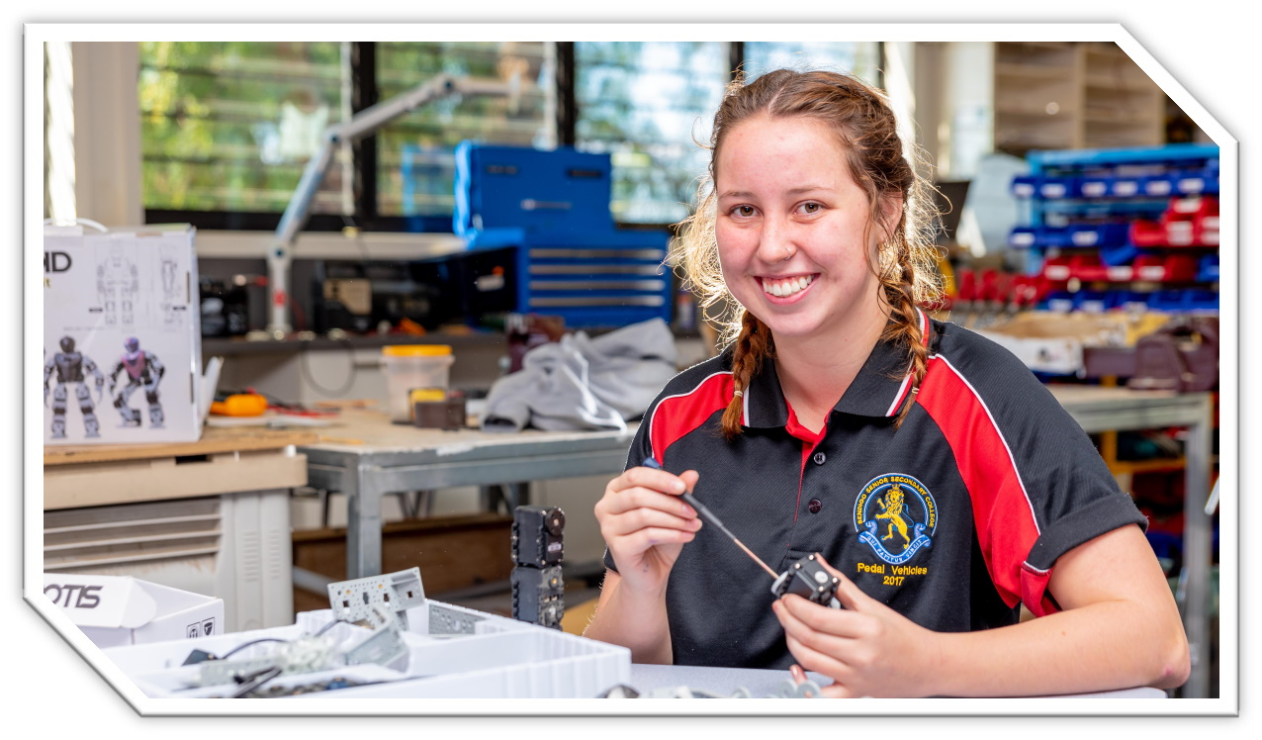
VCE VET Integrated Technologies

22586VIC Certificate II in Integrated Technologies
Student name:

Authorised and published by the Victorian Curriculum and Assessment Authority
Level 7, 200 Victoria Pde
East Melbourne VIC 3002
© Victorian Curriculum and Assessment Authority 2024

No part of this publication may be reproduced except as specified under the Copyright Act 1968 or by permission from the VCAA. Excepting third-party elements, schools may use this resource in accordance with the VCAA educational allowance. For more information go to https://www.vcaa.vic.edu.au/Footer/Pages/Copyright.aspx.
The VCAA provides the only official, up-to-date versions of VCAA publications. Details of updates can be found on the VCAA website at www.vcaa.vic.edu.au.
This publication may contain copyright material belonging to a third party. Every effort has been made to contact all copyright owners. If you believe that material in this publication is an infringement of your copyright, please email the Copyright Officer vcaa.copyright@edumail.vic.gov.au
Copyright in materials appearing at any sites linked to this document rests with the copyright owner/s of those materials, subject to the Copyright Act. The VCAA recommends you refer to copyright statements at linked sites before using such materials.
The VCAA logo is a registered trademark of the Victorian Curriculum and Assessment Authority.

Contact us if you need this information in an accessible format - for example, large print or audio.
Telephone (03) 9032 1635 or email vcaa.media.publications@edumail.vic.gov.au

Structured Workplace Learning Recognition
VCE Structured Workplace Learning Recognition for VET provides students with the opportunity to gain credit towards their VCE (including the VCE VM) or VPC by undertaking a Structured Workplace Learning (SWL) placement that is aligned to their VE1 VCE VET program or VE2 School-based Apprenticeship or Traineeship (SBAT).
To receive credit, students are required to demonstrate satisfactory achievement of the outcomes for the relevant unit of the VCE Structured Workplace Learning Recognition for VET study design.
Students must maintain a Workplace Learning Record (WLR) for each placement. In the WLR students must reflect on a minimum of six units of competency (UoCs) from their program, including a workplace health and safety (WHS) UoC.

About this workplace learning record
Students undertaking this study must maintain a Workplace Learning Record (WLR) related to the SWL placement for recording, authentication and assessment purposes.
Student reflections on their SWL placement are to be recorded in the three sections of this WLR to document the skills and knowledge learned, employability skills developed, and industry experience gained relating to the VET qualification being undertaken.
Students must undertake a work placement in a different workplace setting or context for each VCE unit and maintain a separate WLR per placement.

The WLR is divided into three sections.
Section 1: Learner profile
Section 2: Learning about VET units of competency (UoCs) in the workplace
Section 3: Post-placement reflections

Please complete the details of your workplace.
Employer/Company/Business
Supervisor name
Contact phone number

Employer/Company/Business
Supervisor name
Contact phone number

Employer/Company/Business
Supervisor name
Contact phone number

Section 1: Learner profile
Complete the learner profile and discuss this with your host employer on or before your first day of SWL placement.
Student Name
School
Phone number
Email
Explain why you decided to undertake this VET certificate?
List the other studies that you are undertaking.
Explain why you have chosen this overall program.
Outline what interests you about the industry.
What is your planned career path or future career aspiration?
Describe any workplace skills you have developed through previous work experience, SWL or part time employment.
How have you developed these skills?

Section 2: Learning about VET units of competency in the workplace
This section of the WLR will contain three key questions per unit of competency (UoC) designed to draw out related experiences you may be exposed to in a workplace.
This does not cover all the elements or performance criteria within the units and is not designed as a UoC assessment tool.
You should comment on the UoCs you have experienced in the workplace and reflect on actual observations or activities that you have been exposed to. Your observations will:
- reinforce the training you have undertaken
- identify differences in practice or equipment
- identify areas requiring further training or practical experience.
You are encouraged to take photos and/or video where appropriate to showcase learning in the workplace. Evidence you collect can include:
- observations
- descriptions of activities and tasks
- conversations with employers and other staff
- participation in meetings
- workplace documents
- research in the workplace
- photos of equipment/processes/events
- video of workplace activities.
Note: please speak to your host employer before taking photos or video. Do not use the names or details of any clients/stakeholders external to the organisation/other. This record does not require identifying actual people or events, as this may breach confidentiality.

Program outline

22586VIC Certificate II in Integrated Technologies
The compulsory UoCs and a selection of electives are listed in the table below. You may list any additional UoC(s) relating to your experiences in the workplace in the table. Indicate the year in which you are undertaking each UoC. You must reflect on a minimum of six UoCs from your program, including a workplace health and safety (WHS) UoC.
UoC code | UoC title | Nominal hours | Year | Page
Work, Health and Safety
UEECD0007 | Apply work health and safety regulations, codes and practices in the workplace | 20 |  | 90
Compulsory
VU23109 | Prepare to work in an integrated technologies environment | 20 |  | 10
VU23110 | Use routine work practices in an integrated technologies environment | 40 |  | 11
VU23111 | Apply electrotechnology knowledge and skills in integrated technologies work | 80 |  | 12
VU23112 | Use Computer Aided Drafting and Design software applications in integrated technologies work | 20 |  | 13
VU23113 | Carry out an integrated technologies project | 60 |  | 14
Elective
ICTICT302 | Install and optimise operating system software | 20 |  | 15
ICTICT303 | Connect internal hardware components | 20 |  | 16
ICTPRG302 | Apply introductory programming techniques | 40 |  | 17
ICTSAS309 | Maintain and repair ICT equipment and software | 20 |  | 18
VU22338 | Configure and program a basic robotic system | 60 |  | 19
VU22340 | Use 3D printing to create products | 40 |  | 20
VU22674 | Explore applications and operation of the Internet of Things (IoT) | 20 |  | 21
VU22963 | Build and implement a basic network | 100 |  | 22
VU23118 | Install, test and verify correct operation of a by-wire control system | 30 |  | 23
VU23119 | Install, set up and test an embedded control system | 30 |  | 24
VU23120 | Set up and operate a small scale stand-alone photovoltaic energy system with battery storage | 60 |  | 25
Reflect on the UoCs you have experienced in the workplace on the following pages.

VCE VET units of competency

UEECD0007 - Apply work health and safety regulations, codes and practices in the workplace
This unit involves the skills and knowledge required to apply work health and safety (WHS)/occupational health and safety (OHS) regulations and codes of practices in the electrotechnology workplace.
Respond to the following | Comments/observations
How did you learn about the WHS policies and procedures?
Briefly outline the purpose of a workplace safety meeting you attended, or a workplace consultative activity you participated in.
In your experience at this workplace, how were actual and foreseeable workplace hazards identified?

VU23109 - Prepare to work in an integrated technologies environment
This unit describes the performance outcomes, skills and knowledge required to prepare a person for work within an integrated technologies environment.
Respond to the following | Comments/observations
What job roles did you observe within the workplace? What was the main function of each job?
Which areas of integrated technology work would you investigate further having experienced the workplace?
What are your personal strengths and weaknesses in relation to the job roles in this workplace?

VU23110 - Use routine work practices in an integrated technologies environment
This unit describes the performance outcomes, skills and knowledge required to apply routine work practices in an integrated technologies environment.
Respond to the following | Comments/observations
What devices and/or components did you use or observe being used in this workplace?
How did they ensure equipment or machine circuits were safe before work was commenced?
What test equipment did you use or observe being used in this workplace?

VU23111 - Apply electrotechnology knowledge and skills in integrated technologies work
This unit describes the performance outcomes required for a person to use basic electrotechnology knowledge and skills in an integrated technologies environment.
Respond to the following | Comments/observations
Give an example of some calculations you had to carry out in the workplace.
Name a graph or chart used in this workplace.
What cable types did you use or observe being used in the workplace?

VU23112 - Use Computer Aided Drafting and Design software applications in integrated technologies work
This unit describes the performance outcomes, skills and knowledge required to use computer aided drawing and design (CAD) software to support the application of technologies in an integrated environment.
Respond to the following | Comments/observations
Give an example of one way you used CAD in the workplace including describing any calculations you had to make.
Describe a 2D or 3D component you had to draw or observed being drawn using CAD in this workplace.
Describe a block diagram or flowchart you used or observed in the workplace.

VU23113 - Carry out an integrated technologies project
This unit of competency sets out the knowledge and skills required to carry out an integrated technology project by merging distinct electrotechnology domains to achieve an innovative and integrated technical solution.
Respond to the following | Comments/observations
Outline the integrated technology projects that you observed in the workplace.
Describe the project specifications that were used in the workplace including any project briefs, contracts or tender documents.
Describe your role in the workplace on an integrated technology project.

ICTICT302 - Install and optimise operating system software
This unit defines the skills and knowledge required to install, configure and optimise operating system (OS) software to meet business and client needs.
Respond to the following | Comments/observations
Name at least two operating systems you installed in the workplace.
Describe at least two things you did to test the operating system after installation.
Describe at least two things you did to optimise the operating system after installation.

ICTICT303 - Connect internal hardware components
This unit describes the skills and knowledge required to install and configure internal hardware components and evaluate the modified system according to client and user requirements.
Respond to the following | Comments/observations
List some hardware components you connected in the workplace.
Describe some technical vendor specifications you needed in the workplace and how you obtained them.
Describe at least two tests you were required to carry out on internal hardware components you installed and connected in this workplace.

ICTPRG302 - Apply introductory programming techniques
This unit describes the skills and knowledge required to create simple applications through introductory programming techniques.
Respond to the following | Comments/observations
In this workplace what programming or scripting languages were they using?
How did they test code and document the test results in your workplace?
How did you learn about the organisations security guidelines?

ICTSAS309 - Maintain and repair ICT equipment and software
This unit describes the skills and knowledge required to carry out maintenance and fault repair according to organisational procedures, in order to keep Information and Communications Technology (ICT) equipment and software operating.
Respond to the following | Comments/observations
How were equipment problems reported?
Who were problems reported to?
What procedure did you use in the workplace for testing faulty equipment or software?
In the workplace how did you obtain approval to carry out diagnostic repairs?

VU22338 - Configure and program a basic robotic system
This unit of competency sets out the knowledge and skills required to configure and program a basic robotic system. Typical tasks for basic robotics system operation include pick and place, motion, navigation.
Respond to the following | Comments/observations
Outline how the workplace planned the configuration and programming of basic robotics systems.
Describe how a robotic system was tested for correct operation in the workplace? How was this documented?
Describe the materials used in the construction of robots in the workplace and the drive mechanisms used.

VU22340 - Use 3D printing to create products
This unit describes the skills and knowledge to utilise a three-dimensional (3D) printer to produce basic products.
Respond to the following | Comments/observations
Describe a product you created or observed being created using 3D printing in this workplace.
What 3D printing hardware and software did they use in this workplace and why did they choose those options?
What factors influenced the decision to use 3D printing for a particular project in this workplace?

VU22674 - Explore applications and operation of the Internet of Things (IoT)
This unit describes the performance outcomes, skills and knowledge required to recognise the current applications and potential of the Internet of Things (IoT) including its application in the electrotechnology industry.
Respond to the following | Comments/observations
Describe two typical IoT devices and briefly explain their function.
Describe any occasion where you undertook or observed troubleshooting of an IoT system in the workplace.
Describe one technique they used in this workplace to securely connect to Wi-Fi devices in an IoT system.

VU22963 - Build and implement a basic network
This unit of competency describes the performance outcomes, knowledge and skills required to investigate the structure, functions, protocols and components of a computer network in order to build a basic network for a small enterprise and establish end-to-end connectivity.
Respond to the following | Comments/observations
How did they determine network requirements when designing a network in this workplace?
Name some of the physical layer technologies you used in this workplace.
Name at least one base level trooubleshooting procedure you used in this workplace.

VU23118 - Install, test and verify correct operation of a by-wire control system
This unit of competency sets out the knowledge and skills required to test and verify correct operations of a by-wire control system.
Respond to the following | Comments/observations
What safety precautions did the workplace take when installing and testing “by-wire” control systems?
Describe the methods for dealing with unexpected situations that you observed being used in the workplace.
Outline any “by-wire” control system that you observed being installed and tested in the workplace.

VU23119 - Install, set up and test an embedded control system
This unit of competency sets out the knowledge and skills required to install, set up and test embedded control systems used for automatic or semi-automatic operation of a wide range of consumer and industrial equipment.
Respond to the following | Comments/observations
What different types of embedded control systems did you observe in the workplace?
Outline the processes used in the workplace when installing and configuring an embedded control system.
What was your role in the process for testing embedded control systems?

VU23120 - Set up and operate a small scale stand-alone photovoltaic energy system with battery storage
This unit describes the performance outcomes, skills and knowledge required to plan, set up and operate a small scale (not to exceed 32V), stand-alone, photovoltaic (PV) energy system with battery storage.
Respond to the following | Comments/observations
Name at least three photovoltaic (PV) energy system components you installed and briefly explain the role of each component.
How did you determine if a proposed installation site was suitable?
How did you test if the system you setup was charging correctly and outputting the required power?

Comments/observations on any other UoCs not listed
UoCs | Comments/observations

Section 3: Student post-placement reflection
Employability skills are a set of eight skills we use every day in the workplace.
- Communication
- Teamwork
- Problem solving
- Self-management
- Planning and organising
- Technology
- Learning
- Initiative and enterprise
When you are on work placement, you will be using employability skills in many ways.
This record will assist you when applying for jobs and in interviews. The skills you are developing may be transferred to a range of occupations.
In Section 3, identify the employability skills you have used and how you have demonstrated them in the workplace. Identify how the skills you have acquired and used during your 80 hours of SWL might assist you in the future.

List of employability skills
How did you demonstrate communication skills? For example, by listening and understanding, speaking clearly and directly, or reading and writing.
How did you demonstrate teamwork? For example, by working as part of a team or sharing ideas and resources with co-workers.

How did you demonstrate problem solving? For example, by identifying problems or developing solutions to workplace issues.
How did you demonstrate self-management? For example, by taking responsibility, managing time and tasks effectively, monitoring your own performance or having the ability to work unsupervised.

How did you demonstrate planning and organising? For example, by time management, setting priorities, making decisions, setting goals, collecting, or analysing and organising information.
How did you demonstrate the use of technology? For example, by being prepared to use a range of technology systems, IT skills (typing or data entry), or being able to learn new skills from the technology used in this industry.

How did you demonstrate learning? For example, by being willing to learn new things, being open to new ideas or adapting to change.
How did you demonstrate initiative and enterprise? For example, being creative, adapting to new situations, turning ideas into actions, coming up with a variety of options.

Summary of industry learning
At the conclusion of your SWL for this VET qualification, think about the experiences you have had in the workplace, your reflection of learning against the UoCs and the employability skills you have developed.
How will these learnings assist you in your pathway to employment or further training in this industry?

Student declaration
I confirm that I have undertaken work placement with:
Employer/Company/Business name | Dates of placement | Total hours of placement
TOTAL

I have completed the reflections and evidence submitted in this WLR and they are from my own experiences.
Signed (Student)
Name
Date

