Workplace Learning Record

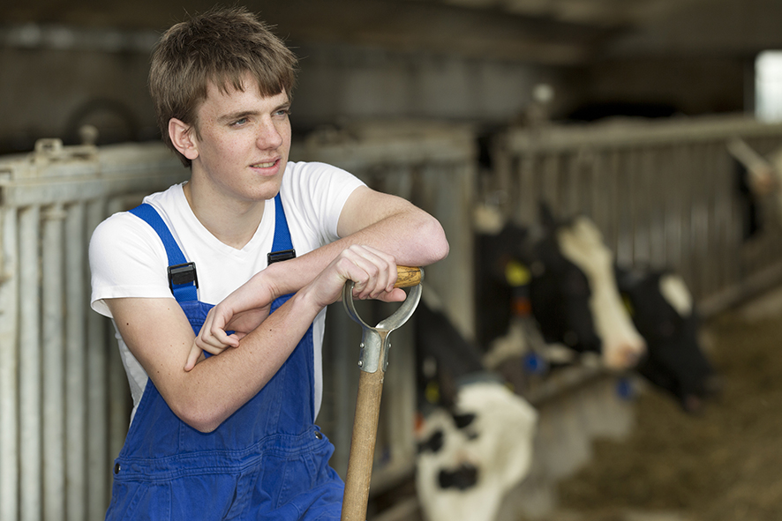
VCE VET Agriculture, Horticulture, Conservation and Ecosystem Management

AHC20122 Certificate II in Agriculture
Student name:

Authorised and published by the Victorian Curriculum and Assessment Authority
Level 7, 200 Victoria Pde
East Melbourne VIC 3002
© Victorian Curriculum and Assessment Authority 2024

No part of this publication may be reproduced except as specified under the Copyright Act 1968 or by permission from the VCAA. Excepting third-party elements, schools may use this resource in accordance with the VCAA educational allowance. For more information go to https://www.vcaa.vic.edu.au/Footer/Pages/Copyright.aspx.
The VCAA provides the only official, up-to-date versions of VCAA publications. Details of updates can be found on the VCAA website at www.vcaa.vic.edu.au.
This publication may contain copyright material belonging to a third party. Every effort has been made to contact all copyright owners. If you believe that material in this publication is an infringement of your copyright, please email the Copyright Officer vcaa.copyright@edumail.vic.gov.au
Copyright in materials appearing at any sites linked to this document rests with the copyright owner/s of those materials, subject to the Copyright Act. The VCAA recommends you refer to copyright statements at linked sites before using such materials.
The VCAA logo is a registered trademark of the Victorian Curriculum and Assessment Authority.

Contact us if you need this information in an accessible format - for example, large print or audio.
Telephone (03) 9032 1635 or email vcaa.media.publications@edumail.vic.gov.au

Structured Workplace Learning Recognition
VCE Structured Workplace Learning Recognition for VET provides students with the opportunity to gain credit towards their VCE (including the VCE VM) or VPC by undertaking a Structured Workplace Learning (SWL) placement that is aligned to their VE1 VCE VET program or VE2 School-based Apprenticeship or Traineeship (SBAT).
To receive credit, students are required to demonstrate satisfactory achievement of the outcomes for the relevant unit of the VCE Structured Workplace Learning Recognition for VET study design.
Students must maintain a Workplace Learning Record (WLR) for each placement. In the WLR students must reflect on a minimum of six units of competency (UoCs) from their program, including a workplace health and safety (WHS) UoC.

About this workplace learning record
Students undertaking this study must maintain a Workplace Learning Record (WLR) related to the SWL placement for recording, authentication and assessment purposes.
Student reflections on their SWL placement are to be recorded in the three sections of this WLR to document the skills and knowledge learned, employability skills developed, and industry experience gained relating to the VET qualification being undertaken.
Students must undertake a work placement in a different workplace setting or context for each VCE unit and maintain a separate WLR per placement.

The WLR is divided into three sections.
Section 1: Learner profile
Section 2: Learning about VET units of competency (UoCs) in the workplace
Section 3: Post-placement reflections

Please complete the details of your workplace.
Employer/Company/Business
Supervisor name
Contact phone number

Employer/Company/Business
Supervisor name
Contact phone number

Employer/Company/Business
Supervisor name
Contact phone number

Section 1: Learner profile
Complete the learner profile and discuss this with your host employer on or before your first day of SWL placement.
Student Name
School
Phone number
Email
Explain why you decided to undertake this VET certificate?
List the other studies that you are undertaking.
Explain why you have chosen this overall program.
Outline what interests you about the industry.
What is your planned career path or future career aspiration?
Describe any workplace skills you have developed through previous work experience, SWL or part time employment.
How have you developed these skills?

Section 2: Learning about VET units of competency in the workplace
This section of the WLR will contain three key questions per unit of competency (UoC) designed to draw out related experiences you may be exposed to in a workplace.
This does not cover all the elements or performance criteria within the units and is not designed as a UoC assessment tool.
You should comment on the UoCs you have experienced in the workplace and reflect on actual observations or activities that you have been exposed to. Your observations will:
- reinforce the training you have undertaken
- identify differences in practice or equipment
- identify areas requiring further training or practical experience.
You are encouraged to take photos and/or video where appropriate to showcase learning in the workplace. Evidence you collect can include:
- observations
- descriptions of activities and tasks
- conversations with employers and other staff
- participation in meetings
- workplace documents
- research in the workplace
- photos of equipment/processes/events
- video of workplace activities.
Note: please speak to your host employer before taking photos or video. Do not use the names or details of any clients/stakeholders external to the organisation/other. This record does not require identifying actual people or events, as this may breach confidentiality.

Program outline

AHC20122 Certificate II in Agriculture (Release 1)
The compulsory UoCs and a selection of electives are listed in the table below. You may list any additional UoC(s) relating to your experiences in the workplace in the table. Indicate the year in which you are undertaking each UoC. You must reflect on a minimum of six UoCs from your program, including a workplace health and safety (WHS) UoC.
UoC code | UoC title | Nominal hours | Year | Page
Work, Health and Safety
AHCWHS202 | Participate in workplace health and safety processes | 30 |  | 9
Compulsory
AHCLSK204 | Carry out regular livestock observation | 40 |  | 10
AHCWRK211 | Participate in environmentally sustainable work practices | 30 |  | 11
AHCWRK212 | Work effectively in industry | 30 |  | 12
AHCWRK213 | Participate in workplace communications | 40 |  | 13
Electives
AHCCHM201 | Apply chemicals under supervision | 30 |  | 14
AHCINF205 | Carry out basic electric fencing operations | 40 |  | 15
AHCINF206 | Install, maintain and repair farm fencing | 30 |  | 16
AHCLSK202 | Care for health and welfare of livestock | 40 |  | 17
AHCLSK205 | Handle livestock using basic techniques | 30 |  | 18
AHCLSK209 | Monitor water supplies | 20 |  | 19
AHCLSK210 | Muster and move livestock | 25 |  | 20
AHCLSK211 | Provide feed for livestock | 30 |  | 21
AHCMOM202 | Operate tractors | 40 |  | 22
AHCPCM204 | Recognise plants | 40 |  | 23
AHCPMG201 | Treat weeds | 40 |  | 24
AHCWRK210 | Observe and report on weather | 20 |  | 25
AHCWRK215 | Collect and record production data | 40 |  | 26
HLTAID010 | Provide basic emergency life support | 12 |  | 27
Reflect on the UoCs you have experienced in the workplace on the following pages.

VCE VET units of competency

AHCWHS202 - Participate in workplace health and safety processes
This unit of competency describes the skills and knowledge required to recognise and report hazards in the workplace, and follow workplace health and safety procedures and directions.
Respond to the following | Comments/observations
How did you learn about the WHS policies and procedures in your workplace?
Briefly outline what you observed about the designated WHS role within the workplace.
In your experience, in this workplace, what are the specific WHS issues when responding to incidents?

AHCLSK204 - Carry out regular livestock observation
This unit of competency describes the skills and knowledge required to carry out regular livestock observation.
Respond to the following | Comments/observations
List some of the tools, equipment and personal protective equipment you used when observing livestock?
What were some of the hazards you needed to be aware of when observing livestock?
What were some of the signs of illness or injury that you were looking for when observing livestock?

AHCWRK211 - Participate in environmentally sustainable work practices
This unit of competency describes the skills and knowledge required to participate in environmentally sustainable work practices.
Respond to the following | Comments/observations
What were the workplace environmental and resource efficiency issues?
What environmental regulations did the workplace have to consider?
How was the workplace trying to improve environmental practices and resource efficiency?

AHCWRK212 - Work effectively in industry
This unit of competency describes the skills and knowledge required to work effectively within an industry on an individual basis and within a work team, including observing employment requirements and accepting responsibility for quality of own work.
Respond to the following | Comments/observations
What were your employer’s expectations?
Briefly outline how workplace cooperation was promoted in the workplace.
How did you contribute to a productive work environment?
How was industry knowledge shared?

AHCWRK213 - Participate in workplace communications
This unit of competency describes the skills and knowledge required to participate in workplace communications.
Respond to the following | Comments/observations
Give examples of two routine instructions you followed in the workplace.
Describe the work related documents you observed, assisted with or completed in the workplace.
Describe how you communicated with colleagues in the workplace.

AHCCHM201 - Apply chemicals under supervision
This unit of competency describes the skills and knowledge required to handle, transport, and apply chemicals under supervision using workplace specified chemicals and application equipment.
Respond to the following | Comments/observations
What was the process used by the workplace in preparing to handle chemicals?
What safety precautions and personal protective equipment (PPE) did you observe being used in the workplace while applying chemicals?
Outline the uses of chemicals that you observed in the workplace.

AHCINF205 - Carry out basic electric fencing operations
This unit of competency describes the skills and knowledge required to install and maintain basic electric fences.
Respond to the following | Comments/observations
How did the workplace prepare for fencing operations?
What tools and equipment were used by the workplace for erecting, installing, and repairing electric fencing?
How did the workplace dispose of all non-reusable materials?
Was this environmentally friendly?

AHCINF206 - Install, maintain and repair farm fencing
This unit of competency describes the skills and knowledge required to install, maintain and repair farm fencing using appropriate tools and techniques.
Respond to the following | Comments/observations
What was your role in farm fence installation in the workplace?
What tools and equipment were used by the workplace for erecting and repairing farm fencing?
What workplace records were completed regarding the installation and repair of farm fencing?

AHCLSK202 - Care for health and welfare of livestock
This unit of competency describes the skills and knowledge required to care for the health and welfare of livestock.
Respond to the following | Comments/observations
What livestock did the workplace work with and how was their health and welfare monitored and assessed?
Describe how the workplace treated sick and injured livestock or made arrangements to humanely destroy livestock, if necessary.
Describe how the workplace administered drenches, vaccines and prescribed treatments to livestock.

AHCLSK205 - Handle livestock using basic techniques
This unit of competency describes the skills and knowledge required to safely move, draft and control livestock using basic methods and procedures in an agricultural enterprise.
Respond to the following | Comments/observations
How did the workplace identify, prepare and maintain livestock handling areas, gates and access routes?
Describe the techniques used in the workplace to move livestock to designated handling areas.
Describe how the workplace restrained livestock safely and with minimum stress and discomfort in line with enterprise animal welfare policies.

AHCLSK209 - Monitor water supplies
This unit of competency describes the skills and knowledge required to monitor the supply of potable water for livestock from water storages and sources.
Respond to the following | Comments/observations
How did the workplace monitor water supplies?
What was your role in inspecting and clearing intake and outlet points on water supplies?
Outline the water delivery equipment that you observed being used in the workplace.

AHCLSK210 - Muster and move livestock
This unit of competency describes the skills and knowledge required to muster and move livestock as part of a team.
Respond to the following | Comments/observations
How did the workplace identify mustering requirements?
What was your role in locating livestock and the muster process?
How were livestock moved in the workplace and what were the reasons for moving them?

AHCLSK211 - Provide feed for livestock
This unit of competency describes the skills and knowledge required to prepare and provide feed for livestock.
Respond to the following | Comments/observations
How did the workplace develop feeding plans and ensure that feed and feed supplements were prepared in line with these plans?
What livestock were you involved in feeding in the workplace?
Describe the feeding process.
What records were maintained by the workplace regarding feeding?
What were these records used for?

AHCMOM202 - Operate tractors
This unit of competency describes the skills and knowledge required to prepare for, operate and complete tractor operations under general supervision in the agriculture, horticulture and land management sectors.
Respond to the following | Comments/observations
How did the workplace conduct safety preoperational checks on both the tractor and any attached equipment?
Describe the operation and use of tractors in the workplace.
What processes did the workplace follow to clean, decontaminate, secure and store tractors and attached equipment?

AHCPCM204 - Recognise plants
This unit of competency describes the skills and knowledge required to recognise commonly encountered plants, including desired species and weeds, and to document and confirm plant identification.
Respond to the following | Comments/observations
What were the processes used in the workplace to identify a range of desirable and non-desirable plants?
Outline the different types of plants that you were required to recognise in the workplace.
What characteristics and significant features of plants allow you to identify them?
What workplace records were completed regarding the recognition of plants?

AHCPMG201 - Treat weeds
This unit of competency describes the skills and knowledge required to recognise significant weed species and apply a range of weed treatment control options.
Respond to the following | Comments/observations
How did the workplace prepare to treat weeds?
What was your role in treating weeds in the workplace?
Outline the processes and equipment that you observed being used in the workplace for treating weeds.

AHCWRK210 - Observe and report on weather
This unit of competency describes the skills and knowledge required to observe and report on weather and carry out preventative action in response to weather and climate.
Respond to the following | Comments/observations
Describe some of the weather equipment used in this workplace and how it was prepared for use.
How were some work tasks adjusted in response to weather and climate changes?
What information did you have to record in workplace weather records?

AHCWRK215 - Collect and record production data
This unit of competency describes the skills and knowledge required to collect and record production data obtained from a variety of sources.
Respond to the following | Comments/observations
Describe how you prepared tools, equipment and materials required for data collection, including how you calibrated at least one tool.
Give at least two examples of production data you had to collect.
Give at least one example of how production data was recorded and presented to meet specific requirements.

HLTAID010 - Provide basic emergency life support
This unit describes the skills and knowledge required to recognise and respond to life-threatening emergencies in line with first aid guidelines determined by the Australian Resuscitation Council (ARC) and other Australian national peak clinical bodies.
Respond to the following | Comments/observations
What was the procedure for responding to an emergency situation in the workplace?
Briefly outline the role that you observed of the person responsible for First Aid within the workplace.
In your experience in this workplace, how were details of incidents reported?

Comments/observations on any other UoCs not listed
UoCs | Comments/observations

Section 3: Student post-placement reflection
Employability skills are a set of eight skills we use every day in the workplace.
- Communication
- Teamwork
- Problem solving
- Self-management
- Planning and organising
- Technology
- Learning
- Initiative and enterprise
When you are on work placement, you will be using employability skills in many ways.
This record will assist you when applying for jobs and in interviews. The skills you are developing may be transferred to a range of occupations.
In Section 3, identify the employability skills you have used and how you have demonstrated them in the workplace. Identify how the skills you have acquired and used during your 80 hours of SWL might assist you in the future.

List of employability skills
How did you demonstrate communication skills? For example, by listening and understanding, speaking clearly and directly, or reading and writing.
How did you demonstrate teamwork? For example, by working as part of a team or sharing ideas and resources with co-workers.

How did you demonstrate problem solving? For example, by identifying problems or developing solutions to workplace issues.
How did you demonstrate self-management? For example, by taking responsibility, managing time and tasks effectively, monitoring your own performance or having the ability to work unsupervised.

How did you demonstrate planning and organising? For example, by time management, setting priorities, making decisions, setting goals, collecting, or analysing and organising information.
How did you demonstrate the use of technology? For example, by being prepared to use a range of technology systems, IT skills (typing or data entry), or being able to learn new skills from the technology used in this industry.

How did you demonstrate learning? For example, by being willing to learn new things, being open to new ideas or adapting to change.
How did you demonstrate initiative and enterprise? For example, being creative, adapting to new situations, turning ideas into actions, coming up with a variety of options.

Summary of industry learning
At the conclusion of your SWL for this VET qualification, think about the experiences you have had in the workplace, your reflection of learning against the UoCs and the employability skills you have developed.
How will these learnings assist you in your pathway to employment or further training in this industry?

Student declaration
I confirm that I have undertaken work placement with:
Employer/Company/Business name | Dates of placement | Total hours of placement
TOTAL

I have completed the reflections and evidence submitted in this WLR and they are from my own experiences.
Signed (Student)
Name
Date

