Workplace Learning Record

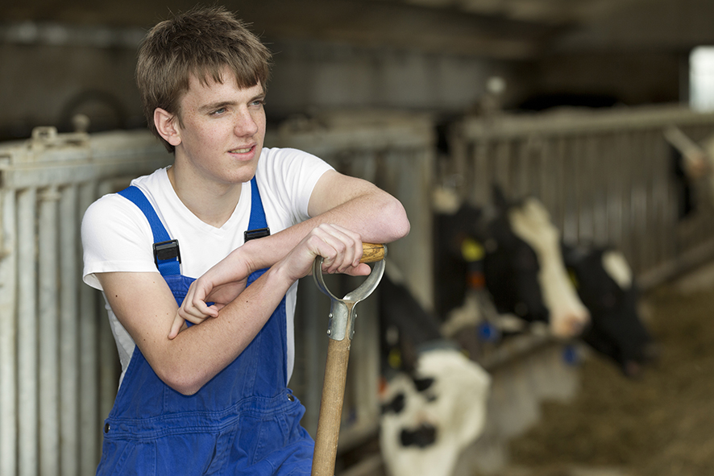
VCE VET Agriculture, Horticulture, Conservation and Ecosystem Management

AHC21020 Certificate II in Conservation and Ecosystem Management
Student name:

Authorised and published by the Victorian Curriculum and Assessment Authority
Level 7, 200 Victoria Pde
East Melbourne VIC 3002
© Victorian Curriculum and Assessment Authority 2024

No part of this publication may be reproduced except as specified under the Copyright Act 1968 or by permission from the VCAA. Excepting third-party elements, schools may use this resource in accordance with the VCAA educational allowance. For more information go to https://www.vcaa.vic.edu.au/Footer/Pages/Copyright.aspx.
The VCAA provides the only official, up-to-date versions of VCAA publications. Details of updates can be found on the VCAA website at www.vcaa.vic.edu.au.
This publication may contain copyright material belonging to a third party. Every effort has been made to contact all copyright owners. If you believe that material in this publication is an infringement of your copyright, please email the Copyright Officer vcaa.copyright@edumail.vic.gov.au
Copyright in materials appearing at any sites linked to this document rests with the copyright owner/s of those materials, subject to the Copyright Act. The VCAA recommends you refer to copyright statements at linked sites before using such materials.
The VCAA logo is a registered trademark of the Victorian Curriculum and Assessment Authority.

Contact us if you need this information in an accessible format - for example, large print or audio.
Telephone (03) 9032 1635 or email vcaa.media.publications@edumail.vic.gov.au

Structured Workplace Learning Recognition
VCE Structured Workplace Learning Recognition for VET provides students with the opportunity to gain credit towards their VCE (including the VCE VM) or VPC by undertaking a Structured Workplace Learning (SWL) placement that is aligned to their VE1 VCE VET program or VE2 School-based Apprenticeship or Traineeship (SBAT).
To receive credit, students are required to demonstrate satisfactory achievement of the outcomes for the relevant unit of the VCE Structured Workplace Learning Recognition for VET study design.
Students must maintain a Workplace Learning Record (WLR) for each placement. In the WLR students must reflect on a minimum of six units of competency (UoCs) from their program, including a workplace health and safety (WHS) UoC.

About this workplace learning record
Students undertaking this study must maintain a Workplace Learning Record (WLR) related to the SWL placement for recording, authentication and assessment purposes.
Student reflections on their SWL placement are to be recorded in the three sections of this WLR to document the skills and knowledge learned, employability skills developed, and industry experience gained relating to the VET qualification being undertaken.
Students must undertake a work placement in a different workplace setting or context for each VCE unit and maintain a separate WLR per placement.

The WLR is divided into three sections.
Section 1: Learner profile
Section 2: Learning about VET units of competency (UoCs) in the workplace
Section 3: Post-placement reflections

Please complete the details of your workplace.
Employer/Company/Business
Supervisor name
Contact phone number

Employer/Company/Business
Supervisor name
Contact phone number

Employer/Company/Business
Supervisor name
Contact phone number

Section 1: Learner profile
Complete the learner profile and discuss this with your host employer on or before your first day of SWL placement.
Student Name
School
Phone number
Email
Explain why you decided to undertake this VET certificate?
List the other studies that you are undertaking.
Explain why you have chosen this overall program.
Outline what interests you about the industry.
What is your planned career path or future career aspiration?
Describe any workplace skills you have developed through previous work experience, SWL or part time employment.
How have you developed these skills?

Section 2: Learning about VET units of competency in the workplace
This section of the WLR will contain three key questions per unit of competency (UoC) designed to draw out related experiences you may be exposed to in a workplace.
This does not cover all the elements or performance criteria within the units and is not designed as a UoC assessment tool.
You should comment on the UoCs you have experienced in the workplace and reflect on actual observations or activities that you have been exposed to. Your observations will:
- reinforce the training you have undertaken
- identify differences in practice or equipment
- identify areas requiring further training or practical experience.
You are encouraged to take photos and/or video where appropriate to showcase learning in the workplace. Evidence you collect can include:
- observations
- descriptions of activities and tasks
- conversations with employers and other staff
- participation in meetings
- workplace documents
- research in the workplace
- photos of equipment/processes/events
- video of workplace activities.
Note: please speak to your host employer before taking photos or video. Do not use the names or details of any clients/stakeholders external to the organisation/other. This record does not require identifying actual people or events, as this may breach confidentiality.

Program outline

AHC21020 Certificate II in Conservation and Ecosystem Management
The compulsory UoCs and a selection of electives are listed in the table below. You may list any additional UoC(s) relating to your experiences in the workplace in the table. Indicate the year in which you are undertaking each UoC. You must reflect on a minimum of six UoCs from your program, including a workplace health and safety (WHS) UoC.
UoC code | UoC title | Nominal hours | Year | Page
Work, Health and Safety
AHCWHS201 | Participate in work health and safety processes | 20 |  | 9
Compulsory
AHCWRK209 | Participate in environmentally sustainable work practices | 20 |  | 10
Electives
AHCBIO203 | Inspect and clean machinery, tools and equipment to preserve biosecurity | 20 |  | 11
AHCECR201 | Capture digital media for fieldwork | 30 |  | 12
AHCECR202 | Maintain wildlife habitat refuges | 40 |  | 13
AHCECR203 | Perform basic ecological restoration works | 40 |  | 14
AHCECR305 | Collect native seed | 40 |  | 15
AHCFAU202 | Recognise fauna | 40 |  | 16
AHCLPW201 | Operate a handheld GPS device | 30 |  | 17
AHCSAW202 | Recognise landforms and soil types | 50 |  | 18
AHCWRK312 | Operate in isolated and remote situations | 40 |  | 19
PUALAW001 | Protect and preserve incident scene | 20 |  | 20
Reflect on the UoCs you have experienced in the workplace on the following pages.

VCE VET units of competency

AHCWHS201 - Participate in work health and safety processes
This unit of competency describes the skills and knowledge required to recognise and report hazards in the workplace. It also describes the skills and knowledge required to follow work health and safety (WHS) procedures and directions.
Respond to the following | Comments/observations
How did you learn about the WHS policies and procedures in your workplace?
Briefly outline what you observed about the designated WHS role within the workplace.
In your experience, in this workplace, what are the specific WHS issues when responding to incidents?

AHCWRK209 - Participate in environmentally sustainable work practices
This unit of competency describes the skills and knowledge required to follow workplace procedures and instructions, and to participate in environmentally sustainable work practices.
Respond to the following | Comments/observations
What were the workplace environmental and resource efficiency issues?
What environmental regulations did the workplace have to consider?
How was the workplace trying to improve environmental practices and resource efficiency?

AHCBIO203 - Inspect and clean machinery, tools and equipment to preserve biosecurity
This unit of competency describes the skills and knowledge required to inspect and clean machinery, tools and other equipment, including vehicles, of material that may contribute to the spread of biosecurity threats.
Respond to the following | Comments/observations
What machinery did you observe being inspected and cleaned in the workplace?
How were machinery, tools and equipment cleaned of contamination?
Describe the biosecurity and environmental procedures that you observed in the workplace.

AHCECR201 - Capture digital media for fieldwork
This unit of competency describes the skills and knowledge required to use compact cameras, mobile phones and tablets to capture and record basic digital media in the field, store media and perform basic digital editing.
Respond to the following | Comments/observations
What digital media devices and editing software were used in the workplace?
What was the purpose and requirements of the imagery captured in the field?
How was the digital capture device set up in the field?

AHCECR202 - Maintain wildlife habitat refuges
This unit of competency describes the skills and knowledge required to maintain wildlife habitats and refuges to protect desirable animal species from invasive species.
Respond to the following | Comments/observations
Describe a wildlife habitat that you observed being preserved.
Describe the biosecurity and sustainable practices that you observed.
What strategies to control invasive pests did you observe?

AHCECR203 - Perform basic ecological restoration works
This unit of competency describes the skills and knowledge required to carry out basic ecological restoration works following a restoration plan and instructions.
Respond to the following | Comments/observations
What ecological restoration works did you observe being carried out in the workplace?
Describe an assisted regeneration treatment that you observed in the workplace.
What were the work health and safety requirements and biosecurity requirements in the workplace?

AHCECR305 - Collect native seed
This unit of competency describes the skills and knowledge required to collect, treat and store seed for native revegetation projects.
Respond to the following | Comments/observations
What different types of native seeds and species did you observe being collected?
What equipment was used to collect native seeds in the workplace?
Describe how seeds were identified, collected and stored in the workplace.

AHCFAU202 - Recognise fauna
This unit of competency describes the skills and knowledge required to observe, recognise and record fauna that are encountered when undertaking agricultural, horticultural and land management activities.
Respond to the following | Comments/observations
Describe the techniques you used observe and identify fauna in the field.
How was minimal damage to the environment ensured when accessing natural areas to observe fauna?
How were details of fauna observations recorded in the workplace?

AHCLPW201 - Operate a handheld GPS device
This unit of competency describes the skills and knowledge required to operate a handheld Global Positioning System (GPS) device, including tablet and phone-based GPS systems, and record and use spatial information relating to points, tracks and routes.
Respond to the following | Comments/observations
What was the GPS data collected in the field used for?
What software was used in the workplace to retrieve/manipulate/store GPS data and what was its purpose?
What were the workplace procedures for the use and storage of GPS devices?

AHCSAW202 - Recognise landforms and soil types
This unit of competency describes the skills and knowledge required to recognise commonly encountered landforms and soil, their origins and human and natural influences on their degradation.
Respond to the following | Comments/observations
What sampling and testing equipment was used in the field?
What procedures were used for sampling rocks and soils?
Describe the landform and soil conditions for a site that you visited.

AHCWRK312 - Operate in isolated and remote situations
This unit of competency describes the skills and knowledge required to plan, prepare for and work safely in isolated and remote situations.
Respond to the following | Comments/observations
Describe what was involved in planning for operating in a remote environment. What were the emergency procedures?
Describe the communication procedures used to notify location and activities.
Describe the survival and bushcraft skills you observed.

PUALAW001 - Protect and preserve incident scene
This unit of competency involves the skills and knowledge required to conduct an initial assessment on receipt of a call, when enroute and/or at the incident and to then take action to maintain public safety, preserve scene and record details and information on arrival at the scene of an accident or incident.
Respond to the following | Comments/observations
Describe how an incident scene was secured.
How were details of the incident scene recorded?
How was information about the incident scene recorded?

Comments/observations on any other UoCs not listed
UoCs | Comments/observations

Section 3: Student post-placement reflection
Employability skills are a set of eight skills we use every day in the workplace.
- Communication
- Teamwork
- Problem solving
- Self-management
- Planning and organising
- Technology
- Learning
- Initiative and enterprise
When you are on work placement, you will be using employability skills in many ways.
This record will assist you when applying for jobs and in interviews. The skills you are developing may be transferred to a range of occupations.
In Section 3, identify the employability skills you have used and how you have demonstrated them in the workplace. Identify how the skills you have acquired and used during your 80 hours of SWL might assist you in the future.

List of employability skills
How did you demonstrate communication skills? For example, by listening and understanding, speaking clearly and directly, or reading and writing.
How did you demonstrate teamwork? For example, by working as part of a team or sharing ideas and resources with co-workers.

How did you demonstrate problem solving? For example, by identifying problems or developing solutions to workplace issues.
How did you demonstrate self-management? For example, by taking responsibility, managing time and tasks effectively, monitoring your own performance or having the ability to work unsupervised.

How did you demonstrate planning and organising? For example, by time management, setting priorities, making decisions, setting goals, collecting, or analysing and organising information.
How did you demonstrate the use of technology? For example, by being prepared to use a range of technology systems, IT skills (typing or data entry), or being able to learn new skills from the technology used in this industry.

How did you demonstrate learning? For example, by being willing to learn new things, being open to new ideas or adapting to change.
How did you demonstrate initiative and enterprise? For example, being creative, adapting to new situations, turning ideas into actions, coming up with a variety of options.

Summary of industry learning
At the conclusion of your SWL for this VET qualification, think about the experiences you have had in the workplace, your reflection of learning against the UoCs and the employability skills you have developed.
How will these learnings assist you in your pathway to employment or further training in this industry?

Student declaration
I confirm that I have undertaken work placement with:
Employer/Company/Business name | Dates of placement | Total hours of placement
TOTAL

I have completed the reflections and evidence submitted in this WLR and they are from my own experiences.
Signed (Student)
Name
Date

