Workplace Learning Record

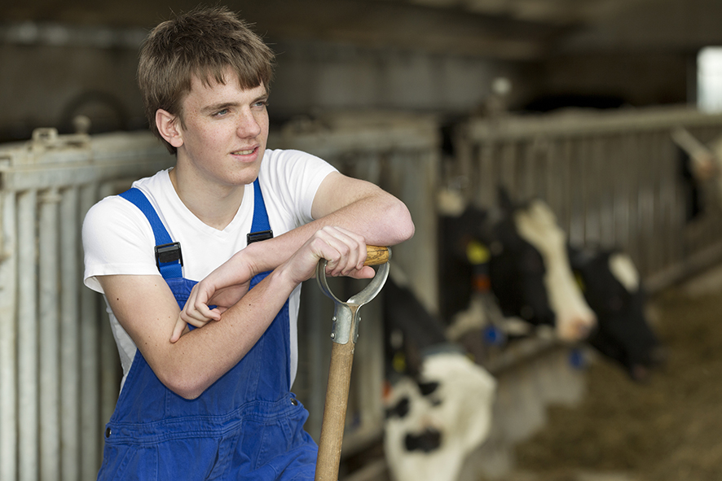
VCE VET Agriculture, Horticulture, Conservation and Ecosystem Management

AHC21216 Certificate II in Rural Operations
Student name:

Authorised and published by the Victorian Curriculum and Assessment Authority
Level 7, 200 Victoria Pde
East Melbourne VIC 3002
© Victorian Curriculum and Assessment Authority 2024

No part of this publication may be reproduced except as specified under the Copyright Act 1968 or by permission from the VCAA. Excepting third-party elements, schools may use this resource in accordance with the VCAA educational allowance. For more information go to https://www.vcaa.vic.edu.au/Footer/Pages/Copyright.aspx.
The VCAA provides the only official, up-to-date versions of VCAA publications. Details of updates can be found on the VCAA website at www.vcaa.vic.edu.au.
This publication may contain copyright material belonging to a third party. Every effort has been made to contact all copyright owners. If you believe that material in this publication is an infringement of your copyright, please email the Copyright Officer vcaa.copyright@edumail.vic.gov.au
Copyright in materials appearing at any sites linked to this document rests with the copyright owner/s of those materials, subject to the Copyright Act. The VCAA recommends you refer to copyright statements at linked sites before using such materials.
The VCAA logo is a registered trademark of the Victorian Curriculum and Assessment Authority.

Contact us if you need this information in an accessible format - for example, large print or audio.
Telephone (03) 9032 1635 or email vcaa.media.publications@edumail.vic.gov.au

Structured Workplace Learning Recognition
VCE Structured Workplace Learning Recognition for VET provides students with the opportunity to gain credit towards their VCE (including the VCE VM) or VPC by undertaking a Structured Workplace Learning (SWL) placement that is aligned to their VE1 VCE VET program or VE2 School-based Apprenticeship or Traineeship (SBAT).
To receive credit, students are required to demonstrate satisfactory achievement of the outcomes for the relevant unit of the VCE Structured Workplace Learning Recognition for VET study design.
Students must maintain a Workplace Learning Record (WLR) for each placement. In the WLR students must reflect on a minimum of six units of competency (UoCs) from their program, including a workplace health and safety (WHS) UoC.

About this workplace learning record
Students undertaking this study must maintain a Workplace Learning Record (WLR) related to the SWL placement for recording, authentication and assessment purposes.
Student reflections on their SWL placement are to be recorded in the three sections of this WLR to document the skills and knowledge learned, employability skills developed, and industry experience gained relating to the VET qualification being undertaken.
Students must undertake a work placement in a different workplace setting or context for each VCE unit and maintain a separate WLR per placement.

The WLR is divided into three sections.
Section 1: Learner profile
Section 2: Learning about VET units of competency (UoCs) in the workplace
Section 3: Post-placement reflections

Please complete the details of your workplace.
Employer/Company/Business
Supervisor name
Contact phone number

Employer/Company/Business
Supervisor name
Contact phone number

Employer/Company/Business
Supervisor name
Contact phone number

Section 1: Learner profile
Complete the learner profile and discuss this with your host employer on or before your first day of SWL placement.
Student Name
School
Phone number
Email
Explain why you decided to undertake this VET certificate?
List the other studies that you are undertaking.
Explain why you have chosen this overall program.
Outline what interests you about the industry.
What is your planned career path or future career aspiration?
Describe any workplace skills you have developed through previous work experience, SWL or part time employment.
How have you developed these skills?

Section 2: Learning about VET units of competency in the workplace
This section of the WLR will contain three key questions per unit of competency (UoC) designed to draw out related experiences you may be exposed to in a workplace.
This does not cover all the elements or performance criteria within the units and is not designed as a UoC assessment tool.
You should comment on the UoCs you have experienced in the workplace and reflect on actual observations or activities that you have been exposed to. Your observations will:
- reinforce the training you have undertaken
- identify differences in practice or equipment
- identify areas requiring further training or practical experience.
You are encouraged to take photos and/or video where appropriate to showcase learning in the workplace. Evidence you collect can include:
- observations
- descriptions of activities and tasks
- conversations with employers and other staff
- participation in meetings
- workplace documents
- research in the workplace
- photos of equipment/processes/events
- video of workplace activities.
Note: please speak to your host employer before taking photos or video. Do not use the names or details of any clients/stakeholders external to the organisation/other. This record does not require identifying actual people or events, as this may breach confidentiality.

Program outline

AHC21216 Certificate II in Rural Operations (Release 1)
The compulsory UoCs and a selection of electives are listed in the table below. You may list any additional UoC(s) relating to your experiences in the workplace in the table. Indicate the year in which you are undertaking each UoC. You must reflect on a minimum of six UoCs from your program, including a workplace health and safety (WHS) UoC.
UoC code | UoC title | Nominal hours | Year | Page
Work, Health and Safety
AHCWHS202 | Participate in workplace health and safety processes | 30 |  | 9
Compulsory
AHCWRK204 | Work effectively in the industry | 20 |  | 10
AHCWRK209 | Participate in environmentally sustainable work practices | 20 |  | 11
Electives
AHCBIO203 | Inspect and clean machinery, tools and equipment to preserve biosecurity | 20 |  | 12
AHCCHM201 | Apply chemicals under supervision | 30 |  | 13
AHCINF206 | Install, maintain and repair farm fencing | 30 |  | 14
AHCLPW201 | Operate a handheld GPS device | 30 |  | 15
AHCLSC206 | Assist with landscape construction work | 30 |  | 16
AHCLSK205 | Handle livestock using basic techniques | 30 |  | 17
AHCMOM203 | Operate basic machinery and equipment | 20 |  | 18
AHCPCM204 | Recognise plants | 40 |  | 19
AHCWRK323 | Operate in isolated and remote situations | 40 |  | 20
Reflect on the UoCs you have experienced in the workplace on the following pages.

VCE VET units of competency

AHCWHS202 - Participate in workplace health and safety processes
This unit of competency describes the skills and knowledge required to recognise and report hazards in the workplace, and follow workplace health and safety procedures and directions.
Respond to the following | Comments/observations
How did you learn about the WHS policies and procedures in your workplace?
Briefly outline what you observed about the designated WHS role within the workplace.
In your experience, in this workplace, what are the specific WHS issues when responding to incidents?

AHCWRK204 - Work effectively in the industry
This unit of competency describes the skills and knowledge required to work effectively within an industry on an individual basis and within a work team, including observing employment requirements and accepting responsibility for quality of own work.
Respond to the following | Comments/observations
What were your employer’s expectations?
Briefly outline how workplace cooperation was promoted in the workplace.
How did you contribute to a productive work environment?
How was industry knowledge shared?

AHCWRK209 - Participate in environmentally sustainable work practices
This unit of competency describes the skills and knowledge required to participate in environmentally sustainable work practices.
Respond to the following | Comments/observations
What were the workplace environmental and resource efficiency issues?
What environmental regulations did the workplace have to consider?
How was the workplace trying to improve environmental practices and resource efficiency?

AHCBIO203 - Inspect and clean machinery, tools and equipment to preserve biosecurity
This unit of competency describes the skills and knowledge required to inspect and clean machinery, tools and other equipment, including vehicles, of material that may contribute to the spread of biosecurity threats.
Respond to the following | Comments/observations
What machinery did you observe being inspected and cleaned in the workplace?
How were machinery, tools and equipment cleaned of contamination?
Describe the biosecurity and environmental procedures that you observed in the workplace.

AHCCHM201 - Apply chemicals under supervision
This unit of competency describes the skills and knowledge required to handle, transport, and apply chemicals under supervision using workplace specified chemicals and application equipment.
Respond to the following | Comments/observations
What was the process used by the workplace in preparing to handle chemicals?
What safety precautions and personal protective equipment (PPE) did you observe being used in the workplace while applying chemicals?
Outline the uses of chemicals that you observed in the workplace.

AHCINF206 - Install, maintain and repair farm fencing
This unit of competency describes the skills and knowledge required to install, maintain and repair farm fencing using appropriate tools and techniques.
Respond to the following | Comments/observations
What was your role in farm fence installation in the workplace?
What tools and equipment were used by the workplace for erecting and repairing farm fencing?
What workplace records were completed regarding the installation and repair of farm fencing?

AHCLPW201 - Operate a handheld GPS device
This unit of competency describes the skills and knowledge required to operate a handheld Global Positioning System (GPS) device, including tablet and phone-based GPS systems, and record and use spatial information relating to points, tracks and routes.
Respond to the following | Comments/observations
What was the GPS data collected in the field used for?
What software was used in the workplace to retrieve/manipulate/store GPS data and what was its purpose?
What were the workplace procedures for the use and storage of GPS devices?

AHCLSC206 - Assist with landscape construction work
This unit of competency describes the skills and knowledge required to assist with landscape works, including preparing for and undertaking landscape construction work as directed, handling materials and equipment, and clean up on completion of landscaping work in public, commercial and domestic situations.
Respond to the following | Comments/observations
What materials, tools and equipment did you observe being used for landscaping work in the workplace?
What personal protective equipment (PPE) were you required to use in the workplace?
Outline the landscape construction work that you assisted with while on SWL placement.

AHCLSK205 - Handle livestock using basic techniques
This unit of competency describes the skills and knowledge required to safely move, draft and control livestock using basic methods and procedures in an agricultural enterprise.
Respond to the following | Comments/observations
How did the workplace identify, prepare and maintain livestock handling areas, gates and access routes?
Describe the techniques used in the workplace to move livestock to designated handling areas.
Describe how the workplace restrained livestock safely and with minimum stress and discomfort in line with enterprise animal welfare policies.

AHCMOM203 - Operate basic machinery and equipment
This unit of competency describes the skills and knowledge required to undertake pre start checks, operate, maintain and shut down basic machinery and equipment used in the agriculture, horticulture and land management sectors.
Respond to the following | Comments/observations
What basic machinery and equipment was used in the workplace?
Describe a situation where you operated basic machinery or equipment in the workplace and the safety requirements that you were required to adhere to.
What maintenance was carried out in the workplace on basic machinery and equipment? Explain the process you observed.

AHCPCM204 - Recognise plants
This unit of competency describes the skills and knowledge required to recognise commonly encountered plants, including desired species and weeds, and to document and confirm plant identification.
Respond to the following | Comments/observations
What were the processes used in the workplace to identify a range of desirable and non-desirable plants?
Outline the different types of plants that you were required to recognise in the workplace.
What characteristics and significant features of plants allow you to identify them?
What workplace records were completed regarding the recognition of plants?

AHCWRK323 - Operate in isolated and remote situations
This unit of competency describes the skills and knowledge required to plan, prepare for and work safely in isolated and remote situations.
Respond to the following | Comments/observations
Describe what was involved in planning for operating in a remote environment. What were the emergency procedures?
Describe the communication procedures used to notify location and activities.
Describe the survival and bushcraft skills you observed.

Comments/observations on any other UoCs not listed
UoCs | Comments/observations

Section 3: Student post-placement reflection
Employability skills are a set of eight skills we use every day in the workplace.
- Communication
- Teamwork
- Problem solving
- Self-management
- Planning and organising
- Technology
- Learning
- Initiative and enterprise
When you are on work placement, you will be using employability skills in many ways.
This record will assist you when applying for jobs and in interviews. The skills you are developing may be transferred to a range of occupations.
In Section 3, identify the employability skills you have used and how you have demonstrated them in the workplace. Identify how the skills you have acquired and used during your 80 hours of SWL might assist you in the future.

List of employability skills
How did you demonstrate communication skills? For example, by listening and understanding, speaking clearly and directly, or reading and writing.
How did you demonstrate teamwork? For example, by working as part of a team or sharing ideas and resources with co-workers.

How did you demonstrate problem solving? For example, by identifying problems or developing solutions to workplace issues.
How did you demonstrate self-management? For example, by taking responsibility, managing time and tasks effectively, monitoring your own performance or having the ability to work unsupervised.

How did you demonstrate planning and organising? For example, by time management, setting priorities, making decisions, setting goals, collecting, or analysing and organising information.
How did you demonstrate the use of technology? For example, by being prepared to use a range of technology systems, IT skills (typing or data entry), or being able to learn new skills from the technology used in this industry.

How did you demonstrate learning? For example, by being willing to learn new things, being open to new ideas or adapting to change.
How did you demonstrate initiative and enterprise? For example, being creative, adapting to new situations, turning ideas into actions, coming up with a variety of options.

Summary of industry learning
At the conclusion of your SWL for this VET qualification, think about the experiences you have had in the workplace, your reflection of learning against the UoCs and the employability skills you have developed.
How will these learnings assist you in your pathway to employment or further training in this industry?

Student declaration
I confirm that I have undertaken work placement with:
Employer/Company/Business name | Dates of placement | Total hours of placement
TOTAL

I have completed the reflections and evidence submitted in this WLR and they are from my own experiences.
Signed (Student)
Name
Date

