Workplace Learning Record

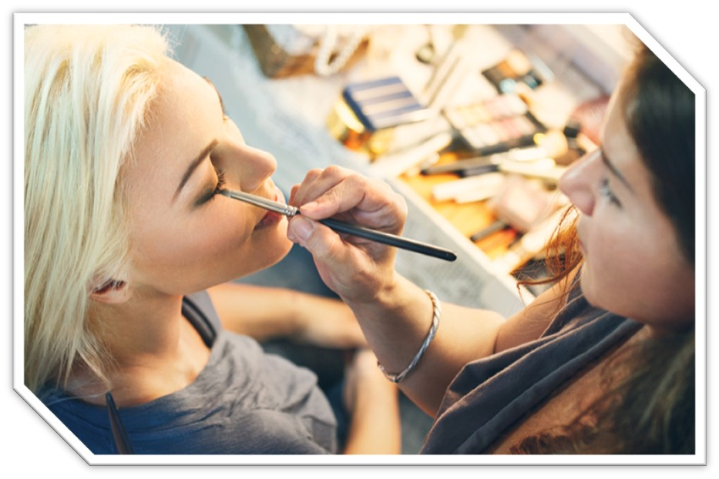VCE VET Hair And Beauty

SHB30221 Certificate III in Make-Up

**Student name:**

Authorised and published by the Victorian Curriculum and Assessment Authority  
Level 7, 200 Victoria Pde  
East Melbourne VIC 3002

© Victorian Curriculum and Assessment Authority 2024

No part of this publication may be reproduced except as specified under the *Copyright Act 1968* or by permission from the VCAA. Excepting third-party elements, schools may use this resource in accordance with the [VCAA educational allowance](https://www.vcaa.vic.edu.au/Footer/Pages/Copyright.aspx). For more information go to <https://www.vcaa.vic.edu.au/Footer/Pages/Copyright.aspx>.

The VCAA provides the only official, up-to-date versions of VCAA publications. Details of updates can be found on the VCAA website at [www.vcaa.vic.edu.au](https://www.vcaa.vic.edu.au/Pages/HomePage.aspx).

This publication may contain copyright material belonging to a third party. Every effort has been made to contact all copyright owners. If you believe that material in this publication is an infringement of your copyright, please email the Copyright Officer [vcaa.copyright@edumail.vic.gov.au](mailto:vcaa.copyright@edumail.vic.gov.au)

Copyright in materials appearing at any sites linked to this document rests with the copyright owner/s of those materials, subject to the Copyright Act. The VCAA recommends you refer to copyright statements at linked sites before using such materials.

The VCAA logo is a registered trademark of the Victorian Curriculum and Assessment Authority.

|  |
| --- |
| Contact us if you need this information in an accessible format - for example, large print or audio.  Telephone (03) 9032 1635 or email [vcaa.media.publications@edumail.vic.gov.au](mailto:vcaa.media.publications@edumail.vic.gov.au) |

Structured Workplace Learning Recognition

[VCE Structured Workplace Learning Recognition for VET](https://www.vcaa.vic.edu.au/curriculum/vce/vce-study-designs/SWLRforVET/Pages/Index.aspx) provides students with the opportunity to gain credit towards their VCE (including the VCE VM) or VPC by undertaking a Structured Workplace Learning (SWL) placement that is aligned to their VE1 VCE VET program or VE2 School-based Apprenticeship or Traineeship (SBAT).

To receive credit, students are required to demonstrate satisfactory achievement of the outcomes for the relevant unit of the *VCE Structured Workplace Learning Recognition for VET* study design.

Students must maintain a Workplace Learning Record (WLR) for each placement. In the WLR students must reflect on a minimum of six units of competency (UoCs) from their program, including a workplace health and safety (WHS) UoC.

About this workplace learning record

Students undertaking this study must maintain a Workplace Learning Record (WLR) related to the SWL placement for recording, authentication and assessment purposes.

Student reflections on their SWL placement are to be recorded in the three sections of this WLR to document the skills and knowledge learned, employability skills developed, and industry experience gained relating to the VET qualification being undertaken.

Students must undertake a work placement in a different workplace setting or context for each VCE unit and maintain a separate WLR per placement.

The WLR is divided into three sections.

**Section 1**: Learner profile

**Section 2**: Learning about VET units of competency (UoCs) in the workplace

**Section 3**: Post-placement reflections

Please complete the details of your workplace.

|  |  |
| --- | --- |
| **Employer/Company/Business** |  |
| **Supervisor name** |  |
| **Contact phone number** |  |

|  |  |
| --- | --- |
| **Employer/Company/Business** |  |
| **Supervisor name** |  |
| **Contact phone number** |  |

|  |  |
| --- | --- |
| **Employer/Company/Business** |  |
| **Supervisor name** |  |
| **Contact phone number** |  |

Section 1: Learner profile

Complete the learner profile and discuss this with your host employer on or before your first day of SWL placement.

|  |  |
| --- | --- |
| **Student Name** |  |
| **School** |  |
| **Phone number** |  |
| **Email** |  |
| **Explain why you decided to undertake this VET certificate?** | |
|  | |
| **List the other studies that you are undertaking.** | |
|  | |
| **Explain why you have chosen this overall program.** | |
|  | |
| **Outline what interests you about the industry.** | |
|  | |
| **What is your planned career path or future career aspiration?** | |
|  | |
| **Describe any workplace skills you have developed through previous work experience, SWL or part time employment.** | |
|  | |
| **How have you developed these skills?** | |
|  | |

Section 2: Learning about VET units of competency in the workplace

This section of the WLR will contain three key questions per unit of competency (UoC) designed to draw out related experiences you may be exposed to in a workplace.

This does not cover all the elements or performance criteria within the units and is not designed as a UoC assessment tool.

You should comment on the UoCs you have experienced in the workplace and reflect on actual observations or activities that you have been exposed to. Your observations will:

* reinforce the training you have undertaken
* identify differences in practice or equipment
* identify areas requiring further training or practical experience.

You are encouraged to take photos and/or video where appropriate to showcase learning in the workplace. Evidence you collect can include:

* observations
* descriptions of activities and tasks
* conversations with employers and other staff
* participation in meetings
* workplace documents
* research in the workplace
* photos of equipment/processes/events
* video of workplace activities.

**Note**: please speak to your host employer before taking photos or video. Do not use the names or details of any clients/stakeholders external to the organisation/other. This record does not require identifying actual people or events, as this may breach confidentiality.

Program outline

SHB30221 Certificate III in Make-Up

The compulsory UoCs and a selection of electives are listed in the table below. You may list any additional UoC(s) relating to your experiences in the workplace in the table. Indicate the year in which you are undertaking each UoC. You must reflect on a minimum of six UoCs from your program, including a workplace health and safety (WHS) UoC.

|  |  |  |  |  |
| --- | --- | --- | --- | --- |
| UoC code | UoC title | Nominal hours | Year | Page |
| **Work, Health and Safety** | | | | |
| SHBXWHS003 | Apply safe hygiene, health and work practices | 40 |  | 9 |
| **Compulsory** | | | | |
| SHBBMUP009 | Design and apply make-up | 45 |  | 10 |
| SHBBMUP010 | Design and apply make-up for photography | 30 |  | 11 |
| SHBBMUP013 | Design and apply creative make-up | 50 |  | 12 |
| SHBBRES003 | Research and apply beauty industry information | 20 |  | 13 |
| SHBXCCS008 | Provide salon services to clients | 30 |  | 14 |
| SHBXIND003 | Comply with organisational requirements within a personal services environment | 45 |  | 15 |
| **Elective** | | | | |
| SHBBBOS007 | Apply cosmetic tanning products | 20 |  | 16 |
| SHBBCCS005 | Advise on beauty products and services | 30 |  | 17 |
| SHBBFAS004 | Provide lash and brow services | 30 |  | 18 |
| SHBBHRS010 | Provide waxing services | 100 |  | 19 |
| SHBBINF002 | Maintain infection control standards | 75 |  | 20 |
| SHBBMUP008 | Apply eyelash extensions | 40 |  | 21 |
| SHBBMUP011 | Design and apply remedial camouflage make-up | 35 |  | 22 |
| SHBXCCS007 | Conduct salon financial transactions | 25 |  | 23 |
|  |  |  |  |  |
|  |  |  |  |  |
|  |  |  |  |  |
|  |  |  |  |  |

Reflect on the UoCs you have experienced in the workplace on the following pages.

VCE VET units of competency

SHBXWHS003 - Apply safe hygiene, health and work practices

This unit describes the performance outcomes, skills and knowledge required to follow safe practices to minimise risks to self, client and colleagues in a salon environment.

|  |  |
| --- | --- |
| Respond to the following | Comments/observations |
| In the day-to-day work functions in the salon, what infection control procedures did you use or observe? |  |
| Briefly outline the workplace procedure for effective decontamination of reusable equipment. |  |
| List three ways the workplace maintained a clean and healthy work environment |  |

SHBBMUP009 - Design and apply make-up

This unit describes the performance outcomes, skills and knowledge required to apply facial make-up products for day, evening or special occasions.

|  |  |
| --- | --- |
| Respond to the following | Comments/observations |
| What were the workplace requirements for preparing the service area, equipment and yourself? |  |
| What experience did you have designing a make-up plan? |  |
| How did you seek client feedback on a make-up plan? |  |

SHBBMUP010 - Design and apply make-up for photography

This unit describes the performance outcomes, skills and knowledge required to design and apply make-up for photographic shoots in natural and artificial light.

|  |  |
| --- | --- |
| Respond to the following | Comments/observations |
| Why is it important to design and record make-up plans for clients?  What details did you record in the make-up plan at the workplace? |  |
| Briefly outline two photographic make-up principles used during a photographic make-up service. |  |
| What specific workplace requirements did you observe relating to equipment and product use and maintenance? |  |

SHBBMUP013 - Design and apply creative make-up

This unit describes the performance outcomes, skills and knowledge required to work in a personal services environment by integrating knowledge of workplace rights and responsibilities and organisational policies and procedures, and by using effective team and individual work practices to plan and organise daily work activities.

|  |  |
| --- | --- |
| Respond to the following | Comments/observations |
| In your workplace what were the organisational policies and procedures for personal hygiene and presentation? |  |
| What contemporary creative make-up products, equipment or application techniques did you use? |  |
| What visual images sources informed your creative designs? |  |

SHBBRES003 - Research and apply beauty industry information

This unit describes the performance outcomes, skills and knowledge required to access information and update knowledge of the beauty industry and relevant industry legislation.

|  |  |
| --- | --- |
| Respond to the following | Comments/observations |
| What sources of information were available in your workplace about the beauty industry? |  |
| What are three ethical industry practices you used or observed in the day-to-day work activities? |  |
| What are common ways you can monitor current industry developments and issues? |  |

SHBXCCS008 - Provide salon services to clients

This unit describes the performance outcomes, skills and knowledge required to provide a complete customer salon service experience.

|  |  |
| --- | --- |
| Respond to the following | Comments/observations |
| What was the workplace practice for recording client information? |  |
| What was the workplace practice for recording client information?  What procedures did you observe in the workplace for responding to client complaints? |  |
| What procedure did you use to schedule and confirm appointments with clients? |  |

SHBXIND003 - Comply with organisational requirements within a personal services environment

This unit describes the performance outcomes, skills and knowledge required to work in a personal services environment by integrating knowledge of workplace rights and responsibilities and organisational policies and procedures, and by using effective team and individual work practices to plan and organise daily work activities.

|  |  |
| --- | --- |
| Respond to the following | Comments/observations |
| What did you learn about employment rights and responsibilities, whilst at the workplace? |  |
| Describe three key areas you learned about in the workplace policy and procedures manual. |  |
| What teamwork tasks/activities were you involved in? |  |

SHBBBOS007 - Apply cosmetic tanning products

This unit describes the performance outcomes, skills and knowledge required to select and apply cosmetic tanning products.

|  |  |
| --- | --- |
| Respond to the following | Comments/observations |
| In the workplace how did you maintain client records to record contraindications (e.g. where a particular product should not be used on the client)? |  |
| How did you select a suitable colour choice for client skin and type? |  |
| How did you learn about the workplace ingredients of tanning products, exfoliators and moisturisers and their effects on skin? |  |

SHBBCCS005 - Advise on beauty products and services

This unit describes the performance outcomes, skills and knowledge required to advise clients on a range of professional beauty products and services.

|  |  |
| --- | --- |
| Respond to the following | Comments/observations |
| How did you develop your knowledge of the workplace product and service range and prices? |  |
| What legal requirements relating to providing advice and sale of beauty products did you observe or learn? |  |
| What steps did you use to prepare a client for a product demonstration? |  |

SHBBFAS004 - Provide lash and brow services

This unit describes the performance outcomes, skills and knowledge required to provide lash and brow services that include shaping and colouring.

|  |  |
| --- | --- |
| Respond to the following | Comments/observations |
| Describe the workplace requirements for preparing the treatment area. |  |
| What information did you collect from the client prior to a lash and brow service? |  |
| What process did you use to evaluate a client’s treatment plan? |  |

SHBBHRS010 - Provide waxing services

This unit describes the performance outcomes, skills and knowledge required to provide waxing services to remove unwanted facial and body hair.

|  |  |
| --- | --- |
| Respond to the following | Comments/observations |
| Briefly describe the factors that may restrict a client treatment plan. |  |
| How did you or others ensure there was minimum risk of injury to self and client throughout the waxing service? |  |
| What experience did you have in monitoring client reactions and responses during the waxing service? |  |

SHBBINF002 - Maintain infection control standards

This unit describes the performance outcomes, skills and knowledge required to maintain infection control during skin penetration treatments and to review clinic compliance with the applicable state or territory and local council requirements.

|  |  |
| --- | --- |
| Respond to the following | Comments/observations |
| How did you find out about the infection control regulations and guidelines in your workplace? |  |
| List three step the work team take to ensure that they maintain hygienic processes |  |
| Describe specific workplace procedures you undertook or observed relating to sterilisation of equipment |  |

SHBBMUP008 - Apply eyelash extensions

This unit describes the performance outcomes, skills and knowledge required to apply eyelash extensions for added length and thickness of natural lashes to meet client needs.

|  |  |
| --- | --- |
| Respond to the following | Comments/observations |
| What was the workplace procedure for patch testing prior to application of eyelash extensions? |  |
| Why is it important to record and maintain client treatment plans for each eyelash extension treatment? |  |
| What are the advantages of using different tweezers during the eyelash extension treatment? |  |

SHBBMUP011 - Design and apply remedial camouflage make-up

This unit describes the performance outcomes, skills and knowledge required to apply specialised make-up products to disguise skin imperfections on the face and body.

|  |  |
| --- | --- |
| Respond to the following | Comments/observations |
| How were camouflage make-up plans recorded for clients, in the workplace? |  |
| What factors did you consider when applying remedial camouflage make-up? |  |
| In the workplace how did you manage product quantities to avoid waste of consumables? |  |

SHBXCCS007 - Conduct salon financial transactions

This unit describes the performance outcomes, skills and knowledge required to provide a complete customer salon service experience.

|  |  |
| --- | --- |
| Respond to the following | Comments/observations |
| What secure payment handling procedures did you operate or observe in your workplace? |  |
| Describe the process for balancing the end of shift or daily takings in the workplace. |  |
| In your workplace what was the process used to report discrepancies in financial transactions? |  |

Comments/observations on any other UoCs not listed

|  |  |
| --- | --- |
| UoCs | Comments/observations |
|  |  |

Section 3: Student post-placement reflection

Employability skills are a set of eight skills we use every day in the workplace.

1. Communication
2. Teamwork
3. Problem solving
4. Self-management
5. Planning and organising
6. Technology
7. Learning
8. Initiative and enterprise

When you are on work placement, you will be using employability skills in many ways.

This record will assist you when applying for jobs and in interviews. The skills you are developing may be transferred to a range of occupations.

In Section 3, identify the employability skills you have used and how you have demonstrated them in the workplace. Identify how the skills you have acquired and used during your 80 hours of SWL might assist you in the future.

List of employability skills

How did you demonstrate **communication skills**? For example, by listening and understanding, speaking clearly and directly, or reading and writing.

|  |
| --- |
|  |

How did you demonstrate **teamwork**? For example, by working as part of a team or sharing ideas and resources with co-workers.

|  |
| --- |
|  |

How did you demonstrate **problem solving**? For example, by identifying problems or developing solutions to workplace issues.

|  |
| --- |
|  |

How did you demonstrate **self-management**? For example, by taking responsibility, managing time and tasks effectively, monitoring your own performance or having the ability to work unsupervised.

|  |
| --- |
|  |

How did you demonstrate **planning and organising**? For example, by time management, setting priorities, making decisions, setting goals, collecting, or analysing and organising information.

|  |
| --- |
|  |

How did you demonstrate the use of **technology**? For example, by being prepared to use a range of technology systems, IT skills (typing or data entry), or being able to learn new skills from the technology used in this industry.

|  |
| --- |
|  |

How did you demonstrate **learning**? For example, by being willing to learn new things, being open to new ideas or adapting to change.

|  |
| --- |
|  |

How did you demonstrate **initiative and enterprise**? For example, being creative, adapting to new situations, turning ideas into actions, coming up with a variety of options.

|  |
| --- |
|  |

Summary of industry learning

At the conclusion of your SWL for this VET qualification, think about the experiences you have had in the workplace, your reflection of learning against the UoCs and the employability skills you have developed.

How will these learnings assist you in your pathway to employment or further training in this industry?

|  |
| --- |
|  |

Student declaration

I confirm that I have undertaken work placement with:

|  |  |  |
| --- | --- | --- |
| **Employer/Company/Business name** | **Dates of placement** | **Total hours of placement** |
|  |  |  |
|  |  |  |
|  |  |  |
| **TOTAL** |  |  |

I have completed the reflections and evidence submitted in this WLR and they are from my own experiences.

**Signed** (Student)

**Name**

**Date**