Workplace Learning Record

VCE VET Equine Studies
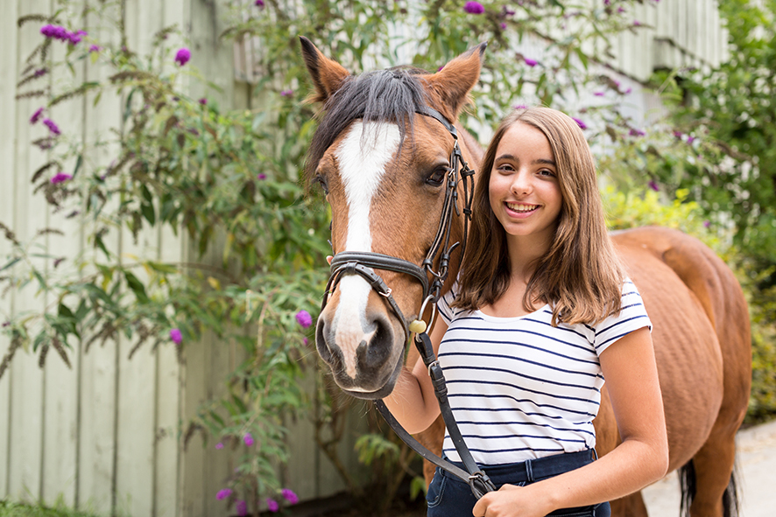

22513VIC Certificate III in Equine Studies
Student name:

Modification history
Version | Status | Release Date | Comments
1.0 | Current | July 2020 | Updated for new Certificate III course
Authorised and published by the Victorian Curriculum and Assessment Authority
Level 7, 2 Lonsdale Street
Melbourne VIC 3000
ISBN: 978-1-74010-047-2
© Victorian Curriculum and Assessment Authority 2020

No part of this publication may be reproduced except as specified under the Copyright Act 1968 or by permission from the VCAA. Excepting third-party elements, schools may use this resource in accordance with the VCAA educational allowance. For more information go to: www.vcaa.vic.edu.au/Footer/Pages/Copyright.aspx.
The VCAA provides the only official, up-to-date versions of VCAA publications. Details of updates can be found on the VCAA website: www.vcaa.vic.edu.au.
This publication may contain copyright material belonging to a third party. Every effort has been made to contact all copyright owners. If you believe that material in this publication is an infringement of your copyright, please email the Copyright Officer: vcaa.copyright@edumail.vic.gov.au
Copyright in materials appearing at any sites linked to this document rests with the copyright owner/s of those materials, subject to the Copyright Act. The VCAA recommends you refer to copyright statements at linked sites before using such materials.

The VCAA logo is a registered trademark of the Victorian Curriculum and Assessment Authority.

SWL Recognition
Structured Workplace Learning (SWL) recognition provides you with the opportunity to gain credit into your VCE or VCAL for undertaking SWL that matches your VCE VET program.
To receive recognition and credit, you will be required to reflect on your experience in the workplace and how this relates to your VET course. Your reflections are to be recorded in the three sections of this Workplace Learning Record (WLR).

About this workplace learning record
This WLR helps you gather evidence for assessment and is part of the requirement for obtaining SWL recognition.
To be eligible for one unit of credit towards your VCE or VCAL, you must:
- be enrolled in a minimum of 180 nominal hours of units of competency (UoCs) from the 22513VIC Certificate III in Equine Studies
- undertake a minimum of 80 hours (equivalent to 10 days of work) in an equine industry placement
- Reflect on a minimum of six UoCs from your program including the WHS UoC (VU22681 Work effectively in an equine organisation – see page 10).

VCE VET Equine Studies

22513VIC Certificate III in Equine Studies
The VCE VET Equine Studies program is drawn from a state accredited course. The VCE VET Equine Studies is an entry-level vocational qualification which will enable successful graduates to apply for employment in different sectors of the equine industry or further study in a range of equine or equine related qualifications in horse breeding, sport or racing.
The course will expose students to key skills, knowledge and attributes required to work effectively in the equine industry.
Specifically a graduate of this course will have developed an understanding of:
- safe work practices
- handling horses
- equine nutrition
- equine health and welfare
- daily horse care requirements
- equine anatomy and physiology.
Job roles may include:
- stable hand
- stud hand
- groom
- farm hand
- trail ride assistant.

Workplace Learning Record
The WLR is divided into three sections.
Section 1: Learner profile
Section 2: Learning about VET UoCs in the workplace
Section 3: Post-placement reflections
Please complete the details of your workplace.
Employer/Company/Business
Supervisor name
Contact phone number

Employer/Company/Business
Supervisor name
Contact phone number

Employer/Company/Business
Supervisor name
Contact phone number

Section 1: Learner profile
Complete the Learner profile and discuss this with your host employer on or before your first day of placement.
Name
School
Contact information
Within your VCE/VCAL why did you undertake this VET course?
What VCE/VCAL subjects are you also undertaking?
Why have you chosen this overall VCE/VCAL program?

Program outline

22513VIC Certificate III in Equine Studies
UoCs included in this program are listed below. There are compulsory UoCs, along with a selection of electives. You can make a note of any UoC that relates to your experiences in the workplace. Indicate the year you are undertaking each UoC.
Unit code | Unit of competency | Year | Page
VCE VET Units 1–2
Compulsory
ACMEQU205 | Apply knowledge of horse behavior (60) |  | 8
ACMEQU202 | Handle horses safely (100) |  | 9
VU22681 | Work effectively in an equine organization (50) |  | 10
VU22685 | Identify equine anatomy (30) |  | 11
Electives
VU22688 | Assist in the preparation of a horse for an event (40) |  | 12
VU22689 | Assist in the conduct and organisation of an event in the equine industry (40) |  | 13
VU22690 | Examine horse breeding principles and practices (40) |  | 14
VU22691 | Prepare for the care of pregnant mares, foals and young horses (40) |  | 15
HLTAID003 | Provide first aid (18) |  | 16
ACMEQU201 | Work safely in industries with horses (40) |  | 17
VCE VET Units 3–4
Compulsory
VU22682 | Implement horse health and welfare practices (50) |  | 18
VU22683 | Implement and monitor horse feeding programs (50) |  | 19
VU22684 | Relate equine form to function (50) |  | 20
VU22686 | Identify and describe equine physiology (50) |  | 21
List any other units you are undertaking and include comments regarding additional units on page 22.

What interests you about the industry?
What is your planned career path or future career aspiration?
Describe any workplace skills you have developed through previous work experience, SWL or part time employment?

Section 2: Learning about VET units of competency in the workplace
This WLR contains three key questions per UoC designed to draw out related experiences you may be exposed to in an equine industry workplace.
This does not cover all the elements or performance criteria within the units and is not designed as a UoC assessment tool.
You should comment on the UoCs you have experienced in the workplace, and reflect on actual observations or activities that you have been exposed to. Your observations will:
- reinforce the training you have undertaken
- identify differences in practice or equipment
- identify areas requiring further training or practical experience.
You are encouraged to take photos and/or video where appropriate to showcase learning in the workplace. Evidence you collect can include:
- observations
- descriptions of activities and tasks
- conversations with employers and other staff
- participation in meetings
- workplace documents
- research in the workplace
- photos of equipment/processes/events
- video of workplace activities.
Note: please speak to your host employer before taking photos or video. This record does not require identifying actual people or events, as this may breach confidentiality.

VCE VET Units of competency

ACMEQU205 Apply knowledge of horse behaviour
This unit of competency describes the skills and knowledge required to develop basic knowledge of horse behaviour, read horse body language and minimise risk to self and others when interacting with horses.
Respond to the following | Comments/observations
List some examples of horse body language that you observed at your workplace.

Describe your interpretation of the body language that you observed.
Describe the human body language and behaviour you used in the workplace when working around horses.
What strategies were used in your workplace to minimise and control common risks associated with interacting with horses?

ACMEQU202 Handle horses safely
This unit of competency describes the skills and knowledge required to identify, safely catch, control and handle calm, consistent and obedient horses educated for the relevant activity. It covers knowledge of potential risks working with and around horses and following industry guidelines and procedures to ensure the welfare and safety of the individual, other workers and the horse.
Respond to the following | Comments/observations
What gear did you use when catching, leading and tying up horses in the workplace?

How was information communicated in your workplace?

Give an example of how you worked co-operatively as an individual and as part of a team.

What were the safe horse handling procedures required in your workplace?

VU22681 Work effectively in an equine organisation
This unit of competency covers the skills and knowledge required to undertake work in the equine industry. It involves safety in the workplace, career opportunities and the correct use of tools and equipment. It involves the ability to perform work, meet employer requirements, communicate effectively and complete workplace documentation where required.
Respond to the following | Comments/observations
Describe three OHS requirements and safe work practices that you followed.

What personal protective clothing and equipment was required to be used by workers in the workplace?
Describe the tasks you undertook at the workplace to clean the stables and surrounding areas.

What steps did you follow to groom horses to the workplace standard?
What did you look for when you were checking the conditions of the horses?

VU22685 Identify equine anatomy
This unit describes the skills and knowledge to recognise the external features and anatomy of horses being trained or used for racing, competitive performance, breeding and/or recreation.
Respond to the following | Comments/observations
Using appropriate terminology, describe the coat colours and markings of two horses you observed in the workplace.

Using appropriate terminology, describe the brands and any other identifying features of two horses you observed in the workplace.
Using appropriate terminology, describe the head and body of two horses observed in the workplace.

VU22688 Assist in preparation of a horse for an event
This unit of competency describes the skills and knowledge required to enable an individual to assist a professional competitor or trainer in the preparation of a horse for a competition. Functions include assisting with the exercise program, preparation for travel and caring for a horse, before, during and after a competition.
Respond to the following | Comments/observations
What exercise routine was used in the workplace to prepare a horse for competition?
Describe the standard of grooming required for a horse at a professional competition.

Describe the equipment that may be required at a professional level competition.

VU22689 Assist in the conduct and organisation of an event in the equine industry
This unit covers the skills and knowledge required to assist with the range of activities and the steps involved in organising an equine event such as a competition, event, demonstration or lecture.
Respond to the following | Comments/observations
Describe the tasks you assisted with in preparing for, conducting, and post event activities.
Describe the different roles of various event personnel.
List some ways that events in the industry are promoted.

VU22690 Examine horse breeding principles and practices
This unit provides an introduction to horse breeding through an examination of breeding systems and programs and the practical requirements of breeding.
Respond to the following | Comments/observations
What breeding method was used in your workplace?
Describe the breeding facilities at your workplace.
How were breeding records maintained in your workplace?
What requirements of progeny were being bred for in your workplace?

VU22691 Prepare for the care of pregnant mares, foals and young horses
This unit provides the knowledge related to the practices used to monitor the health of pregnant mares, the foaling process and the care of newborn foals and other young horses.
Respond to the following | Comments/observations
How were mares cared for and monitored prior to foaling in your workplace?
Describe the foaling environment, foaling plan and post foaling monitoring in your workplace.

What basic training was given to foals, weanlings and young horses in your workplace?

HLTAID003 Provide first aid
This unit describes the skills and knowledge required to provide a first aid response to a casualty. The unit applies to all workers who may be required to provide a first aid response in a range of situations, including community and workplace settings.
Respond to the following | Comments/observations
Describe how the workplace recognised and responded to an emergency situation.

Provide examples of how hazards were identified and minimised ensuring the health and safety of all people in the workplace.

What types of workplace documentation were completed for reporting the details of emergency incidents, the first aid provided and preventative measures?

ACMEQU201 Work safely in industries with horses
This unit of competency describes the skills and knowledge required to work safely and sustainably in industry sectors that use horses. It covers knowledge of potential risks when working with and around horses and following industry guidelines and procedures to ensure the welfare and safety of the individual and the horse.
Respond to the following | Comments/observations
What work, health and safety (WHS) procedures did you follow in the workplace?
How did your workplace manage environmental hazards?
What equipment, tools and gear did you use to complete tasks in your workplace?

VU22682 Implement horse health and welfare practices
This unit covers the skills and knowledge required to monitor and identify signs of common illness and injuries in horses and other signs of distress, and to report observations accurately and in a timely fashion. The unit also covers preventative programs that are an integral part of horse husbandry.
Respond to the following | Comments/observations
Describe how horse health and welfare was monitored in the workplace.

What common illnesses and injuries for horses did you observe in the workplace?

Describe the records and documentation completed to monitor health and welfare of horses in the workplace.

VU22683 Implement and monitor horse feeding programs
This unit of competency specifies the skills and knowledge required to implement a feeding program, monitor the quality of feed and feed supplements and monitor feeding habits and variations of individual horses.
Respond to the following | Comments/observations
Describe the feeds and supplements for horses that you observed in the workplace.
Describe the special nutritional requirements for two horses you observed in the workplace.
How was feed quality monitored for contamination?

VU22684 Relate equine form to function
This unit describes the skills and knowledge to recognise conformation features of horses. It requires the ability to identify desirable and poor conformation in horses and the ability to use standard conformation terminology, recognising unsoundness and blemishes and the ability to relate conformation to the way of going.
Respond to the following | Comments/observations
Describe the conformation features of the breed / types of horses that you observed in the workplace.
Describe two desirable conformation features of horses that you observed in the workplace.

Describe one undesirable conformation feature and one soundness issue that you observed in the workplace.

VU22686 Identify and describe equine physiology
This unit describes the foundational skills and knowledge related to the major systems within equine physiology and how these systems relate to horse health and performance.
Respond to the following | Comments/observations
Describe an illness, injury or abnormality that you observed in the workplace.
What physiological system(s) did the illness / injury / abnormality affect?
What was the impact of the illness / injury / abnormality on the horse?

Comments/observations on any other unit(s) of competency not listed
Unit(s) | Comments/observations

Section 3: Student post-placement reflection
Employability skills are a set of eight skills we use every day in the workplace.
- Communication
- Team work
- Problem solving
- Self-management
- Planning and organising
- Technology
- Learning
- Initiative and enterprise
When you are on work placement, you will be using employability skills in many different ways.
This record will assist you when applying for jobs and in interviews. The skills you are developing may be transferred to a range of occupations. Assessment of SWL recognition is based on a discussion of each of the sections from this booklet with a school representative.
In Section 3, identify the employability skills you have used and how you have demonstrated them in the workplace. Identify how the skills you have acquired and used during your 80 hours of SWL might assist you in the future.

List of employability skills
How did you demonstrate communication skills? For example, by listening and understanding, speaking clearly and directly or reading and writing.
How did you demonstrate team work? For example, by working as part of a team or sharing ideas and resources with co-workers.

How did you demonstrate problem solving? For example, by identifying problems or developing solutions to workplace issues.
How did you demonstrate self-management? For example, by taking responsibility, managing time and tasks effectively, monitoring your own performance or having the ability to work unsupervised.

How did you demonstrate planning and organising? For example, by time management, setting priorities, making decisions, setting goals, collecting or analysing and organising information.
How did you demonstrate the use of technology? For example, by being prepared to use a range of technology systems, IT skills (typing or data entry) or being able to learn new skills from the technology used in this industry.

How did you demonstrate learning? For example, by being willing to learn new things, being open to new ideas or adapting to change.
How did you demonstrate initiative and enterprise? For example, being creative, adapting to new situations, turning ideas into actions, coming up with a variety of options.

Summary of industry learning
At the conclusion of your SWL for this VET Qualification, think about the experiences you have had in the workplace, your reflection of learning against the UoCs and the employability skills you have developed.
How will these learnings assist you in your pathway to employment or further training in this industry?

Student declaration
I confirm that I have undertaken work placement with:
Employer/Company/Business name | Total hours of placement
TOTAL

I have completed the reflections and evidence submitted in this WLR and they are from my own experiences.
Signed (Student)
Name (Block letters)
Date

