Workplace Learning Record

VCE VET Integrated Technologies
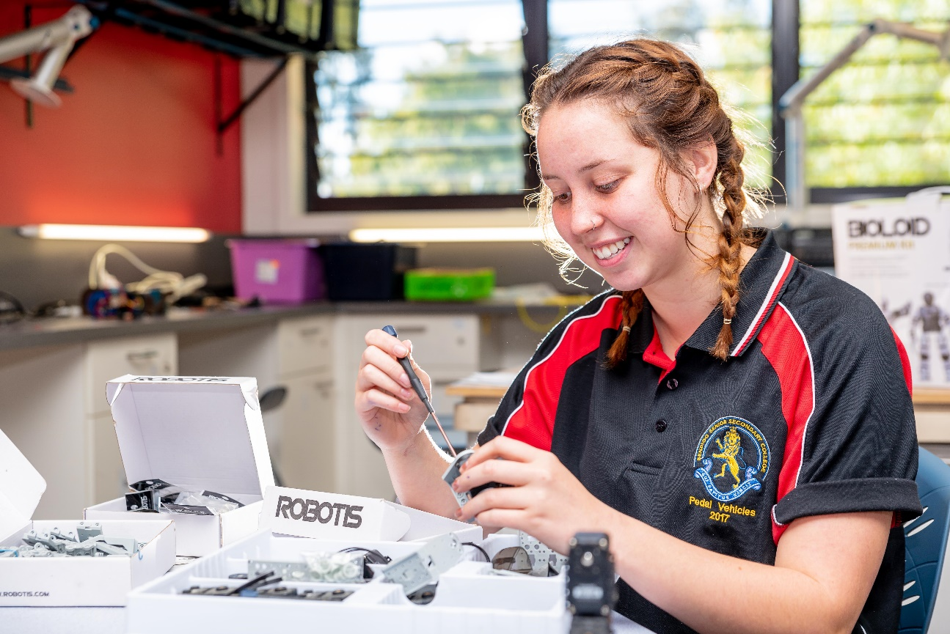

22289VIC Certificate II in Integrated Technologies
Student name:

Modification history
Version | Status | Release Date | Comments
1.0 | Current | July 2020 | Original document with minor updates
Authorised and published by the Victorian Curriculum and Assessment Authority
Level 7, 2 Lonsdale Street
Melbourne VIC 3000
ISBN: 978-1-74010-047-2
© Victorian Curriculum and Assessment Authority 2019

No part of this publication may be reproduced except as specified under the Copyright Act 1968 or by permission from the VCAA. Excepting third-party elements, schools may use this resource in accordance with the VCAA educational allowance. For more information go to: www.vcaa.vic.edu.au/Footer/Pages/Copyright.aspx.
The VCAA provides the only official, up-to-date versions of VCAA publications. Details of updates can be found on the VCAA website: www.vcaa.vic.edu.au.
This publication may contain copyright material belonging to a third party. Every effort has been made to contact all copyright owners. If you believe that material in this publication is an infringement of your copyright, please email the Copyright Officer: vcaa.copyright@edumail.vic.gov.au
Copyright in materials appearing at any sites linked to this document rests with the copyright owner/s of those materials, subject to the Copyright Act. The VCAA recommends you refer to copyright statements at linked sites before using such materials.

The VCAA logo is a registered trademark of the Victorian Curriculum and Assessment Authority.

SWL Recognition
Structured Workplace Learning (SWL) recognition provides you with the opportunity to gain credit into your VCE or VCAL for undertaking SWL that matches your VCE VET program.
To receive recognition and credit, you will be required to reflect on your experience in the workplace and how this relates to your VET course. Your reflections are to be recorded in the three sections of this Workplace Learning Record (WLR).

About this workplace learning record
This WLR helps you gather evidence for assessment and is part of the requirement for obtaining SWL recognition.
To be eligible for one unit of credit towards your VCE or VCAL, you must:
- be enrolled in a minimum of 180 nominal hours of units of competency (UoCs) from the 22289VIC Certificate II in Integrated Technologies
- undertake a minimum of 80 hours (equivalent to 10 days of work) in an integrated technology industry placement
- reflect on a minimum of six UoCs from your program including the WHS UoC (MEM13014A – see page 8).

VCE VET Integrated Technologies

22289VIC Certificate II in Integrated Technologies
The VCE VET Integrated Technologies program is drawn from the state accredited curriculum and offers portable qualifications which are recognised throughout Australia.
This is a pre-vocational course that will provide learners with the skills required by industries, which broadly encompass electrotechnology, telecommunications, information technology and security systems to:
- continue vocational training
- gain work and further training through an apprenticeship, traineeship or cadetship
- find employment in fields such an electronics, entertainment, wireless systems, technical support for computer and electronic equipment, energy generation, sustainability, computer controlled applications, electronic equipment or computer network support.

Workplace Learning Record
The WLR is divided into three sections.
Section 1: Learner profile
Section 2: Learning about VET UoCs in the workplace
Section 3: Post-placement reflections
Please complete the details of your workplace.
Employer/Company/Business
Supervisor name
Contact phone number

Employer/Company/Business
Supervisor name
Contact phone number

Employer/Company/Business
Supervisor name
Contact phone number

Section 1: Learner profile
Complete the Learner profile and discuss this with your host employer on or before your first day of placement.
Name
School
Contact information
Within your VCE/VCAL why did you undertake this VET course?
What VCE/VCAL subjects are you also undertaking?
Why have you chosen this overall VCE/VCAL program?

Program outline

22289VIC Certificate II in Integrated Technologies
UoCs included in this program are listed below. There are compulsory UoCs, along with a selection of electives. You can make a note of any UoC that relates to your experiences in the workplace. Indicate the year you are undertaking each UoC.
Unit code | Unit of Competency | Year | Page
VCE VET Units 1–2
Compulsory
MEM13014A | Apply principles of occupational health and safety in the work environment |  | 8
VU21701 | Carry out an integrated technology project |  | 9
VU21702 | Prepare for working in the integrated technology sector |  | 10
VCE VET Units 3–4
Compulsory
VU21703 | Work in an integrated technology environment |  | 11
VU21704 | Use electrotechnology skills in integrated technology work |  | 12
VU21705 | Use software applications in integrated technology work |  | 13
Electives
ICASAS304A | Provide basic system administration |  | 14
ICASAS307A | Install, configure and secure a small office home office network |  | 15
VU20906 | Configure and program a basic robotic system |  | 16
VU21352 | Implement a digital circuit using a programmable logic device (PLD) |  | 17
VU21387 | Test and verify correct operation of a “by-wire” control system |  | 18
VU21388 | Set up and test an embedded control system |  | 19
VU21542 | Identify and locate building blocks of a centralised power generation system |  | 20
VU21552 | Operate a small power supply system |  | 21
VU21568 | Set up and operate a wireless communication link |  | 22
VU21569 | Install communications antennae |  | 23
VU21581 | Build a small wireless LAN |  | 24
List any other units you are undertaking and include comments regarding additional units on page 25.

What interests you about the industry?
What is your planned career path or future career aspiration?
Describe any workplace skills you have developed through previous work experience, SWL or part time employment?

Section 2: Learning about VET units of competency in the workplace
This WLR contains three key questions per UoC designed to draw out related experiences you may be exposed to in an integrated technology industry workplace.
This does not cover all the elements or performance criteria within the units and is not designed as a UoC assessment tool.
You should comment on the UoCs you have experienced in the workplace, and reflect on actual observations or activities that you have been exposed to. Your observations will:
- reinforce the training you have undertaken
- identify differences in practice or equipment
- identify areas requiring further training or practical experience.
You are encouraged to take photos and/or video where appropriate to showcase learning in the workplace. Evidence you collect can include:
- observations
- descriptions of activities and tasks
- conversations with employers and other staff
- participation in meetings
- workplace documents
- research in the workplace
- photos of equipment/processes/events
- video of workplace activities.
Note: please speak to your host employer before taking photos or video. This record does not require identifying actual people or events, as this may breach confidentiality.

VCE VET Units of competency

MEM13014A Apply principles of occupational health and safety in the work environment
This unit covers following occupational health and safety procedures in an engineering or similar work environment.
Respond to the following | Comments/observations
How did you learn about the WHS policies and procedures?
Briefly outline the purpose of a workplace safety meeting you attended, or a workplace consultative activity you participated in.
In your experience at this workplace, how were actual and foreseeable workplace hazards identified?

VU21701 Carry out an integrated technology project
This unit of competency sets out the knowledge and skills required to carry out an integrated technology project by merging distinct electrotechnology domains to achieve an innovative and integrated technical solution.
Respond to the following | Comments/observations
Outline the integrated technology projects that you observed in the workplace.
Describe the project specifications that were used in the workplace including any project briefs, contracts or tender documents.
Describe your role in the workplace on an integrated technology project.

VU21702 Prepare for working in the integrated technology sector
This unit provides the skills and knowledge to prepare participants for working in the integrated technologies industry.
Respond to the following | Comments/observations
What different job roles did you observe within the workplace? What was the main function of each job?
Which areas of integrated technology work would you investigate further having experienced the workplace.
What are your personal strengths and weaknesses in relation to the job roles in this workplace?

VU21703 Work in an integrated technology environment
This unit provides the skills and knowledge to conduct routine work practices in the integrated technologies industry. It encompasses the safe use of hand tools, power tools, dismantling and assembling components and the use of integrated technologies.
Respond to the following | Comments/observations
Describe the industry apparatus that you were involved in dismantling and assembling in the workplace.
What tools were used in the workplace and what was their function within the integrated technology environment?
Outline how the workplace disposed of any waste using environmentally sustainable practices.

VU21704 Use electrotechnology skills in integrated technology work
This unit provides the skills and knowledge required for an entry-level worker to use basic electrotechnology skills in integrated technology work.
Respond to the following | Comments/observations
Describe the range of work requirements that you observed in the workplace including the use of calculations.
How did the workplace connect up, test and verify low voltage (LV) DC and extra low voltage (ELV) AC circuitry?
Describe how the workplace compared the characteristics of analogue signals and digital signals.

VU21705 Use software applications in integrated technology work
This unit provides the skills and knowledge required to safely and effectively use basic software applications in integrated technology work.
Respond to the following | Comments/observations
Outline the software applications used at the workplace and their purpose.
What software did you use in the workplace and what was its purpose?
Describe how the workplace generated block diagrams, flowcharts and engineering drawings. Whose role was this?

ICASAS304A Provide basic system administration
This unit describes the skills and knowledge required to implement components of systems backup, restore, security and licensing in a stand-alone or client server environment.
Respond to the following | Comments/observations
What workplace procedures did you use/observe for maintaining software licences?
Describe the process used to track licenses.
Within the workplace what was the procedure for carrying out system backups?
How did you learn about the organisations security guidelines?

ICASAS307A Install, configure and secure a small office or home office network
This unit describes the skills and knowledge required to identify available network components relevant to client requirements and to install, configure and secure those components as part of a small office or home office (SOHO) network.
Respond to the following | Comments/observations
In the workplace how were client requirements determined?
How did the workplace source vendors and service suppliers to obtain specifications, costs etc. for components?
What common tests did you use in the workplace to troubleshoot network settings?

VU20906 Configure and program a basic robotic system
This unit of competency sets out the knowledge and skills required to configure and program a basic robotic system. Typical tasks for basic robotics system operation include pick and place, motion, navigation.
Respond to the following | Comments/observations
Outline how the workplace planned the configuration and programming of basic robotics systems.
Describe how a robotic system was tested for correct operation in the workplace? How was this documented?
Describe the materials used in the construction of robots in the workplace and the drive mechanisms used.

VU21352 Implement a digital circuit using a programmable logic device (PLD)
This unit of competency sets out the knowledge and skills required to implement, from a given design file, digital circuits on programmable logic devices.
Respond to the following | Comments/observations
How did staff establish PLD programming requirements? Which personnel were involved?
Explain the process that you observed for programming a PLD in the workplace.
What equipment and tools did the workplace use in the implementation on PLD programming and how were these stored?

VU21387 Test and verify correct operation of a “by-wire” control system
This unit of competency sets out the knowledge and skills required to test and verify correct operations of a by-wire control system.
Respond to the following | Comments/observations
What safety precautions did the workplace take when installing and testing “by-wire” control systems?
Describe the methods for dealing with unexpected situations that you observed being used in the workplace.
Outline any “by-wire” control system that you observed being installed and tested in the workplace.

VU21388 Set up and test an embedded control system
This unit of competency sets out the knowledge and skills required to install, set up and test embedded control systems used for automatic or semi-automatic operation of a wide range of consumer and industrial equipment.
Respond to the following | Comments/observations
What different types of embedded control systems did you observe in the workplace?
Outline the processes used in the workplace when installing and configuring an embedded control system.
What was your role in the process for testing embedded control systems?

VU21542 Identify and locate building blocks of a centralised power generation system
This unit of competency sets out the knowledge and skills required to locate and identify the building blocks and outline broad principles of operation for a reticulated centralised power system.
Respond to the following | Comments/observations
How did the workplace obtain information about centralised power generation systems?
Describe how the building blocks of a power generation system were identified and their operation confirmed by staff in the workplace.
What tools, equipment and PPE were used in the workplace whilst identifying and locating the building blocks of a centralised power generation system?

VU21552 Operate a small power supply system
This unit of competency sets out the knowledge and skills required to monitor the operation of a small scale power supply system at the site of power supply system.
Respond to the following | Comments/observations
When did the workplace operate small scale power supply systems? What was the purpose?
What was your role in operating small scale power supply systems?
Outline the documentation and reporting of deviations from normal operating conditions that were required in the workplace?

VU21568 Set up and operate a wireless communication link
This competency unit sets out the knowledge and skills required to set up and operate a wireless communications link. This includes point to point links for a range of purposes using a range of frequency bands and may extend into the infrared and visible portion of the electromagnetic spectrum.
Respond to the following | Comments/observations
What requirements did you observe being followed in the workplace for setting up a wireless communications link?
Outline the components selected in at least one wireless communications link that you observed in the workplace.
What tools and equipment were used in the workplace whilst setting up and operating a wireless communications link?

VU21569 Install communications antennae
This competency unit sets out the knowledge and skills required to install communications antennas. This includes basic receiving and transmitting antennas for mainly domestic, small commercial and short distance communications application.
Respond to the following | Comments/observations
What were the WHS requirements and risk control measures and procedures that the workplace followed in the installation of an antenna?
Describe the communications antenna equipment that you observed and/or used whilst installing and configuring in the workplace.
Outline all of the antenna applications that the workplace was involved with. What was different about each application?

VU21581 Build a small wireless LAN
This competency unit sets out the knowledge and skills required to construct, configure and operate a small wireless local area network consisting of a maximum of five computers linked through a network to the internet.
Respond to the following | Comments/observations
What computer and wireless network equipment was used in the workplace for building small wireless LANs?
Explain the basic network security features that the workplace implemented across small wireless LANs.
What workplace documentation was completed by staff when building a small wireless LAN?

Comments/observations on any other unit(s) of competency not listed
Unit(s) | Comments/observations

Section 3: Student post-placement reflection
Employability skills are a set of eight skills we use every day in the workplace.
- Communication
- Team work
- Problem solving
- Self-management
- Planning and organising
- Technology
- Learning
- Initiative and enterprise
When you are on work placement, you will be using employability skills in many different ways.
This record will assist you when applying for jobs and in interviews. The skills you are developing may be transferred to a range of occupations. Assessment of SWL recognition is based on a discussion of each of the sections from this booklet with a school representative.
In Section 3, identify the employability skills you have used and how you have demonstrated them in the workplace. Identify how the skills you have acquired and used during your 80 hours of SWL might assist you in the future.

List of employability skills
How did you demonstrate communication skills? For example, by listening and understanding, speaking clearly and directly or reading and writing.
How did you demonstrate team work? For example, by working as part of a team or sharing ideas and resources with co-workers.

How did you demonstrate problem solving? For example, by identifying problems or developing solutions to workplace issues.
How did you demonstrate self-management? For example, by taking responsibility, managing time and tasks effectively, monitoring your own performance or having the ability to work unsupervised.

How did you demonstrate planning and organising? For example, by time management, setting priorities, making decisions, setting goals, collecting or analysing and organising information.
How did you demonstrate the use of technology? For example, by being prepared to use a range of technology systems, IT skills (typing or data entry) or being able to learn new skills from the technology used in this industry.

How did you demonstrate learning? For example, by being willing to learn new things, being open to new ideas or adapting to change.
How did you demonstrate initiative and enterprise? For example, being creative, adapting to new situations, turning ideas into actions, coming up with a variety of options.

Summary of industry learning
At the conclusion of your SWL for this VET Qualification, think about the experiences you have had in the workplace, your reflection of learning against the UoCs and the employability skills you have developed.
How will these learnings assist you in your pathway to employment or further training in this industry?

Student declaration
I confirm that I have undertaken work placement with:
Employer/Company/Business name | Total hours of placement
TOTAL

I have completed the reflections and evidence submitted in this WLR and they are from my own experiences.
Signed (Student)
Name (Block letters)
Date

