Learning about bushfires

Lesson: Causes and effects of a bushfire

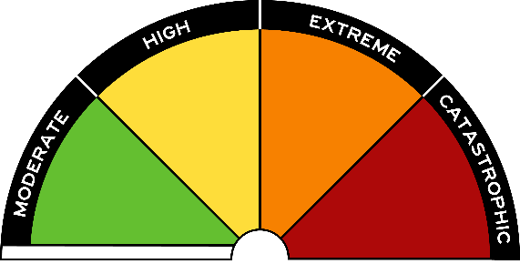
Overview
Curriculum levels: 5 and 6
Time: 50 minutes (approximately)
Links to the Victorian Curriculum F–10:
Geography, Levels 5 and 6
Geographical Concepts and Skills
Describe and explain interconnections within places and between places, and the effects of these interconnections (VCGGC087)
Collect and record relevant geographical data and information from the field and secondary sources, using ethical protocols (VCGGC088)
Geographical Knowledge
Impacts of bushfires or floods on environments and communities, and how people can respond (VCGGK095)
Learning intention:
Students will understand and be able to identify the main causes, processes and effects of bushfires, as well as grassfires, coastal fires and scrub fires, in Victoria.
Suggested resources:
- Student workbooks or paper
- Pens, pencils or markers
- Materials as selected for recording student responses, e.g. workbooks and markers, tablets, recording devices
- Online resources such as the images and linked resources listed in the Resources section of the VCAA Bushfire Education webpages

Activities

Starting
Engage students in a discussion or think-pair-share strategy to revise students’ knowledge about the causes and effects of a bushfire. Use the following questions as prompts:
- How can bushfires start?
- What conditions (heat, dryness, etc.) impact the chances of a bushfire?
- What happens during a bushfire?
- What is left after a bushfire?
Introduce, discuss and define the terms used within this session:
- causes
- processes
- effects

Exploring
In pairs or in small groups, have students build a script for an imaginary TV presenter, who is reporting on the causes, processes and effects of bushfires. Students use a model structure, sample text and images to build an explanation of what causes bushfires. They include sections on causes, processes and effects in the script. They connect ideas in the script by adding words to form noun groups, such as ‘many hectares’ and ‘surrounding trees’.

Bringing it together

Presentation of the causes, processes and effects of a bushfire
Using the news report they have created and their knowledge from previous sessions, students present the three steps (causes, processes and effects) of bushfires. This could be presented in the form of a flow chart or diagram, using a digital program, on a poster or as a recorded news report.

Extending

Bushfire weather
Review the Bushfire Weather page on the Bureau of Meteorology website.
In pairs or in small groups, have students answer the following questions:
- Which months are the most dangerous for bushfires in Victoria?
- Thinking about what you have already learnt about the factors that cause a bushfire, why do you think these months are the most dangerous?
- How does Victoria’s major fire danger period compare with those in other Australian states and territories?
- Why do you think different states and territories have different fire danger periods?
To learn more about bushfire weather across Australia, see the relevant resources under ‘Learning About Bushfires’, on the Resources section of the VCAA Bushfire Education webpages.

