Learning about bushfires

Lesson: Exploring Victoria’s bushfire history

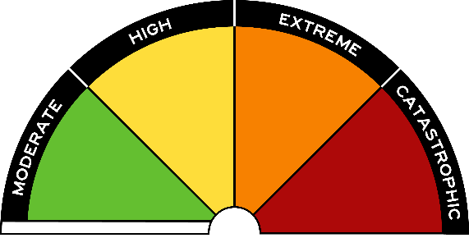
Overview
Curriculum levels: 5 and 6
Time: 50 minutes (approximately)
Links to the Victorian Curriculum F–10:
History, Levels 5 and 6
Historical Concepts and Skills
Explain the significance of an event and an individual or group that influenced change in the Australian colonies and in Australian society since Federation (VCHHC087)
Historical Knowledge
The effects of a significant development or event on a colony (VCHHK090)
Critical and Creative Thinking, Levels 5 and 6
Reasoning
Explore what a criterion is, different kinds of criteria, and how to select appropriate criteria for the purposes of filtering information and ideas (VCCCTR028)
Geography, Levels 5 and 6
Geographical Concepts and Skills
Identify and describe locations and describe and explain spatial distributions and patterns (VCGGC086)
Collect and record relevant geographical data and information from the field and secondary sources, using ethical protocols (VCGGC088)
Geographical Knowledge
Impacts of bushfires or floods on environments and communities, and how people can respond (VCGGK095)
Learning intention:
Students read and research the history of Australian bushfires, with a focus on significant bushfires that have occurred in Victoria. The session explores the history of bushfires from the perspective that they are naturally occurring events that regularly feature in our recorded history.
Suggested resources:
- Student workbooks or paper
- Pens, pencils or markers
- Materials as selected for recording student responses, e.g. workbooks and markers, tablets, recording devices
- Online resources such as the images and linked resources listed in the Resources section of the VCAA Bushfire Education webpages
- Internet access for further research

Activities

Starting
Provide students with a download of the ‘Bushfires in our history’ table, which illustrates the regularity and severity of bushfires. Inform students that:
- the table only shows major fires after European settlers arrived in Victoria
- bushfires have been an important part of the Australian environment for about 30 million years.
Help students read and understand the information presented in the table. Respond to any questions about the information presented.

Exploring
Allow some time for students to read and study the table. Have students suggest criteria that might be used to determine the severity of bushfires. Criteria may include:
- number of deaths
- financial cost
- physical extent of fire
- how long the fire burnt
- environmental damage
- psychological costs
- stock losses
- infrastructure damage
Using your agreed severity criteria, refer back to the table and determine four ‘major’ Victorian bushfires.

Bringing it together
Have students work on the following activities according to their capabilities, at the teacher’s discretion.

Victoria’s major bushfires
Assign a small group of students to each of the agreed ‘major’ bushfires and, using the resource links, have them complete activities appropriate to their level:
- Do an online web search to collect extra facts about the bushfire.
- Locate the fire on a map of Victoria.
- Draw or select an illustration or short video clip to represent the fire.
- Write a brief paragraph about the fire and its effects.
- Enter the information on an interactive timeline using a free online timeline maker such as Preceden or Timetoast.

Bushfire presentation
In small groups, students research information about one of the bushfires on the ‘Bushfires in our history’ table, then organise their research into a class presentation. Students should focus their research and information gathering around the following:
- On which date(s) did the bushfire take place?
- How long did the bushfire crisis last?
- In what part(s) of Victoria did the bushfire occur and in what sorts of vegetation?
- What role did the weather, winds, fuel load and topography play in starting and spreading the fire?
- What were the effects and costs of the fire?
- Who helped fight the fire? What methods did they use?
The following resources may be helpful for the educator:
- CFA: The Black Friday fires and the birth of CFA
- CFA: Remembering Ash Wednesday
- AIDR: Ash Wednesday Bushfire 1983
- AIDR: Remembering Black Saturday
- Bureau of Meteorology: Bushfire Weather
Please note: All educators need to be aware that there is potential for discomfort or distress among some learners when talking, viewing and reading about bushfires. The 2009 Victorian bushfires especially were traumatic events for many in the Victorian community, and teachers need to preview, adapt and manage the teaching and learning activities and resources with respect to the particular needs and backgrounds of their learners.

Extending

Graphing Victorian bushfires
Have students refer to the ‘Bushfires in our history’ table and prepare a graph showing the months in which major bushfires have occurred in Victoria.
Student could record this data in a table with the months listed, and then record the years according to which month the fires occurred. Students could then plot this data on a scatter graph with a long X-axis for years and a shorter Y-axis for months.
Once the graph is complete, students need to answer the following questions:
- Considering the graph, what months do you predict are the most dangerous for bushfires in Victoria?
- Taking into account what you have already learnt about the factors necessary for a bushfire, what are possible reasons for your answer to the previous question?
- Does this prediction appear to be correct? (Check information about climate, weather and fuel in Victoria during the months highlighted in the scatter graph.)

