Learning about bushfires

Lesson: Living with bushfires: Mallacoota, 2019–20

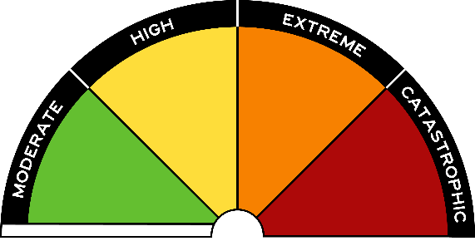
Overview
Curriculum levels: 7 and 8
Time: 50 minutes (approximately) × 2
Links to the Victorian Curriculum F–10:
Geography, Levels 7 and 8
Geographical Concepts and Skills
Collect and record relevant geographical data and information from useful primary and secondary sources, using ethical protocols (VCGGC102)
Geographical Knowledge
Causes of a geomorphological hazard and its impacts on places and human responses to it to minimise harmful effects on places in the future (VCGGK121)
Personal and Social Capability, Levels 7 and 8
Self-Awareness and Management
Describe how and why emotional responses may change in different contexts (VCPSCSE034)
Learning intention:
In this lesson students explore the 2019–20 bushfires, also known as Black Summer, as an introduction to learning about bushfires, with a particular focus on the experiences of people in Mallacoota, Victoria.
Suggested resources:
- Online resources such as the images and linked resources listed below

Activities

Starting
Introduce the 2019–20 bushfires. Explain that these bushfires in Australia were the most extensive in our history, with the land area burnt 25 time greater than Black Saturday 2009. Mallacoota was one of dozens of townships and communities throughout Australia engulfed by the disaster. The geographical location of Mallacoota and the nature of the fires meant that thousands of tourists as well as locals were trapped in the town. Four thousand people spent New Year’s Eve on the beach while the town burned behind them. Many were rescued by sea and air, using the resources of the defence forces.
As a class, watch the following news videos on YouTube. These news items were broadcast at the time of the bushfires at Mallacoota and cover the experience of the fires, the defence force evacuations by sea and air, and the aftermath for the town. (Note, there are a range of reports available on YouTube.)
- Hard-hit Victorian town of Mallacoota cut off by bushfires, ABC News (2:34)
- Bushfires hit towns in East Gippsland including Mallacoota, 7NEWS (7:25)
- Mallacoota residents assess damage after fire tears through town, 7NEWS (3:59)
- Victoria fires: Stranded tourists, residents rescued by HMAS Choules, Nine News Australia (12:33) – First half of this report only
- More than 300 people evacuated by air from Mallacoota, 7.30, ABC News (7:59)
Discuss with students:
- their own responses to the videos
- the geographical location of Mallacoota and how this affected the experience of the fires, including people’s ability to escape
- the time of year and the numbers of people in the town
- measures people undertook to keep safe
- the rescue
- the extent of the damage
- individual feelings and responses to the fire
- community responses to the fire
- why they think the fire attracted international media attention.

Exploring

Extent of the fires
The following table lists some of the key Black Summer 2019–20 bushfires. Have students research one of these fires in pairs and note the:
- location of the fire
- month of the fire
- length of the fire
- impact of the fire on people and the environment.

Main Black Summer 2019–20 fires
State or territory | Location
Queensland | Lamington National Park
New South Wales | Gospers Mountain  Green Wattle Creek  Nowra  Cobargo
Victoria | East Gippsland  Mallacoota  Buchan  North East Victoria  Corryong
South Australia | Adelaide Hills  Kangaroo Island
Australian Capital Territory | Canberra
Western Australia | Eyre Highway, Nullabor  Stirling Ranges  Perth Hills
For a summary of key fires for teachers, see How heat and drought created a tinderbox, ABC News.

Smoke haze
The bushfires shrouded many places in smoke haze, which lasted for different periods of time in different places.
Have students, in groups, read the following articles and list the impacts on people and events:
- Queensland fire emergency leaves Brisbane’s air quality worse than Beijing, ABC News
- Sydney smoke: Residents ‘choking’ on intense bushfire pollution, BBC News
- Melbourne’s air quality ‘worst in world’ as bushfire smoke blankets city ahead of Australian Open, The Telegraph, UK
- NSW fires will continue to blanket Canberra in smoke for foreseeable future, experts say, ABC News

Global responses
The Black Summer bushfires 2019–20 were reported across the globe. Have students look at the following articles and note some of the global responses to the Australian crisis:
- Australia fires: How the world has responded to the crisis, BBC News
- Australia bushfires: ongoing crisis prompts massive international response, Global New
- New Zealand glaciers turn brown from Australian bushfires’ smoke, ash and dust, The Guardian

Bringing it together
Have student pairs report their research on key bushfires to the class. Mark the places of the key bushfires on a class map of Australia.
Discuss student findings about the impact of smoke haze in major Australian cities. What were impacts on health, work, entertainment and environment?
Discuss: How did the global community respond to the Australian bushfires?
Use the ‘five big numbers’ in the following article to sum up the Black Summer bushfires:
- The size of Australia’s bushfire crisis captured in five big numbers, ABC News

Extending
Have students use the video material and online research to write a report on one of the following topics:
- International firefighters support for Australia during the summer bushfires of 2019–20
- The involvement of the Australian Defence Forces (ADF) in the rescue and firefighting effort.

