Learning about bushfires

Lesson: The Fire Triangle

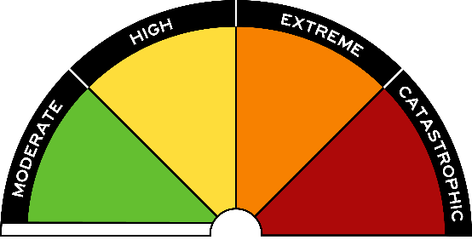
Overview
Curriculum levels: 7 and 8
Time: 50 minutes (approximately) × 2
Links to the Victorian Curriculum F–10:
Science, Levels 7 and 8
Science Understanding
Energy appears in different forms including movement (kinetic energy), heat, light, chemical energy and potential energy; devices can change energy from one form to another (VCSSU104)
Science Inquiry Skills
Identify questions, problems and claims that can be investigated scientifically and make predictions based on scientific knowledge (VCSIS107)
Collaboratively and individually plan and conduct a range of investigation types, including fieldwork and experiments, ensuring safety and ethical guidelines are followed (VCSIS108)
Use scientific knowledge and findings from investigations to identify relationships, evaluate claims and draw conclusions (VCSIS111)
Communicate ideas, findings and solutions to problems including identifying impacts and limitations of conclusions and using appropriate scientific language and representations (VCSIS113)
Learning intention:
Students learn that fire needs three things to start and continue burning: oxygen, fuel and heat. Therefore, to prevent or control a fire, at least one of these components must be removed.
Advice: Teachers conducting demonstrations are advised to trial the activity prior to the session so that they are aware of any inherent safety requirements and potential issues. Demonstrations that involve burning should be undertaken in a fume cupboard or in a well-ventilated area. Check for smoke alarms that may be triggered by demonstrations involving burning.
Suggested resources:
- The Fire Triangle (under ‘Images’ in the Resources section of the VCAA Bushfire Education webpages)
- ‘What is fire?’, Science Learning Hub
- Resources required for investigations as listed below

Activities

Starting
Ask students what they know about the Fire Triangle. Have students draw and label the Fire Triangle and explain their understanding to a partner. Have several students share their ideas with the class. Ask students to draw, describe and explain their reasons for their predictions about what would occur if:
- the fuel was damp or contained moisture
- wind blew more oxygen (air) into the fire
- the fuel source was made up of fine fuel, no bigger than the diameter of one finger
- the fuel source was removed.
Students could use a table such as this to present their predictions:
Situation | Prediction | Reasoning
Damp, moist fuels

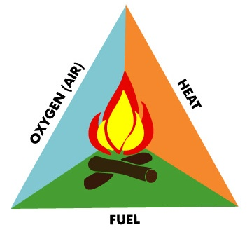

Exploring

Predict, Observe, Explain (POE)
Set up several investigations for students using the Predict, Observe, Explain (POE) strategy.
Safety: Make students aware of safety instructions for working with a flame. Ensure the bench is clear of any flammable materials. Have a heat-proof mat, a container of water to extinguish the burning match, and a damp towel to smother the candle if required.

Investigation 1: Oxygen
Materials required per group of students:
- heat-proof mat
- matches
- two candles
- glass jar
- larger glass jar
- clock or stopwatch
- tray of water
- a container of water
- damp towel
Have students work in pairs, following strict safety procedures, to predict what will occur if a lit candle is covered with an upturned glass jar. On the second observation, have students measure the time taken for the flame to go out. Students may observe a small amount of condensation appearing on the sides of the glass jar. They may also feel the heat from the candle. Students explain their observations and relate them to the Fire Triangle.
Students use the POE strategy to investigate what occurs in each of the following situations:
- A much larger jar is used to cover the lit candle. (Students should make the connection that the larger the jar, the more oxygen is available, so the longer the candle will stay alight.)
- Two candles are covered by the one overturned glass jar. (Students make the connection that two candles will require more oxygen than one, so the oxygen will be used up more quickly, causing the flame to go out sooner.)
- A lit candle is sitting in a tray of water with the overturned glass jar placed over the candle. (Students should make the connection that as the candle uses up the oxygen, the difference in air pressure will cause the water level in the tray to rise and take up some of the space left by the oxygen.)

Investigation 2: Fuel
Materials required per group of students:
- heat-proof mat
- matches
- 6–8 dry eucalyptus leaves
- container of water
- damp towel
Following safety procedures, students investigate burning dry eucalyptus leaves in a fume cupboard or well-ventilated area.
On a heat-proof mat, students light three or four dry leaves. They then add another leaf and observe what happens. They add another leaf, and then another, and observe what happens. No other leaves are added.
Students predict, observe and explain what happens.

Investigation 3: Heat
Materials required per group of students:
- a tripod stand
- a Bunsen burner
- heat-proof mat
- matches
- sheet of metal
- 3 or 4 dry eucalyptus leaves
- 3 or 4 green eucalyptus leaves
- container of water
- damp towel
Conduct the following activity as a demonstration or student investigation:
- Set up a tripod stand and a Bunsen burner on a heat-proof mat.
- Place a thin metal sheet over the Bunsen burner.
- Place three or four dry eucalyptus leaves on the metal sheet.
- Students predict, observe and explain what happens.
In discussion, introduce the term ‘ignition temperature’ to explain the temperature at which a material will ignite and start to burn.
Conduct the same experiment using some green (just picked) eucalyptus leaves instead of the dry eucalyptus leaves. Compare the results.
Describe differences in ignition. Relate this to the moisture content of each leaf (fuel). Ensure students make the connection that the fuel did not need to be in direct contact with a flame to ignite.

Bringing it together
Refer students back to the table created at the beginning of the session. Ask them to review and update it after the POE investigations and subsequent discussion.
Situation | Prediction | Reasoning
Damp, moist fuels
Relate what students discovered about fire and the concept of the Fire Triangle to a bushfire.
- What are potential fuels in a bushfire?
- How can those fuels ignite?
- How does wind support the continued burning and the spread of bushfires?
- Use the Fire Triangle to explain how a lightning strike can start a bushfire.

Vocabulary
burning, carbon dioxide, combustion, extinguish, fuel, heat, ignite, oxygen, smoke, smother, water vapour

