Learning about bushfires

Lesson: The impact of radiant heat during bushfires

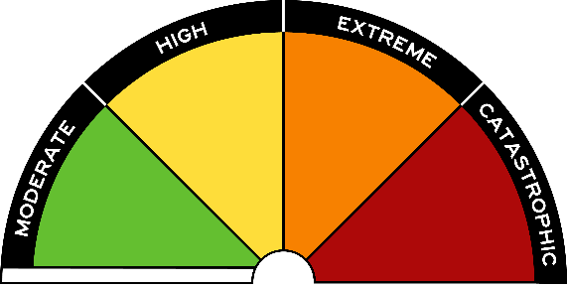
Overview
Curriculum levels: 5 and 6
Time: 50 minutes (approximately)
Links to the Victorian Curriculum F–10:
Geography, Levels 5 and 6
Geographical Concepts and Skills
Describe and explain interconnections within places and between places, and the effects of these interconnections (VCGGC087)
Geographical Knowledge
Impacts of bushfires or floods on environments and communities, and how people can respond (VCGGK095)
Health and Physical Education, Levels 5 and 6
Personal, Social and Community Health
Plan and practise strategies to promote health, safety and wellbeing (VCHPEP108)
Learning intention:
Students will come to understand the term ‘radiant heat’. They will be able to describe the dangers of radiant heat in a bushfire situation.
Suggested resources:
- Student workbooks or paper
- Pens, pencils or markers
- Materials as selected for recording student responses, e.g. workbooks and markers, tablets, recording devices
- Online resources such as the images and linked resources listed in the Resources section of the VCAA Bushfire Education webpages

Activities

Starting
Initial discussion focus:
- How can a house catch fire even though the flames of the bushfire have not yet reached it?
Guide the discussion towards:
- students’ experiences of an open log fire, wood heater or campfire
- the heat they felt from these sources.
Introduce the concept of radiant heat and relate this to a bushfire and to bushfire safety.

Exploring
Drawing on ideas from the above discussion, encourage students to consider how different materials might react to a bushfire’s radiant heat, e.g. glass windows, plastic guttering or wood fencing.
Referring to the extreme heat from a bushfire, emphasise the importance of removing flammable materials from around the house and keeping a suitable distance between house and vegetation.

Bringing it together
Drawing on ideas from the previous session, have students work on the activities listed below. Provide students with access to these resources to complete the activities:
- ‘How to stay safe this summer’ (The Age)
- CFA ‘Radiant heat’ fact sheet
The CFA’s Fire Ready Kit may also be useful.

Create a visual display/labelled diagram
Students draw a labelled diagram showing how radiant heat is dangerous in a bushfire, and outlining what steps can be taken to reduce the risks of radiant heat.

Preparing for a bushfire role-play
Have students role-play sitting around a campfire, and discuss how radiant heat relates to this scenario.
- Discuss where they would sit if the fire was small.
- Discuss what it would mean if the fire was a bit bigger. How would this affect where they were sitting?
- Discuss what would happen if they put something in between them and the campfire. What would this mean?
Students need to focus their action in the role-play on ways to reduce the effect of radiant heat.

