Learning about bushfires

Lesson: Understanding the Fire Danger Rating system

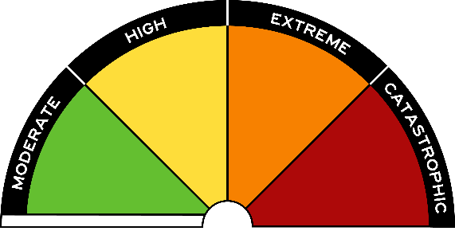
Overview
Curriculum levels: 5 and 6
Time: 50 minutes (approximately)
Links to the Victorian Curriculum F–10:
Geography, Levels 5 and 6
Geographical Concepts and Skills
Describe and explain interconnections within places and between places, and the effects of these interconnections (VCGGC087)
Interpret maps and other geographical data and information using digital and spatial technologies as appropriate, to develop identifications, descriptions, explanations and conclusions that use geographical terminology (VCGGC090)
Geographical Knowledge
Impacts of bushfires or floods on environments and communities, and how people can respond (VCGGK095)
Learning intention:
Students will explore the factors and conditions related to the Fire Danger Rating system used in Victoria, and how this is a safety system for alerting people to potential bushfire dangers.
Suggested resources:
- Student workbooks or paper
- Pens, pencils or markers
- Materials as selected for recording student responses, e.g. workbooks and markers, tablets, recording devices
- Online resources such as the images and linked resources listed in the Resources section of the VCAA Bushfire Education webpages

Activities

Starting
Initial discussion focus:
- What is the Fire Danger Rating system?
- What are the colours used, and what do they mean?
- Where is the Fire Danger Rating found?
- Why is it important?

Exploring
With students, discuss how the fire danger rating is determined. It is important to note that these ratings are used all year round; the system is just more active in the warmer months. Ratings will differ from area to area, depending on the weather in that particular area.
It is also important to note that these ratings are used for all environments, as they reflect the risk of bushfires, grassfires and coastal and scrub fires.

Bringing it together
Introduce the fire danger ratings as a way the CFA informs the community of the bushfire danger.
Show students the short CFA video Understand Fire Danger Ratings.
Provide students with the CFA’s Fire Danger Rating brochure.
