Preparing for bushfires

Lesson: Bushfire survival plans

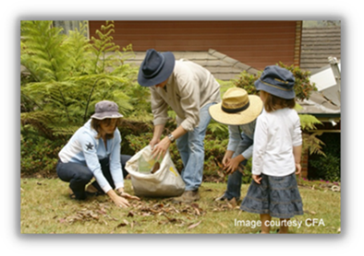
Overview
Curriculum levels: 7 and 8
Time: 50 minutes (approximately) × 2
Links to the Victorian Curriculum F–10:
Geography, Levels 7 and 8
Geographical Concepts and Skills
Collect and record relevant geographical data and information from useful primary and secondary sources, using ethical protocols (VCGGC102)
Geographical Knowledge
Causes of a geomorphological hazard and its impacts on places and human responses to it to minimise harmful effects on places in the future (VCGGK121)
Health and Physical Education, Levels 7 and 8
Personal, Social and Community Health
Plan and use strategies and resources to enhance the health, safety and wellbeing of their communities (VCHPEP130)
Learning intention:
Students learn that residents in high fire-risk areas across Victoria should develop a bushfire survival plan as an essential part of preparing for the bushfire season.
Suggested resources:
- Interactive whiteboard
- Online resources such as the linked resources listed below

Activities

Starting
Begin with a general discussion about what a bushfire survival plan is and who should have one. In this context, pose the question, ‘Who is responsible for our safety on days of high bushfire risk?’

Exploring
Using an interactive whiteboard, show students the Context of the Bushfire Safety Policy Framework, which is on page 5. (Alternatively, this may be printed out.)
Explain to students that this policy was revised in light of further experiences of bushfires, most recently in 2018.
In relation to bushfire safety, what does the document say about the responsibilities of the following:
- the government
- individuals who live in bushfire-prone areas
- all Victorians?
Explain that a bushfire survival plan is designed to help individuals take responsibility for their own safety and to decide on their contingency options.
Using an interactive whiteboard or large computer display, read the ‘Am I at Risk?’ section of the CFA’s Fire Ready Kit to emphasise that all sorts of houses in all sorts of environments are vulnerable to bushfires.
Discuss the concept of a bushfire survival plan in more detail. Point out that the CFA’s Fire Ready Kit identifies phases of planning for people who live in bushfire-prone areas. These planning phases include:
- actions leading up to bushfire season
- actions during bushfire season
- actions on fire-risk days
- actions to put in place as a backup if things don’t go to plan.
Ask students why the CFA has supplied a planning kit rather than a definite set of instructions. Refer students to the situations described in the ‘Am I at Risk?’ section of the Fire Ready Kit to emphasise that bushfire survival plans need to be specific to particular locations and specific circumstances. Plans need to take the following into account:
- local vegetation and topography
- local fire weather potential
- local types of fire events
- family circumstances and priorities
- peculiarities of home design, construction and location.
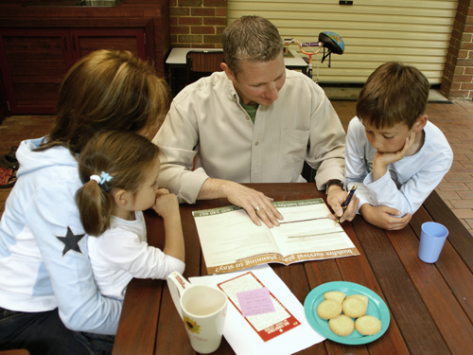
Bushfire survival plans should be prepared in consultation with the whole family. Point out that a major decision to be made in any survival plan is whether people will stay to defend their property or leave early.

Bringing it together
Students imagine that the house they currently live in is in a high fire-risk area. They should develop a bushfire survival plan based on the 10 key decisions to make with your family (see page 14 of the Fire Ready Kit). Use the template ‘Leaving Early: Bushfire Survival Planning Template’.

Extending
Have students develop their own emergency kit. Encourage them to be specific. Refer to the Fire Ready Kit.

