Preparing for bushfires

Lesson: Bushfires matter to all Victorians

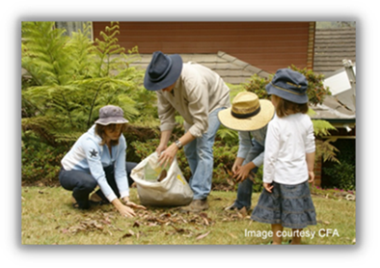
Overview
Curriculum levels: 1 and 2
Time: 50 minutes (approximately)
Links to the Victorian Curriculum F–10:
Geography, Foundation to Level 2
Geographical Concepts and Skills
Collect and record geographical data and information from the field and other sources (VCGGC060)
Interpret data and information to draw conclusions and describe the direction and location of places, using terms such as north, south, opposite, near, far (VCGGC062)
Geographical Knowledge
Natural, managed and constructed features of places, their location and how they change (VCGGK068)
English, Level 2
Reading and Viewing
Discuss different texts on a similar topic, identifying similarities and differences between the texts (VCELY220)
Speaking and Listening
Understand the use of vocabulary about familiar and new topics and experiment with and begin to make conscious choices of vocabulary to suit audience and purpose (VCELA237)
Learning intention:
Students will consider why it is important to learn about bushfires and bushfire safety in order to help them understand the risks of bushfire in their own area.
Note: Educators should carefully consider the themes and session that are most appropriate for their students, communities and context, and adapt session content and resources accordingly. For example, ‘Preparing for bushfires’ may be more relevant to the higher levels of this age range, where students may be less likely to find immediate bushfire dangers overwhelming.
Suggested resources:
- Whiteboard, IWB or poster paper, with appropriate markers
- Materials for recording student responses, e.g. workbooks and markers, tablets, recording devices
- Online resources such as the images and linked resources listed in the Resources section of the Bushfire Education website

Activities

Starting
Revise and remind students about the ideas and learning points covered in the ‘Learning about bushfires’ theme.
Brainstorm, discuss and list ideas about the following questions:
- Why do you think it is important to learn about bushfires?
- Why do you think it is important to learn about bushfire safety?

Exploring
Discuss the focus question:
- Do you believe that you live in an area where a bushfire could start or spread?
Some examples of contributing factors include:
- previous bushfires
- the amount of trees
- their home’s proximity to a forest
- cultivated gardens or grasslands.

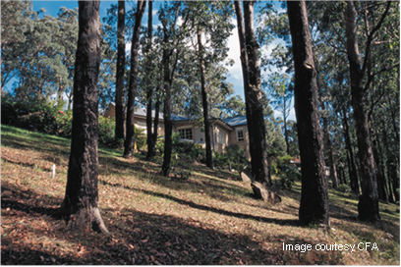
Discuss the key idea that bushfires matter to all Victorians for many reasons. For example:
- some people live or travel in areas affected by bushfires
- we might feel sad or worried when there is a bushfire because we care about the people and places affected.

Bringing it together
Using the CFA’s introduction, Am I at Risk?, help students learn how to identify the different fire risk environments, and explore how this information helps us prepare bushfire safety plans to help keep us safe.
Key ideas:
- Victoria is prone to bushfires.
- Learning about the different fire risk environments helps us to better plan and prepare.
- Everyone benefits from creating bushfire safety plans and helping others to feel safe.

Extending

Assessing risk: local vegetation
Provide or ask students to bring a photograph of their homes, nearby natural areas or the school environment featuring vegetation. Compare and contrast the environment in the photograph to the images from ‘Vegetation examples’ (pp. 6–9) in the CFA’s Fire Ready Kit.
Invite students to:
- compare the resemblance of the vegetation in the images to that near their homes and school
- identify the types of vegetation that can be found in the surrounding area.
Discuss what can be done to reduce the fire risk from vegetation.

