Preparing for bushfires

Lesson: Closer to home

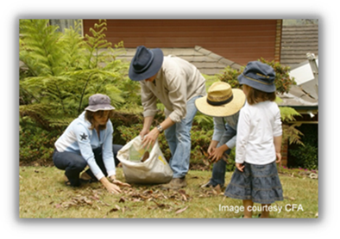
Overview
Curriculum levels: 7 and 8
Time: 50 minutes (approximately)
Links to the Victorian Curriculum F–10:
Geography, Years 7 and 8
Geographical Concepts and Skills
Identify, analyse and explain interconnections within places and between places and identify and explain changes resulting from these interconnections (VCGGC101)
Geographical Knowledge
Factors that influence the decisions people make about where to live and their perceptions of the liveability of places (VCGGK111)
Learning intention:
Students understand potential risks around the home and how addressing those risks can help reduce the damage caused by bushfires.
Suggested resources:
- ‘Bushfire myths and misconceptions’ factsheet (from the Resources section of the VCAA Bushfire Education webpages)
- Fire Danger Ratings

Activities

Starting
Review the three key mechanisms by which bushfires spread and affect structures:
- ember attack
- radiant heat
- direct flame.
Pose the question: What things around a property might be a fire hazard if a bushfire did approach the area?

Exploring
Students make up a list of potential household dangers, such as wooden fencing, long grass, mulch close to the house, leaves in guttering and eaves, wood piles, trees close to the house, wooden decking, and fuels and flammable liquids stored in the garage.
Generate discussion about why these things are dangers. Link them back to the fuel that a bushfire requires in order to continue burning. Focus on the effect that radiant heat, ember attack and direct flame have on the spread of bushfire. Also focus on how these elements contribute to ignition of a fire around a house or structure.
Pose another question: What things could be done to a house or structure to make it safer during a bushfire? Have students consider the following parts of a house: windows, doors, guttering, flooring.
Use these questions for a follow-up discussion:
- What does it mean to ‘understand’ the type of fire weather and the type of fire event that might affect your area? How can your household find out about these things?
- How does proximity to bushland affect the way you prepare for the threat of bushfire?
- How do houses catch fire even when they are not in direct contact with flames from a bushfire?
- How safe is your home from the threat of bushfire and what can your family do to reduce their risk?

Bringing it together
Organise students into pairs and have them view the CFA short video Preparing your property this fire season.
Have students read the CFA’s Your Guide to Property Preparation and then complete the following checklist. Lead a discussion about what actions can be taken to safeguard homes.
Area of the house/property | Action taken to make house safer from bushfire
Flooring and subflooring
Windows
Doors
Roof
Carport, deck, verandah
Lawns and garden beds
Shrubs and trees
Garden litter
Outdoor furniture

Extending
Have students research the changes to building regulations in Victoria after Black Saturday 2009 (see A guide to building in Victoria after bushfires, Victorian Building Authority). In what ways do the new building standards make houses safer?

