Preparing for bushfires

Lesson: Getting help to prepare for bushfires

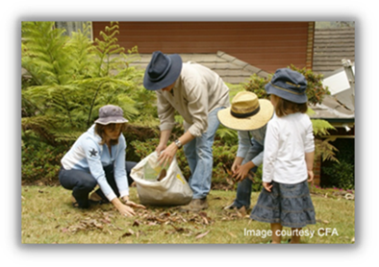
Overview
Curriculum levels: 5 and 6
Time: 50 minutes (approximately)
Links to the Victorian Curriculum F–10:
Civics and Citizenship, Levels 5 and 6
Citizenship, Diversity and Identity
Investigate how people with shared beliefs and values work together to achieve their goals and plan for action (VCCCC016)
Health and Physical Education, Levels 5 and 6
Personal, Social and Community Health
Investigate community resources and strategies to seek help about health, safety and wellbeing (VCHPEP107)
Learning intention:
Students learn about the local fire service and emergency agencies in their area, and how these services assist local communities to be prepared for the bushfire season.
Suggested resources:
- Whiteboard, IWB or poster paper, and appropriate markers
- Materials as selected for recording student responses, e.g. workbooks and markers, tablets, recording devices
- Student workbooks or paper
- Pens, pencils or markers
- Online resources such as the images and linked resources listed in the Resources section of the VCAA Bushfire Education webpages

Activities

Starting
Guide students to think and talk about:
- Who can we get to help us to prepare for bushfire season?
- What is the role of our local fire service?
- What other emergency agencies operate in our area?

Exploring

Student research task
Have students research the roles and contacts of the different fire services and emergency agencies in their local area OR they can research these details for another specific locality in one of the nine Fire Districts in Victoria.
Include the following services or agencies:
- Country Fire Authority
- Fire Rescue
- Victoria State Emergency Service
- Victoria Police
- their local council (access its website through the Know your council website)
- their local hospital or medical centre (access through Health.vic)
- Ambulance Victoria
- Forest Fire Management Victoria
- Parks Victoria
Students should find out how these agencies could help:
- in the event of a bushfire
- in their preparation for a bushfire.

Bringing it together

Bushfire poster
Working in small groups or as individuals, students choose one of the following topics as the basis for creating an informative and eye-catching poster about the important message being conveyed. The poster may be created electronically or as a hard copy.
Option 1: Design a bushfire communications tree for your local area, showing all the branches of communications for bushfire information in the area.
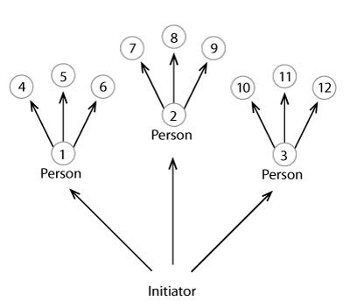
Example of a communication tree

If time and space allow, include some broader state-wide communication points, such as key websites and emergency radio broadcasters.
Option 2: Design a poster informing people about how to use either CFA services, the VicEmergency website or the VicEmergency Hotline. Your poster must:
- describe when you would use the service
- explain how you would use the service and what you would expect to see/hear/say/enter when you access the service.
Option 3: Design a poster for a CFA volunteer recruitment campaign. Your poster must:
- describe the CFA’s main responsibilities
- explain why volunteers are needed.
Visit the Volunteer Today section of the CFA website for background information.

Extending

Key fire services quiz
The students or teacher generate quiz questions to reinforce key information about the research conducted on the services or agencies that help with fire and safety information. Questions might include:
- Who would help your family find out about your home’s local fire risk?
- What can a Community Fireguard Group in your area help you with before the bushfire season starts?
- Where could you find out if there is a Community Information Guide in your area?
- What phone numbers should you have on hand as bushfire season begins?
- What is a Neighbourhood Safer Place?
- Who could tell you where a Neighbourhood Safer Place is in your district?
- What services might be provided by the local SES during the bushfire season?
- Who provides up-to-date information about fire danger ratings?
- Where and how would you find fire danger rating information?
- How does the CFA recruit the vast majority of its firefighters?

