Recovering from bushfires

Lesson: Commemorating the Black Saturday bushfires in 2019

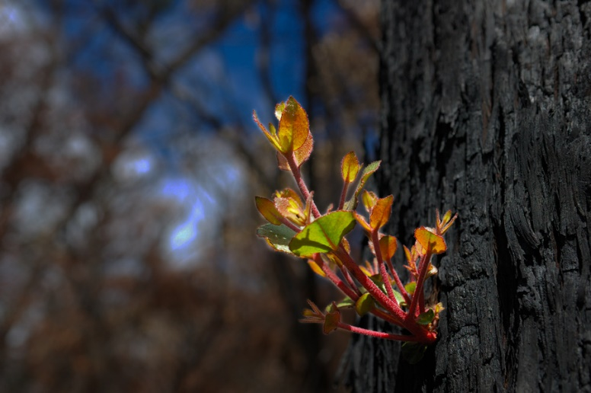
Overview
Curriculum levels: 5 and 6
Time: 50 minutes (approximately)
Links to the Victorian Curriculum F–10:
Civics and Citizenship, Levels 5 and 6
Citizenship, Diversity and Identity
Investigate how people with shared beliefs and values work together to achieve their goals and plan for action (VCCCC016)
English, Level 5
Reading and Viewing
Use comprehension strategies to analyse information, integrating and linking ideas from a variety of print and digital sources (VCELY319)
Learning intention:
Students look at the commemoration of Black Saturday in 2019 – 10 years after the fires – and the roles that commemoration plays in the community, both for those directly affected and the broader community.
Suggested resources:
- Whiteboard, IWB or poster paper, and appropriate markers
- Materials as selected for recording student responses, e.g. workbooks and markers, tablets, recording devices
- Online resources such as the images and linked resources listed in the Resources section of the VCAA Bushfire Education webpages

Activities

Starting
Conduct a class discussion:
- How do we remember significant events and lives in Australia?
- What does ‘commemorate’ mean?
Share and record responses and ideas. This might include public holidays, special ceremonies, construction of memorials, etc.
Make clear the difference between commemoration and celebration, e.g. we commemorate the sacrifices made by people on Anzac Day, but we celebrate Australia Day.
Commemorate means to take notice of or remember a significant event or person. This might involve having a special ceremony, building a memorial, putting a person’s picture or name on something (e.g. a street, a stamp or a banknote or coin), or giving them an award.

Exploring
Read the article ‘Black Saturday fires commemoration highlights kindness and recovery’ with students and watch the short video contained in the article.
Discuss with students:
- the purpose of the ceremony
- the things that helped people recover
- the symbolism of the map of Victoria
- the importance of remembering.

Bringing it together
Working in pairs, have students research one or more of the bushfire memorials from the 2009 bushfires (see 2009 Bushfire Memorials, Regional Development Victoria).
Students report back to the class on the nature and feature of their memorial:
- What does the memorial look like? (Include an appropriate image.)
- What are the special features of the memorial?
- What does the memorial symbolise?
Discuss:
- What impact might the construction of a memorial have on the local community?

Extending
Option A: Have students view ‘Black Saturday horror and hope remembered’ and discuss the various messages that people from Marysville present on the tenth anniversary of Black Saturday. How do the people interviewed view their recovery?
Option B: News media staff covering the bushfires were also deeply affected by the tragedy. Have students read and listen to ‘“We were people first, reporters second”: ABC news teams and broadcasters reflect on covering Black Saturday’. What were the responses of media staff to the tragedy? How did they share the feelings of the community in covering the tragedy?

